#### 12.4.3 Quantum Confined Stark Effect

The quantum confined Stark effect (QCSE, Sect. [15.​1.​2](#u116076_4_En_15_Chapter)) in quantum wells shifts energy levels when electric fields are present along the width of the quantum well. A strong effect exists for pyro- and piezoelectric material combinations such as *c*-axis oriented (In,Ga)N/(Al,Ga)N [1211, 1212] or (Cd,Zn)O/(Mg,Zn)O [1213, 1214] quantum wells due to the built-in electric field (cf. Sect. [16.​2](#u116076_4_En_16_Chapter)). The QCSE induced red-shift is larger in thicker quantum wells and goes beyond the bulk band gap of the quantum well material (Fig. [12.43](#u116076_4_En_12_Chapter-Fig43)b). Also the wavefunction overlap is reduced with increasing well width, leading to an increase of the radiative recombination lifetime as shown in Fig. [12.43](#u116076_4_En_12_Chapter-Fig43). The pyroelectric field and the related modification of lifetime are absent in quantum wells grown on non-polar directions such as [11.0] (Fig. [12.43](#u116076_4_En_12_Chapter-Fig43)a).

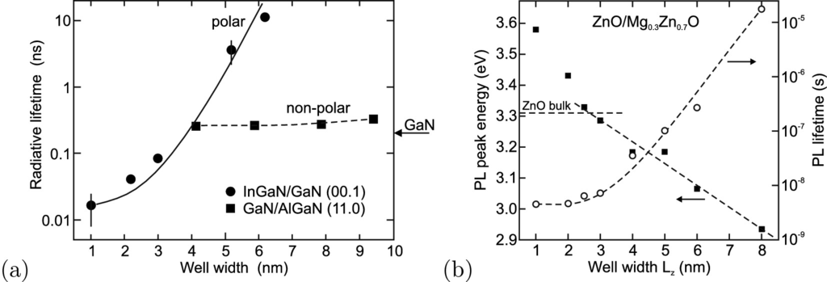

Fig. 12.43

**a** Radiative lifetime of electron-hole pairs in polar [00.1]-oriented In

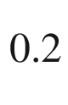

Ga

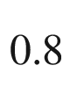

N/GaN (*circles*) and non-polar [11.0]-oriented GaN/Al

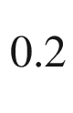

Ga

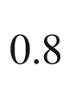

N (*squares*) quantum wells of varying thickness. Experimental data are shown in *symbols*. The *solid line* is the (scaled) theoretical dependence of the electron-hole overlap for (In,Ga)N/GaN QWs. The *dashed line* is guide to the eye. The *arrow* denotes the recombination time constant in bulk GaN. Adapted from [1215, 1216]. **b** Low temperature PL peak recombination energy (*solid squares*) for ZnO/Mg

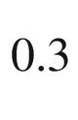

Zn

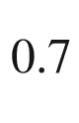

O quantum wells for various well widths

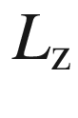

(barrier width

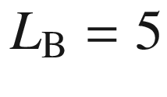

 nm). *Dashed line* indicates dependence for internal field of 0.9 MV/cm, *horizontal dashed line* indicates recombination energy in ZnO bulk. Carrier lifetime determined from PL (*circles*), *dashed line* is guide to the eye.

Adapted from [1214]

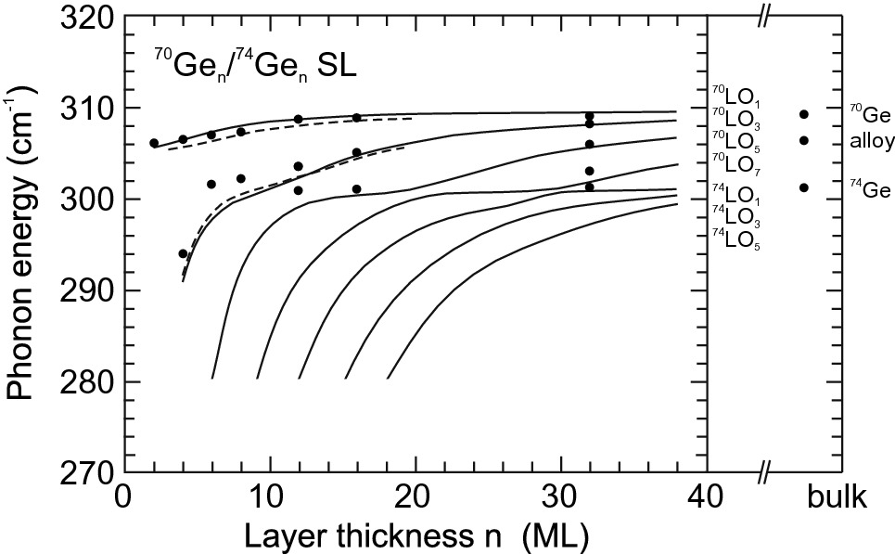

Fig. 12.44

Measured (*full circles*) and theoretical (*solid lines*) confined LO phonon energies in

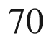

Ge



/

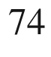

Ge



superlattices versus the layer thickness (number of monolayers) *n*. The *dashed lines* represent a calculation that considers intermixing at the interfaces. On the right, the energies of bulk modes for isotopically pure

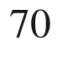

Ge and

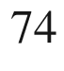

Ge are shown together with that of an



Ge

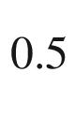

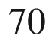

Ge



alloy.

Adapted from [1217]

### 12.5 Isotope Superlattices

A special type of heterostructure is the modulation of the isotope content. The first kind of heterostructures made like this were



Ge



/

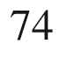

Ge



symmetric superlattices [1217]. Figure [12.44](#u116076_4_En_12_Chapter-Fig44) shows phonon energies determined from Raman spectroscopy for various layer numbers *n*. The modes are classified by

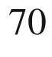

LO

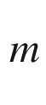

and



LO

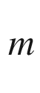

denoting the material in which the amplitude is maximal and *m* being the number of maxima in that medium.[8](#u116076_4_En_12_Chapter-Fn8) Such modes are visualized in Fig. [12.45](#u116076_4_En_12_Chapter-Fig45)a for a

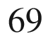

GaP

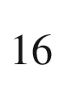

/

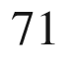

GaP

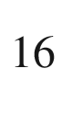

superlattice. Theoretical mode energies as a function of the superlattice period are shown in Fig. [12.45](#u116076_4_En_12_Chapter-Fig45)b.

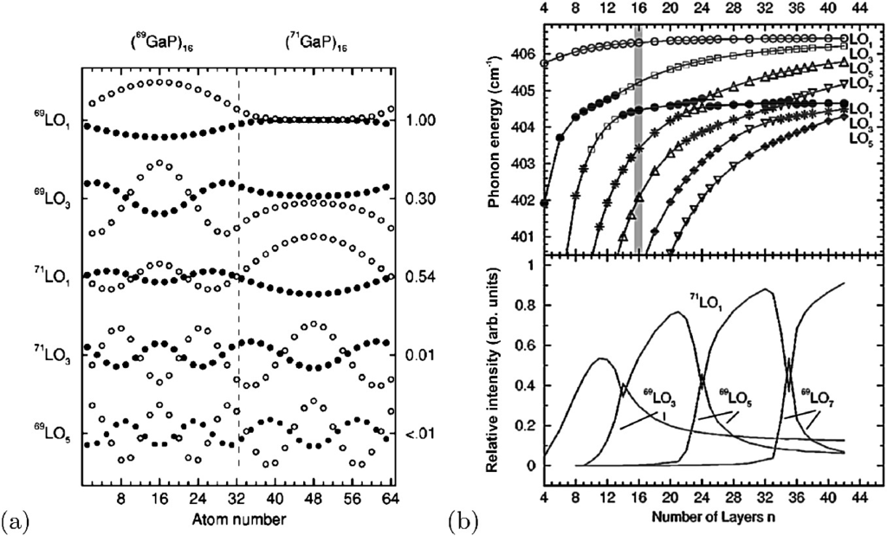

Fig. 12.45

**a** Atomic displacements [Ga (*filled dots*) and P (*open circles*)] of odd-index LO modes in a

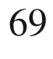

Ga

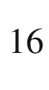

P/

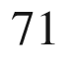

Ga



P superlattice unit cell. These modes have even parity with respect to midlayer planes, which are at atom numbers 16 and 48 in this example. The labels on the left identify the predominant character of the mode, those on the right give the relative Raman intensities with respect to that of the

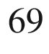

LO



mode. The tick marks on the vertical axis indicate zero displacement of the respective mode. **b** *Upper panel*: Energies and characters of odd-index LO phonon modes in GaP isotope SLs as calculated within the planar bond charge model for the case of ideal interfaces.

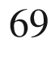

LO



modes are shown as *open symbols*;

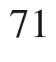

LO



modes as *full symbols*. The *shaded area* marks

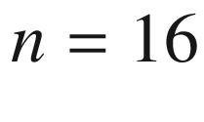

for which the atomic displacements of the modes are shown in part (**a**). *Lower panel*: Calculated intensities of the modes relative to that of the

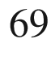

LO



phonon mode.

Adapted from [379], reprinted with permission, ©1999 APS

### 12.6 Wafer Bonding

Wafer bonding is a fairly recently developed method to join different and dissimilar materials. Two wafers of the respective materials are put together face to face and are adequately fused. The idea is to not only ‘glue’ the wafers together with a sticky (and compliant) organic material, but to form strong atomic bonds between the two materials with possibly a perfect interface. In some cases, the interface needs to allow charge-carrier transport through it. Less stringent conditions need to be met for photon transport.

Mechanical deficiencies such as surface roughness, dust particles and the like must be avoided in the wafer-bonding process since they result in voids. Several methods have been developed for bonding various materials [1220–1222]. Such processes are successful for large substrate sizes. With proper processing, ideal interfaces can be created, as shown in Fig. [12.46](#u116076_4_En_12_Chapter-Fig46). Such structures, if made between a p-doped and a n-doped semiconductor, show diode characteristics.

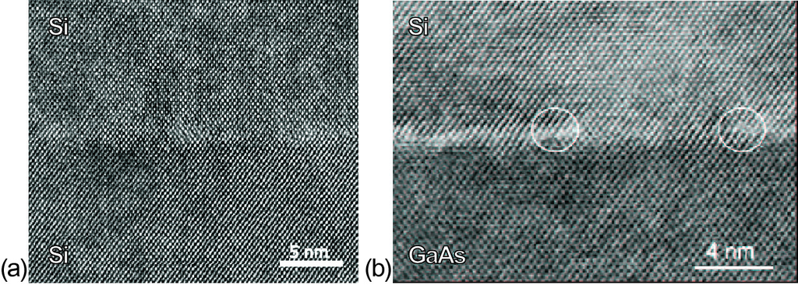

Fig. 12.46

High-resolution TEM images of wafer-bonded **a** Si–Si and **b** GaAs–Si interfaces. *White circles* indicate the position of misfit dislocations. Part (**a**) reprinted from [1218], ©2003, with permission from Elsevier.

Part (**b**) reprinted with permission from [1219], ©1998 AIP

Footnotes

[1](The_Physics_of_Semiconductors00005.docx#u116076_4_En_12_Chapter-Fn1_source)

In the ‘US’ flat definition, the primary flat is the

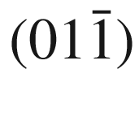

surface, in the ‘EJ’ definition, the primary flat is

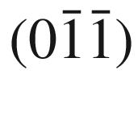

.

[2](The_Physics_of_Semiconductors00005.docx#u116076_4_En_12_Chapter-Fn2_source)

This is the growth mode of self-assembled epitaxial quantum dots as discussed in Sect. [14.​4.​3](#u116076_4_En_14_Chapter).

[3](The_Physics_of_Semiconductors00005.docx#u116076_4_En_12_Chapter-Fn3_source)

For ZnO, homosubstrates have recently been produced with 3-inch diameter [1136].

[4](The_Physics_of_Semiconductors00005.docx#u116076_4_En_12_Chapter-Fn4_source)

The kinetic energy term in ([12.5](The_Physics_of_Semiconductors00005.docx#u116076_4_En_12_Chapter-Equ6)) is written as

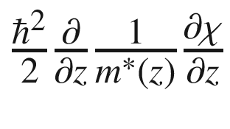

for varying mass across the structure [1179].

[5](The_Physics_of_Semiconductors00005.docx#u116076_4_En_12_Chapter-Fn5_source)

neglecting excitonic enhancement.

[6](The_Physics_of_Semiconductors00005.docx#u116076_4_En_12_Chapter-Fn6_source)

The error function is defined as

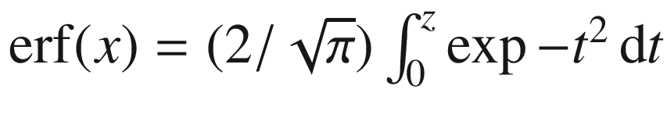

.

[7](The_Physics_of_Semiconductors00005.docx#u116076_4_En_12_Chapter-Fn7_source)

Formula ([12.11](The_Physics_of_Semiconductors00005.docx#u116076_4_En_12_Chapter-Equ14)) is exact for the product of a Gaussian and the Boltzmann function.

[8](#u116076_4_En_12_Chapter-Fn8_source)

Only modes with odd *m* are Raman-active.

© Springer Nature Switzerland AG 2021

M. Grundmann

The Physics of Semiconductors

Graduate Texts in Physics

<https://doi.org/10.1007/978-3-030-51569-0_13>

## 13. Two-Dimensional Semiconductors

Marius Grundmann[1](#u116076_4_En_13_Chapter-Aff11)

(1)

Felix Bloch Institute for Solid State Physics, Universität Leipzig, Leipzig, Germany

Marius Grundmann

Email:

[grundmann@physik.uni-leipzig.de](mailto:grundmann@physik.uni-leipzig.de)

*Introducing a new experimental system is generally more rewarding than trying to find new phenomena within crowded areas. [...] Of course, the fantastic results one originally hopes for are unlikely to materialise, but, in the process of studying any new system, something original inevitably shows up.*

*A.K. Geim, 2010* [1223]

## Abstract

2D materials or atomic sheets are materials without a bulk. They offer unique physics and properties, but also challenges in preparation and stability. Stacking of such 2D materials in van-der-Waals heterostructures extends the possibilities.

2D materials are the ultimate thickness limit for semiconductors. While the thickness of quantum wells can be controlled to the sub-atomic average thickness, they are still impacted by the roughness or undulation of the underlying substrate. 2D materials are more like free two-dimensional molecules with giant lateral extension and a vertical structure well defined by atomic bonding. Paper collections and textbooks are available for this topic, e.g. [1224–1226].

### 13.1 Graphene and Related Materials

Graphene, its name proposed in [1227], is the ultimately thin material, a single sheet of carbon atoms in honeycomb arrangement; this is *not* a hexagonal (cf. Fig. [3.​3](The_Physics_of_Semiconductors00001.docx#u116076_4_En_3_Chapter-Fig3)b) but a trigonal lattice with a two-atom basis (Fig. [13.1](#u116076_4_En_13_Chapter-Fig1)). Graphene possesses unique physical properties such as a linear dispersion around the Fermi energy, making it a solid-state analogue to ultra-relativistic physics [1228]. Graphene does not possess a band gap in its ideal form. An account of the history of graphene research, starting in 1840, is given in [1229].

Many applications for graphene and graphene-based composites have been envisioned in electronics such as superior conductor or transistor material [1230, 1231] as well as applications in energy, biomedical, membranes and sensors [1232, 1233], but the current industrial use is still rather limited. Here, we introduce ’flat’ graphene while quasi one-dimensional nanotubes based on graphene are treated in Sect. [14.​3](#u116076_4_En_14_Chapter).

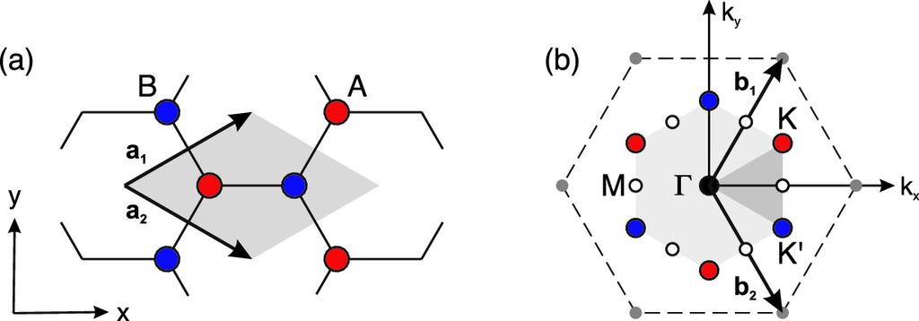

Fig. 13.1

Unit cell of A–B compound honeycomb lattice in **a** real space and **b** reciprocal space. The irreducible part of the Brillouin zone is shown in dark grey

#### 13.1.1 Structural Properties

The carbon bond length in graphene is

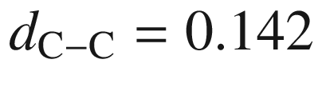

 nm (cmp. Table [13.1](#u116076_4_En_13_Chapter-Tab1)). Due to instabilities [1234, 1235], freely suspended graphene layers are not perfectly flat but exhibit corrugations [1236]. Graphene can be prepared from graphite via micromechanical cleavage, i.e. mechanical exfoliation (repeated peeling) of small mesas of highly oriented pyrolytic graphite [1237, 1238]. Epitaxial growth on SiC [1239] and the growth on copper in large sheets [1232] have been reported.

Graphite is a stacked arrangement of such graphene sheets (Fig. [13.2](#u116076_4_En_13_Chapter-Fig2)a) held together by van-der-Waals forces (cmp. Sect. [13.3](#u116076_4_En_13_Chapter-Sec12)) as shown in Fig. [13.2](#u116076_4_En_13_Chapter-Fig2)b. The carbon atoms bond via sp

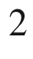

hybridization. Organic molecules such as, e.g., anthracene or coronene (Fig. [18.​1](#u116076_4_En_18_Chapter-Fig1)) can be understood as molecular-size pieces of such two-dimensional graphene sheet with hydrogen saturating the outside, broken bonds. Single layer graphene sheets (SLG) and few-layer graphene (FLG) sheets must distinguished since for the latter the exact stacking arrangement and vertical coupling effects play a role. Ideally, such two-dimensional crystal is infinitely extended, e.g. for band structure calculations. Of course real crystals always have a (quasi-) one-dimensional boundary which is topologically a line or very thin sidewall. Various defects have been studied in graphene. The vacancy is discussed in [1241] and exhibits a magnetic moment of

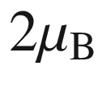

.

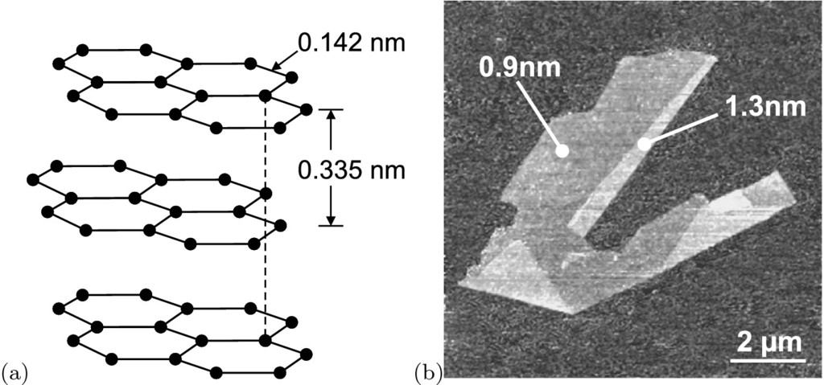

Fig. 13.2

**a** Schematic layer structure of graphite with bond length and layer distance labelled. **b** AFM image of graphene on oxidized silicon. The height of two areas relative to the background is labelled.

Adapted from [1240]

The unit cells in real and reciprocal space are shown in Fig. [13.1](#u116076_4_En_13_Chapter-Fig1). The lattice vectors are

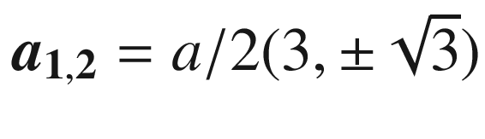

(Fig. [13.1](#u116076_4_En_13_Chapter-Fig1)a). The reciprocal lattice vectors are

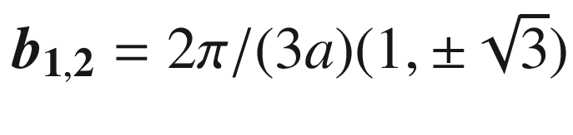

, where

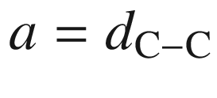

. The Brillouin zone (Fig. [13.1](#u116076_4_En_13_Chapter-Fig1)b) has two triples of K-points that are labeled K and K’ (or K

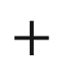

and K−) at

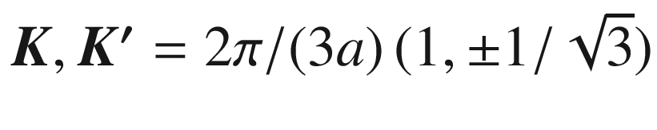

. When the A- and B-sites are identical, as for graphene, the difference between K- and K’-points is often subtle and a

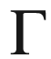

–M–K Brillouin zone is sufficient.

Mechanical properties of graphene are discussed in [1242, 1243]; it has exceptional strength (Young’s modulus in the range of 1 TPa). The breaking stress 200 times greater than steel, with a 2D tensile stress of 42 N/m, corresponding to a strain of 25%. The phonon dispersion of graphene is shown in Fig. [13.3](#u116076_4_En_13_Chapter-Fig3)a. For the ZA and ZO modes, the displacement is perpendicular to the graphene plane (out-of plane modes). In Fig. [13.3](#u116076_4_En_13_Chapter-Fig3)b the Raman spectra of graphite and graphene are compared. The peak (termed ‘G’) at about 1580 cm

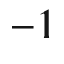

ist due to the zone center mode. The peak at about 2680 cm



(termed ‘2D’) is due to two phonons (double resonance) with opposite momentum in the highest optical branch near the K-point. It splits into four peaks for bilayer graphene due to changes in the electronic band structure [1245].

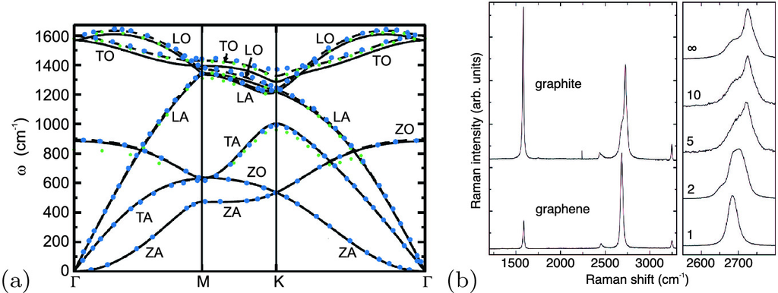

Fig. 13.3

**a** Phonon dispersion in graphene (cmp. Fig. [13.1](#u116076_4_En_13_Chapter-Fig1)b). *Symbols* are experimental data from various methods. *Dashed lines* is DFT-LDA theory, *solid lines* GGA. Adapted from [1244], reprinted with permission, ©2004 Elsevier Ltd. **b** Comparison of graphite and graphene Raman spectra (excited at 514 nm). In the right panel the number of monolayers in FLG is labeled (1: graphene,

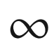

: graphite).

Adapted from [1245], reprinted with permission, ©2006 APS

#### 13.1.2 Band Structures

The band structure of graphene from first principles [1246] is depicted in Fig. [13.4](#u116076_4_En_13_Chapter-Fig4)a. Graphene is a zero-gap semiconductor (cf. Fig. [6.​46](The_Physics_of_Semiconductors00003.docx#u116076_4_En_6_Chapter-Fig46)) which shows a linear photon-like spectrum,

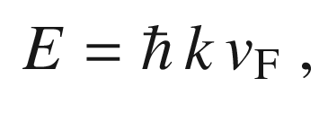

(13.1)

around the Fermi energy at the K-point (Fig. [13.4](#u116076_4_En_13_Chapter-Fig4)b). Such point is also called ’Dirac’ point.

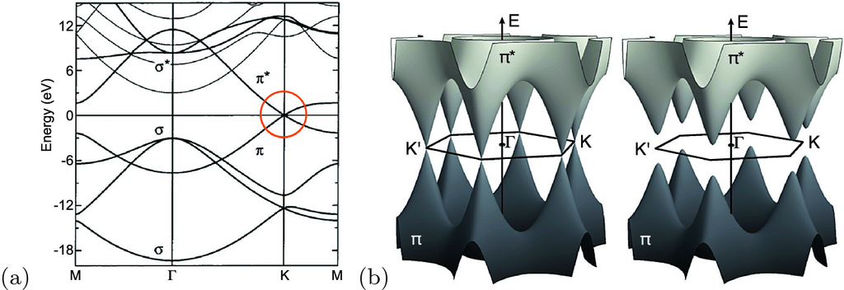

Fig. 13.4

**a** Band structure of graphene from first principles (zero energy refers to the intrinsic Fermi level). The *circle* focusses on the linear band crossing at the Fermi level. Adapted from [1247], reprinted with permission, ©2004 WILEY-VCH. **b** Three-dimensional representation

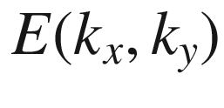

of the

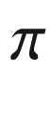

-bands of graphene (*left*) and of graphene-like material with gap (*right*)

The important bands close to the Fermi level stem from the (out-of-plane)



-orbitals while the (in-plane) chemical bonds are sp

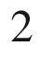

-type (Sect. [2.​2.​3](The_Physics_of_Semiconductors00001.docx#u116076_4_En_2_Chapter)). The linear dispersion around the K-point is similar to that of relativistic particles without rest mass. The electrons in graphene are of course not really massless, their velocity ([6.​35](The_Physics_of_Semiconductors00003.docx#u116076_4_En_6_Chapter)) being

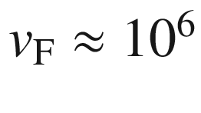

 m/s, about 300 times smaller than the speed of light [1248, 1249].

In the simplest tight-binding approximation (cf. Appendix G), considering the coupling of the carbon (out-of-plane) p



-orbitals with three nearest neighbors, the band structure is given as [1250, 1251] (cf. (G.23)

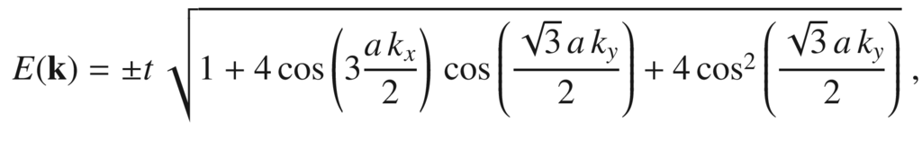

(13.2)

where

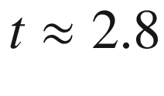

 eV is the next-neighbor hopping energy (cf. Fig. G.1). More elaborate tight-binding schemes have been reported [1252, 1365]. The second next-neighbor energy

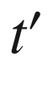

is about a factor of 10–100 smaller; a tight-binding fit to cyclotron resonance experiments finds

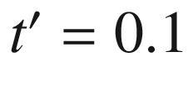

 eV [1253]. The two-dimensional band structure is visualized in Fig. [13.4](#u116076_4_En_13_Chapter-Fig4)b. Such band structure has been directly confirmed experimentally [1254] as shown in Fig. [13.6](#u116076_4_En_13_Chapter-Fig6)a–e. The distortion of the band structure with increasing electron concentration (Fig. [13.6](#u116076_4_En_13_Chapter-Fig6)e–h) from the conical bands is due to strong electron-electron, electron-phonon, and electron-plasmon coupling effects [1254].

The band structures of atomic sheets of C, Si and Ge are compared in Fig. [13.5](#u116076_4_En_13_Chapter-Fig5). The bands cross for all three materials at the K-point while the band gap at the zone center decreases with increases order number. Any kind of asymmetry between the A- and B-sites, as might occur for example on certain corrugated substrates, will introduce a band gap at the Dirac points (Fig. [13.4](#u116076_4_En_13_Chapter-Fig4)b).

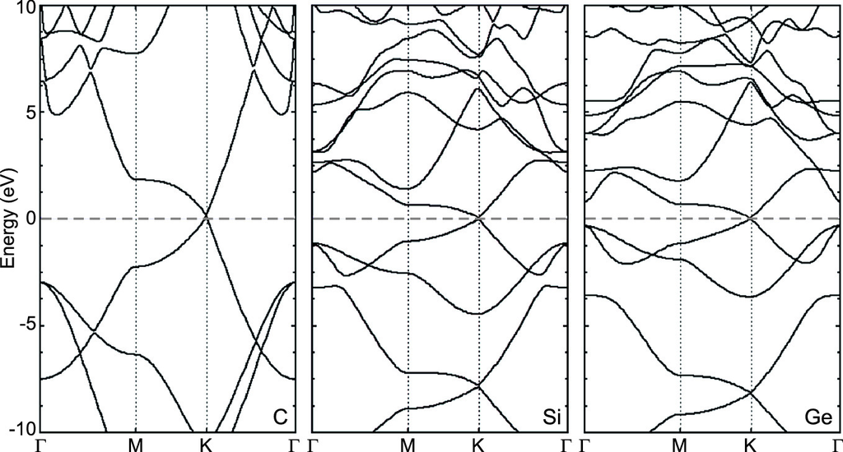

Fig. 13.5

Band structure of graphene, silicene and germanene as labeled.

Adapted from [1255], reprinted with permission, ©2014 RSC

The band structure of FLG has been theoretically analyzed in [1256, 1257]. For bilayers experimental data on the band structure can be found in [1258]. Subtle differences exist for different stacking orders of the graphene sheets (see below, Sect. [13.3](#u116076_4_En_13_Chapter-Sec12)). Bulk graphite shows a semi-metallic behavior with a band overlap of about 41 meV. For more than ten graphene layers the difference with the band overlap in bulk graphite is less than 10%.

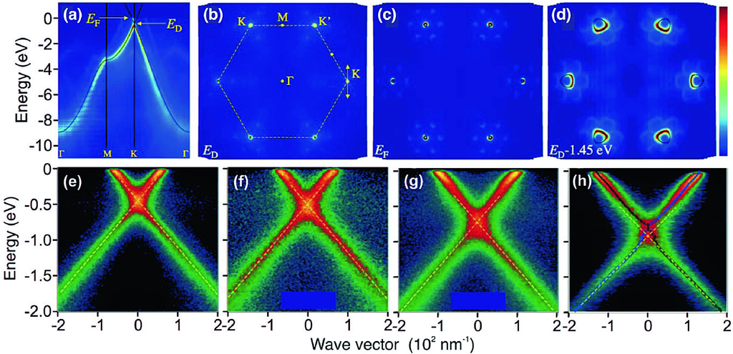

Fig. 13.6

Experimental bandstructure of graphene (on (0001) 6H-SiC) as determined from ARPES. **a** Energy distribution of states as a function of momentum along principal directions in the Brillouin zone. The single-orbital tight-binding model ([13.2](#u116076_4_En_13_Chapter-Equ2)) with

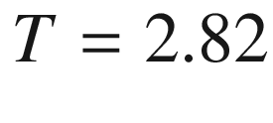

 eV is shown as *solid lines*. The Fermi level is shifted by 0.435 eV due to doping. **b** Constant energy map of the states at binding energy corresponding to the Dirac energy

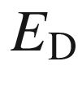

; the boundary of the Brillouin Zone boundary is superimposed as *dashed line*. The arrow at the K-point indicates the directions over which the data in (**e**–**h**) were acquired. **c**, **d** Constant energy maps at the Fermi energy

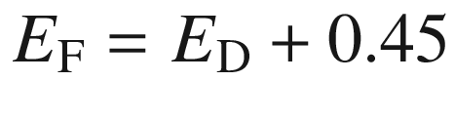

 eV and

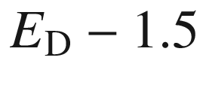

 eV, respectively. **e**–**h** Experimental energy bands along the line through the K-point parallel to

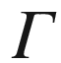

–M direction as indicated in (**b**). The *dashed lines* are an extrapolation of the lower bands below the Dirac crossing energy, which are observed not to pass through the upper bands (above

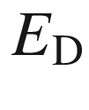

), suggesting the kinked shape of the bands around

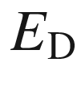

. The sheet electron density is

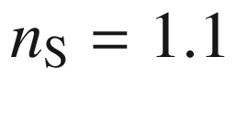

, 1.5, 3.7, and

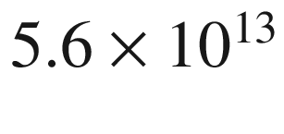

 cm

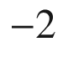

for (**e**)–(**h**), respectively, due to increased doping upon potassium adsorption.

Adapted from [1254], reprinted with permission, ©2006, Springer Nature

#### 13.1.3 Electrical Properties

The Shubnikov-de Haas (SdH) oscillations from a graphene sheet exhibit a behavior [1249]

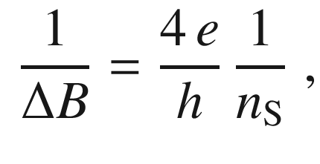

(13.3)

which corresponds to ([15.​39](#u116076_4_En_15_Chapter)) for a two-dimensional electron system and a spin- and valley-degeneracy[1](#u116076_4_En_13_Chapter-Fn1) of both two.  The cyclotron mass has been determined from the temperature dependence of the SdH oscillations to be proportional[2](#u116076_4_En_13_Chapter-Fn2) to

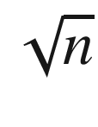

(Fig. [13.7](#u116076_4_En_13_Chapter-Fig7)). The cyclotron mass is generally related [1259] to the area

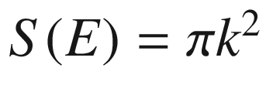

in *k*-space of the orbits at the Fermi energy via

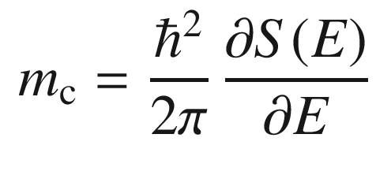

(13.4)

With the linear dispersion ([13.1](#u116076_4_En_13_Chapter-Equ1)) we can write ([13.4](#u116076_4_En_13_Chapter-Equ4)) as

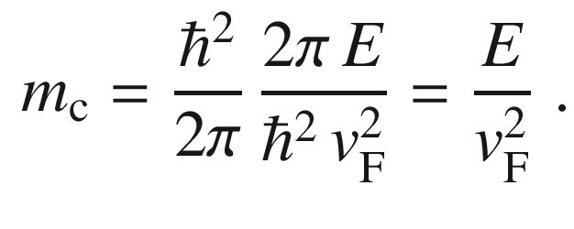

(13.5)

For the linear energy dispersion ([13.1](#u116076_4_En_13_Chapter-Equ1)) the number of states up to energy

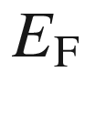

is (with a degeneracy of 4)

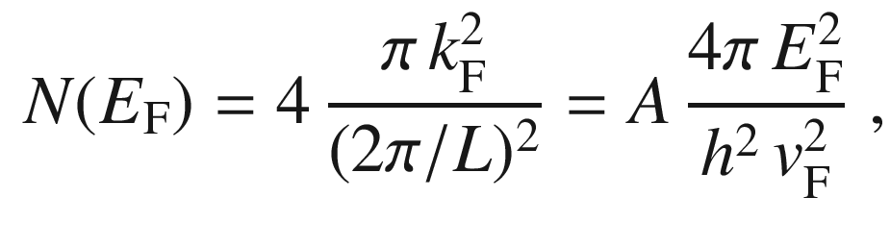

(13.6)

where *A* is the system area. Therefore we have (at low temperature) with ([13.5](#u116076_4_En_13_Chapter-Equ5))

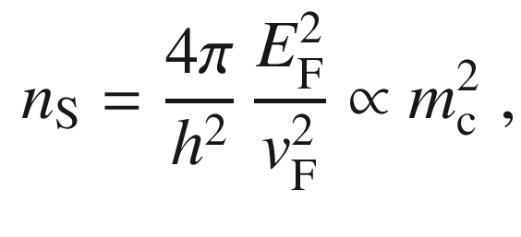

(13.7)

as determined experimentally. Therefore the behavior of the SdH oscillations confirms the linear dispersion relation. The experimental value for the velocity is

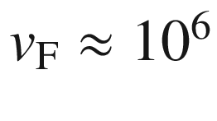

 m/s. From ([13.7](#u116076_4_En_13_Chapter-Equ7)) the density of states (per area and energy) around the Dirac point increases linearly with energy,

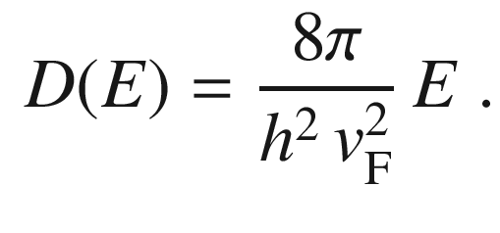

(13.8)

The carrier density in a graphene sheet can be controlled via the field effect. The graphene is positioned on an insulator/semiconductor structure, typically SiO



/Si (cf. Sect. [21.​3](The_Physics_of_Semiconductors00007.docx#u116076_4_En_21_Chapter)). The carrier density is then related to the applied (gate) voltage

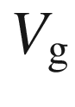

via ([21.​93](The_Physics_of_Semiconductors00007.docx#u116076_4_En_21_Chapter)) and ([21.​95](The_Physics_of_Semiconductors00007.docx#u116076_4_En_21_Chapter)), i.e.

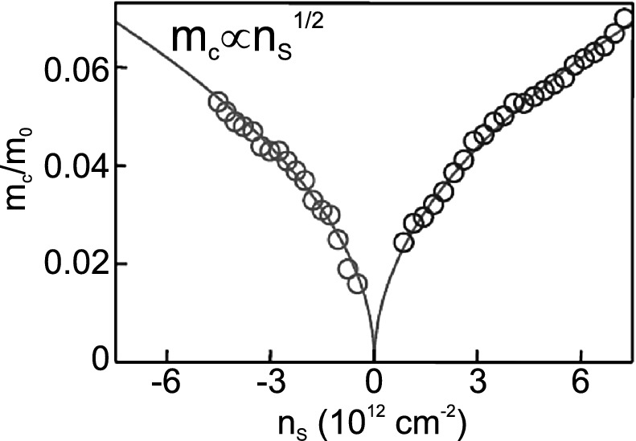

Fig. 13.7

Cyclotron mass in graphene as a function of the sheet electron concentration

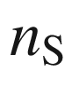

(negative values relate to hole concentration,

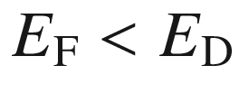

).

Adapted from [1249]

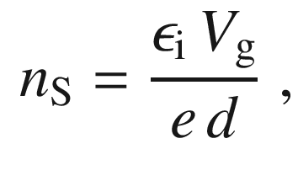

(13.9)

where *d* is the thickness of the insulator and

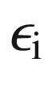

its dielectric constant. By applying positive (negative) bias electron (holes) can be induced in the sheet. The electron and hole densities depend on the Fermi energies[3](#u116076_4_En_13_Chapter-Fn3)

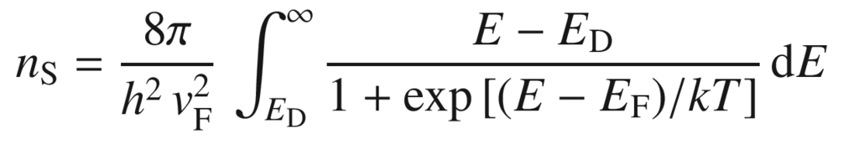

(13.10a)

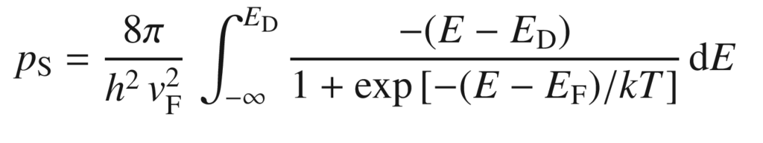

(13.10b)

as visualized in Fig. [13.8](#u116076_4_En_13_Chapter-Fig8). These relations cannot be inverted to obtain

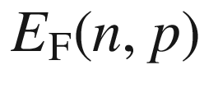

analytically. The total charge carrier density is

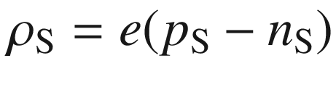

.

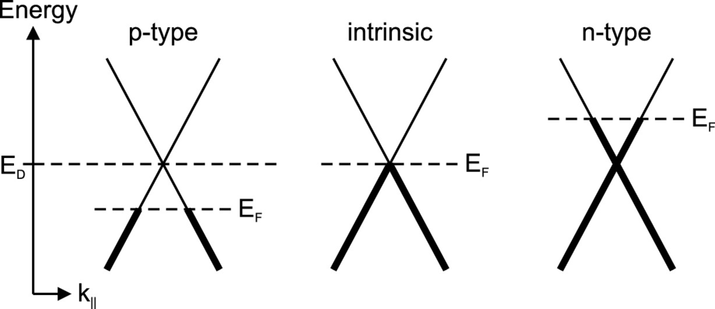

Fig. 13.8

Band structure of graphene with various positions of the Fermi energy

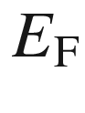

in relation to the Dirac energy



. States occupied with electrons are shown with in *bold*

The Hall effect (Fig. [13.9](#u116076_4_En_13_Chapter-Fig9)) shows the expected ambipolar dependence according to ([15.​16](#u116076_4_En_15_Chapter)) which takes the form

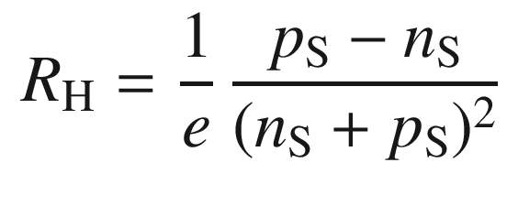

(13.11)

for equal electron and hole mobilities.[4](#u116076_4_En_13_Chapter-Fn4)

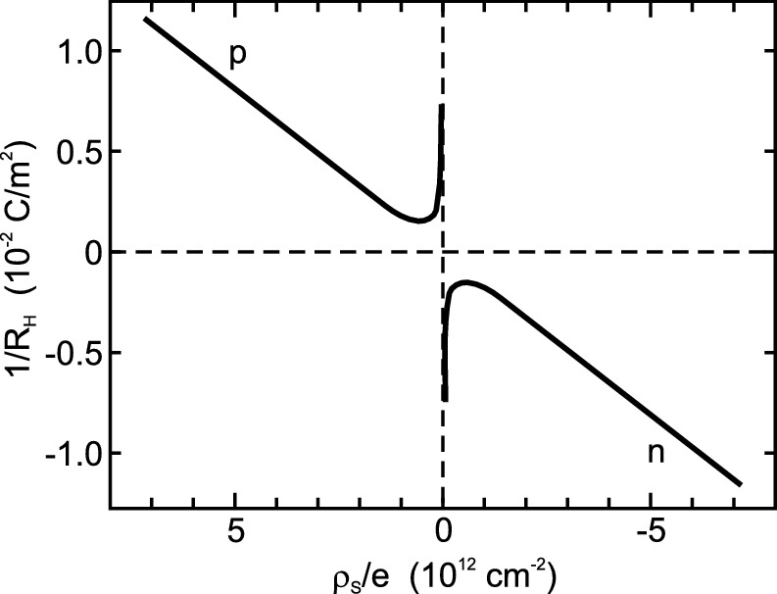

Fig. 13.9

Hall coefficient (

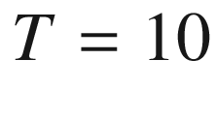

 K) for a graphene sheet as a function of the free carrier sheet density

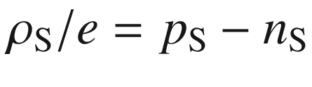

(positive values indicate p-type).

Data shown as *solid lines* from [1249]

From Hall effect measurements the mobility has been determined to be about

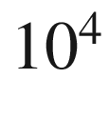

 cm



/Vs, independent of temperature between 10 and 100 K, and the same for electrons and holes. This value, however, is much smaller than the in-plane mobility of about

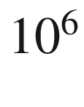

 cm



/Vs at 4.2 K in high quality samples of highly ordered pyrolithic graphite (HOPG) [1260]. In suspended graphene a mobility of

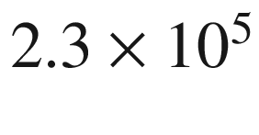

 cm

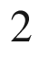

/Vs has been found, limited by finite sample size [1261]. Thus in graphene layers on a solid surface extrinsic effects such as charge traps, interfacial phonons, ripples or fabrication residue seem to limit the carrier mobility.

The QHE has been observed in graphene [1249], reportedly up at room temperature [1262]. The plateaus

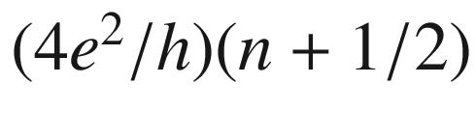

correspond to unusual half-integer filling, the first plateau occurring at

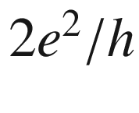

, as has been also suggested from theory, and related to the ‘pseudospin’. Another consequence of the Dirac-like behavior of the fermions in graphene is the presence of finite maximum resistivity

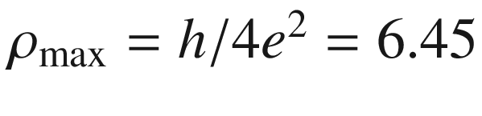

 k

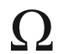

even at low temperature and

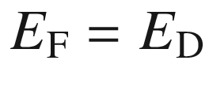

. It is due to the fact that localization effects, leading to insulating behavior, are strongly suppressed. Then each carrier keeps a mean free path in the order of its Fermi wavelength.

The Klein paradox [1263, 1264], the efficient tunneling of Dirac particles through high and thick barriers seems accessible in transport experiments with graphene [1265].

#### 13.1.4 Optical Properties

The transmission of graphene has been investigated in [1266] over apertures and in [1267] on SiO



substrate. The band-band absorption process is schematically shown in Fig. [13.10](#u116076_4_En_13_Chapter-Fig10)a. A theoretical analysis of this process yields an absorbance of

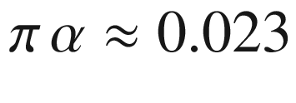

,

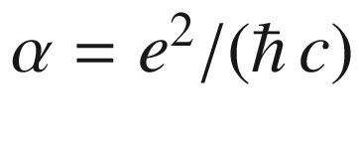

being the fine structure constant [1266, 1268]. Effects due to next-to-nearest neighbors are not present theoretically [1269]. This universal number is found in the experimental spectrum in the visible spectral range as shown in Fig. [13.10](#u116076_4_En_13_Chapter-Fig10)b. In order to exhibit this value, half the photon energy may not be too large because the band structure will deviate from the linear dependence due to the triangular warping and nonlinearities (cf. Appendix G.3.2 and remember

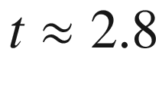

 eV). In the infrared regime, deviations are due to state blocking due to finite temperature and non-zero Fermi level relative to the Dirac point and due to intraband transitions [1267]. For FLG, the transmission decreases stepwise; the step sequence deviates from

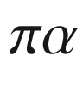

due to inter-layer effects [1270].

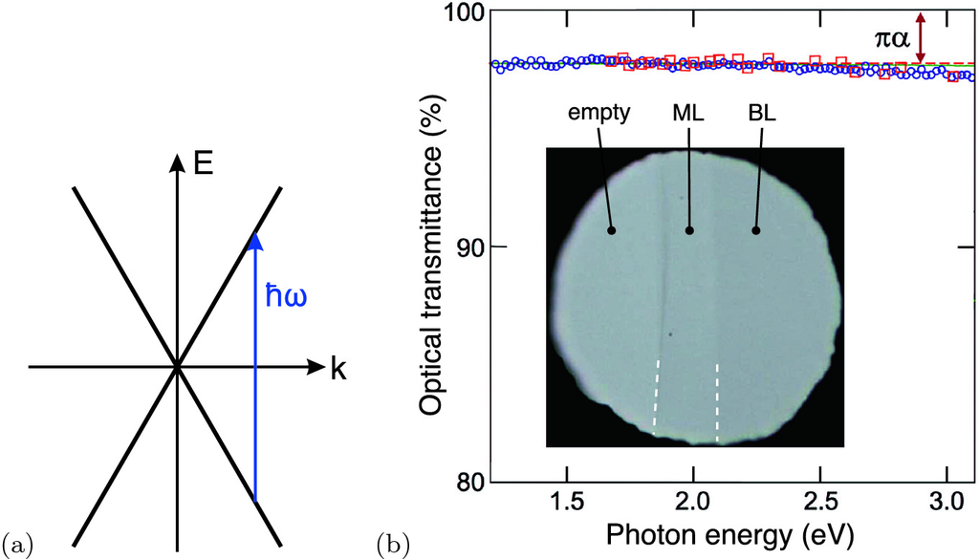

Fig. 13.10

**a** Scheme for interband absorption in the graphene band structure around one of the Dirac points. **b** Transmission spectrum of graphene, measured using standard spectroscopy for a uniform membrane that completely covered a 30

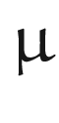

m aperture (*blue circles*) and measured using an optical microscope (*red squares*). The inset shows a 50

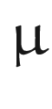

m aperture partly covered with monolayer (ML) and bilayer (BL) graphene as labeled (*white dashed lines* highlight the borders).

Adapted from [1266]

### 13.2 Two-Dimensional Compound Semiconductors

Two-dimensional crystals have been reported also for compound semiconductor materials such as BN, MoS



, NbSe



, Bi



Sr



CaCu



O



[1238] or ZnO [1271] and in particular transition metal dichalcogenides (TMDC) of the type MX



, where M represents a transition metal atom and X a chalcogen atom forming the (W,Mo)(S,Se,Te)



system [1272, 1273]. But many other materials also form atomically thin sheets [1225, 1255, 1274]. The main difference to graphene is that they form a band gap. A few physical properties are listed in Table [13.1](#u116076_4_En_13_Chapter-Tab1).

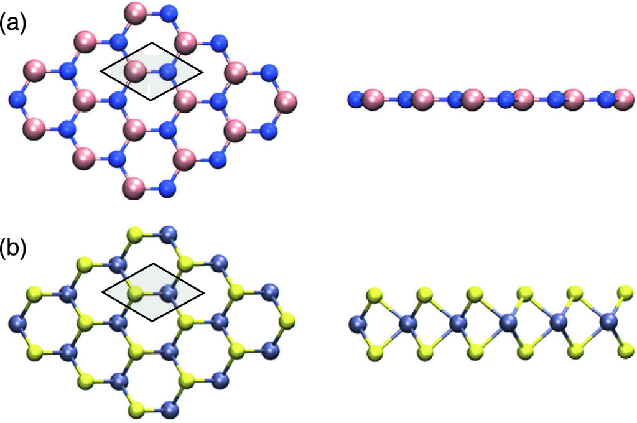

Fig. 13.11

Crystal structure of two 2D materials of **a** hexagonal BN-type and **b** MX



-type transition metal dichalcogenides. The unit cell is indicated. *Left*: Bird’s eye view on the plane and *right*: side view. The greyed area denotes an elementary cell.

Adapted from [1255], reprinted with permission, ©2014 RSC

Table 13.1

Properties of various two-dimensional (monolayer) semiconductors, in-plane nearest neighbor distance

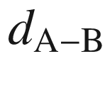

, vertical distance of anions

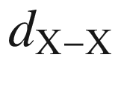

for MX



-type TMDC, band gap

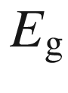

, exciton binding energy

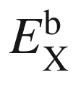

(exfoliated on silica) and spin-splitting

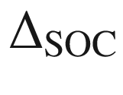

in conduction and valence band

| material | C | BN | MoS  $$_2$$ | MoSe  $$_2$$ | WS  $$_2$$ | WSe  $$_2$$ |
| --- | --- | --- | --- | --- | --- | --- |
| $$d_{\mathrm {A-B}}$$  (nm) | 0.142 | 0.144 | 0.184 | 0.192 | 0.184 | 0.192 |
| $$d_{\mathrm {X-X}}$$  (nm) |  |  | 0.317 | 0.334 | 0.314 | 0.334 |
| $$E_{\mathrm {g}}$$  (eV) | 0 | 7.3 | 2.15 | 2.18 | 2.41 | 2.2 |
| $$E_{\mathrm {X}}^{\mathrm {b}}$$  (eV) |  | 2.2 | 0.31 | 0.5 | 0.32 | 0.5 |
| $$\Delta _{\mathrm {SOC,CB}}$$  (meV) | 0 |  | -3 | -21 | 29 | 36 |
| $$\Delta _{\mathrm {SOC,VB}}$$  (meV) | 0 |  | 148 | 184 | 430 | 466 |

#### 13.2.1 Structural Properties

Various two-dimensional configurations are known, the two most prominent that are typical for BN (1H, hexagonal) and for TMDC (2H, trigonal prismatic, ABA-stacking) respectively, are shown in Fig. [13.11](#u116076_4_En_13_Chapter-Fig11). A plane-view TEM of the 2H structure of MoS



is depicted in Fig. [13.12](#u116076_4_En_13_Chapter-Fig12) [1275]. Other configurations of the TMDC such as an ABC-like stacking (1T, distorted octahedral) are possible [1276]. A variation are Janus TMDC of MXY type where the bottom and top layer consist of different anions [1277]. Two-dimensional alloys can be formed by mixing cations [1279] or anions [1283] (or both). As example, a STEM image of a Mo

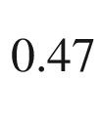

W

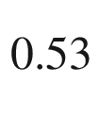

S



monolayer is shown in Fig. [13.12](#u116076_4_En_13_Chapter-Fig12)b which shows the distribution of W and Mo atoms.

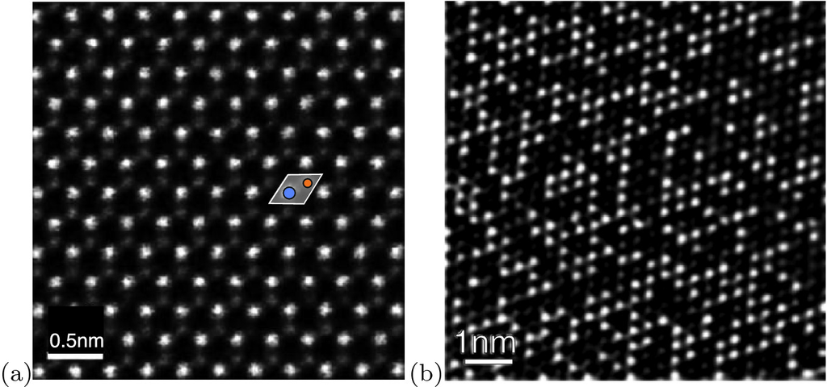

Fig. 13.12

**a** STEM-ADF image of a MoS



monolayer; a unit cell with Mo (S) atom shown in *blue* (*orange*) is overlaid (cf. Fig. [13.1](#u116076_4_En_13_Chapter-Fig1)a). Reprinted (with adaptation) with permission from [1275]. ©2013 American Chemical Society. **b** STEM image (Fourier filtered) of a Mo

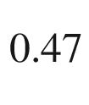

W

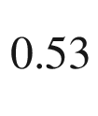

S



monolayer. The bright (dark) spots relate to W (Mo) atoms.

Reprinted (with adaptation) with permission from [1279], ©2013 ACS

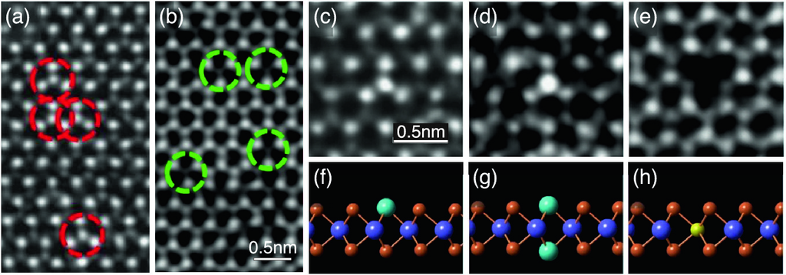

Fig. 13.13

Various point defects (vacancies and antisites) in MoS



monolayer as revealed by TEM (**a**)–(**e**) together with atomic models (**f**)–(**h**). **a** S vacancy (V

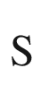

), **b** S divacancy (V

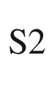

), **c** Mo on S site (Mo

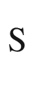

), **d** 2 Mo on 2 S sites (Mo2

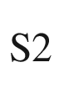

), **e** S on Mo site (S

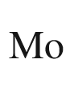

).

Adapted from [1280], reprinted under Creative Commons Attribute (CC BY 4.0) license

Various defects have been investigated for compound 2D semiconductors. For the vacancies in BN we refer to [1284]. Single sulphur vacancies in MoS



are investigated in [1278]. Various antisite defects in MoS



have been identified [1280] (Fig. [13.13](#u116076_4_En_13_Chapter-Fig13)). Also extended defects such as dislocations [1275], grain boundaries [1281] or rotational stacking faults [1282] have been observed.

The phonon spectra of graphene, BN- and BC



N-sheets are compared in Fig. [13.14](#u116076_4_En_13_Chapter-Fig14). The spectrum of BC



N is similar to the superposition of the C and BN spectra [1285]. The Raman peaks from MoS



show discrete peak energies for thickness of 1–5 or 6 monolayers and then merge closely to the bulk values [1286, 1287]. The dispersion of 2D MoS



[1288] (Fig. [13.15](#u116076_4_En_13_Chapter-Fig15)) is quite similar to that of bulk material [1287, 1289]. Of course, due to the mass difference between Mo and S, a clear gap exists between acoustic and optical phonons (which is absent for graphene, cmp. Fig. [13.3](#u116076_4_En_13_Chapter-Fig3)a).

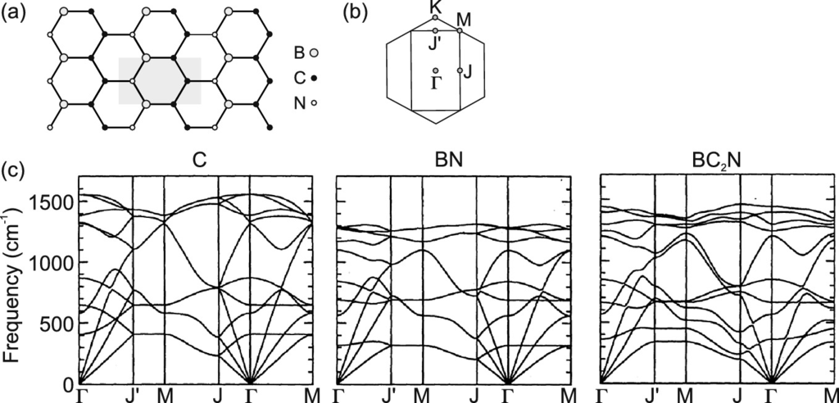

Fig. 13.14

**a** Crystal structure of BC



N with unit cell indicated. **b** Brillouin zone of BC



N (*rectangle*) and C, BN (*hexagon*, cmp. Fig. [13.1](#u116076_4_En_13_Chapter-Fig1)b). **c** Phonon dispersion of graphene (C) and BN- and BC



N-sheets.

Adapted from [1285]

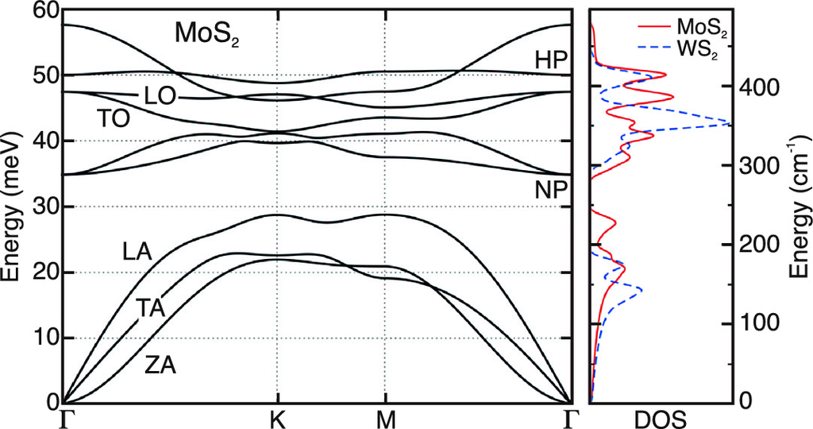

Fig. 13.15

Phonon dispersion of MoS



monolayer. ZA: out-of plane acoustic mode, NP: non-polar optical modes, HP: homopolar modes. On the right, the phonon density of states (DOS) is shown for Mo



(*red solid line*) and for WS



(*blue dashed line*) in comparison.

Dispersion adapted from [1288], DOS adapted from [1287]

#### 13.2.2 Band Structures

The band structure of a h-BN monolayer has been calculated to be indirect [1290]. In Fig. [13.16](#u116076_4_En_13_Chapter-Fig16), the band structure for a typical TMDC is depicted for a monolayer, a bilayer and bulk material. The latter features an indirect band structure with the valence band maximum at the

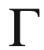

-point and the conduction band minimum about half the way to the K-point. Similar band structures are found for multi-layers down to 2. However, for a single layer the band gap is direct at the K-points. The possible optical transitions are indicated in Fig. [13.16](#u116076_4_En_13_Chapter-Fig16) as arrows. For the single layer, the direct transition has a lower energy than the indirect one; in a bilayer it is vice versa. Generally, the band gap increases with decreasing number of layers; this can be understood by thinking about the slab being a quantum well surrounded by a vacuum ’barrier’.

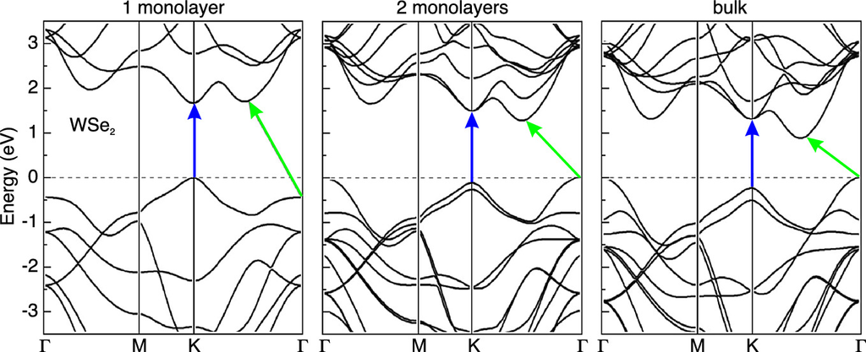

Fig. 13.16

Band structure of monolayer, bilayer and bulk WSe



. The *blue* (*green*) *arrows* indicate the direct (indirect) band-band transitions.

Based on [1272]

The lack of inversion symmetry results in a splitting of the electronic bands due to spin-orbit interaction.  This effect is particularly strong in the valence band. Splitting energies

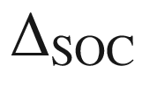

from fully relativistic calculations have been predicted for various 2H-MX



systems [1292, 1293, 1296], ranging between about 150 meV (MoS



) and 500 meV (WTe



). For WSe



, an experimental value of about 500 meV has been found [1297] (Fig. [13.18](#u116076_4_En_13_Chapter-Fig18)). For the same materials, the spin-splitting in the conduction band[5](#u116076_4_En_13_Chapter-Fn5) is an order of magnitude smaller in the range of 3–50 meV [1292, 1293]. Because of time reversal symmetry, the spin-splitting (cf. Sect. [6.​2.​4](The_Physics_of_Semiconductors00003.docx#u116076_4_En_6_Chapter)) of the bands at K and K’ has opposite sign as visualized in Fig. [13.17](#u116076_4_En_13_Chapter-Fig17)a; this property is termed ’spin-valley coupling’.

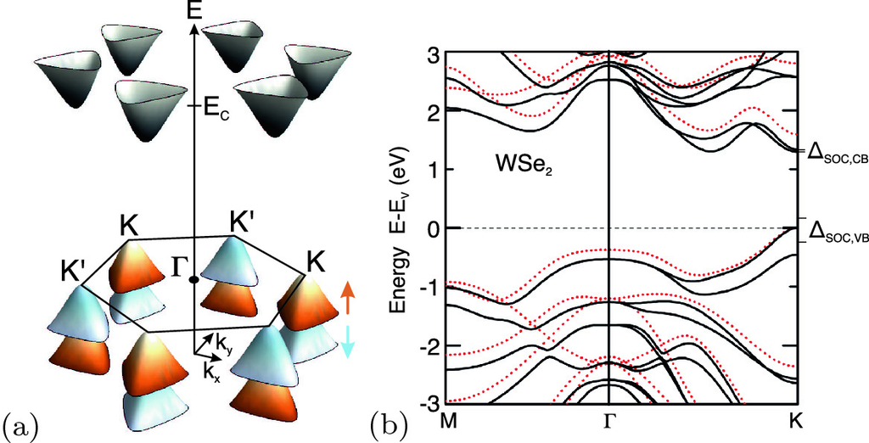

Fig. 13.17

**a** Schematic three-dimensional view of (unsplit) conduction band minima (*grey*) and spin-split valence band maxima with opposite (*red*: up, *blue*: down) spin orientation. **b** Relativistic band structure of 2H-WSe



(*red dots* show band structure without inclusion of spin-orbit splitting) with spin-splittings of conduction and valence band indicated.

Adapted from [1296], reprinted with permission, ©2011 APS

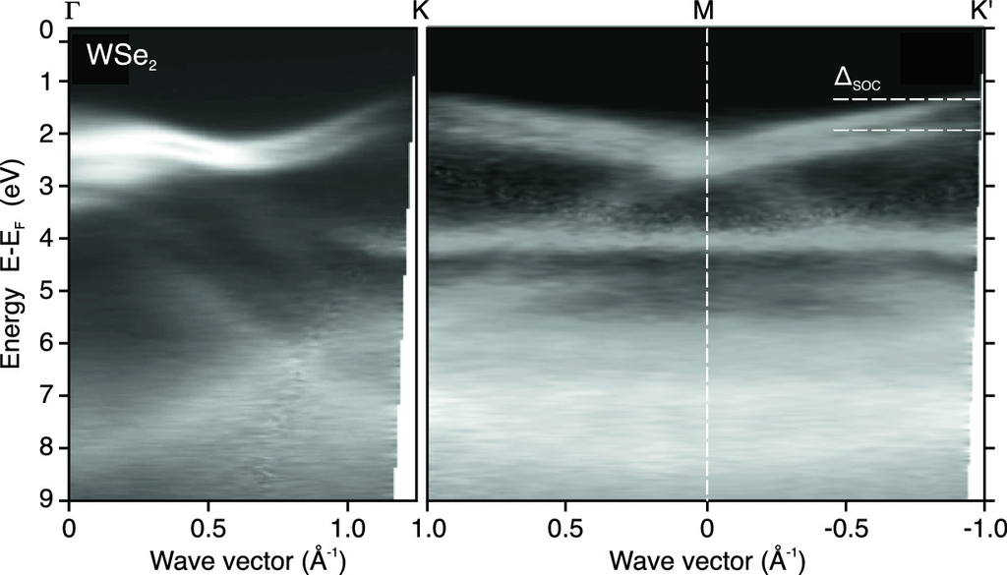

Fig. 13.18

ARPES measurement of the band structure of monolayer WSe



. The *horizontal dashed white lines* indicate the spin-orbit splitting

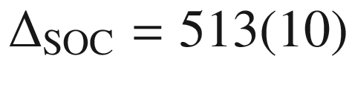

 meV of the top of the valence band.

Adapted from [1297], reprinted with permission, ©2015 IOP Publishing

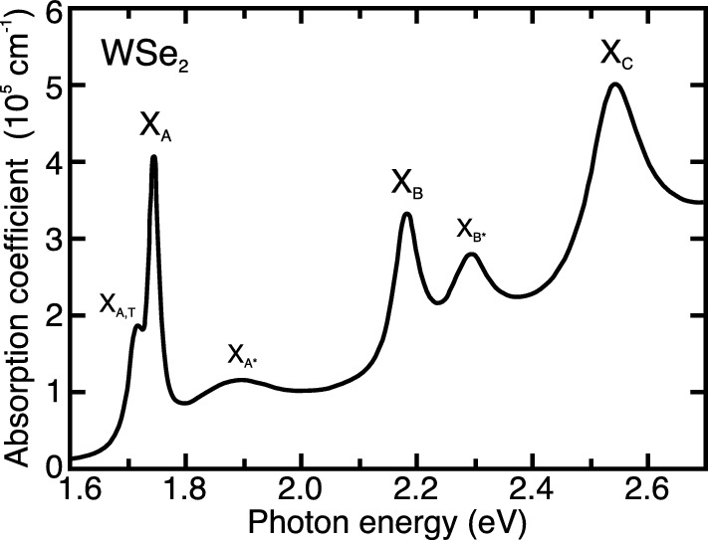

Fig. 13.19

Absorption spectrum of WSe



monolayer (derived from reflectance spectrum). X

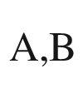

(X

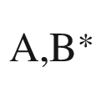

) denote the ground state (excited states) of the A- and B-exciton, respectively. X

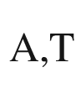

at the low energy side denotes a trion. X

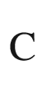

denotes a further transition discussed further in [1299].

Based on data from [1298]

#### 13.2.3 Optical Properties and Valley Polarization

The absorption spectrum of a WSe



monolayer is shown in Fig. [13.19](#u116076_4_En_13_Chapter-Fig19) as reported in [1298]; various excitonic transitions are labeled that are discussed further below. The A- and B-excitons are formed from the upper and lower state of the spin-split valence band, respectively.

The direct-to-indirect transition of the band structure for monolayer and multiplayer TMDC can be directly observed from the photoluminescence. For MoS



, the single layer exhibits a 2–3 orders of magnitude higher luminescence intensity (Fig. [13.20](#u116076_4_En_13_Chapter-Fig20)a) than any multilayer sample since no phonons are needed for the optical band-band transition. The direct transition is at about 1.9 eV; the indirect band gap decreases monotonously and discretely from about 1.6 eV for a bilayer, via that of 3, 4, 5 or 6 layers (Fig. [13.20](#u116076_4_En_13_Chapter-Fig20)b) to that of bulk material (

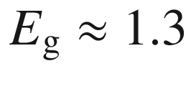

 eV) [1291].

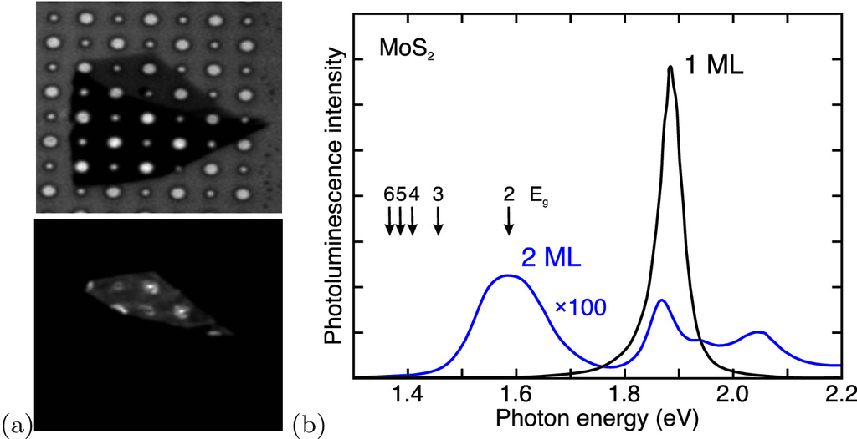

Fig. 13.20

**a** *Top*: Optical image of MoS



crystal on a silicon substrate with 1.0 and 1.5

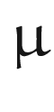

m diameter holes. *Bottom*: Photoluminescence intensity image of the same sample. The freely suspended parts of the single layer exhibit the highest intensity. **b** Photoluminescence spectra (excited at 532 nm) detected from regions with monolayers and bilayers, respectively. The arrows denote the positions of the (indirect) transitions for 2–6 layers.

Adapted from [1291]

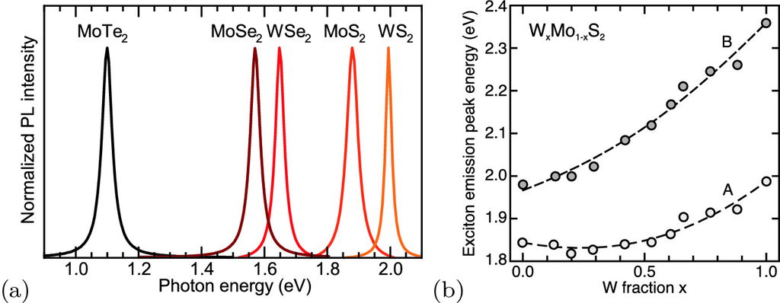

Fig. 13.21

**a** Photoluminescence spectra (at room temperature) of MoS



, WS



, MoSe



, WSe



, and MoTe



monolayers as labeled. From [1300], with permission. **b** Transition energies of A and B excitons in W



Mo

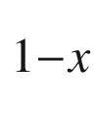

S



alloy monolayers as a function of composition (spectra were excited at 514.5 nm for

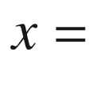

0-0.61 and at 457.9 nm for

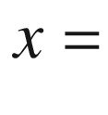

0.66-1). The *dashed lines* are fits with bowing parameters

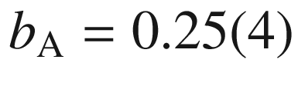

 eV and

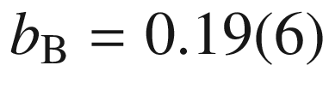

 eV.

Based on data from [1279]

The K- and K’-point pseudo-spin together with the spin-orbit interaction leads to spin-polarized bands as shown schematically in Fig. [13.22](#u116076_4_En_13_Chapter-Fig22)a. If excited with polarized light, optical absorption occurs between bands of the same spin orientation. In the absence of any inter-valley scattering, optical transitions are expected with a high degree of circular polarization [1301], leading to large dichroism effects (without magnetic ions). However, a maximum degree of circular polarization of about 50% was found in [1302] for MoS



excited with circularly polarized light (Fig. [13.22](#u116076_4_En_13_Chapter-Fig22)b). The inter-valley dynamics reducing the polarization effects depends on the time scales of scattering and recombination which both can be in the range of several ps [1303]. The two oppositely polarized peaks in Fig. [13.22](#u116076_4_En_13_Chapter-Fig22)b have the same peak energy as expected from time-reversal symmetry; a magnetic field perpendicular to the layer will lift this degeneracy and introduce a K-K’ splitting (valley Zeeman effect) [1304, 1305] (Fig. [13.21](#u116076_4_En_13_Chapter-Fig21)).

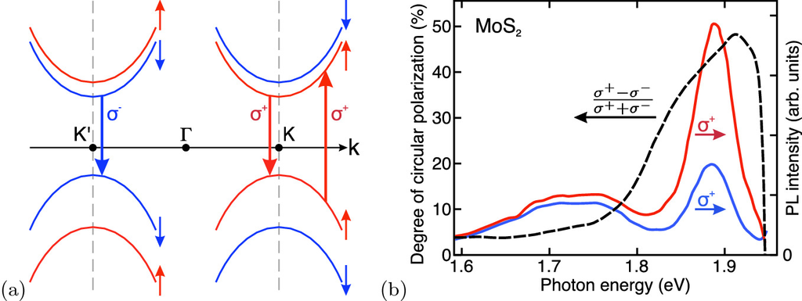

Fig. 13.22

**a** Schematic band structure of MoS



monolayer around the K- and K’-point with spin-splitting (band order according to [1294]). Circularly polarized absorption and recombination processes are shown. **b** Circularly polarized detected photoluminescence (

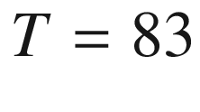

 K) from MoS



monolayer (*red*:

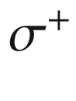

, *blue*:

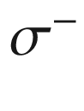

) after excitation with

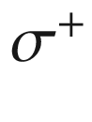

-polarized light at 1.96 eV (at the right end of the energy scale). The degree of circular polarization,

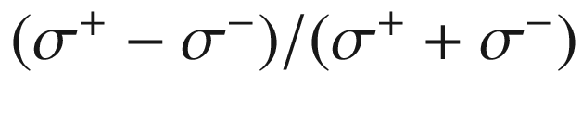

is depicted as black curve with the left-hand scale.

Adapted from data in [1302]

#### 13.2.4 Excitons

The properties of excitons are particular in 2D materials. The purely two-dimensional hydrogen problem [1306, 1307] leads to a series of bound states

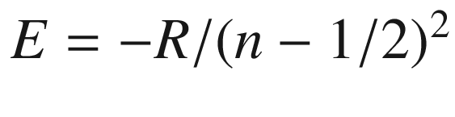

, where *R* denotes the Rydberg energy and

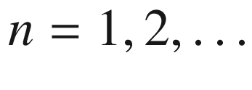

as usual. However, for the excitons in 2D material, the case of a stepwise changing dielectric constant

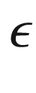

, leading to image charge effects, as known from quantum well heterostructures [1188] (cmp. Sect. [12.​3.​2](The_Physics_of_Semiconductors00005.docx#u116076_4_En_12_Chapter)), must be considered. The thin slab is surrounded by vacuum which gives a huge contrast in

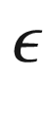

. Even when packed, as often done in experiments, between other layers such as h-BN (

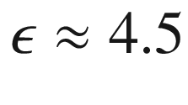

) or on a substrate, the contrast in dielectric constant is very large.[6](#u116076_4_En_13_Chapter-Fn6)

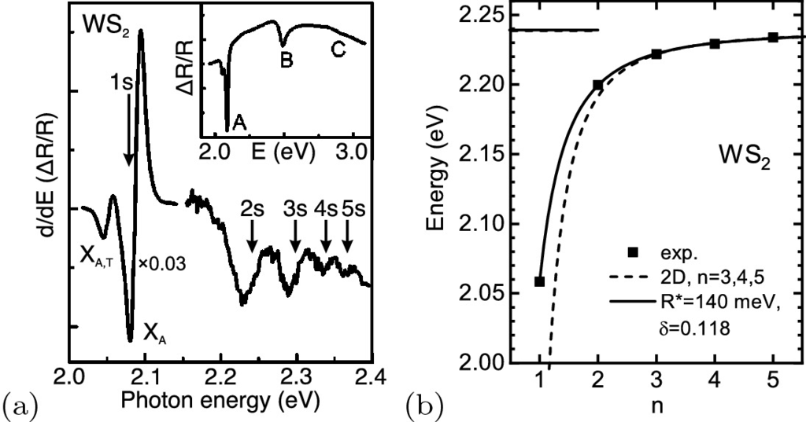

Fig. 13.23

**a** Differential reflection contrast spectrum of WS



monolayer (*inset*: reflection contrast). X

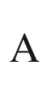

denotes the A-exciton, X



at the low energy side the trion. Based on data from [1311]. **b** Experimental transition energies (*circles*) for WS



from magneto-optical data [1313] (cf. Fig. [15.​13](#u116076_4_En_15_Chapter-Fig13)) with fits using the modified hydrogen model

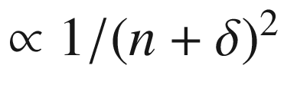

(*solid line*) and a 2D hydrogen model with constant dielectric function fitted to the

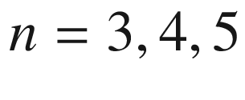

levels (both theories displayed for continuous *n*). The (very similar) band gap

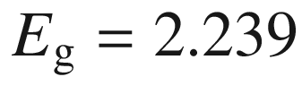

 eV for the two models is shown as *lines* on the left

This problem has been treated theoretically first in [1308, 1309] and recently rigorously in [1310]. The exciton binding energy is typically increased by this effect to several 100 meV. Also, the strongly anisotropic dielectric surrounding affects different quantum states differently, leading to non-hydrogenic terms in the exciton spectrum [1311] (Fig. [13.23](#u116076_4_En_13_Chapter-Fig23)). Schematics of the field lines for the 1s- and 2s-states are depicted in Fig. [13.24](#u116076_4_En_13_Chapter-Fig24)c, motivating that the anisotropic dielectric environment acts differently on these states. The higher the quantum number *n* is, the lower is the average dielectric constant ’seen’ by the 2D-exciton. In the example of excitons in WS



, the effective dielectric constant changes from about 5 for the 1s state to 2.5 for the 2s state to values close to 1 for the higher states [1311].

In [1312] it has been discussed that the exciton level can be well described by the formula

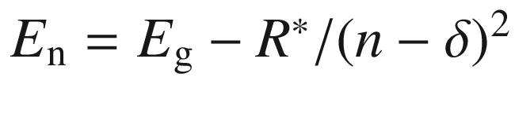

, with

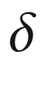

being a fitting parameter. Such parameter

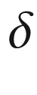

is known as ’quantum defect’ in the description of alkali spectra [1314]. For WSe



(embedded between h-BN layers),

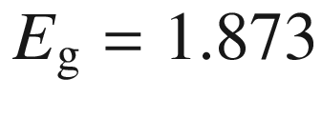

 eV,

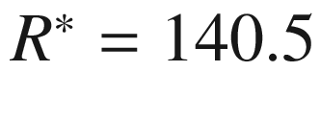

 meV and

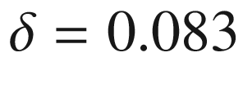

has been found [1312]. The data from [1313] for WS



(also sandwiched between slabs of exfoliated hexagonal h-BN) can be fitted with

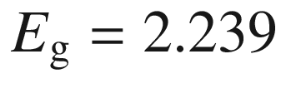

 eV,

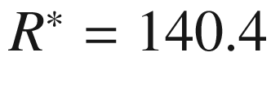

 meV and

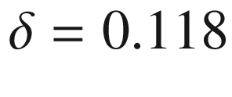

(Fig. [13.23](#u116076_4_En_13_Chapter-Fig23)b).

The calculated plane-view of the electron wave function of the exciton ground state (A-exciton) in a MoS



monolayer is depicted in Fig. [13.24](#u116076_4_En_13_Chapter-Fig24)a; the contributions to the exciton wave packet stem, from around the K-points as shown in Fig. [13.24](#u116076_4_En_13_Chapter-Fig24)b [1299]. Magneto-optical spectroscopy of 2D excitons and the Zeeman splittings and diamagnetic shifts up to the 5*s* state in WS



and Mo(S,Se,Te)



monolayers are reported in [1313] and (on Si/SiO



substrate) [1315]; the *g*-factor (cf. Sect. [15.​2](#u116076_4_En_15_Chapter)) of the exciton is very close to

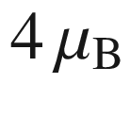

(cf. Fig. [15.​13](#u116076_4_En_15_Chapter-Fig13)d), a fact that is under theoretical consideration [1316]. Charged excitons have been discussed in [1317, 1318]. The influence of various surrounding media to the TMDC on the dielectric screening has been investigated theoretically [1319] and experimentally [1320].

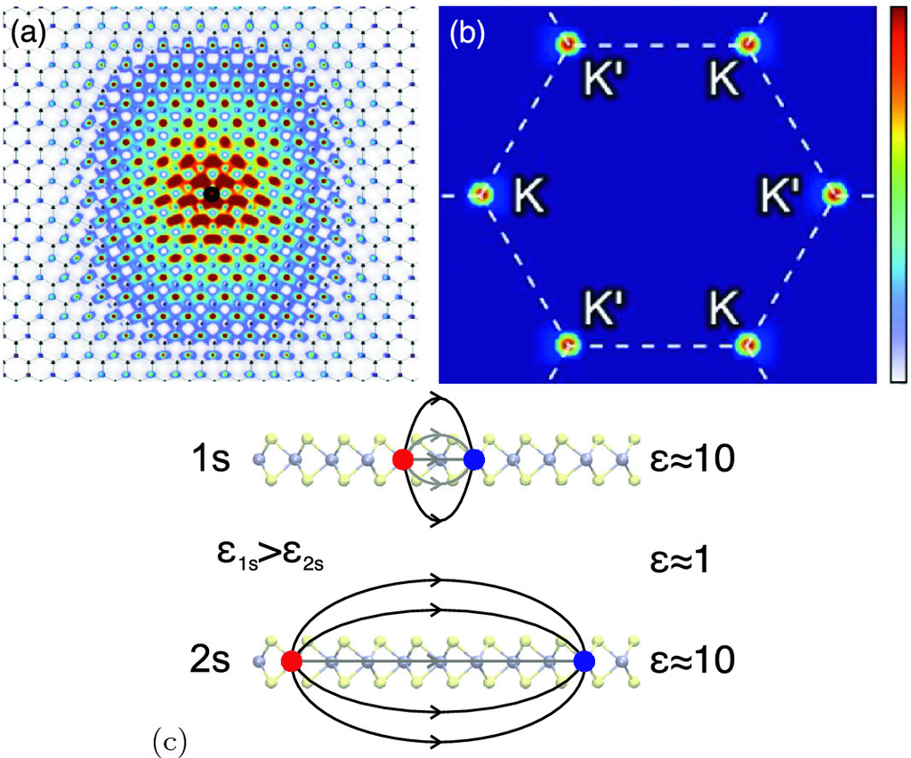

Fig. 13.24

Plane-view of the electron wave function of the exciton ground state in MoS



monolayer in **a** real space and **b**

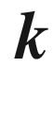

-space. Adapted from [1299], reprinted with permission, ©2013 APS. **c** Schematic 1s and 2s exciton wave functions with different sensing of the low-

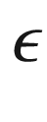

environment

### 13.3 Van-der-Waals Heterostructures

Let’s recall that graphite is a stacked arrangement of graphene layers. It is called the ’Bernal’-phase or -stacking and relates to the AB- or 2H-stacking like in a hcp crystal (Fig. [13.25](#u116076_4_En_13_Chapter-Fig25)a). Other meta-stable arrangements are the AA’-stackings (twisted bilayer graphene), in which the crystallographic axes of the two layers have an arbitrary angle

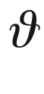

between zero and 30

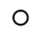

as depicted in Fig. [13.25](#u116076_4_En_13_Chapter-Fig25)b); the stacking vor

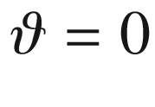

is also termed AA. Electronic properties depend  on the twist angle [1321]. A refined theory considering the super-periodicities (moiré pattern) of interlayer hopping potential has been reported in [1322, 1323]. The different stackings can be distinguished, e.g., in infrared spectroscopic imaging [1324].

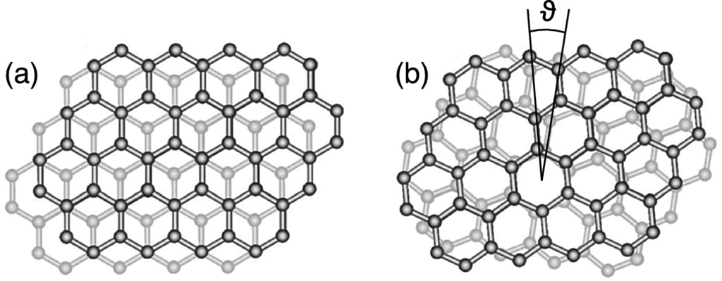

Fig. 13.25

Vertical stacking phases of graphene in **a** AB-type, Bernal-stacking and **b** AA’-type, non-Bernal stacking. The rotation angle



is indicated.

Adapted from [1325]

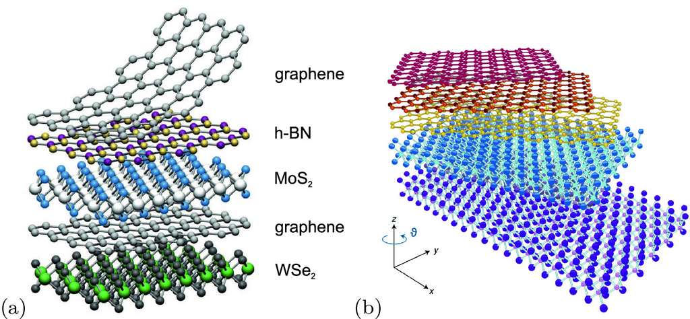

Fig. 13.26

**a** Example of van-der-Waals heterostructure from various 2D materials as proposed in [1326]. Reprinted with permission, ©2013, Springer Nature. **b** Van-der-Waals heterostructure with twisted layers.

Adapted from [1328], reprinted with permission, ©2018, Springer Nature

As an extension of this concept, van-der-Waals heterostructures been conceived [1326, 1327] which consist of vertically stacked atomic sheets of various 2D materials, a kind of molecular LEGO™ (Fig. [13.26](#u116076_4_En_13_Chapter-Fig26)a). Virtually any combination is possible for various electronic, sprintronic and photonic applications [1329, 1330]. An advantage is the well controlled tunneling effect by the present exact layer thicknesses in the device.

The field effect for a graphene layer between BN flakes is shown in Fig. [13.27](#u116076_4_En_13_Chapter-Fig27). The measured mobility (at room temperature) is in the range of

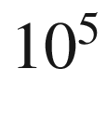

 cm



/Vs for a 2D carrier density below

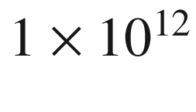

 cm

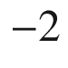

and thus larger than values achieved for InSb or InAs [1331]. Van-der-Waals heterostructures of boron nitride and graphene are reviewed in [1332].

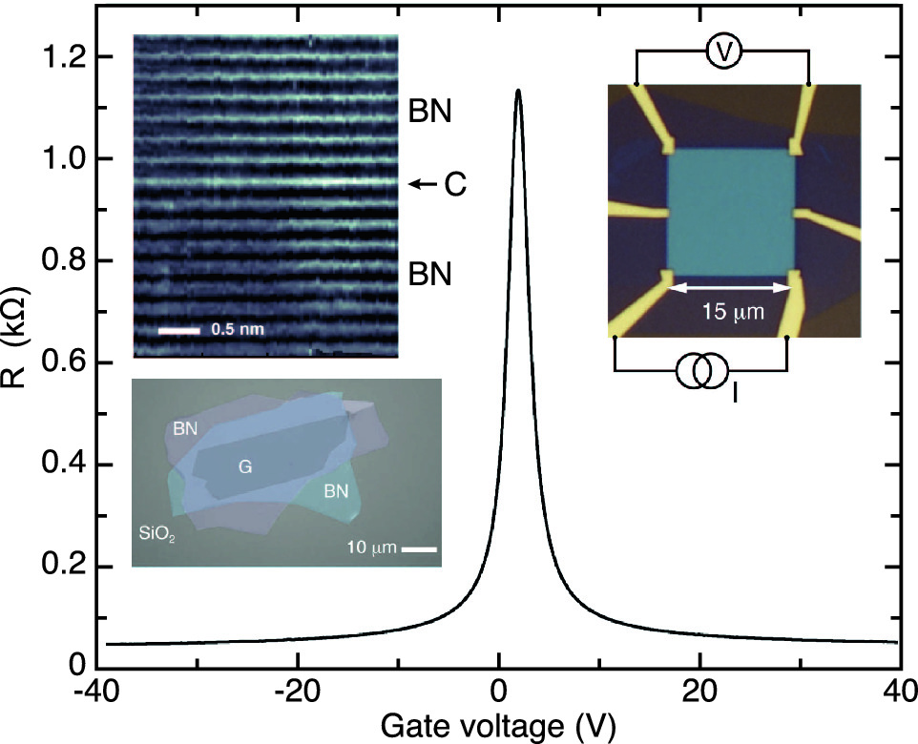

Fig. 13.27

Resistance of BN-graphene-BN van-der-Waals heterostructure (insets show optical image and cross section TEM as well as the device and its schematic measurement scheme).

Adapted from [1331]

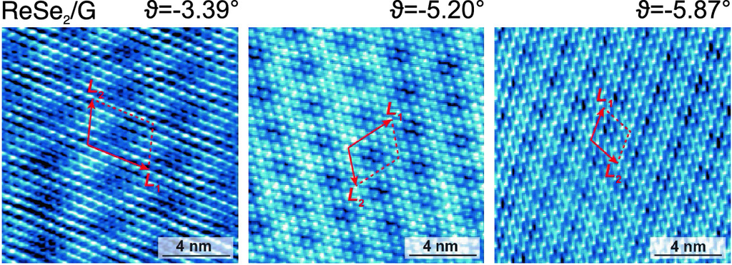

Fig. 13.28

STM images of ReSe



monolayers on graphene. The twist angle

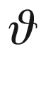

(cmp. Fig. [13.26](#u116076_4_En_13_Chapter-Fig26)b), as deducted from comparison with theoretical calculations, is indicated. The *red arrows* indicate the moiré pattern’s periodicity.

Adapted from [1333], reprinted unter Creative Commons Attribute (CC BY-NC 4.0) license

The effect of surrounding media via the modified dielectric screening on excitons has been mentioned already above [1319, 1320]. Encapsulation by h-BN monolayers can enhance the luminescence yield and reduce the recombination time constant of a TMDC monolayer, as demonstrated in [1334] for a three monolayer h-BN/WS



/h-BN heterostructure.

Generally, in van-der-Waals heterostructures, the weak interlayer bonding allows a new degree of freedom, the twist angle



(cf. Fig. [13.25](#u116076_4_En_13_Chapter-Fig25)b for twist of two graphene layers) between two 2D crystals (Fig. [13.26](#u116076_4_En_13_Chapter-Fig26)b). The situation is similar to the twist boundary between two grains (Sect. [4.​4.​3](The_Physics_of_Semiconductors00002.docx#u116076_4_En_4_Chapter)). This rotation causes the formation of moiré patterns that are directly observable in STM images as depicted in Fig. [13.28](#u116076_4_En_13_Chapter-Fig28). The physical properties of the heterostructure can drastically depend on the twist angle [1335]. A prominent consequence is the periodic modification of the energy landscape for excitons leading to localization and modification of spectra [1336]. A particularly intriguing effect is the occurrence of superconductivity with a critical temperature of up to 1.7 K for a graphene bilayer with the ’magic’ twist angle of

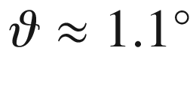

and specific (gate-controlled) carrier densities in the range of (1–2)

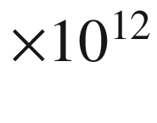

 cm



 [1337].

Footnotes

[1](#u116076_4_En_13_Chapter-Fn1_source)

Each of the six valleys at the K-points is shared by three Brillouin zones; keep in mind that the K- and K’-points are not equivalent.

[2](#u116076_4_En_13_Chapter-Fn2_source)

In a parabolic dispersion as in ([15.​38](#u116076_4_En_15_Chapter)), the cyclotron mass is independent of *n*.

[3](#u116076_4_En_13_Chapter-Fn3_source)

Here we assume the linear dispersion for all thermally populated states.

[4](#u116076_4_En_13_Chapter-Fn4_source)

Including sign,

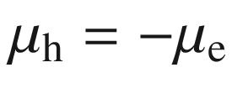

. For

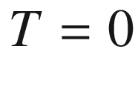

and

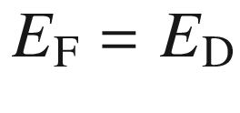

,

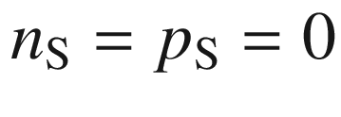

and thus

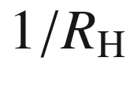

should be zero. For finite temperatures there is always

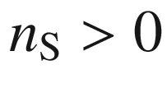

and

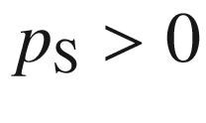

, even for



. Thus

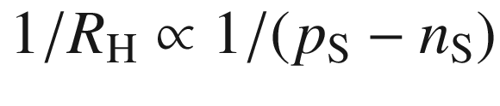

diverges at

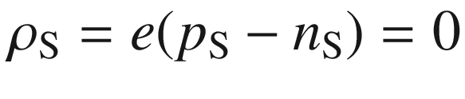

with a change of sign.

[5](#u116076_4_En_13_Chapter-Fn5_source)

The splitting is negative (positive) for MoX



(WX



) compounds, i.e. the lowest conduction band at the K-point is spin up (down) [1292, 1294]; the valence band maximum at K is spin up for all cases.

[6](#u116076_4_En_13_Chapter-Fn6_source)

In QW heterostructures, the differences in



are typically around 1 or smaller [1188].

© Springer Nature Switzerland AG 2021

M. Grundmann

The Physics of Semiconductors

Graduate Texts in Physics

<https://doi.org/10.1007/978-3-030-51569-0_14>

## 14. Nanostructures

Marius Grundmann[1](#u116076_4_En_14_Chapter-Aff11)

(1)

Felix Bloch Institute for Solid State Physics, Universität Leipzig, Leipzig, Germany

Marius Grundmann

Email:

[grundmann@physik.uni-leipzig.de](mailto:grundmann@physik.uni-leipzig.de)

*The principles of physics, as far as I can see, do not speak against the possibility of maneuvering things atom by atom.*

*R.P. Feynman, 1959* [1338]

## Abstract

One-dimensional nanostructures (quantum wires) and zero-dimensional ones (quantum dots) are discussed with regard to their various fabrication methods and the tunable physical properties in such systems. Main effects covered are the modified density of states, confined energy levels, (envelope) wave-function symmetry and the resulting novel electrical and optical properties.

### 14.1 Introduction

When the structural size of functional elements enters the size range of the de Broglie matter wavelength, the electronic and optical properties are dominated by quantum-mechanical effects. The most drastic impact can be seen from the density of states (Fig. [14.1](#u116076_4_En_14_Chapter-Fig1)). The quantization in a potential is ruled by the Schrödinger equation with appropriate boundary conditions. These are simplest if an infinite potential is assumed. For finite potentials, the wavefunction leaks out into the barrier. Besides making the calculation more complicated (and more realistic), this allows electronic coupling of nanostructures. Via the Coulomb interaction, a coupling is even given if there is no wavefunction overlap. In the following, we will discuss some of the fabrication techniques and properties of quantum wires (QWR) and quantum dots (QD). In particular for the latter, several textbooks can also be consulted [1339, 1340].

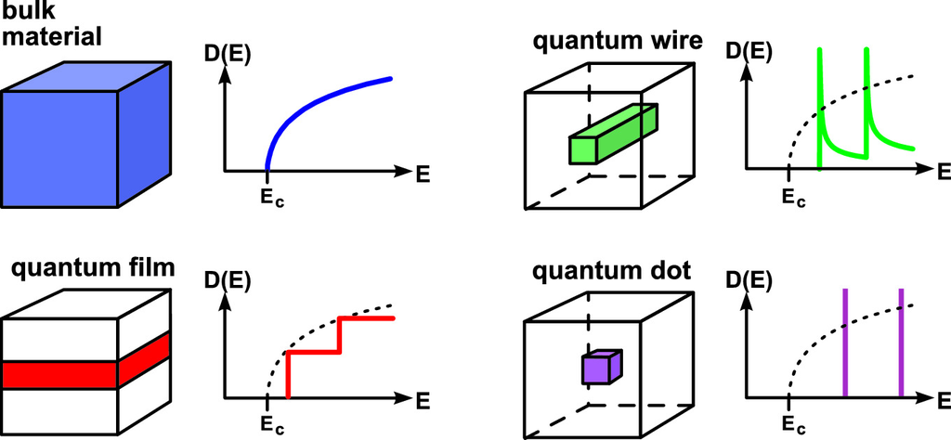

Fig. 14.1

Schematic geometry and density of states for 3D, 2D, 1D and 0D electronic systems

### 14.2 Quantum Wires

#### 14.2.1 V-Groove Quantum Wires

Quantum wires with  high optical quality, i.e. high recombination efficiency and well-defined spectra, can be obtained by employing epitaxial growth on corrugated substrates. The technique is shown schematically in Fig. [14.2](#u116076_4_En_14_Chapter-Fig2). A V-groove is etched, using, e.g., an anisotropic wet chemical etch, into a GaAs substrate. The groove direction is along

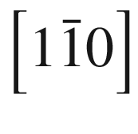

. Even when the etched pattern is not very sharp on the bottom, subsequent growth of AlGaAs sharpens the apex to a self-limited radius

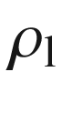

of the order of 10 nm. The side facets of the groove are

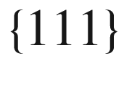

A. Subsequent deposition of GaAs leads to a larger upper radius

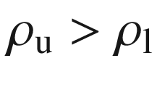

of the heterostructure. The GaAs QWR formed in the bottom of the groove is thus crescent-shaped as shown in Fig. [14.3](#u116076_4_En_14_Chapter-Fig3)a. A thin GaAs layer also forms on the side facets (sidewall quantum well) and on the top of the ridges. Subsequent growth of AlGaAs leads to a resharpening of the V-groove to the initial, self-limited value



. The complete resharpening after a sufficiently thick AlGaAs layer allows vertical stacking of crescent-shaped QWRs of virtually identical size and shape, as shown in Fig. [14.3](#u116076_4_En_14_Chapter-Fig3)b. In this sense, the self-limiting reduction of the radius of curvature and its recovery during barrier-layer growth leads to self-ordering of QWR arrays whose structural parameters are determined solely by growth parameters. The lateral pitch of such wires can be down to 240 nm.

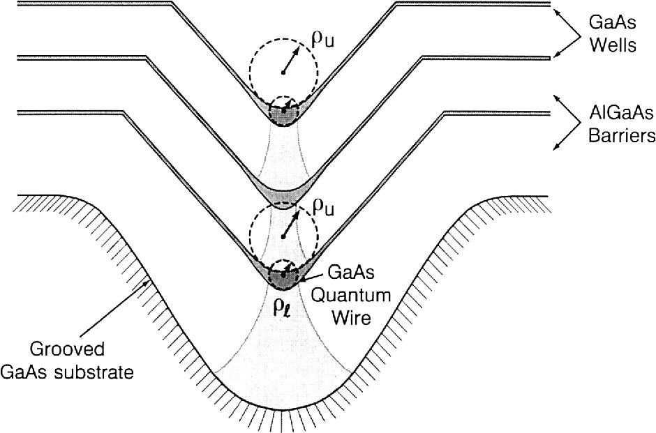

Fig. 14.2

Schematic cross section of a GaAs/AlGaAs heterostructure grown on a channeled substrate, illustrating the concept of self-ordered quantum-wire fabrication.

Adapted from [1341], reprinted with permission, ©1992, Elsevier Ltd

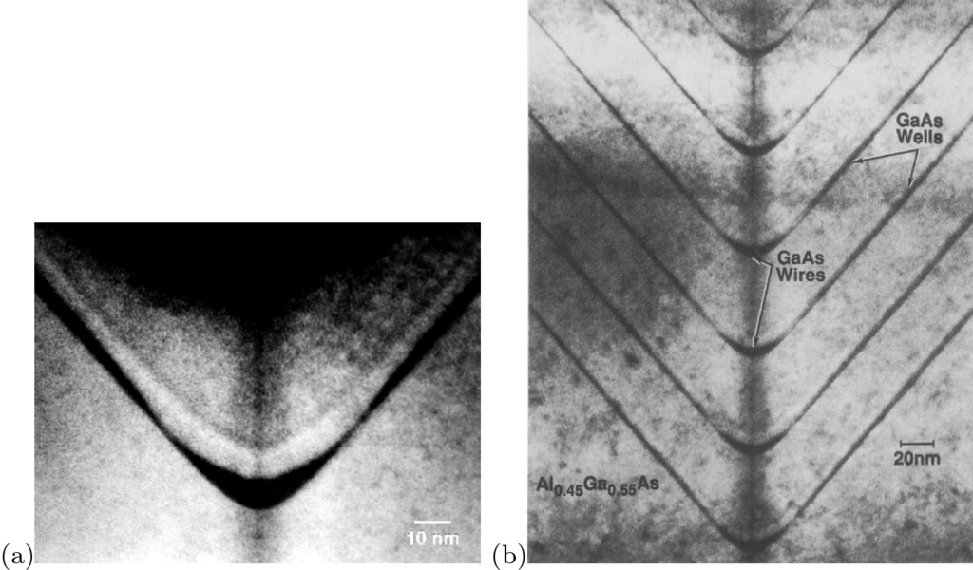

Fig. 14.3

**a** Transmission electron microscopy cross-sectional image of a crescent-shaped single GaAs/AlGaAs quantum wire. From [1342], reprinted with permission, ©1994 IOP. (**b**) TEM cross-sectional image of a vertical stack of identical GaAs/AlGaAs crescent-shaped QWRs.

From [1341], reprinted with permission, ©1992, Elsevier Ltd

To directly visualize the lateral modulation of the band gap, a lateral cathodoluminescence (CL) linescan perpendicular across the wire is displayed in Fig. [14.4](#u116076_4_En_14_Chapter-Fig4). In Fig. [14.4](#u116076_4_En_14_Chapter-Fig4)a, the secondary electron (SE) image of the sample from Fig. [14.3](#u116076_4_En_14_Chapter-Fig3)a is shown in plan view. The top ridge is visible in the upper and lower parts of the figure, while in the middle the sidewalls with the QWR in the center are apparent. In Fig. [14.4](#u116076_4_En_14_Chapter-Fig4)b, the CL spectrum along a linescan perpendicular to the wire (as indicated by the white line in Fig. [14.4](#u116076_4_En_14_Chapter-Fig4)a) is displayed. The *x*-axis is now the emission wavelength, while the *y*-axis is the lateral position along the linescan. The CL intensity is given on a logarithmic scale to display the full dynamic range. The top QW shows almost no variation in band gap energy (

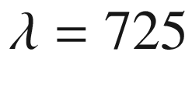

 nm); only directly at the edge close to the sidewall does a second peak at lower energy (

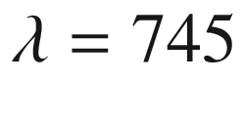

 nm) appear, indicating a thicker region there. The sidewall QW exhibits a recombination wavelength of 700 nm at the edge to the top QW, which gradually increases to about 730 nm at the center of the V-groove. This directly visualizes a linear tapering of the sidewall QW from about 2.1 nm thickness at the edge to 3 nm in the center. The QWR luminescence itself appears at about 800 nm.

After fast capture from the barrier into the QWs and, to a much smaller extent corresponding to its smaller volume, into the QWR, excess carriers will diffuse into the QWR via the adjacent sidewall QW and the vertical QW. The tapering of the sidewall QW induces an additional drift current.

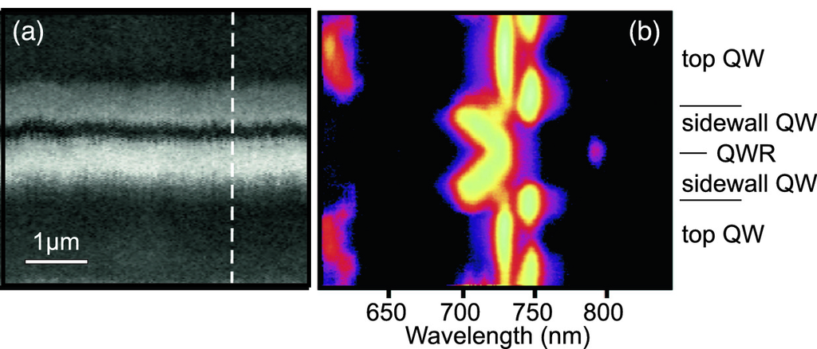

Fig. 14.4

**a** Plan-view SE image of single QWR, showing top and sidewall with QWR in the center. The *white dashed line* indicates the position of the linescan on which the CL spectra linescan **b** has been taken at

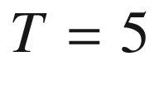

 K. The CL intensity is given on a logarithmic false color scale to display the full dynamic range as a function of wavelength and position.

Adapted from [1342], reprinted with permission, ©1994 IOP

#### 14.2.2 Cleaved-Edge Overgrowth Quantum Wires

Another method to create quantum wires of high structural perfection is cleaved-edge overgrowth (CEO) [1343], shown schematically in Fig. [14.5](#u116076_4_En_14_Chapter-Fig5). First, a layered structure is grown (single or multiple quantum wells or superlattice). Then, a

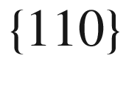

facet is fabricated by cleaving (in vacuum) and epitaxy is continued on the cleaved facet. At the junctures of the

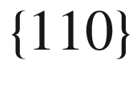

layer and the original quantum wells QWRs form. Due to their cross-sectional form they are also called *T-shaped* QWRs. A second cleave and another growth step allow fabrication of CEO quantum dots [1344, 1345] (Fig. [14.5](#u116076_4_En_14_Chapter-Fig5)c).

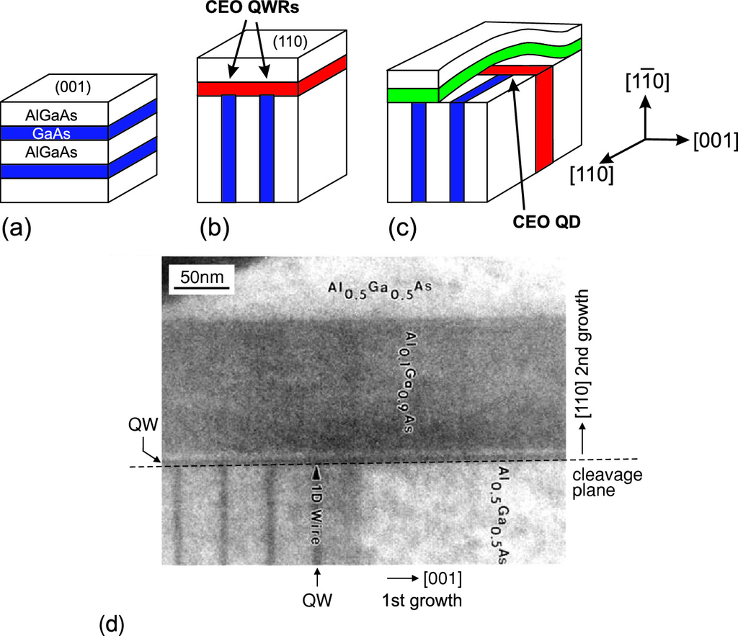

Fig. 14.5

Principle of CEO quantum wires and 2-fold CEO quantum dots. Part (**a**) depicts a layered structure (quantum wells or superlattice, *blue*), (**b**) describes the growth on the cleaved facet used for fabrication of quantum wires. In (**c**) a second cleave and growth on top of the plane allows the fabrication of quantum dots. From [1344]. (**d**) Cross-sectional TEM image of CEO GaAs/AlGaAs quantum wires. Two quantum wells (QW) and the QWR at their junction are labeled. The first epitaxy was from left to right. The second epitaxy step was on top of the cleavage plane (*dashed line*) in the upward direction.

Adapted from [1345], reprinted with permission, ©1997 APS

#### 14.2.3 Nanowhiskers

Whiskers are primarily known as thin metal spikes and have been investigated in detail [1346]. Semiconductor whiskers can be considered as (fairly short) quantum wires. They have been reported for a number of materials, such as Si, GaAs, InP and ZnO [1347]. A field of ZnO whiskers is shown in Fig. [14.6](#u116076_4_En_14_Chapter-Fig6). If heterostructures are incorporated along the whisker axis [1348], quantum dots or tunneling barriers can be created (Fig. [14.7](#u116076_4_En_14_Chapter-Fig7)a). The growth mode relies often a VLS (vapor-liquid-solid) mechanism in which the wire materials are first incorporated into a liquid catalyzer (most often gold) drop at the tip and then used to build up the nanocrystal. In [1349], the layer-by-layer growth of a GaAs nanowire via this mechanism has been observed in-situ by TEM (Fig. [14.7](#u116076_4_En_14_Chapter-Fig7)b) and is also available as an impressive video. Another nanowire growth mechanism is the VSS (vapor-solid-solid) mechanism that works without liquid drop on top of the wire.

Such nanocrystals can also act as a nanolaser [1350, 1351]. In ZnO nanowhiskers the conversion of mechanical energy into electrical energy has been demonstrated [1352] based on the piezoelectric effect (Sect. [16.​4](#u116076_4_En_16_Chapter)).

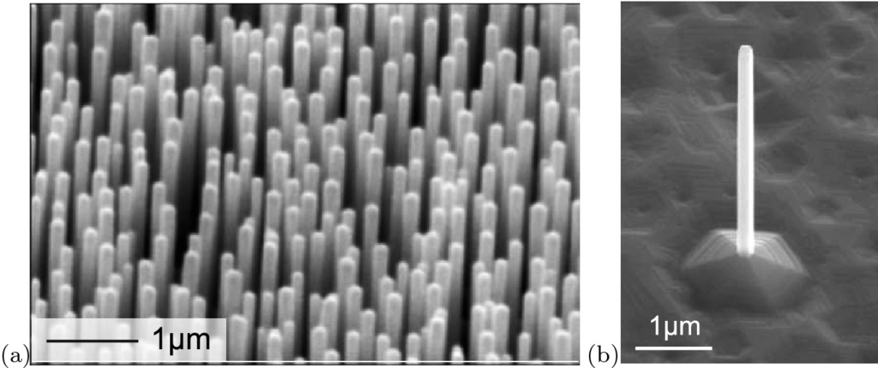

Fig. 14.6

**a** Array of ZnO nanowhiskers on sapphire, fabricated using thermal evaporation. Adapted from [1353]. **b** Single, free-standing ZnO nanowire fabricated using PLD.

Adapted from [1354]

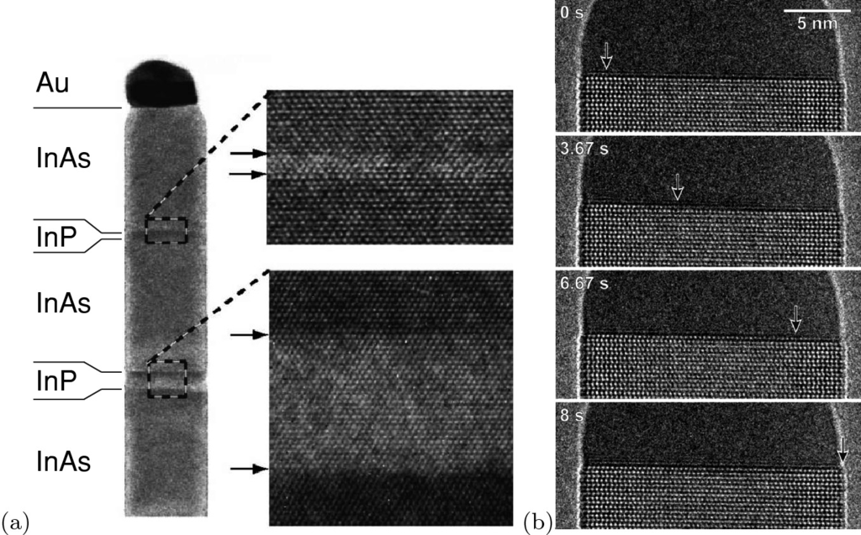

Fig. 14.7

**a** TEM image of a part of an InAs whisker 40 nm in diameter that contains InP barriers. The zooms show sharp interfaces. On top of the whisker is a gold droplet from the so-called vapor–liquid–solid growth mechanism. The whisker axis is [001], the viewing direction is [110]. Adapted from [1348], reprinted with permission, ©2002 AIP. **b** Subsequent growth stages of the tip of a GaAs nanowire with Au cap; times at which (in-situ) TEM image has been taken are labelled. The *arrows* indicate the position of the growth front.

Adapted from [1349], reprinted with permission, ©2018 APS

The critical thickness

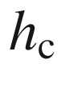

 in nanowire heterostructure is strongly modified from the 2D situation (Sect. [5.​4.​1](The_Physics_of_Semiconductors00002.docx#u116076_4_En_5_Chapter)). Based on the strain distribution of a misfitted slab in a cylindrical wire [1355] the dependence of critical thickness on the nanowhisker radius *r* was developed [1356, 1357]. For given misfit

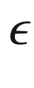

there is a critical radius

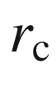

for which

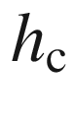

is infinite for

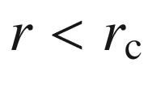

(Fig. [14.8](#u116076_4_En_14_Chapter-Fig8)).

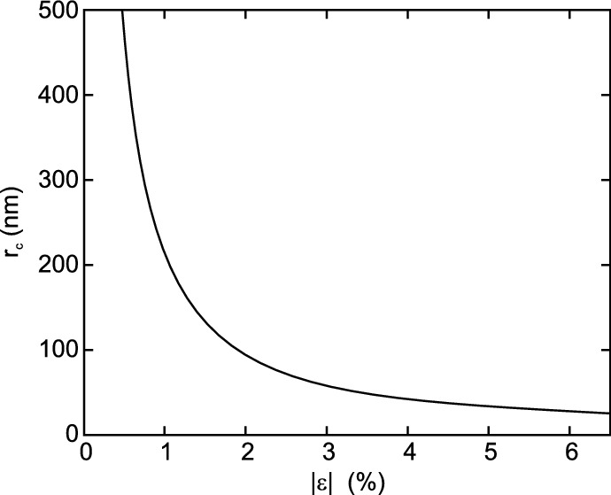

Fig. 14.8

Critical radius

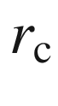

above which an infinitely thick layer with misfit

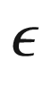

grows coherently on a cylindrical nanowire (relaxation by 60

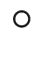

dislocations,

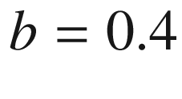

 nm,

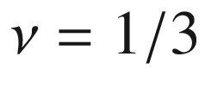

).

Adapted from [1357]

#### 14.2.4 Nanobelts

A number of belt-shaped nanostructures has been reported [1347]. These are wire-like, i.e. very long in one dimension. The cross-section is rectangular with a high aspect ratio. In Fig. [14.9](#u116076_4_En_14_Chapter-Fig9)a ZnO nanobelts are shown. The wire direction is

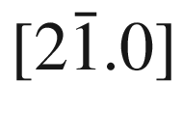

. The large surface is (00.1), the thickness of the belt extends in [01.0]-direction. High resolution transmission microscopy (Fig. [14.9](#u116076_4_En_14_Chapter-Fig9)b) shows that these structures are defect-free. The pyroelectric charges on the ZnO (0001) surfaces (Sect. [16.​2](#u116076_4_En_16_Chapter)) lead to the formation of open (Fig. [14.10](#u116076_4_En_14_Chapter-Fig10)c) spirals. Closed spirals (Fig. [14.10](#u116076_4_En_14_Chapter-Fig10)a) occur if the short dimension is along [00.1] and alternating charges become compensated in a ‘slinky’-like ring (Fig. [14.10](#u116076_4_En_14_Chapter-Fig10)b).

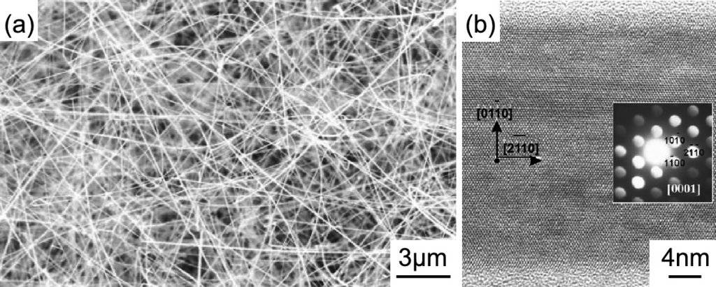

Fig. 14.9

**a** SEM image of an ensemble of ZnO nanobelts. **b** HRTEM image of a single ZnO nanobelt, viewing direction is [00.1]. The *inset* shows the diffraction pattern.

Adapted from [1358], reprinted with permission, ©2004 AIP

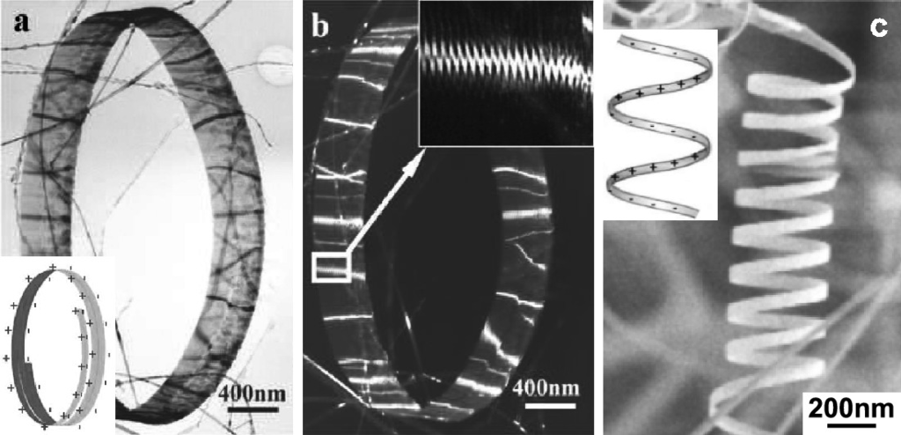

Fig. 14.10

**a** Bright field and **b** dark field TEM image of a ZnO nanoring formed by the ‘slinky’-like growth of a nanobelt. **c** SEM image of an open ZnO nanospiral. The *insets* in (**a**, **c**) show schematically the surface charge distribution.

Adapted from [1359], ©2006 IOP

#### 14.2.5 Quantization in Two-Dimensional Potential Wells

The motion of carriers along the quantum wire is free. In the cross-sectional plane the wavefunction is confined in two dimensions. The simplest case is for constant cross section along the wire. However, generally the cross section along the wire may change and therefore induce a potential variation along the wire. Such potential variation will impact the carrier motion along the longitudinal direction. Also, a twist of the wire along its axis is possible.

In Fig. [14.11](#u116076_4_En_14_Chapter-Fig11), the electron wavefunctions in a V-groove GaAs/AlGaAs QWR are shown. Further properties of V-groove QWRs have been reviewed in [1360]. In Fig. [14.12](#u116076_4_En_14_Chapter-Fig12), the excitonic electron and hole wavefunctions are shown for a (strained) T-shaped QWR.

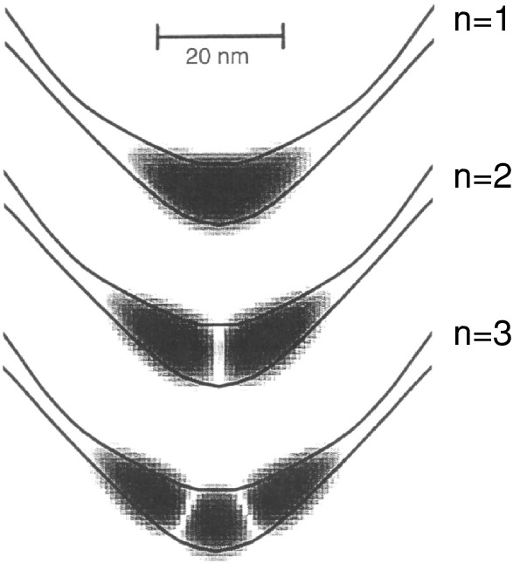

Fig. 14.11

Electron wavefunctions (

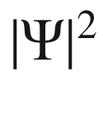

on logarithmic grey scale) for the first three confined levels for the QWR of Fig. [14.3](#u116076_4_En_14_Chapter-Fig3)a.

From [1342]

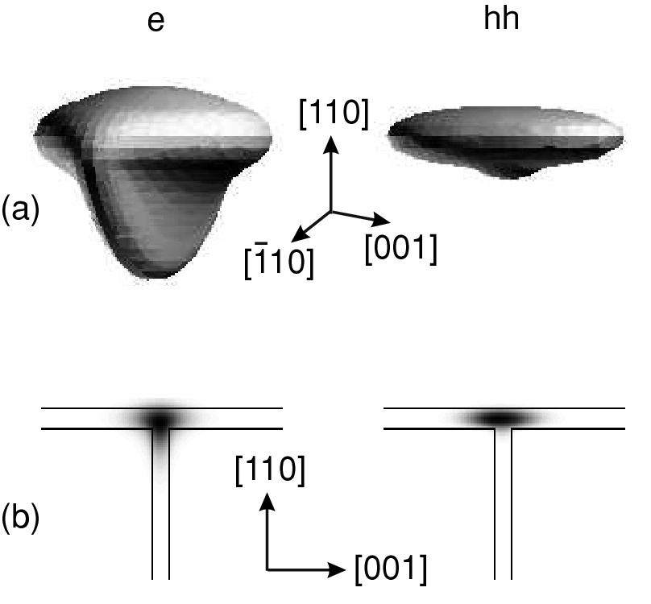

Fig. 14.12

**a** Three-dimensional view of the electron and (heavy) hole part of the excitonic wavefunction in a 4 nm

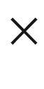

5 nm T-shaped In

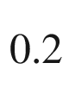

Ga

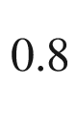

As/GaAs QWR. The orbitals correspond to 70% probability inside. **b** Cross section through the electron and hole orbitals in their center along the wire direction.

Reprinted with permission from [1361], ©1998 APS

In Fig. [14.13](#u116076_4_En_14_Chapter-Fig13)a the atomic structure of a very thin ZnO nanowhisker with a cross-section consisting of seven hexagonal unit cells is shown. The theoretical one-dimensional band structure [1362] is shown in Fig. [14.13](#u116076_4_En_14_Chapter-Fig13)b together with the charge density of the lowest conduction band state (LUMO) and the highest valence band state (HOMO). The band gap is generally too small because of the LDA method used.[1](#u116076_4_En_14_Chapter-Fn1) In [1362] also the properties of nanowires with various diameters are compared. The HOMO at

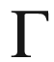

lies only 80 meV above the top of valence band of bulk ZnO, and its position changes little with the wire diameter. It is mainly composed by surface oxygen 2p like dangling bonds (Fig. [14.13](#u116076_4_En_14_Chapter-Fig13)d). The LUMO (Fig. [14.13](#u116076_4_En_14_Chapter-Fig13)c) is delocalized in the whole nanowire, indicating that it is a bulk state. The delocalized distribution is also responsible for the large dispersion of the LUMO from

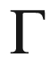

to A. The energy of the LUMO increases substantially with decreasing diameter due to the radial confinement.

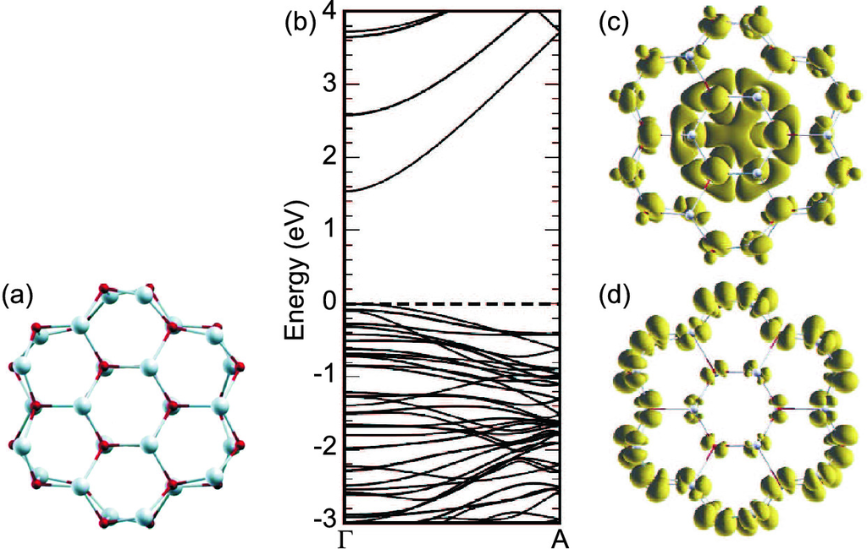

Fig. 14.13

**a** Atomic arrangement of a 1 nm wide ZnO nanowire. **b** Theoretical band structure and charge density of the **c** lowest conduction band and **d** highest valence band state.

Adapted from [1362], reprinted with permission, ©2006 AIP

### 14.3 Carbon Nanotubes

#### 14.3.1 Structure

A carbon nanotube (CNT) is a part of a graphene sheet (cf. Sect. [13.​1](#u116076_4_En_13_Chapter)) rolled up to form a cylinder. CNTs were first described as multi-walled nanotubes by Iijima [1363] in 1991 (Fig. [14.14](#u116076_4_En_14_Chapter-Fig14)b) and in their single-walled form (Fig. [14.14](#u116076_4_En_14_Chapter-Fig14)a) in 1993 [1364]. Reviews can be found in [1247, 1365].

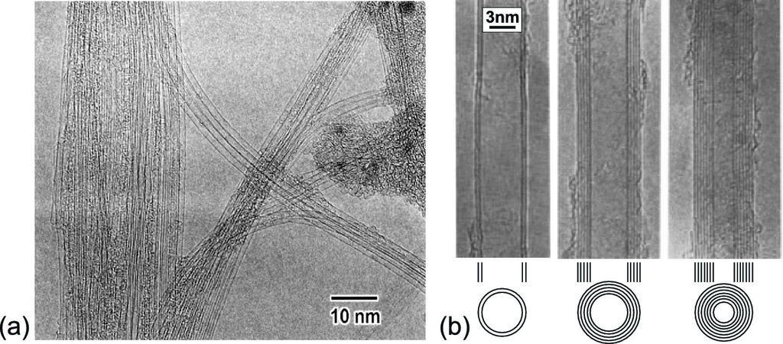

Fig. 14.14

**a** TEM image of single-walled carbon nanotubes (SWNT). **b** TEM images of various multi-walled carbon nanotubes (MWNT).

Adapted from [1363], reprinted with permission, ©1991, SpringerNature

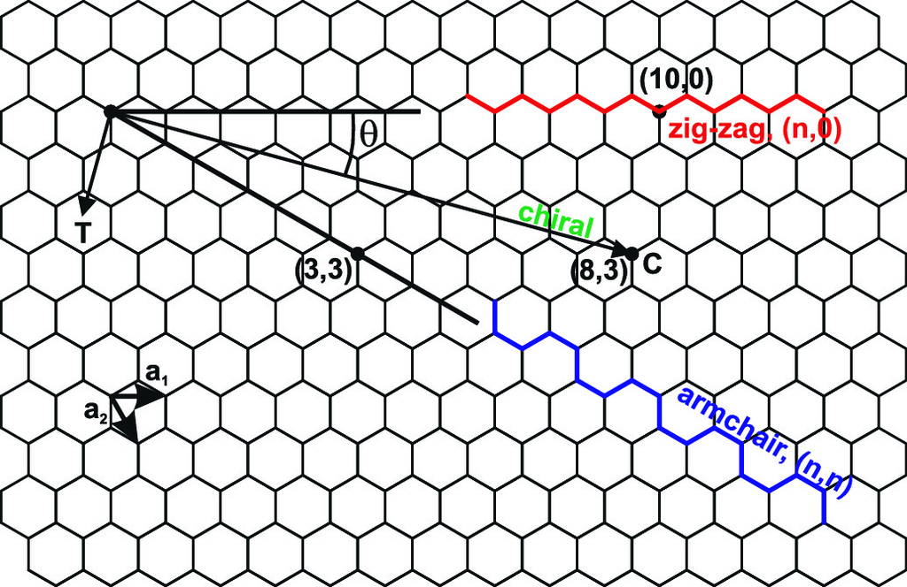

Fig. 14.15

Schematic atomic arrangement in graphene; the C–C bond length is

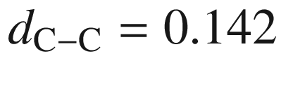

 nm. Several vectors for making carbon nanotubes (cf. Sect. [14.3](#u116076_4_En_14_Chapter-Sec8)) are shown

The chirality and diameter of a nanotube are uniquely described by the chiral vector

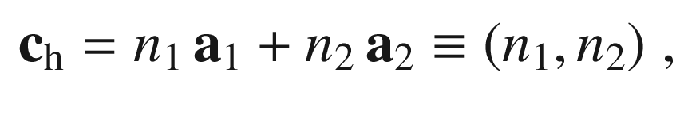

(14.1)

where

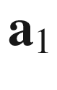

and

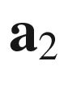

are the unit vectors of the graphene sheet. The chiral vector denotes two crystallographic equivalent sites which are brought together along the circumference of the nanotube. The possible vectors are visualized in Fig. [14.15](#u116076_4_En_14_Chapter-Fig15) for

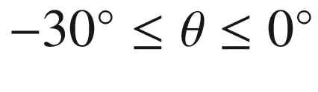

. The fiber diameter is given by

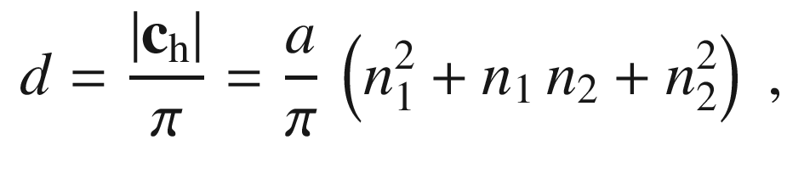

(14.2)

with the graphene lattice constant

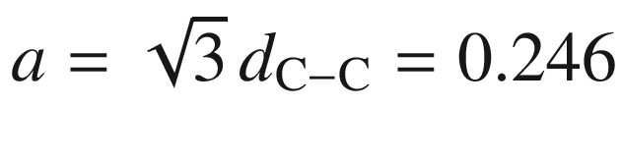

 nm. Ab-initio calculations show that the diameter becomes a function of the chiral angle below 0.8 nm; deviations from ([14.2](#u116076_4_En_14_Chapter-Equ2)) are below 2% for tube diameters

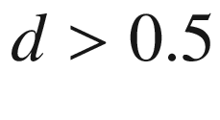

 nm [1366]. The (*n*, 0) tubes (

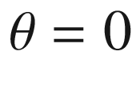

) are termed ‘zig-zag’ and an example is depicted in Fig. [14.16](#u116076_4_En_14_Chapter-Fig16)b. Nanotubes with

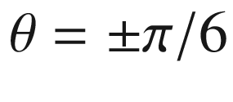

, i.e. of the (*n*, *n*) (and (

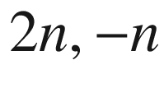

)) type, are called ‘armchair’. All others are termed ‘chiral’.

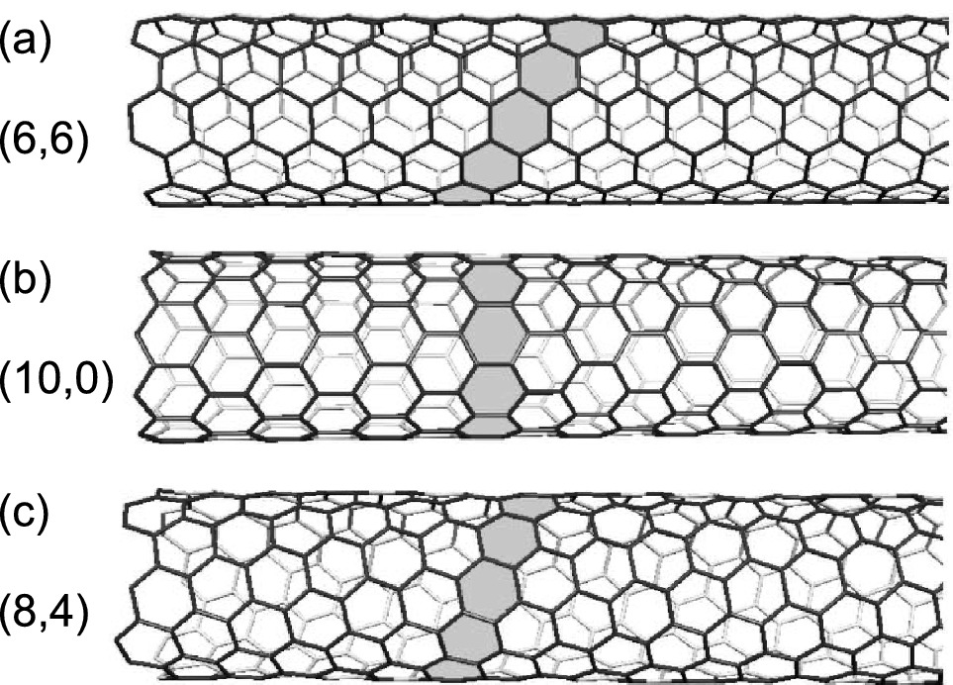

Fig. 14.16

Structure of different types of carbon nanotubes that have similiar diameter of 0.8 nm. **a** Armchair (6, 6), **b** zigzag (8, 0) and **c** chiral symmetry.

Adapted from [1247]

The extension along the wire axis is large compared to the diameter. The tip of a nanotube is part of a buckminster-fullerene type molecule (Fig. [14.17](#u116076_4_En_14_Chapter-Fig17)). When the nanotube if formed by rolling a single sheet of graphene (SLG), a single-walled nanotube (SWNT) is formed. A FLG sheet creates a multi-walled nanotube (MWNT). For small number of layers they are called double-walled, triple-walled and so forth.

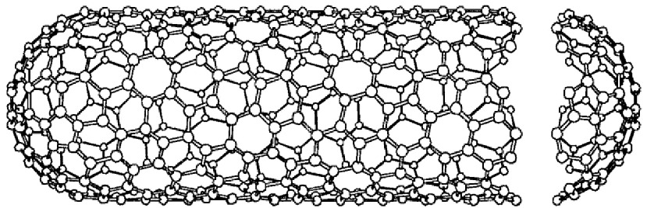

Fig. 14.17

A chiral nanotube (chiral vector is (10, 5),

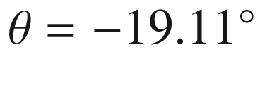

) with hemispherical caps at both ends based on an icosahedral C

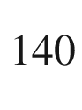

fullerene. The tube diameter is 1.036 nm.

Adapted from [1367]

The mechanical strength of carbon nanotubes is very large. For SWNT Young’s moduli of

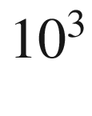

 GPa have been found experimentally [1368] in agreement with theoretical predictions [1369].

#### 14.3.2 Band Structure

In carbon nanotubes there is some mixing of the

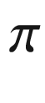

(2p



) and

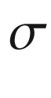

(2s and 2p



) carbon orbitals due to the radial curvature. This mixing is, however, small and can be neglected near the Fermi level [1370]. The band structure of a nanotube is mainly determined by zone-folding of the graphene band structure. The vector along the (infinitely extended) wire

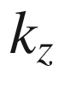

is continuous. The vector

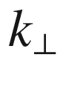

around the nanotube is discrete with the periodic boundary condition

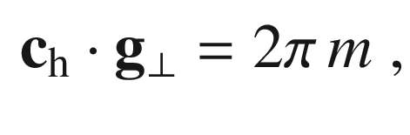

(14.3)

where *m* is an integer. The distance of allowed

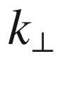

-values is ([5.​5](The_Physics_of_Semiconductors00002.docx#u116076_4_En_5_Chapter))

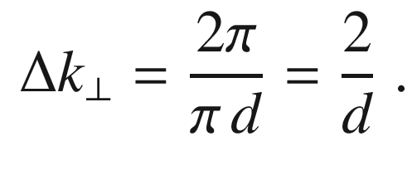

(14.4)

The character of the nanotube band structure depends on how the allowed *k*-values lie relative to the graphene Brillouin zone and its band structure. This is visualized in Fig. [14.18](#u116076_4_En_14_Chapter-Fig18). For the case of an armchair tube (*n*, *n*), as shown in Fig. [14.18](#u116076_4_En_14_Chapter-Fig18)a, the K-point of the graphene band structure always lies on an allowed *k*-point. Therefore, the nanotube is metallic, i.e. zero-gap, as seen in the bandstructure in Fig. [14.18](#u116076_4_En_14_Chapter-Fig18)b. The Dirac point is between

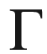

and X. For a zig-zag nanotube, the *k*-space is shown in Fig. [14.18](#u116076_4_En_14_Chapter-Fig18)c for a (6, 0) nanotube. The corresponding band structure for a (6, 0) nanotube is also metallic (Fig. [14.18](#u116076_4_En_14_Chapter-Fig18)d) with the Dirac point at the

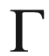

point.

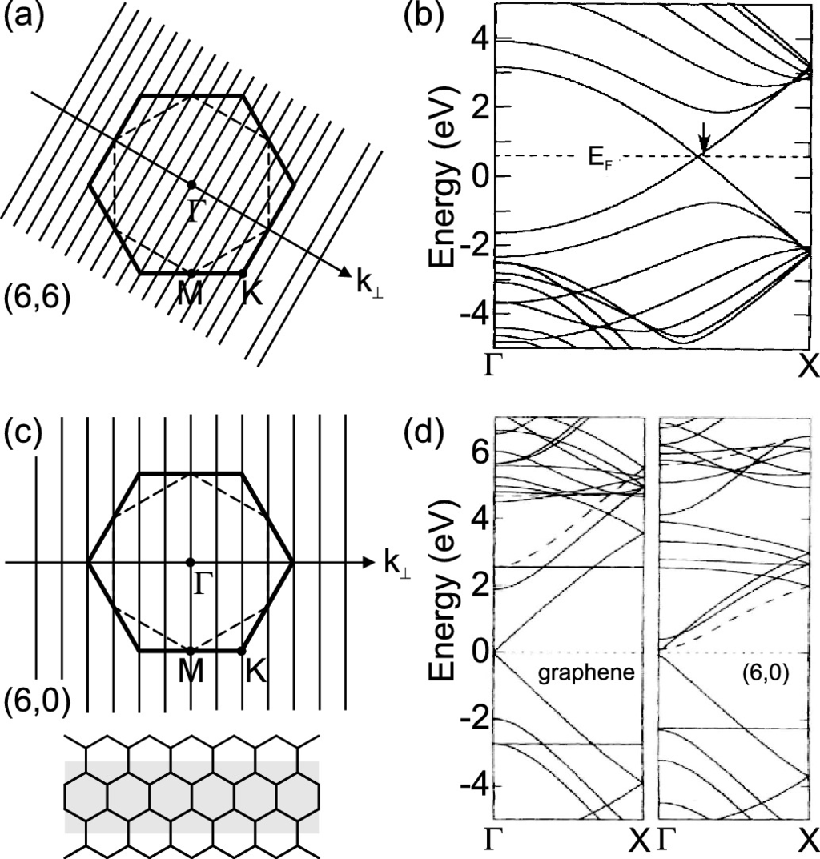

Fig. 14.18

**a** Brillouin zone of the graphene lattice (*bold* line) and allowed *k*-values for a (6, 6) armchair nanotube. **b** Band structure of a (6, 6) carbon nanotube. Adapted from [1371]. **c** Brillouin zone of the graphene lattice (*bold* line) and allowed *k*-values for a (6, 0) zig-zag carbon nanotube. In the *lower part* the real space structure is visualized. (**d**) Band structure of graphene (*left*) and a (6, 6) nanotube (*right*).

Adapted from [1372]

In Fig. [14.19](#u116076_4_En_14_Chapter-Fig19)c the band structure of another metallic (12, 0) zig-zag nanotube is shown. However, only for (3 m, 0) the K-point is on an allowed state and thus the tube metallic. For the other cases, as shown for the *k*-space of a (8, 0) nanotube in Fig. [14.19](#u116076_4_En_14_Chapter-Fig19)b, this is not the case. The corresponding band structure (Fig. [14.19](#u116076_4_En_14_Chapter-Fig19)c for (13, 0)) has a gap and thus the nanotube is a semiconductor. Generally, the condition for a nanotube to be metallic is with an integer *m*

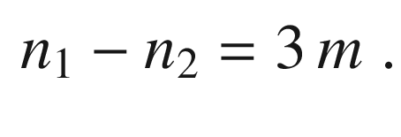

(14.5)

There are two semiconducting ‘branches’ with

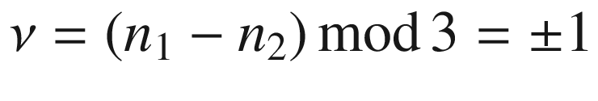

. The tubes with

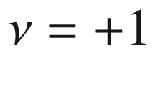

have a small band gap, those with

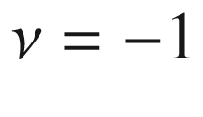

have a larger band gap.

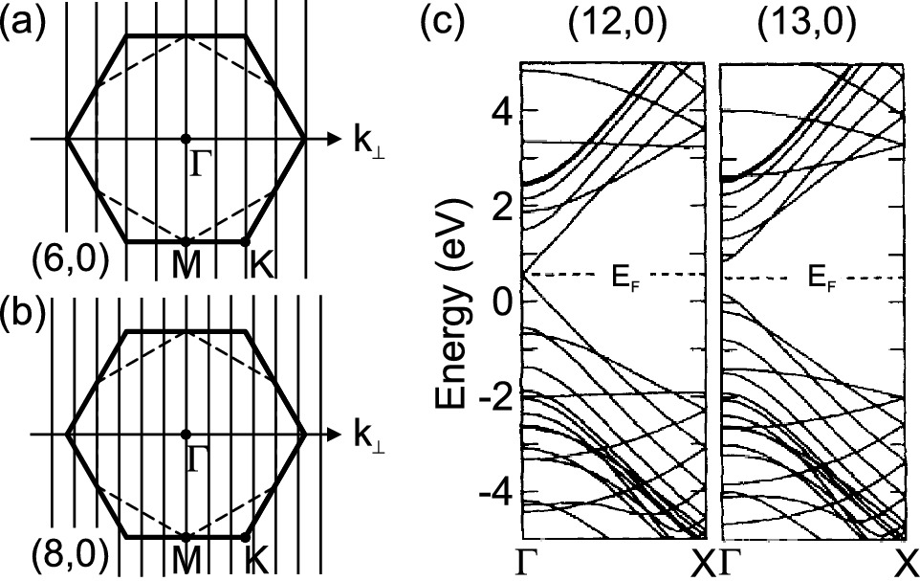

Fig. 14.19

**a**, **b** Brillouin zone of the graphene lattice (*bold* line) and allowed *k*-values for a (**a**) (6, 0) and a (**b**) (8, 0) zig-zag nanotube. **c** Band structures of a (12,0) metallic and (13, 0) semiconducting armchair carbon nanotube.

Adapted from [1371]

The density of states is a series of one-dimensional DOS, proportional to

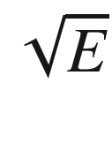

([6.​79](The_Physics_of_Semiconductors00003.docx#u116076_4_En_6_Chapter)). It is compared in Fig. [14.20](#u116076_4_En_14_Chapter-Fig20) for a metallic and a semiconducting nanotube. Within 1 eV from the Fermi energy the DOS can be expressed in an universal term [1373].

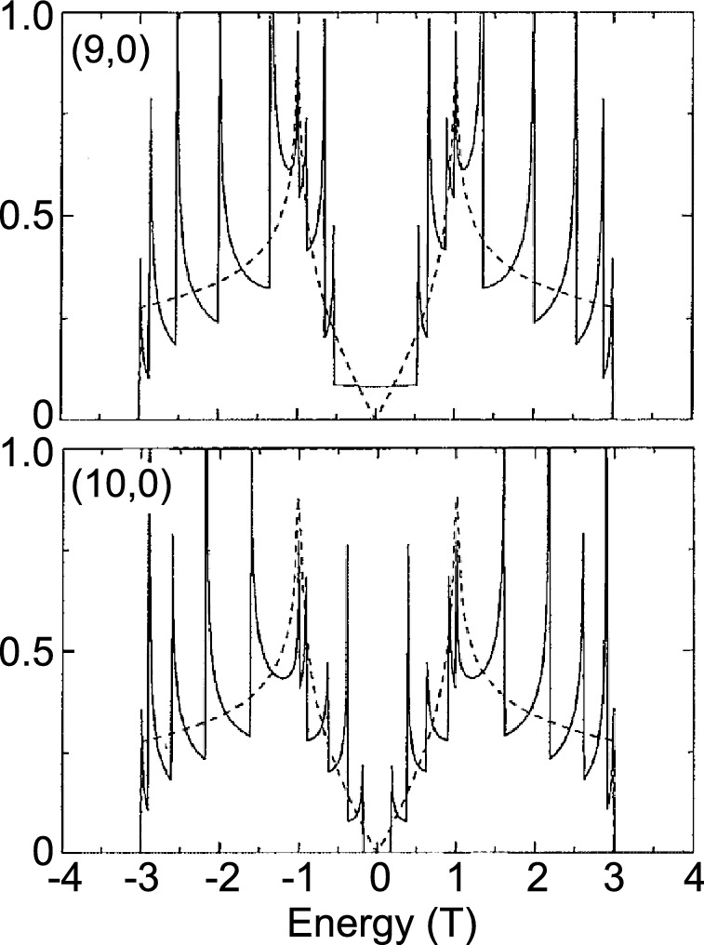

Fig. 14.20

Density of states for a (9, 0) metallic and (10, 0) semiconducting zig-zag carbon nanotube within the tight-binding approximation ([13.​2](#u116076_4_En_13_Chapter)). The energy scale is given in units of the tight-binding parameter

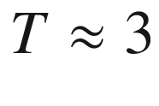

 eV. The *dashed lines* are the DOS of graphene.

Adapted from [1367]

#### 14.3.3 Optical Properties

Optical transitions occur with high probability between the van-Hove singularities of the DOS. The theoretical absorption spectrum of a (10, 0) nanotube is shown in Fig. [14.21](#u116076_4_En_14_Chapter-Fig21).

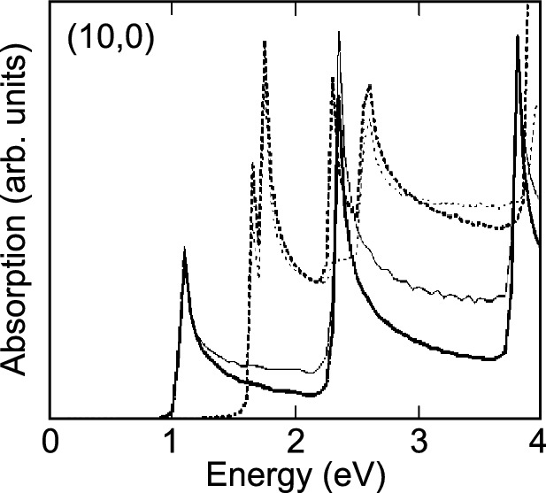

Fig. 14.21

Calculated absorption spectra for a (semiconducting) (10, 0) carbon nanotube for parallel (*solid line*) and perpendicular (*dotted line*) polarization. The *thick* (*thin*) lines are calculated with (without) the matrix element included.

Adapted from [1374]

In an ensemble of nanotubes various types and sizes occur. The transition energies of all possible nanotubes sorted by diameter are assembled in the Kataura plot (Fig. [14.22](#u116076_4_En_14_Chapter-Fig22)a). Experimental data are shwon in Fig. [14.22](#u116076_4_En_14_Chapter-Fig22)b. The two branches of semiconducting nanotubes

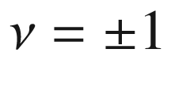

yield different transition energies. The overall dependence of the transition energy follows a 1/*d*-law.

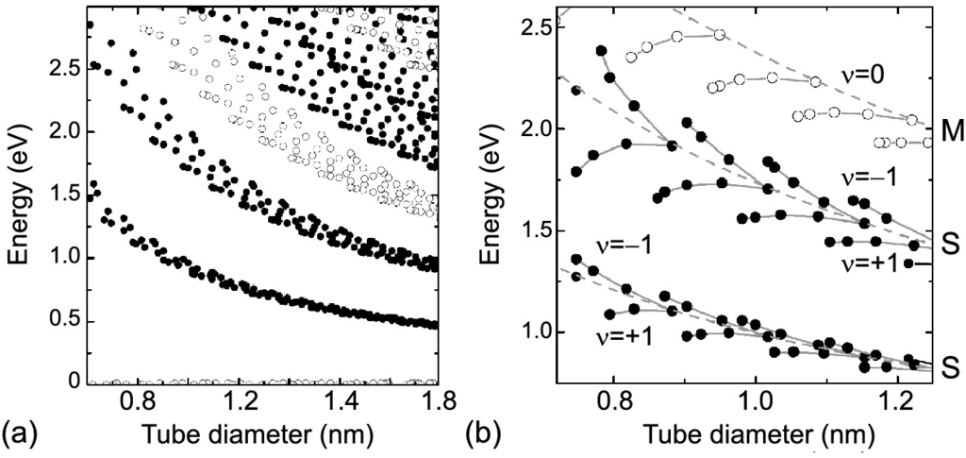

Fig. 14.22

**a** Theoretical transition energies of semiconducting (*filled symbols*) and metallic (*open symbols*) carbon nanotubes as a function of tube diameter (Kataura plot). Energies are calculated from van-Hove singularities in the JDOS within the third-order tight-binding approximation [1252]. **b** Experimental Kataura plot for the first two semiconducting (S, *closed symbols*) and the first metallic (M, *open symbols*) transition. *Dashed lines* connect the (near-to) armchair tubes; *full lines* connect tubes in a branch,

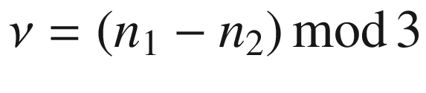

. Data from photoluminescence [1375] and resonant Raman scattering [1376].

Adapted from [1377]

#### 14.3.4 Other Anorganic Nanotubes

Structures similar to carbon nanotubes have been reported for BN [1378, 1379]. A boron nitride nanotube is a cylindrically rolled part of a BN sheet. BN tubes are always semiconducting (Fig. [14.23](#u116076_4_En_14_Chapter-Fig23)) and have a band gap beyond 5 eV similar to hexagonal BN which is mostly independent on chirality and diameter [1380]. Thus, while carbon nanotubes appear black since they absorb within 0–4 eV, BN is transparent (or white if scattering). For high energies larger than 10 eV C and BN tubes are quite similar since they are isoelectronic and the high-lying unoccupied states are less sensitive to the difference in the nuclear charges than the states at and below the Fermi energy [1381].

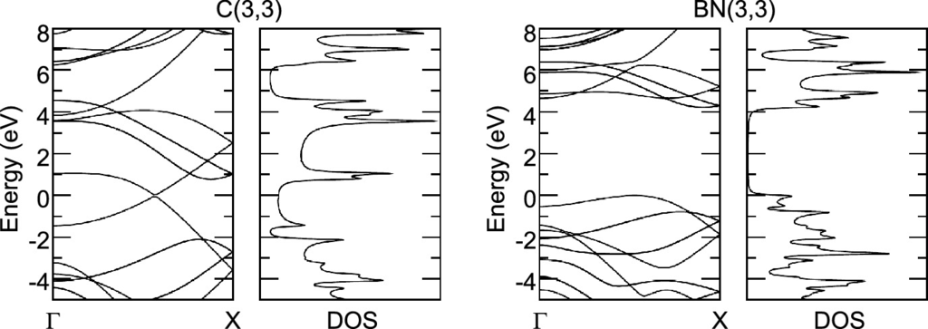

Fig. 14.23

Band structure and density of states (DOS) of C(3,3) and BN(3,3) nanotubes, calculated with DFT-LDA.

Adapted from [1381]

### 14.4 Quantum Dots

#### 14.4.1 Quantization in Three-Dimensional Potential Wells

The solutions for  the *d*-dimensional (

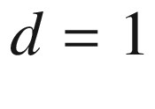

, 2, or 3) harmonic oscillator, i.e. the eigenenergies for the Hamiltonian

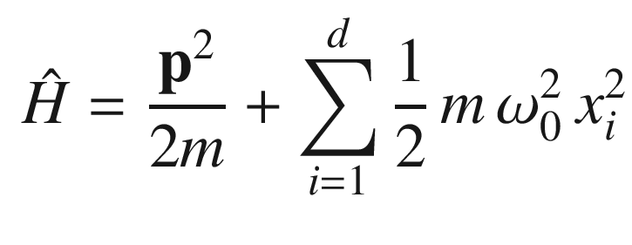

(14.6)

are given by

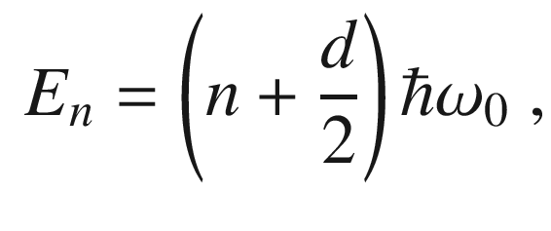

(14.7)

with

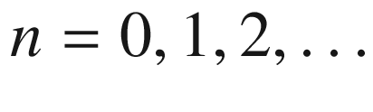

. More detailed treatments can be found in quantum-mechanics textbooks.

Next, we discuss the problem of a particle in a centrosymmetric finite potential well with different masses

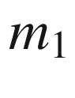

in the dot and

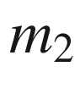

in the barrier. The Hamiltonian and the potential are given by

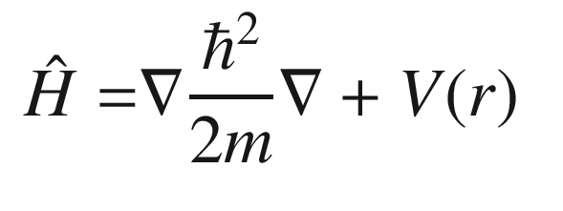

(14.8)

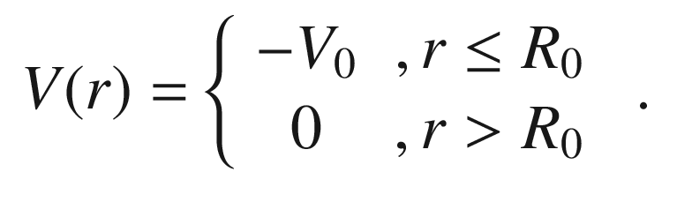

(14.9)

The wavefunction can be separated into radial and angular components

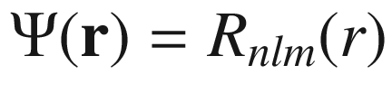

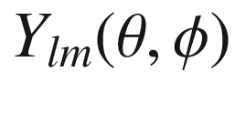

, where

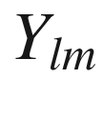

are the spherical harmonic functions. For the ground state (

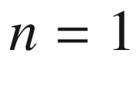

) the angular momentum *l* is zero and the solution for the wavefunction (being regular at

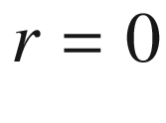

) is given by

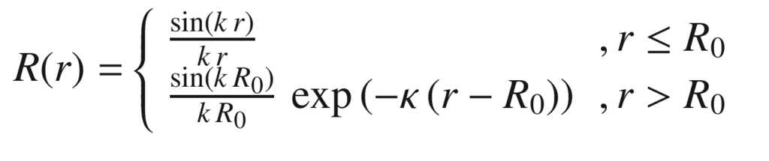

(14.10a)

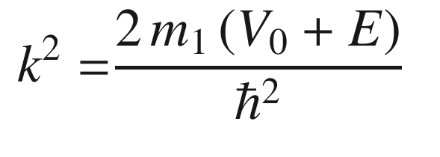

(14.10b)

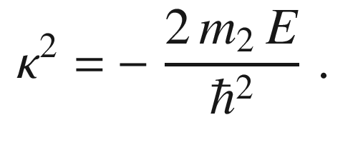

(14.10c)

From the boundary conditions that both *R*(*r*) and

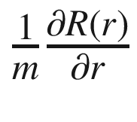

are continuous across the interface at

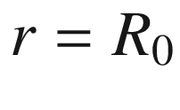

, the transcendental equation

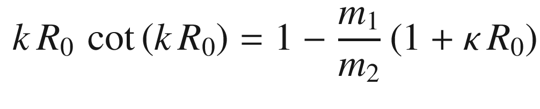

(14.11)

is obtained. From this formula the energy of the single particle ground state in a spherical quantum dot can be determined. For a given radius, the potential needs a certain strength

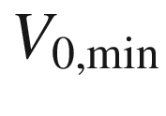

to confine at least one bound state; this condition can be written as

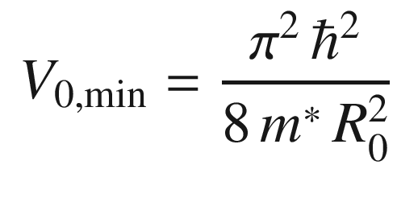

(14.12)

for

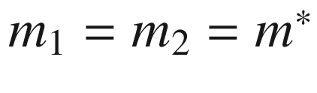

. For a general angular momentum *l*, the wavefunctions are given by spherical Bessel functions

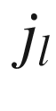

in the dot and spherical Hankel  functions

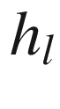

in the barrier. Also, the transcendental equation for the energy of the first excited level can be given:

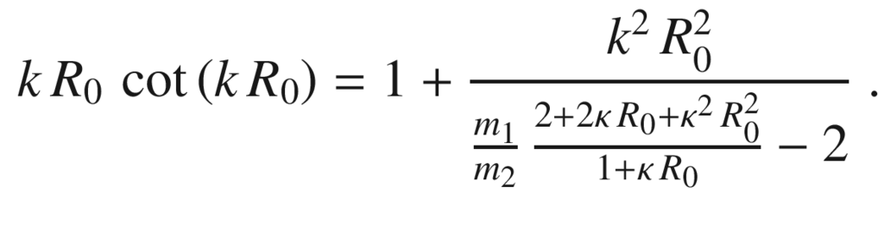

(14.13)

In the case of infinite barriers (

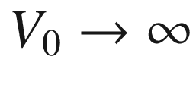

), the wavefunction vanishes outside the dot and is given by (normalized)

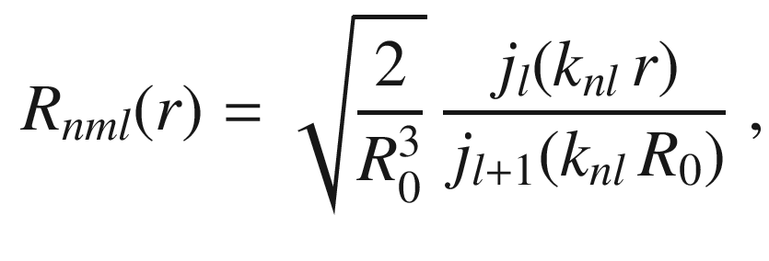

(14.14)

where

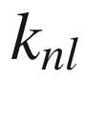

is the *n*-th zero of the Bessel function

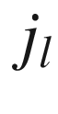

, e.g.

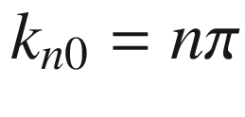

. With two-digit precision the lowest levels are determined by

| $$k_{nl}$$ | $$l=0$$ | $$l=1$$ | $$l=2$$ | $$l=3$$ | $$l=4$$ | $$l=5$$ |
| --- | --- | --- | --- | --- | --- | --- |
| $$n=0$$ | 3.14 | 4.49 | 5.76 | 6.99 | 8.18 | 9.36 |
| $$n=1$$ | 6.28 | 7.73 | 9.10 | 10.42 |  |  |
| $$n=2$$ | 9.42 |  |  |  |  |  |

The (2*l*+1) degenerate energy levels

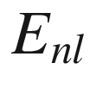

are (

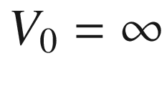

,

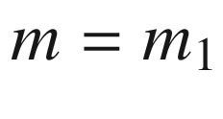

):

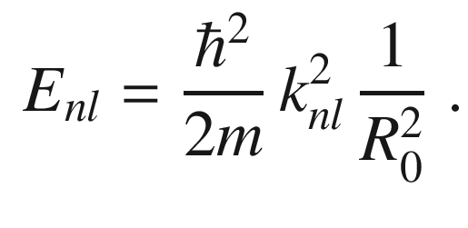

(14.15)

The 1s, 1p, and 1d states have smaller eigenenergies than the 2s state.

A particularly simple solution is given for a cubic quantum dot of side length

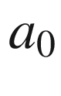

and infinite potential barriers. One finds the levels

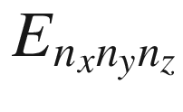

:

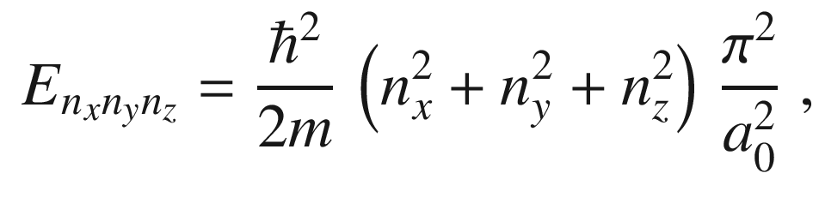

(14.16)

with

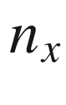

,

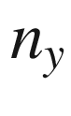

,

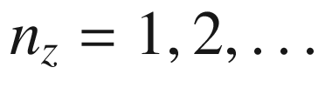

. For a sphere, the separation between the ground and first excited state is

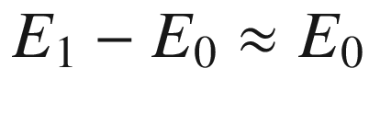

, for a cube and a two-dimensional harmonic oscillator it is exactly

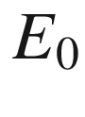

. For a three-dimensional harmonic oscillator this quantity is

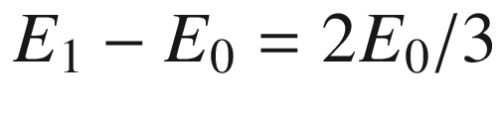

.

For realistic quantum dots a full three-dimensional simulation of strain, piezoelectric fields and the quantum-mechanical confinement must be performed [1382, 1383]. In Fig. [14.24](#u116076_4_En_14_Chapter-Fig24), the lowest four electron and hole wavefunctions in a pyramidal InAs/GaAs quantum dot (for the strain distribution see Fig. [5.​34](The_Physics_of_Semiconductors00003.docx#u116076_4_En_5_Chapter-Fig34) and for the piezoelectric fields see Fig. [16.​16](#u116076_4_En_16_Chapter-Fig16)) are shown. The figure shows that the lowest hole states have dominantly heavy-hole character and contain admixtures of the other hole bands. The wavefunction in such quantum dots can be imaged using scanning tunneling microscopy [1384].

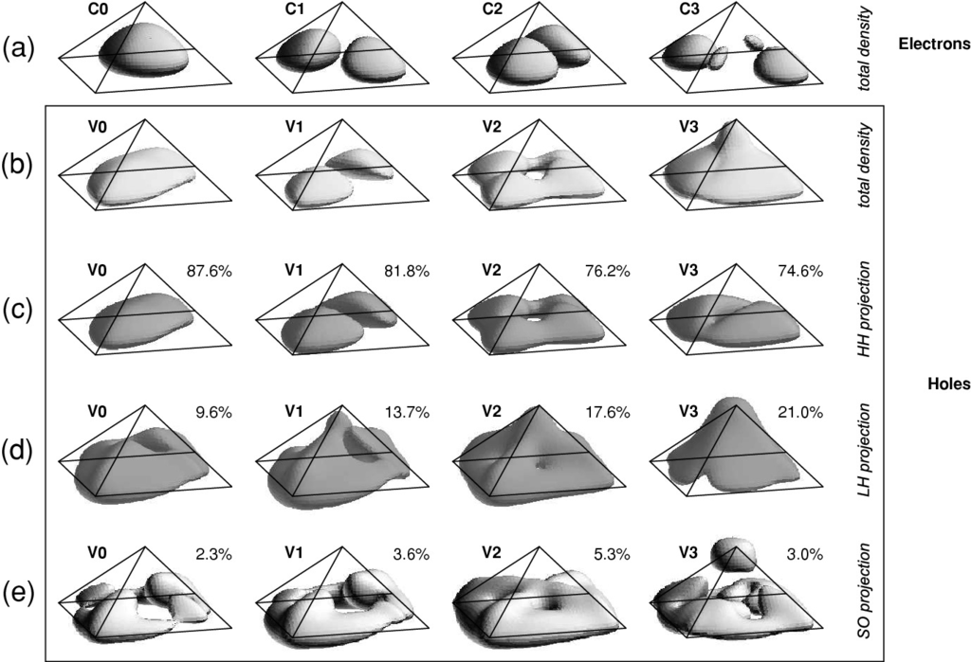

Fig. 14.24

Isosurface plots (25% of maximum value) of the total probability densities **a**, **b** and valence-band projections (**c**)–(**e**) of bound electron (**a**) and hole (**b**)–(**e**) states in a model pyramidal InAs/GaAs quantum dot with base length

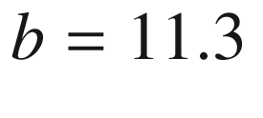

nm. The percentages are the integrals of the projections to the bulk heavy, light and split-off hole bands, respectively, and the isosurfaces show the corresponding projection shapes. For each valence-band state the difference from 100% is the integral

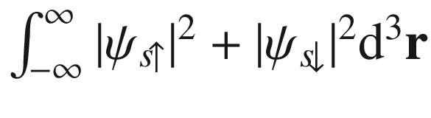

of the *s*-type (conduction band) Bloch function projection (not shown).

Reprinted with permission from [1385], ©2002, Springer

#### 14.4.2 Electrical and Transport Properties

The classical electrostatic energy of a quantum dot with capacitance

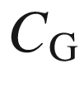

that is capacitively coupled to a gate (Fig. [14.25](#u116076_4_En_14_Chapter-Fig25)) at a bias voltage

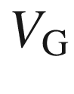

is given by

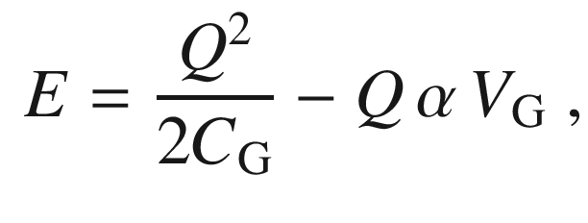

(14.17)

where

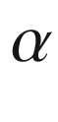

is a dimensionless factor relating the gate voltage to the potential of the island and *Q* is the charge of the island.

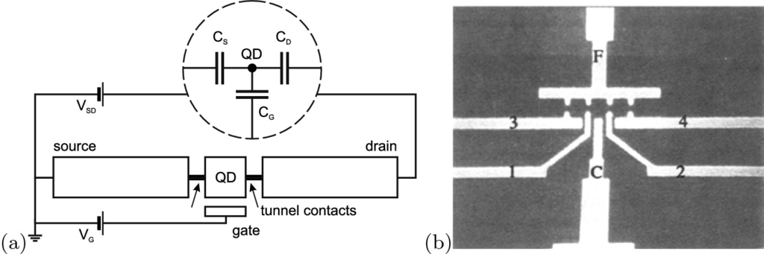

Fig. 14.25

**a** Schematic drawing of a quantum dot (QD) with tunnel contacts and gate electrode. The *inset* depicts an equivalent circuit with capacitances. **b** Realization with an in-plane gate structure. The distance between ‘F’ and ‘C’ (gate electrode) is 1

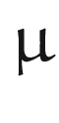

m. Electron transport occurs from a 2DEG between 3/F to 4/F through the quantum points contacts 1/3 and 2/4. Part (**b**) from [1386], reprinted with permission, ©1991, Springer Nature

Mathematically, minimum energy is reached for a charge

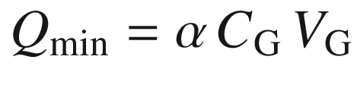

. However, the charge has to be an integer multiple of *e*, i.e.

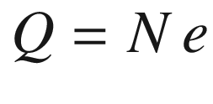

. If

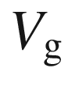

has a value, such that

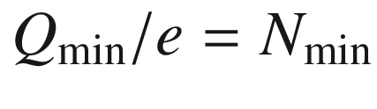

is an integer, the charge cannot fluctuate as long as the temperature is low enough, i.e.

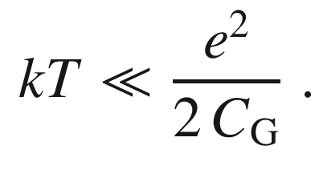

(14.18)

Tunneling into or out of the dot is suppressed by the Coulomb barrier

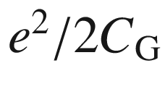

, and the conductance is very low. Analogously, the differential capacitance is small. This effect is called *Coulomb blockade*. Peaks in the tunneling current (Fig. [14.26](#u116076_4_En_14_Chapter-Fig26)b), conductivity (Fig. [14.26](#u116076_4_En_14_Chapter-Fig26)a) and the capacitance occur, when the gate voltage is such that the energies for *N* and

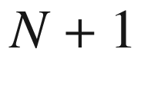

electrons are degenerate, i.e.

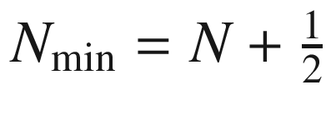

. The expected level spacing is

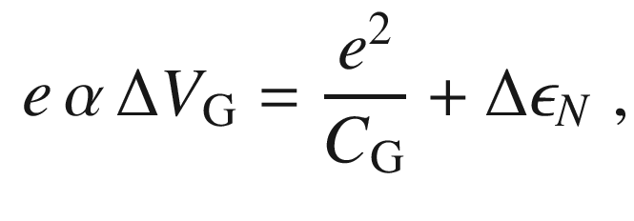

(14.19)

where

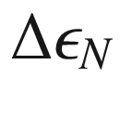

denotes the change in lateral (kinetic) quantization energy for the added electron.

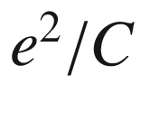

will be called the charging energy in the following.

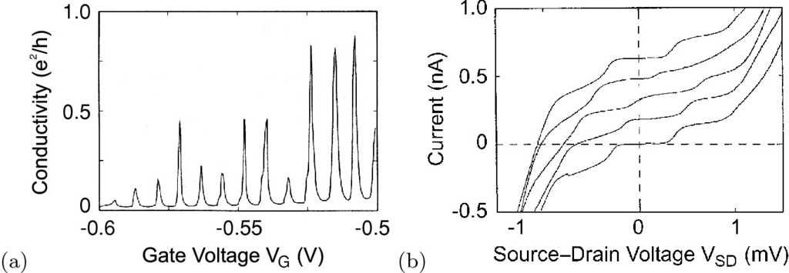

Fig. 14.26

**a** Conductivity (Coulomb oscillations) and **b** current–voltage diagram at different gate voltages (Coulomb staircase, shifted vertically for better readability) of a tunnel junction with a quantum dot as in Fig. [14.25](#u116076_4_En_14_Chapter-Fig25).

Adapted from [1386], reprinted with permission, ©1991, SpringerNature

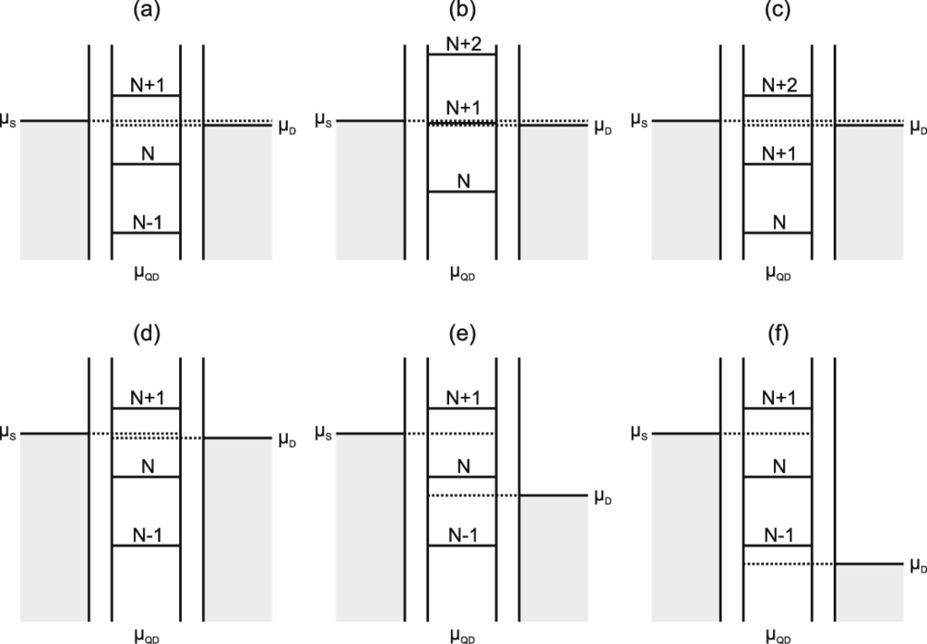

Fig. 14.27

Chemical potentials of source and drain and of a quantum dot in between them. **a**, **b**, and **c** show the sequence for a variation of the gate voltage and visualize the origin of the Coulomb oscillations (see Fig. [14.26](#u116076_4_En_14_Chapter-Fig26)a). **d**, **e** and **f** visualize a variation of the source–drain voltage and the origin of the Coulomb staircase (cf. Fig. [14.26](#u116076_4_En_14_Chapter-Fig26)b)

A variation of the source–drain voltage (for a given gate voltage) leads to a so-called Coulomb staircase since more and more channels of conductivity contribute to the current through the device (Fig. [14.27](#u116076_4_En_14_Chapter-Fig27)). In Fig. [14.28](#u116076_4_En_14_Chapter-Fig28) the tunneling current is shown as a function of the potential of a dot, formed by gates on a WSe



flake [1388], and the source-drain voltage. The iso-current lines form so-called ‘Coulomb blockade diamonds’.

The charge *Q* on the QD is determined by the charges on the gate, source and drain capacities,

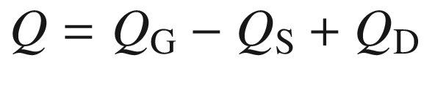

. Together with

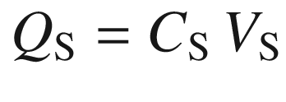

,

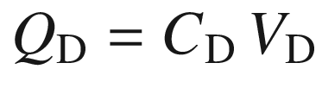

and

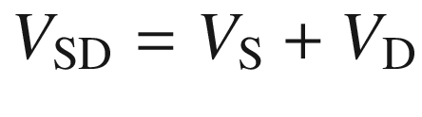

and

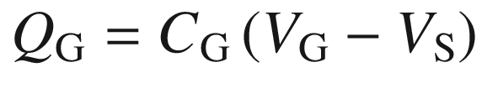

, we find (

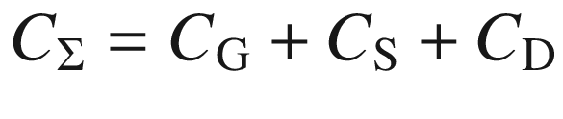

),

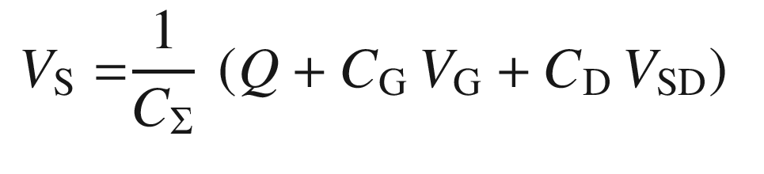

(14.20)

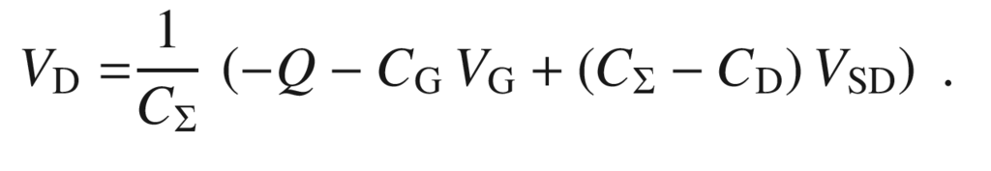

(14.21)

Now, if for a given pair of

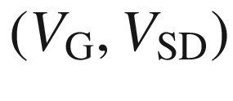

in a diagram like Fig. [14.28](#u116076_4_En_14_Chapter-Fig28)b the current is Coulomb-blocked and low, then it is for all voltages with the same charge *Q* on the dot and either the same

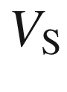

or

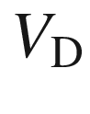

. The derivatives of ([14.20](#u116076_4_En_14_Chapter-Equ22)) and ([14.21](#u116076_4_En_14_Chapter-Equ23)) yield the slopes

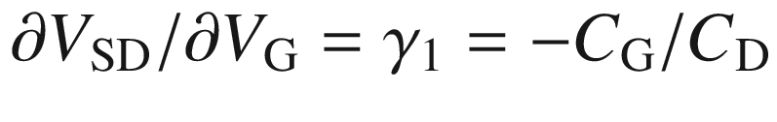

and

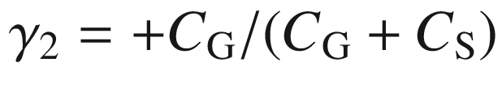

, respectively, that defined the borders of the diamond in the schematic stability diagram as depicted in Fig. [14.29](#u116076_4_En_14_Chapter-Fig29). We note that such analysis is allowed when

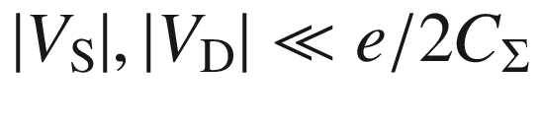

and the quantum dot circuit can be treated as a system of capacitors (inset in Fig. [14.25](#u116076_4_En_14_Chapter-Fig25)a). Changing *Q* to

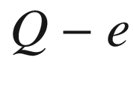

requires

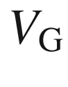

to increase by

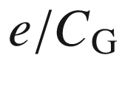

for the same

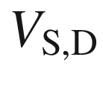

, yielding the periodicity of the stability diagram.

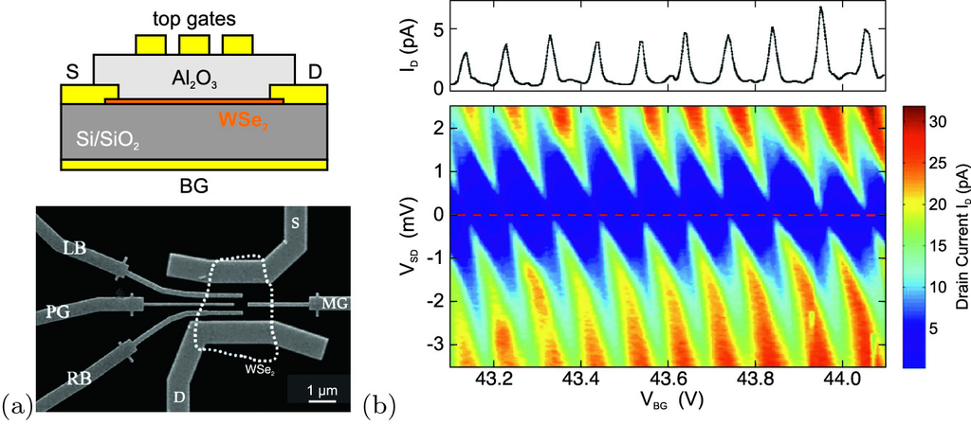

Fig. 14.28

**a** *Top*: Sketch of WSe



flake with gate structure, defining a lateral quantum dot. *Bottom*: SEM image of the structure. The outline of the WSe



flake (thickness 4.5 nm) is indicated as *dotted line*. BG: back gate, PG: plunger gate. **b** Current (in false colors) as a function of the back gate voltage

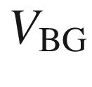

and the source-drain voltage

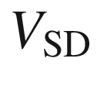

(

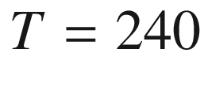

 mK). On the top is a current trace as a function of

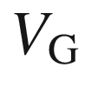

(for

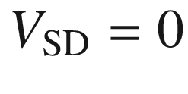

, along the *red dashed line* in the diagram). SEM image in panel (**a**) and panel (**b**) adapted from [1388] with permission from RSC

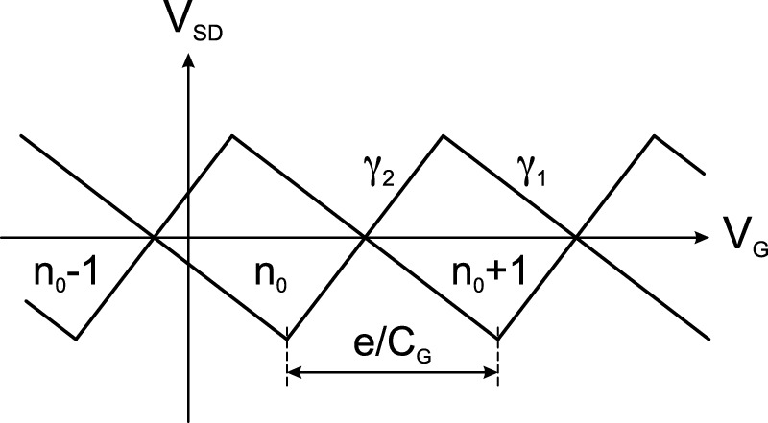

Fig. 14.29

Schematic Coulomb diamond stability diagram. The slopes

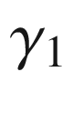

and

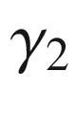

are discussed in the text. The periodicity in the gate voltage is given by

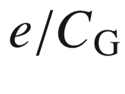

. The charge on the dot is

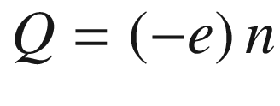

Single electron tunneling (SET) circuits [1387] are investigated with respect to metrology for a novel ampere standard [1389].

A lot of research so far has been done on lithographically defined systems where the lateral quantization energies are small and smaller than the Coulomb charging energy. In this case, periodic oscillations are observed, especially for large *N*. A deviation from periodic oscillations for small *N* and a characteristic shell structure (at

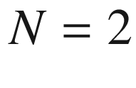

, 6, 12) consistent with a harmonic oscillator model (

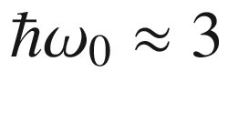

 meV) has been reported for



500-nm diameter mesas (Fig. [14.30](#u116076_4_En_14_Chapter-Fig30)b,c). In this structure, a small mesa has been etched and contacted (top contact, substrate back contact and side gate). The quantum dot consists of a 12-nm In

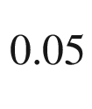

Ga

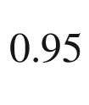

As quantum well that is laterally constricted by the 500-nm mesa and vertically confined due to 9- and 7.5-nm thick Al

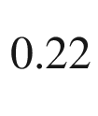

Ga

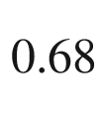

As barriers (Fig. [14.30](#u116076_4_En_14_Chapter-Fig30)a). By tuning the gate voltage, the number of electrons can be varied within 0 and 40. Measurements are typically carried out at a sample temperature of 50 mK.

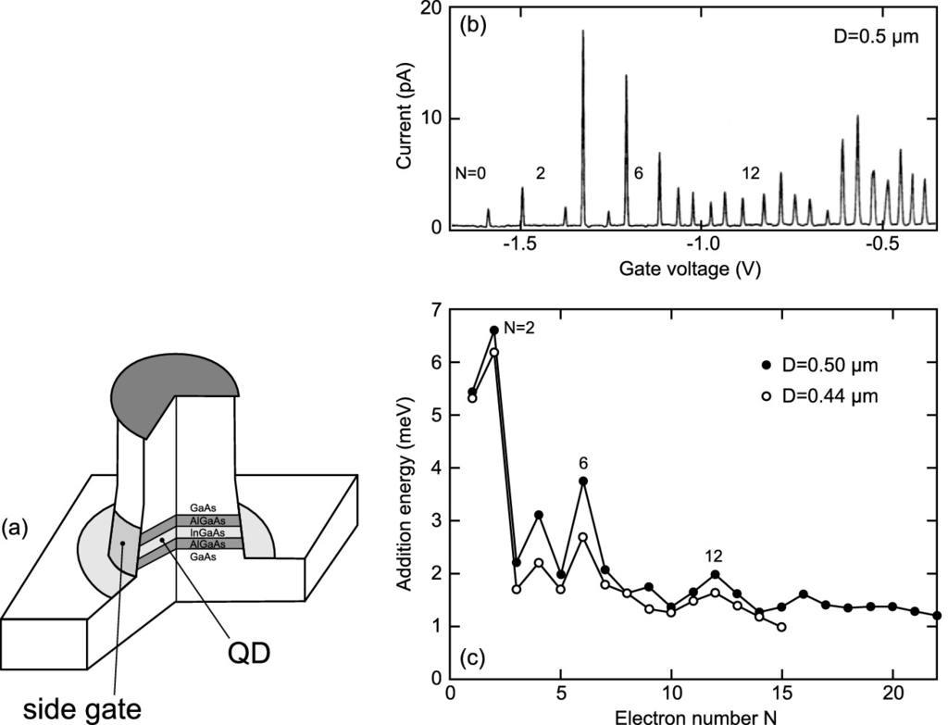

Fig. 14.30

**a** Schematic sample geometry for side-gated In

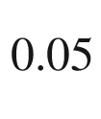

Ga

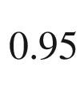

As/Al

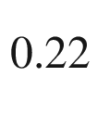

Ga

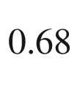

As disk-shaped quantum dot. **b** Coulomb oscillations in the current versus gate voltage at

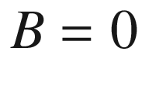

 T observed for a

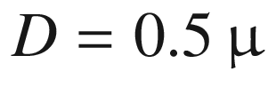

m disk-shaped dot. **c** Addition energy versus electron number for two different dots with

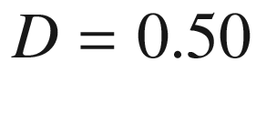

and 0.44



m.

Adapted from [1391]

In the sample shown in Fig. [14.31](#u116076_4_En_14_Chapter-Fig31), self-assembled QDs are positioned in the channel under a split-gate structure. In a suitable structure, tunneling through a single QD is resolved.

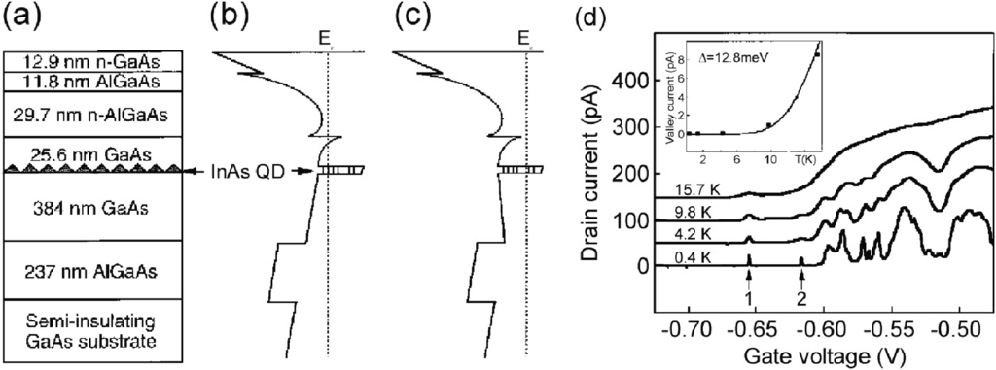

Fig. 14.31

**a** Schematic layer sequence of epitaxial structure comprising a n-AlGaAs/GaAs heterointerface with a two-dimensional electron gas and a layer of InAs/GaAs quantum dots. **b** and **c** are corresponding band diagrams with no gate bias and gate voltage below the critical value, respectively. **d** Experimental dependence of drain current on gate voltage in a split-gate structure at a drain source voltage of 10

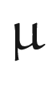

V. *Inset*: Dependence of valley current on temperature (*squares*) with theoretical fit.

Reprinted with permission from [1392], ©1997 AIP

In small self-assembled quantum dots single-particle level separations can be larger than or similar to the Coulomb charging energy. Classically, the capacitance for a metal sphere of radius

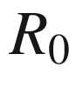

is given as

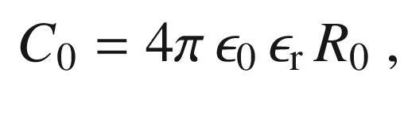

(14.22)

e.g..

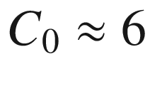

 aF for

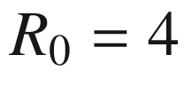

 nm in GaAs, resulting in a charging energy of 26 meV. Quantum mechanically, the charging energy is given in first-order perturbation theory by

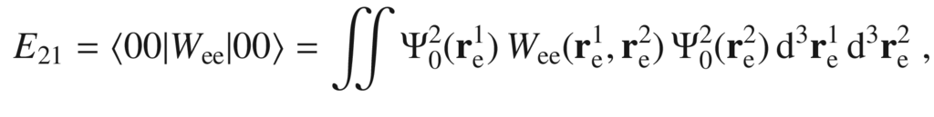

(14.23)

where

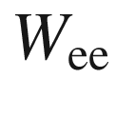

denotes the Coulomb interaction of the two electrons and

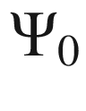

the ground state (single particle) electron wavefunction. The matrix element gives an upper bound for the charging energy since the wavefunctions will rearrange to lower their overlap and the repulsive Coulomb interaction. For lens-shaped InAs/GaAs quantum dots with radius 25 nm a charging energy of about 30 meV has been predicted.

#### 14.4.3 Self-Assembled Preparation

The preparation methods for QDs split into top-down (lithography and etching) and bottom-up (self-assembly) methods. The latter achieve typically smaller sizes and require less effort (at least concerning the machinery).

**Artificial Patterning**

Using artificial patterning, based on lithography and etching (Fig. [14.32](#u116076_4_En_14_Chapter-Fig32)), quantum dots of arbitrary shape can be made (Fig. [14.33](#u116076_4_En_14_Chapter-Fig33)). Due to defects introduced by high-energy ions during reactive ion etching the quantum efficiency of such structures is very low when they are very small. Using wet-chemical etching techniques the damage can be significantly lowered but not completely avoided. Since the QDs have to compete with other structures that can be made structurally perfect, this is not acceptable.

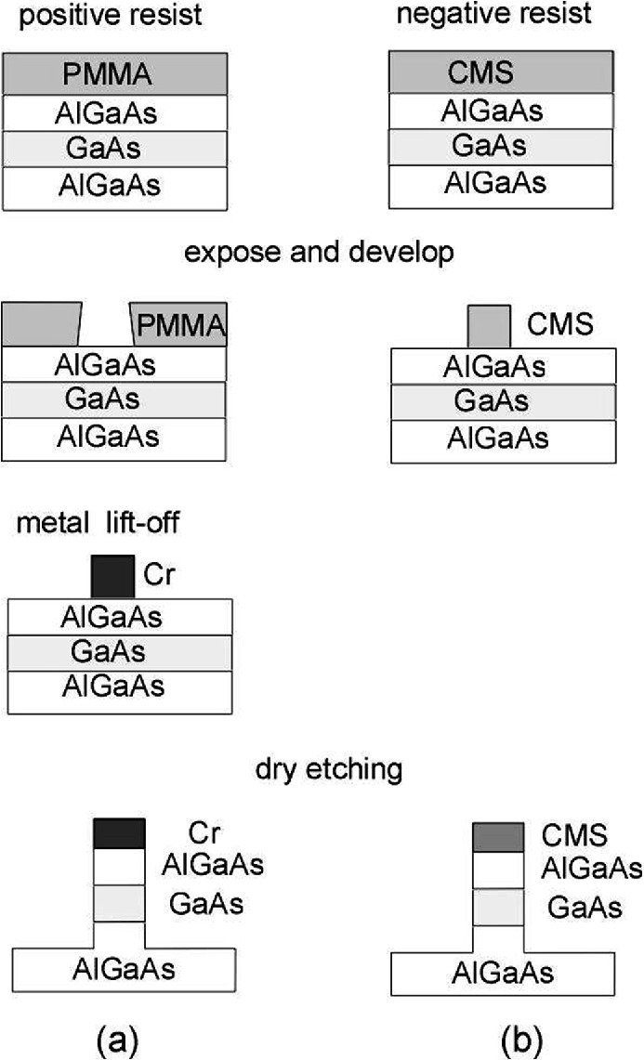

Fig. 14.32

Lithography and etching techniques for the fabrication of semiconductor structures

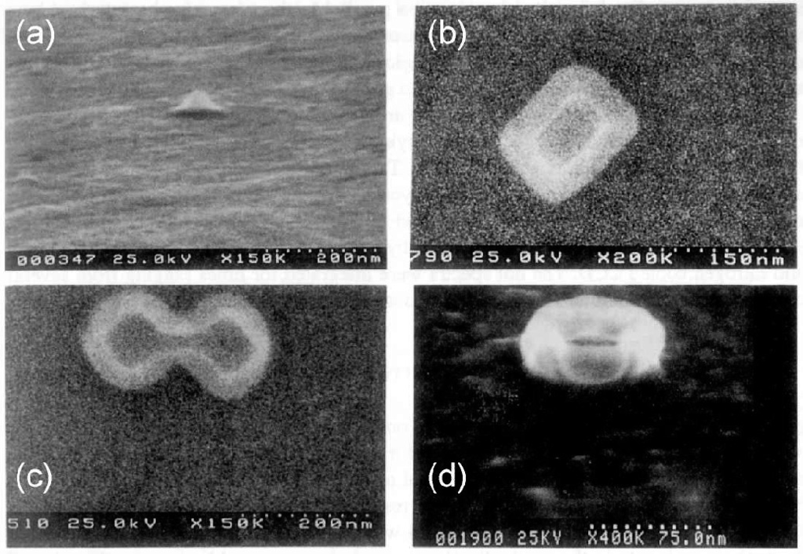

Fig. 14.33

Quantum dots of various shapes created by lithography and etching techniques.

From [1393]

**Template Growth**

Template growth is another technique for the formation of nanostructures. Here, a mesoscopic structure is fabricated by conventional means. The nanostructure is created using size-reduction mechanisms, e.g., faceting, (Fig. [14.34](#u116076_4_En_14_Chapter-Fig34)). This method can potentially suffer from low template density, irregularities of the template, and problems of reproducibility.

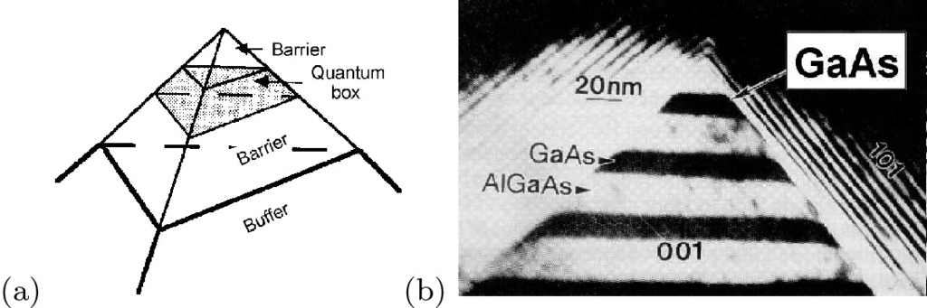

Fig. 14.34

**a** Schematic representation of growth on top of a predefined template, **b** cross-sectional TEM of quantum dot formation at the apex.

Reprinted with permission from [1394], ©1992 MRS

**Colloids**

Another successful route to nanocrystals is the doping of glasses with subsequent annealing (color filters). When nanocrystals are prepared in a sol-gel process, the nanoparticles are present as a colloid in wet solution. With the help of suitable stabilizing agents they are prevented from sticking to each other and can be handled in ensembles and also individually. Such nanocrystals have been synthesized and investigated in particular for II–VI (Fig. [14.35](#u116076_4_En_14_Chapter-Fig35)a) and halide perovskite (Fig. [14.35](#u116076_4_En_14_Chapter-Fig35)b) semiconductors.

**Mismatched Epitaxy**

The self-assembly (or self-organization) relies on strained heterostructures that achieve energy minimization by island growth on a wetting layer (Stranski-Krastanow growth mode, see Sect. [12.​2.​3](The_Physics_of_Semiconductors00005.docx#u116076_4_En_12_Chapter) and [1339]). Additional ordering mechanisms [1397, 1398] lead to ensembles that are homogeneous in size[2](#u116076_4_En_14_Chapter-Fn2) [1399] and shape [1400] (Fig. [14.36](#u116076_4_En_14_Chapter-Fig36)).

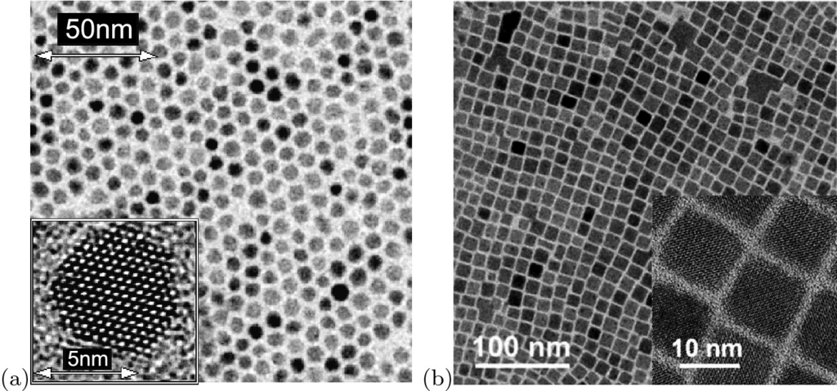

Fig. 14.35

**a** CdSe colloidal (hexagonal) nanoparticles. From [1395]. **b** CsPbBr



perovskite (cubic) colloidal nanocrystals.

Adapted from [1396] under Creative Commons Attribution (CC BY 4.0) license

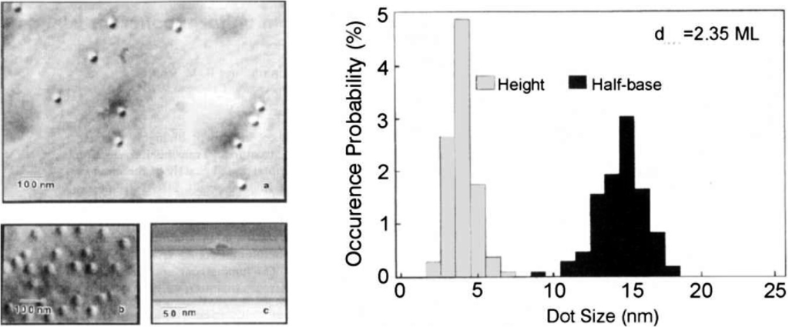

Fig. 14.36

Self-organized formation of InGaAs/GaAs quantum dots during epitaxy. *Left*: Plan-view and cross-sectional transmission electron micrographs. *Right*: Histogram of vertical and lateral size of the quantum dots.

Reprinted with permission from [1401], ©1993 AIP

When a thin layer of a semiconductor is grown on top of a flat substrate with different lattice constant, the layer suffers a tetragonal distortion (Sect. [5.​3.​3](The_Physics_of_Semiconductors00002.docx#u116076_4_En_5_Chapter)). Strain can only relax along the growth direction (Fig. [14.37](#u116076_4_En_14_Chapter-Fig37)). If the strain energy is too large (highly strained layer or large thickness), plastic relaxation via dislocation formation occurs. If there is island geometry, strain can relax in all three directions and about 50% more strain energy can relax, thus making this type of relaxation energetically favorable. When the island is embedded in the host matrix, the strain energy is similar to the 2D case and the matrix becomes strained (metastable state).

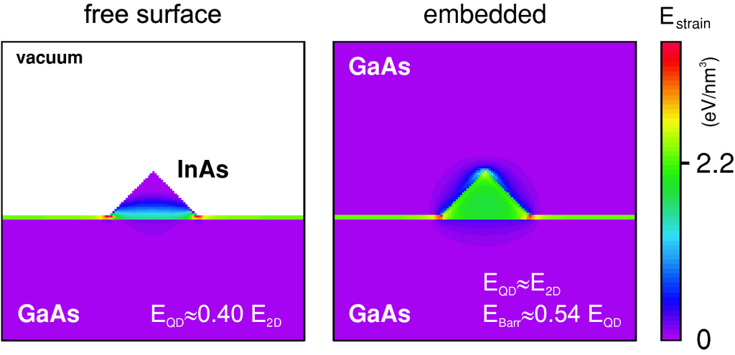

Fig. 14.37

Distribution of strain energy for (*left*) uncapped island and (*right*) island embedded in host matrix. Numerical values are for InAs/GaAs

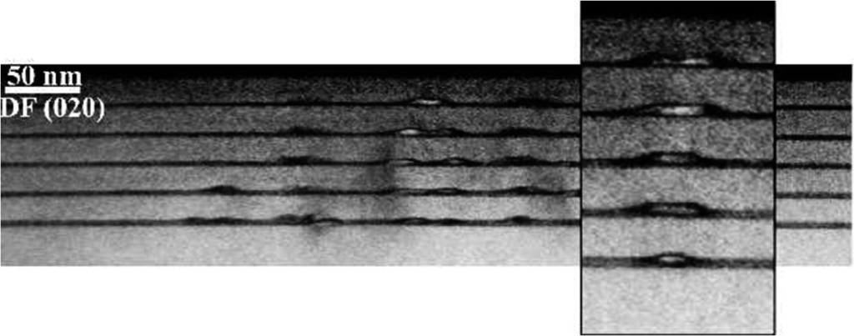

Fig. 14.38

Cross-sectional TEM image of a stack of five layers of quantum dots. Due to strain effects, vertical arrangement is achieved

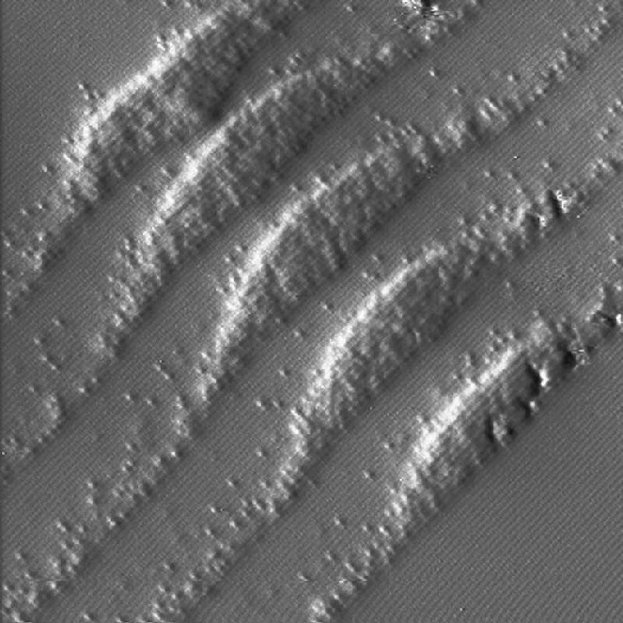

Fig. 14.39

Cross-sectional STM image of a stack of five InAs quantum dots in a GaAs matrix. Individual In atoms can be observed in-between the wetting layers and the quantum dots. Each quantum dot layer was formed by growing 2.4 ML of InAs. The intended distance between the quantum dot layers was 10 nm. Image size is

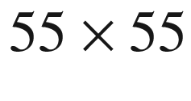

 nm

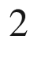

.

Reprinted with permission from [1402], ©2003 AIP

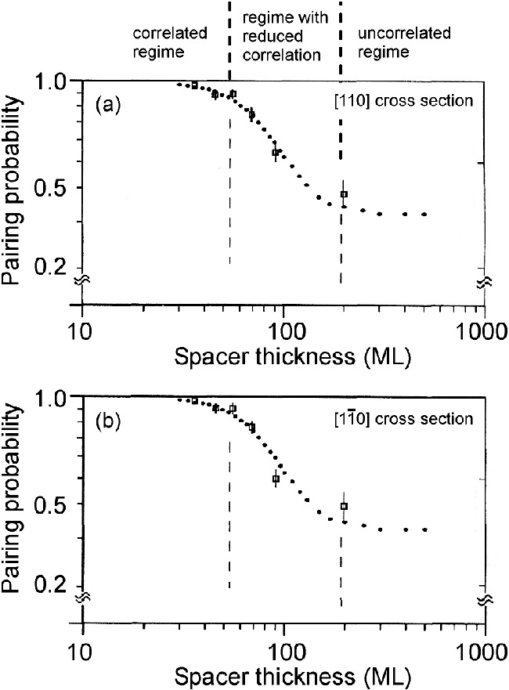

Fig. 14.40

Experimentally observed pairing probability in MBE-grown stacks of InAs/GaAs quantum dots as a function of the spacer-layer thickness. Data are taken from (**a**) (110) and (**b**) (1–10) cross-sectional TEM images. The *filled circles* are fit to data from theory of correlated island formation under strain fields.

Reprinted with permission from [1403], ©1995 APS

When such QD layers are vertically stacked, the individual quantum dots grow on top of each other (Fig. [14.38](#u116076_4_En_14_Chapter-Fig38)) if the separation is not too large (Fig. [14.40](#u116076_4_En_14_Chapter-Fig40)). This effect is due to the effect of the underlying QD. In the case of InAs/GaAs (compressive strain), the buried QD stretches the surface above it (tensile surface strain). Thus, atoms impinging in the next QD layer find a smaller strain right on top of the buried QDs. In STM images of the cross section through (XSTM) such a stack (Fig. [14.39](#u116076_4_En_14_Chapter-Fig39)) individual indium atoms are visible and the shape can be analyzed in detail [1402].

The vertical arrangement can lead to further ordering since a homogenization in lateral position takes place. If two QDs in the first layers are very close, their strain fields overlap and the second layer ‘sees’ only one QD.

The lateral (in-plane) ordering of the QDs with respect to each other occurs in square or hexagonal patterns and is mediated via strain interaction through the substrate. The interaction energy is fairly small, leading only to short-range in-plane order [1397] as shown in Fig. [14.41](#u116076_4_En_14_Chapter-Fig41). The in-plane ordering can be improved up to the point that regular one- or two-dimensional arrays form or individual quantum dots are placed on designated positions using directed self-assembly [1339]. Among others, dislocation networks buried under the growth surface of the nanostructure, surface patterning and modification have been used to direct the QD positioning.

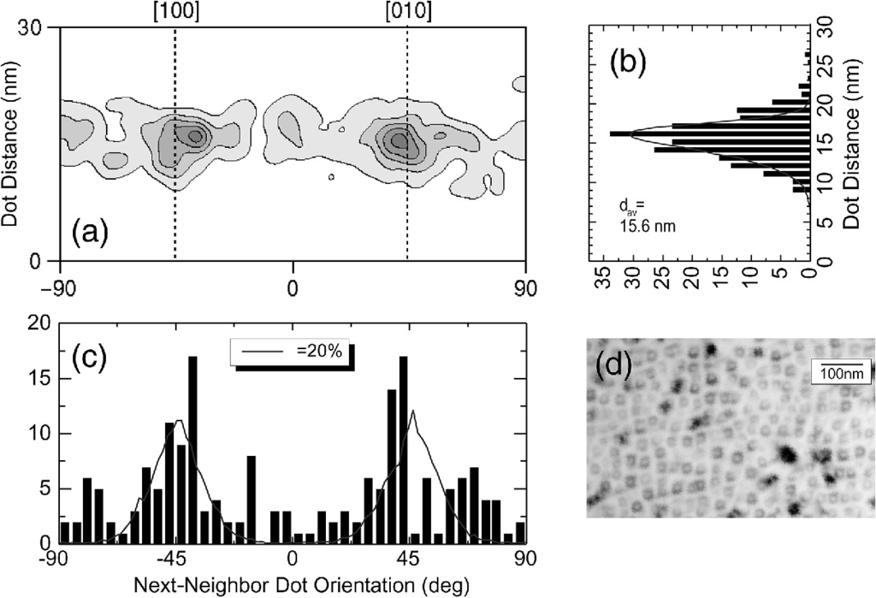

Fig. 14.41

Lateral ordering of QD array. **d** Plan-view TEM of QD array on which the statistical evaluation is based. **a** Two-dimensional histogram of QDs as a function of the nearest-neighbor distance and direction, (**b**, **c**) projections of part (**a**). *Solid lines* in (**b**) and (**c**) are theory for square array with

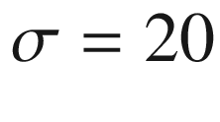

% deviation from ideal position.

Adapted from [1339, 1397]

**Ion-Beam Erosion**

During the erosion of a surface with low-energy ion beam sputtering ordered patterns of dots appear [1404–1407]. Isotropic [1408] and hexagonal [1404, 1406] (Fig. [14.42](#u116076_4_En_14_Chapter-Fig42)) near-range ordering has been observed. The pattern formation mechanism is based on the morphology-dependent sputter yield and further mechanisms of mass redistribution [1409]. Also linear patterns have been reported [1410].

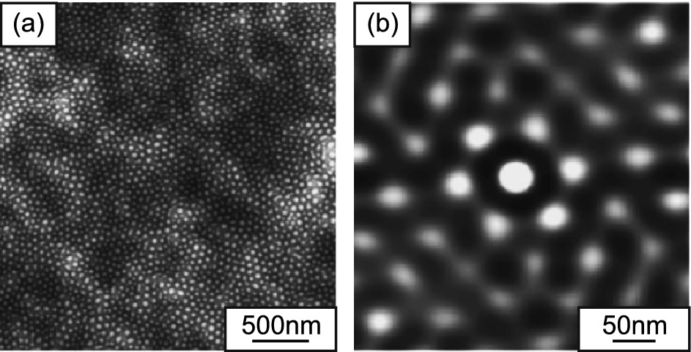

Fig. 14.42

**a** AFM image of a Si (001) substrate after 960 min of ion sputtering (1.2 keV Ar

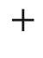

, normal incidence). **b** Two-dimensional autocorrelation function from a

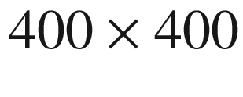

 nm

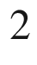

area of image in part (**a**).

Adapted from [1406] with permission, ©2001 AIP

#### 14.4.4 Optical Properties

The optical properties of QDs are related to their electronic density of states. In particular, optical transitions are allowed only at discrete energies due to the zero-dimensional density of states.

Photoluminescence from a single QD is shown in Fig. [14.43](#u116076_4_En_14_Chapter-Fig43). The

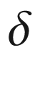

-like sharp transition is strictly true only in the limit of small carrier numbers (

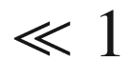

exciton per dot on average) since otherwise many-body effects come into play that can encompass recombination from charged excitons or multiexcitons.  At very low excitation density the recombination spectrum consists only of the one-exciton (X) line. With increasing excitation density small satellites on either side of the X-line develop that are attributed to charged excitons (trions) X

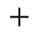

and X

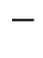

. On the low-energy side, the biexciton (XX) appears. Eventually, the excited states are populated and a multitude of states contribute with rich fine structure. In bulk material the biexciton (Sect. [9.​7.​10](The_Physics_of_Semiconductors00004.docx#u116076_4_En_9_Chapter)) is typically a bound state, i.e. its recombination energy

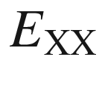

is lower than that of the exciton

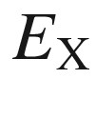

. A similar situation is present in Fig. [14.43](#u116076_4_En_14_Chapter-Fig43). It was pointed out in [1412] that in QDs the biexciton recombination energy can also be *larger* than the exciton recombination energy. In [1413] the modification of the QD confinement potential of InAs/GaAs QDs by annealing was reported. The exciton binding energy (



-



) is tuned from positive (‘normal’) to negative values upon annealing (Fig. [14.44](#u116076_4_En_14_Chapter-Fig44)).

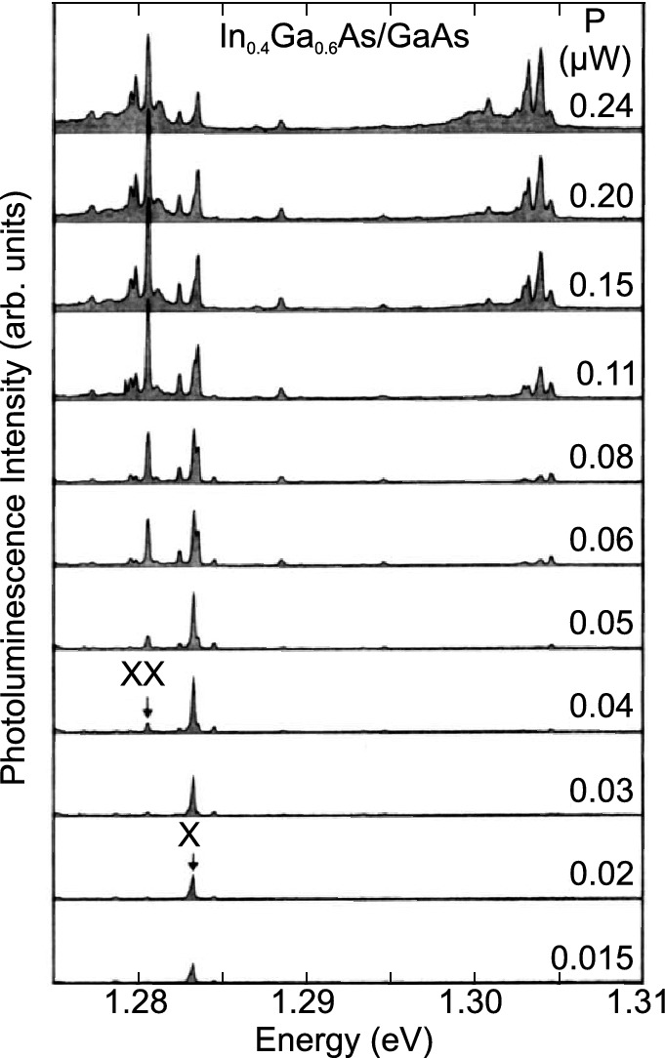

Fig. 14.43

Optical emission spectra (

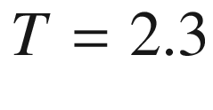

 K) of a single InGaAs/GaAs quantum dot at different laser excitation levels *P* as labeled. The single exciton (X) and biexciton (XX) lines are indicated.

Adapted from [1411]

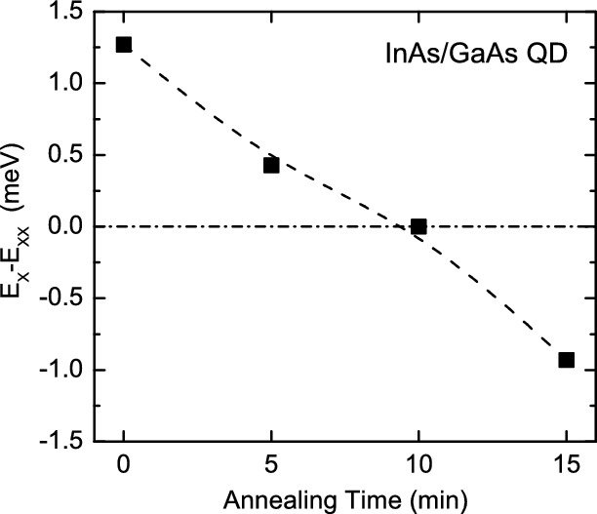

Fig. 14.44

Biexciton binding energy determined for a single InAs/GaAs quantum dot for various annealing times.

Data from [1413]

The charging state of the exciton can be controlled in a field-effect structure. The recombination energy is modified due to Coulomb and exchange effects with the additional carriers. In charge-tunable quantum dots [1414] and rings [1415] exciton emission has been observed in dependence of the number of additional electrons. The electron population can be controlled in a Schottky-diode-like structure through the manipulation of the Fermi level with the bias voltage. At high negative bias all charge carriers tunnel out of the ring and no exciton emission is observed. A variation of the bias then leads to an average population with

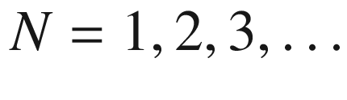

electrons. The recombination of additional laser-excited excitons depends (due to the Coulomb interaction) on the number of the electrons present (Fig. [14.45](#u116076_4_En_14_Chapter-Fig45)). The singly negatively charged exciton X



is also called a trion.

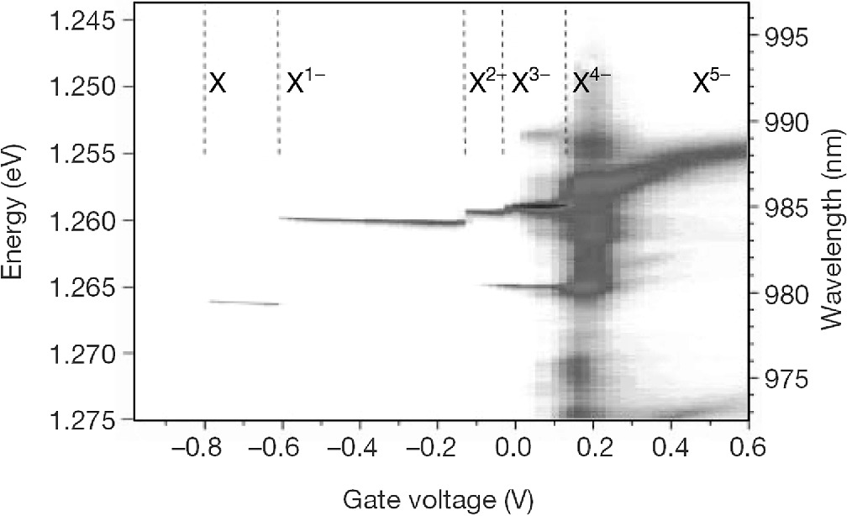

Fig. 14.45

Luminescence of charged excitons from a single quantum ring at

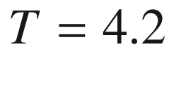

 K versus the bias voltage with which the number of electrons in the quantum dot *N* is tuned from zero to

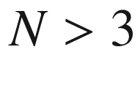

.

Adapted from [1415], reprinted with permission, ©2000, Springer Nature

The interaction of a spin with an exciton in a CdTe quantum dot has been observed in [1416]. If the CdTe quantum dot is pure, a single line arises. If the dot contains a single Mn atom, the exchange interaction of the exciton with the Mn

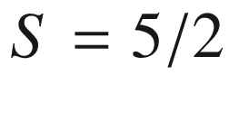

spin leads to a six-fold splitting of the exciton line (Fig. [14.46](#u116076_4_En_14_Chapter-Fig46). In an external magnetic field a splitting into a total of twelve lines due to Zeeman effect at the Mn spin is observed.

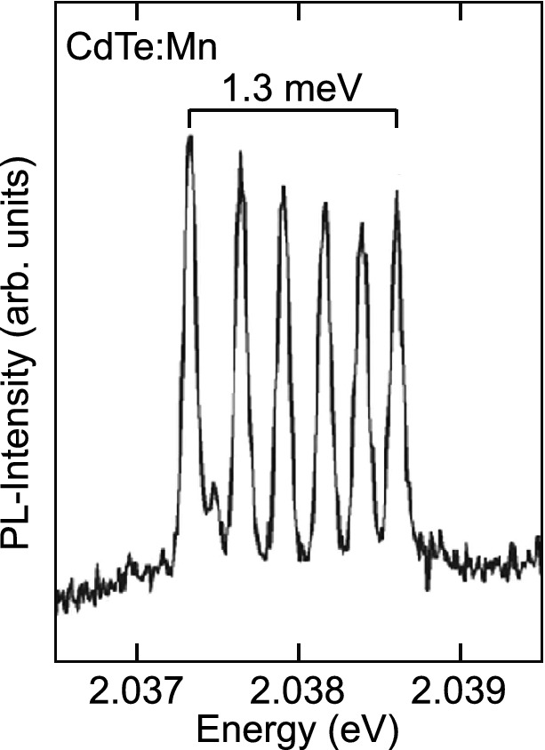

Fig. 14.46

Photoluminescence spectrum of a single CdTe/ZnSe quantum dot containing a single Mn atom (

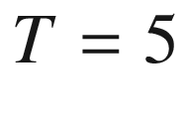

 K).

Adapted from [1416], reprinted with permission, ©2004 APS

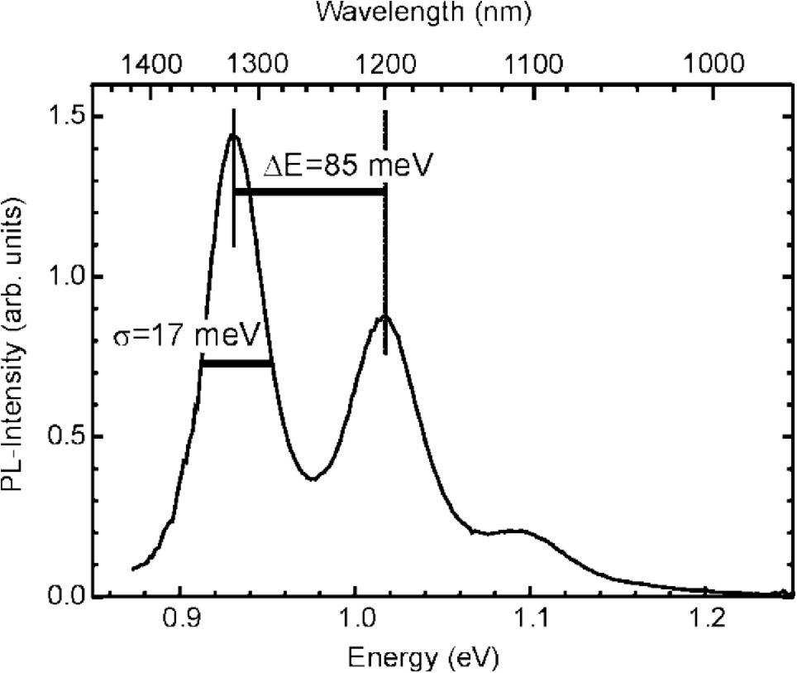

Fig. 14.47

Ensemble photoluminescence spectrum (

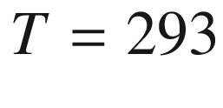

 K, excitation density 500 W/cm



) of InAs/GaAs QDs

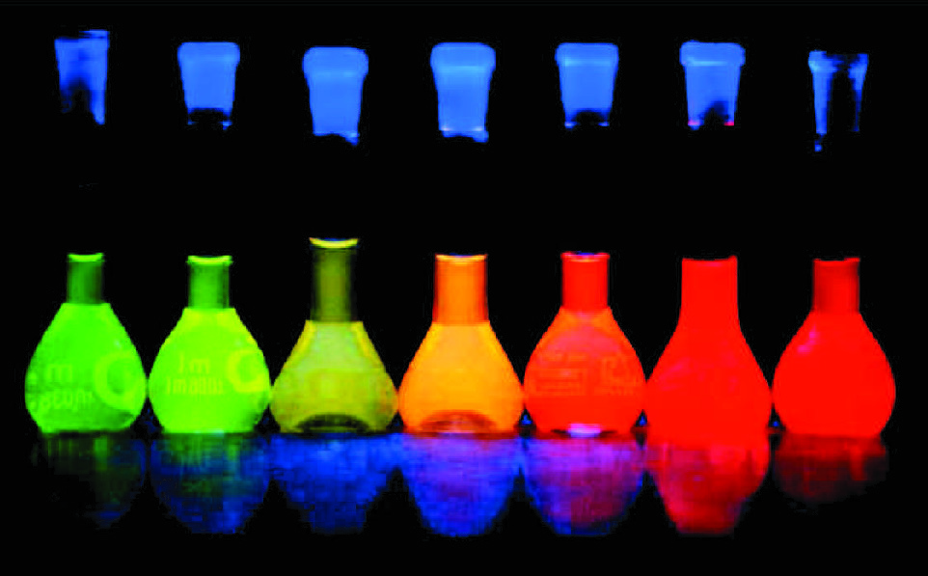

Fig. 14.48

Luminescence (under UV excitation) from flasks of colloidal CdTe quantum dots with increasing size (from left to right).

From [1395]

In a QD ensemble, optical  transitions are inhomogeneously broadened due to fluctuations in the QD size and the size dependence of the confinement energies (Fig. [14.47](#u116076_4_En_14_Chapter-Fig47)). Interband transitions involving electrons and holes suffer from the variation of the electron and hole energies:

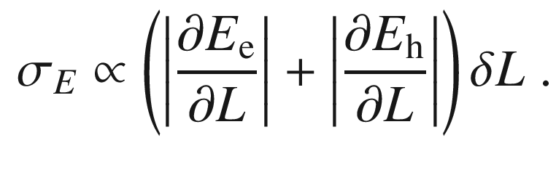

(14.24)

A typical relative size inhomogeneity of

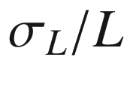

of 7% leads to several tens of meV broadening. Additional to broadening due to different sizes fluctuations of the quantum dot shape can also play a role. The confinement effect leads to an increase of the recombination energy with decreasing quantum-dot size. This effect is nicely demonstrated with colloidal quantum dots of different size as shown in Fig. [14.48](#u116076_4_En_14_Chapter-Fig48).

Footnotes

[1](#u116076_4_En_14_Chapter-Fn1_source)

The LDA in [1362] yields

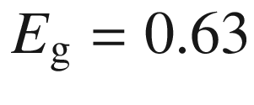

 eV for the bulk ZnO band gap; its experimental value is 3.4 eV.

[2](#u116076_4_En_14_Chapter-Fn2_source)

The ordering in size is remarkable. Typically Ostwald ripening (due to the Gibbs-Thomson effect; smaller droplets have larger vapor pressure and dissolve, larger droplets accordingly grow) occurs in an ensemble of droplets or nuclei. In the case of strained QDs, surface energy terms stabilize a certain QD size.

© Springer Nature Switzerland AG 2021

M. Grundmann

The Physics of Semiconductors

Graduate Texts in Physics

<https://doi.org/10.1007/978-3-030-51569-0_15>

## 15. External Fields

Marius Grundmann[1](#u116076_4_En_15_Chapter-Aff11)

(1)

Felix Bloch Institute for Solid State Physics, Universität Leipzig, Leipzig, Germany

Marius Grundmann

Email:

[grundmann@physik.uni-leipzig.de](mailto:grundmann@physik.uni-leipzig.de)

## Abstract

The effects of external electric and magnetic fields on the electronic and optical properties of bulk materials and quantum wells are discussed including the Stark effect and quantum-confined Stark effect, the Hall effect and Quantized Hall Effects. The energy levels of the solid and its optical and electronic properties depend on external electric and magnetic fields. In high magnetic fields and at low temperatures the quantum Hall effects give evidence for new states of matter in many-body systems.

### 15.1 Electric Fields

#### 15.1.1 Bulk Material

The center-of-mass motion of the exciton is not influenced by a homogeneous electric field. The Hamilton operator for the relative motion of an electron-hole pair of reduced mass

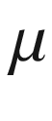

along *z* in the presence of an electric field *E* along the *z* direction is

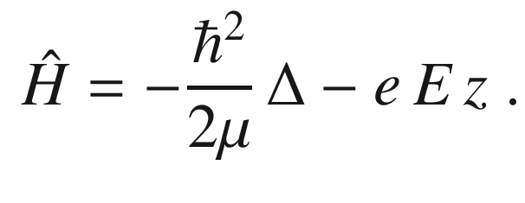

(15.1)

Here, the Coulomb interaction, leading to the formation of bound exciton states, is neglected. In the plane perpendicular to the field (here the *z* direction) the solutions for the relative motion are just plane waves.

In the electric field the bands are tilted (Fig. [15.1](#u116076_4_En_15_Chapter-Fig1)), i.e. there is no longer an overall band gap. Accordingly, the wavefunctions are modified and have exponential tails in the energy gap.

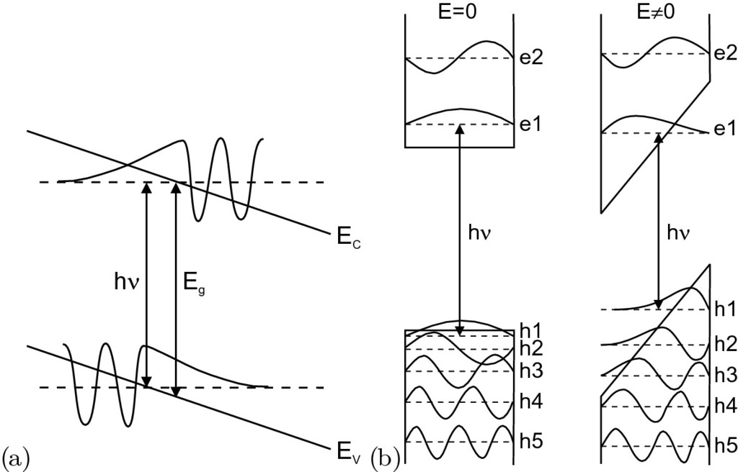

Fig. 15.1

Impact of an electric field on **a** bulk material (tilt of bands) and **b** a quantum well (quantum confined Stark effect, QCSE)

After separation of the motion in the (*x*,*y*) plane the Schrödinger equation for the motion in the *z* direction is

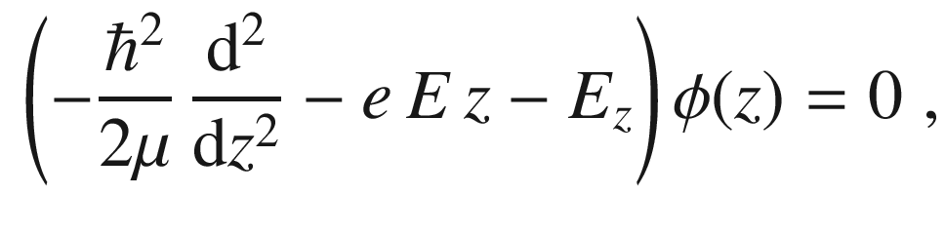

(15.2)

which is of the type

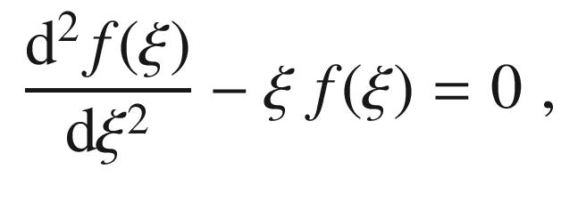

(15.3)

with

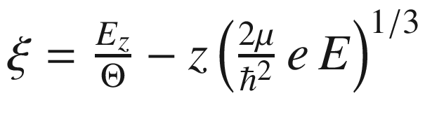

and the optoelectronic energy

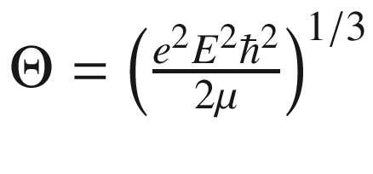

. The solution of ([15.3](#u116076_4_En_15_Chapter-Equ3)) is given by the Airy function Ai (cf. Fig. [15.2](#u116076_4_En_15_Chapter-Fig2)):

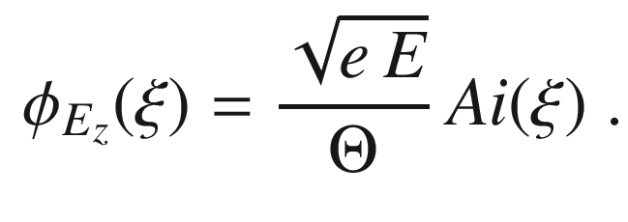

(15.4)

The pre-factor guaranties the orthonormality (with regard to the

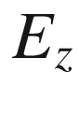

). The absorption spectrum is then given by

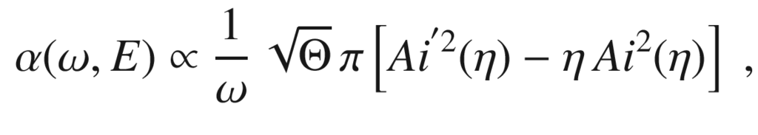

(15.5)

with

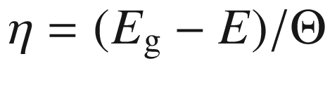

and

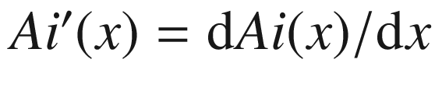

.

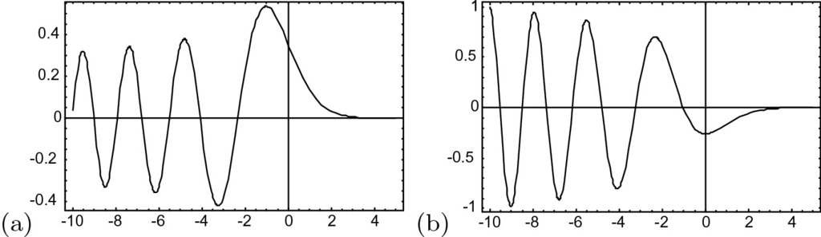

Fig. 15.2

**a** Airy function Ai(*x*), **b** Ai’(*x*)

Optical transitions below the band gap become possible that are photon-assisted tunneling processes. The below-bandgap transitions have the form of an exponential tail. Additionally, oscillations develop above the band gap, the so-called Franz-Keldysh oscillations (FKO) [1417, 1418] (Fig. [15.3](#u116076_4_En_15_Chapter-Fig3)a).

The absorption spectrum scales with the optoelectronic energy

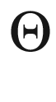

. The energy position of the FKO peaks

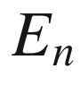

is periodic with (

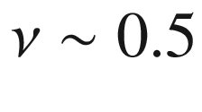

)

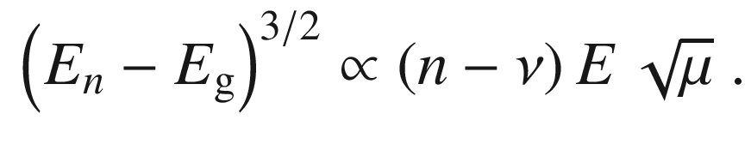

(15.6)

A more detailed theory including interband coupling and excitonic effects can be found in [1419]. The effect is best determined with modulation spectroscopy can measuring the difference of absorption with and without field [1420] since it exhibits more defined features (Fig. [15.3](#u116076_4_En_15_Chapter-Fig3)a, lower panel).

A nonperiodicity can indicate a nonparabolicity of the mass. Also, the contributions of heavy and light holes merge. For a given mass the electric field strength can be determined. Well-pronounced oscillations are only present for homogeneous fields.

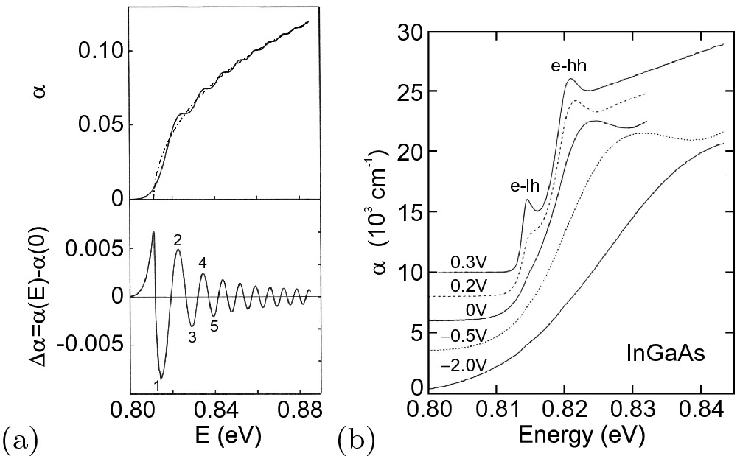

Fig. 15.3

**a** Theoretical absorption (*top panel*) with (*solid line*) and without (*dash-dotted line*) electric field for a volume semiconductor (without Coulomb interaction) and theoretical change of absorption (*bottom panel*). **b** Experimental absorption spectra of (In,Ga)As on InP at

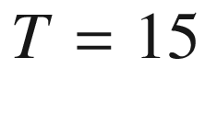

 K for various applied voltages as labeled.

Adapted from [1421]

Experimental spectra show additionally the peaks due to excitonic correlation (Fig. [15.3](#u116076_4_En_15_Chapter-Fig3)b) at low field strength. At higher fields the FKO evolve and the amplitude of the excitonic peaks decreases because the excitons are ionized in the field.

#### 15.1.2 Quantum Wells

In a quantum well an electric field along the confinement direction (*z* direction) causes electrons and holes to shift their mean position to opposite interfaces (Fig. [15.1](#u116076_4_En_15_Chapter-Fig1)b). However, excitons are not ionized due to the electric field. With increasing field (for both field directions) the energy position of the absorption edge and the recombination energy is reduced. This is the quantum confined Stark effect (QCSE). Corresponding experimental data are shown in Fig. [15.4](#u116076_4_En_15_Chapter-Fig4)i–v. The shift depends quadratically on the electric field since the exciton has no permanent dipole moment (mirror symmetry of the quantum well). Thus, only the second-order Stark effect is present (as for the hydrogen atom) in which the field first induces a dipole

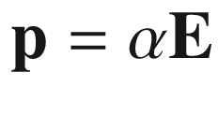

. This dipole interacts with the field with an energy

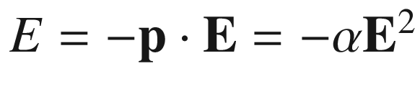

. The carrier separation in opposite sides of the quantum well (Fig. [15.4](#u116076_4_En_15_Chapter-Fig4)b) leads to a reduced overlap of the electron and hole wavefunctions and subsequently to an increased recombination lifetime (see Fig. [12.​43](#u116076_4_En_12_Chapter-Fig43)).

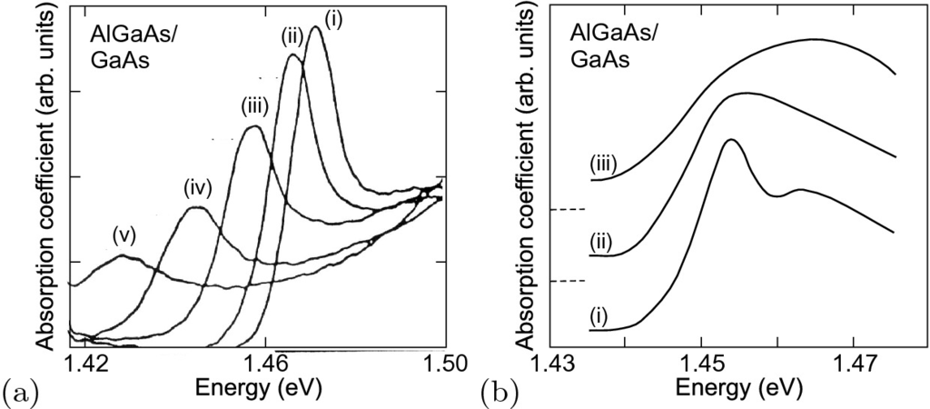

Fig. 15.4

Impact of electric fields on the absorption spectrum of

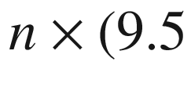

 nm GaAs/9.8 nm Al

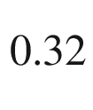

Ga

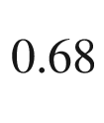

As) multiple quantum well structures. **a** Electric field along the [001] growth direction (

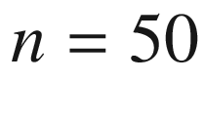

), (**i**)–(**v**)

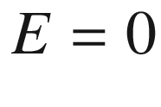

, 0.6, 1.1, 1.5, and

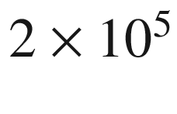

 V/cm. **b** Electric field within the interface plane (n

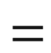

60), (**i**, **ii**, **iii**)

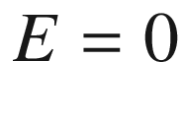

, 1.1, and 2

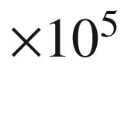

 V/cm.

Adapted from [1422]

If the field is within the quantum-well interface plane, the field leads to the ionization of excitons without shift of the energy position. The loss of the excitonic peak is visualized in the spectra in Fig. [15.4](#u116076_4_En_15_Chapter-Fig4)a–c.

### 15.2 Magnetic Fields

In magnetic fields, electrons (or holes) perform a cyclotron motion with frequency

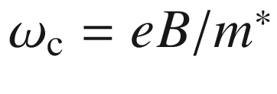

, i.e. a motion perpendicular to the magnetic field on a line of constant energy in



-space. This line is the intersection of a plane perpendicular to the magnetic field and the respective isoenergy surface in



-space. For semiconductors with anisotropic mass, such as Si and Ge, the quantum theory of cyclotron resonance has been given in [1423]. The physics of semiconductors in magnetic fields is covered in detail in [1424].

The ballistic cyclotron motion can only occur between two scattering events. Thus, a significantly long path along the cyclotron trajectory (classically speaking) and the connected magnetotransport properties are only possible when

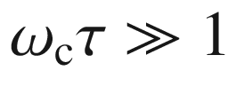

, i.e. when the average scattering time

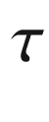

is sufficiently large. This requires high mobility.

the magnetic field is sufficiently strong and the temperature sufficiently low, i.e.

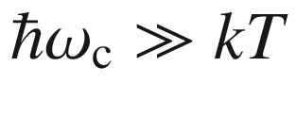

, such that thermal excitations do not scatter electrons between different Landau levels.

the cyclotron path is free of geometric obstructions.

An external magnetic field also produces a Zeeman-like splitting of the spin states. For the electron, the energy splitting

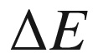

is given by

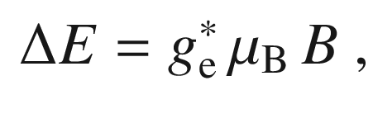

(15.7)

where *B* is the magnetic-field amplitude and

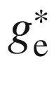

the (effective) electron *g*-factor. This value differs from the free-electron value in vacuum of

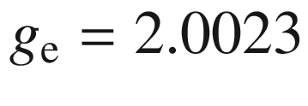

due to the presence of spin-orbit interaction (see Sect. [15.2.3](#u116076_4_En_15_Chapter-Sec7)). Values for



at low carrier density and low temperatures are 2 for Si, 1.2 for InP and ZnSe,

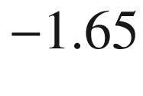

for CdTe,

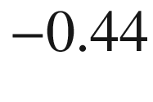

for GaAs,

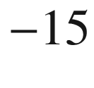

in InAs, and

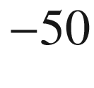

for InSb. In [1425] the temperature dependence of



in GaAs, InP and CdTe is also measured and discussed. The electron *g*-factor increases in thin GaAs/(Al,Ga)As quantum wells [1426].

#### 15.2.1 Classical Hall Effect

An electrical current along the *x* (longitudinal) direction in a perpendicular magnetic field

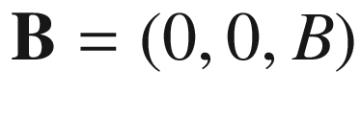

along *z* causes an electric field

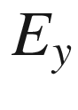

along the transverse (*y*) direction (Fig. [15.5](#u116076_4_En_15_Chapter-Fig5)). The charge accumulation is due to the Lorentz force. The related transverse voltage is called the Hall voltage and the resistivity

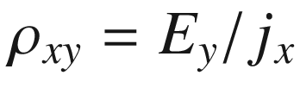

the Hall resistivity [28, 31, 32]. Many aspects of the Hall effect are discussed in [1427]. For thin-film samples typically Hall bars [1428] (see Fig. [15.6](#u116076_4_En_15_Chapter-Fig6) and also Fig. [15.19](#u116076_4_En_15_Chapter-Fig19), for a reasonable measurement of the Hall voltage the ratio of length and width of the Hall bar should be at least 3) or the van-der-Pauw geometry (Fig. [15.7](#u116076_4_En_15_Chapter-Fig7)) and method are used [1429–1431].

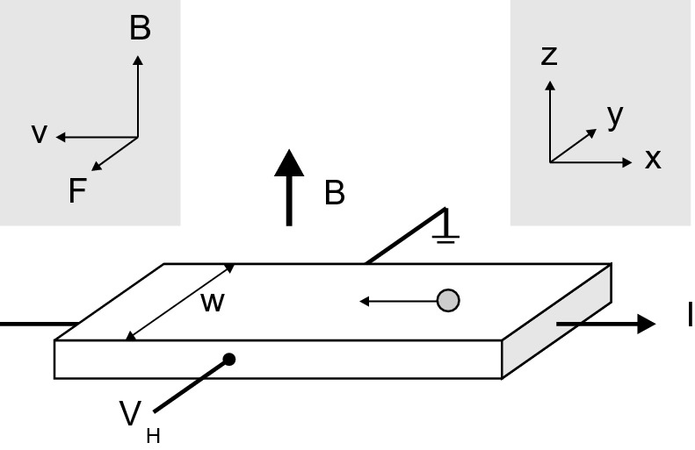

Fig. 15.5

Scheme of the Hall-effect geometry. The movement of one electron in the longitudinal electric current *I* is shown schematically. The coordinate system (*x*, *y*, *z*) and the directions of the magnetic field



, the drift velocity of an electron

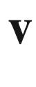

and the resulting Lorentz force



are given. The transverse field



is given by

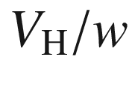

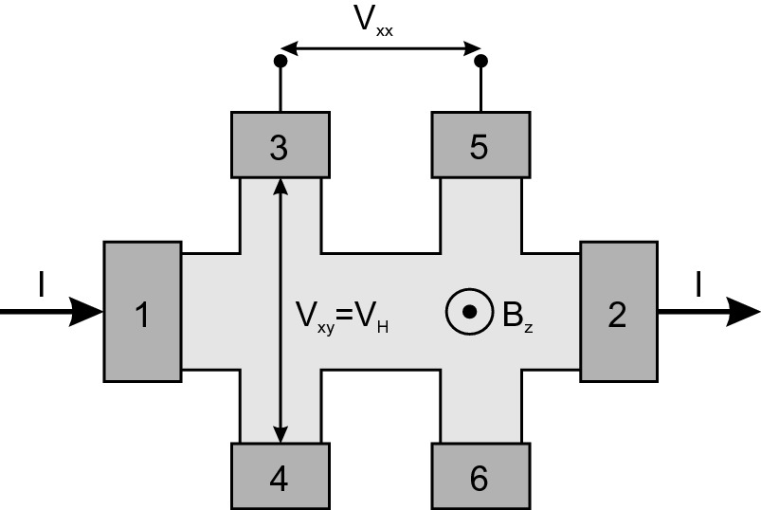

Fig. 15.6

Hallbar geometry. The current *I* is driven by a source from contact 1 to 2. The Hall voltage is measured between contacts 3 and 4, the longitudinal voltage between 3 and 5

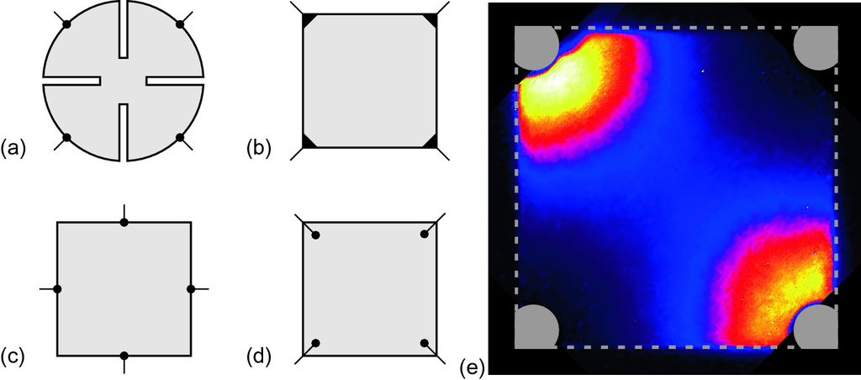

Fig. 15.7

**a**–**d** Geometry for van-der-Pauw Hall measurements. **a** Best geometry (cloverleaf), **b** acceptable square geometry with small contacts on the corners, **c**,**d** not recommended geometries with contacts on the edge centers or inside the square, respectively. **e** Current distribution, as visualized by lock-in thermography [1432], in epitaxial ZnO layer on sapphire with Hall geometry as in part **b**. *Grey dashed line* indicates the outline of the

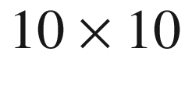

 mm

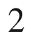

substrate, *grey areas* indicate gold ohmic contacts

For band transport in the relaxation time approximation (Chap. [8.​2](The_Physics_of_Semiconductors00004.docx#u116076_4_En_8_Chapter)), the steady-state equation of motion is (in the vicinity of an isotropic extremum)

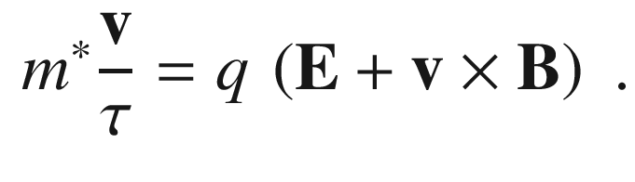

(15.8)

We note that this equation of motion is also valid for holes, given the convention of Sect. [6.​10.​1](The_Physics_of_Semiconductors00003.docx#u116076_4_En_6_Chapter), i.e. positive effective mass and charge. With the cyclotron frequency

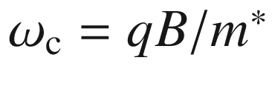

the conductivity tensor is (

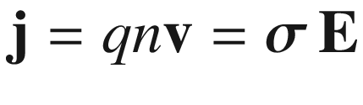

)

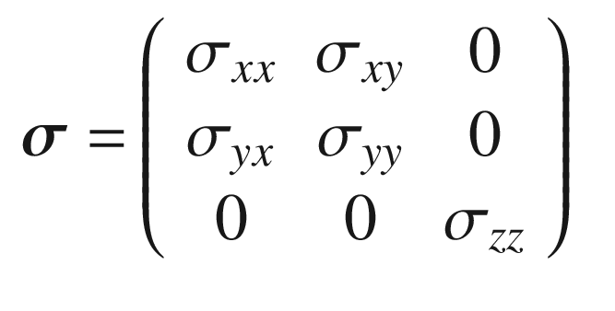

(15.9a)

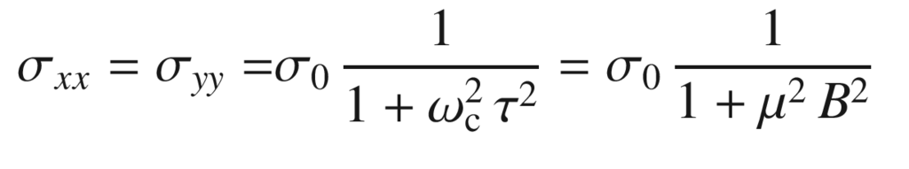

(15.9b)

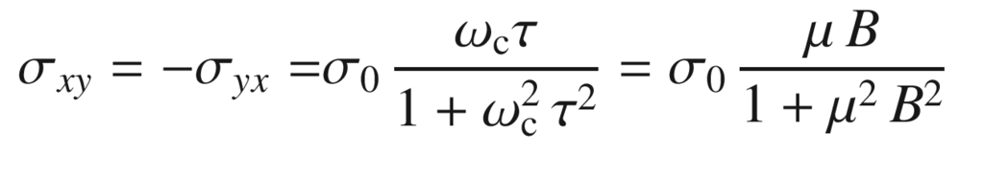

(15.9c)

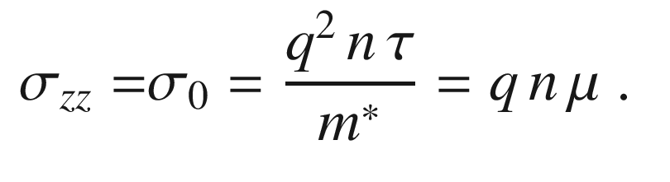

(15.9d)

Perpendicular to the magnetic field, the conductivity (

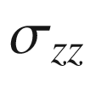

) is given by ([8.​5](The_Physics_of_Semiconductors00004.docx#u116076_4_En_8_Chapter)). If only one type of carrier (charge *q*, density *n*) is considered, the condition

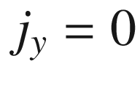

leads to

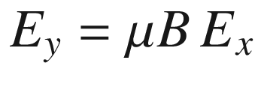

and

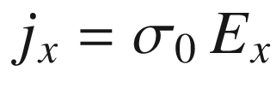

. The Hall coefficient is defined as

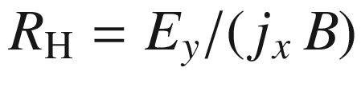

or more precisely as

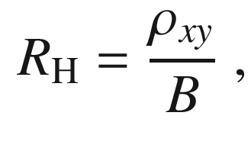

(15.10)

where the resistivity tensor

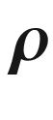

is the inverse of the conductivity tensor

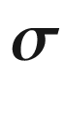

,

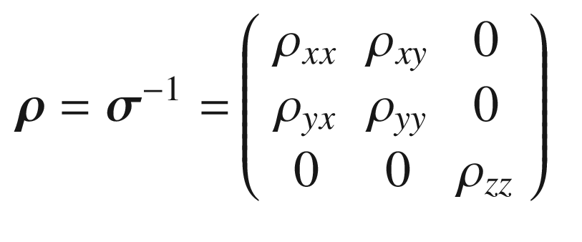

(15.11a)

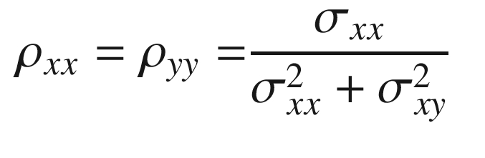

(15.11b)

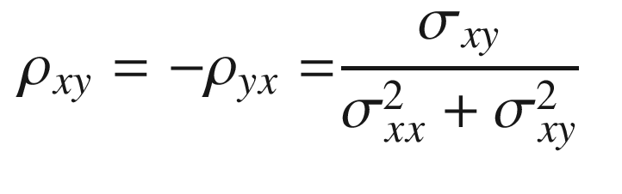

(15.11c)

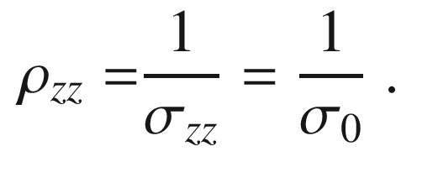

(15.11d)

For a single type of carriers, the Hall coefficient is therefore given by

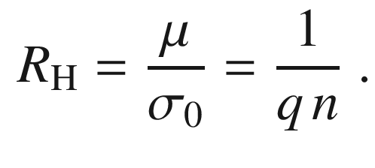

(15.12)

It is negative (positive) for electron (hole) conduction. We note that electrons and holes are deflected in the *same* *y*-direction by the magnetic field and collect at the same electrode. Thus the Hall effect allows the determination of the carrier type and the carrier density.[1](#u116076_4_En_15_Chapter-Fn1)

If both types of carriers are present simultaneously, the conductivity (two-band conduction) is given by the sum of electron and hole conductivity ([8.​11](The_Physics_of_Semiconductors00004.docx#u116076_4_En_8_Chapter)),

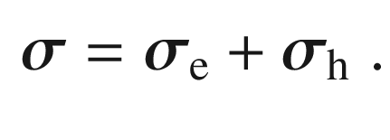

(15.13)

The Hall constant ([15.10](#u116076_4_En_15_Chapter-Equ13)) is then

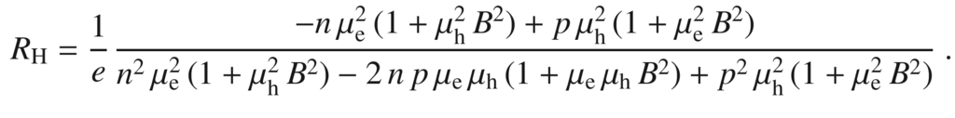

(15.14)

Under the assumption of small magnetic fields,[2](#u116076_4_En_15_Chapter-Fn2) i.e.

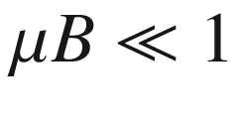

, the Hall coefficient is

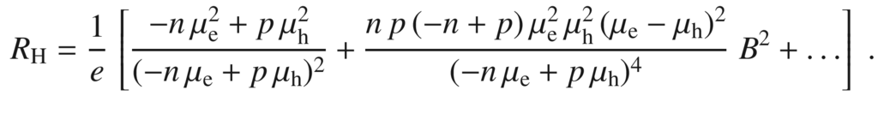

(15.15)

For small magnetic field this can be written as

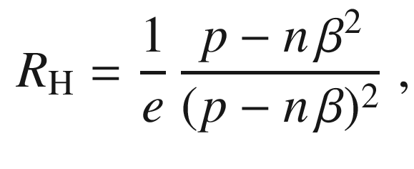

(15.16)

with

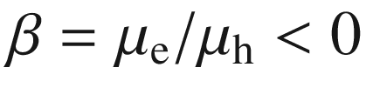

. For large magnetic fields, i.e.

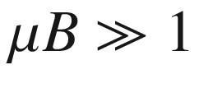

, the Hall coefficient is given by

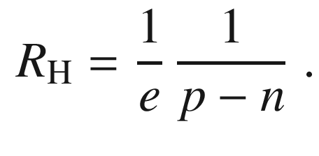

(15.17)

In Fig. [15.8](#u116076_4_En_15_Chapter-Fig8), the absolute value of the Hall coefficient for InSb samples with different doping concentrations is shown. The p-doped samples exhibit a reverse of the sign of the Hall coefficient upon increase of temperature when intrinsic electrons contribute to the conductivity. The zero in

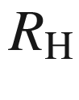

occurs for

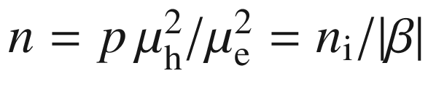

. For high temperatures, the Hall coefficient for n- *and* p-doped samples is dominated by the electrons that have much higher mobility (Table [8.​2](The_Physics_of_Semiconductors00004.docx#u116076_4_En_8_Chapter-Tab2)).

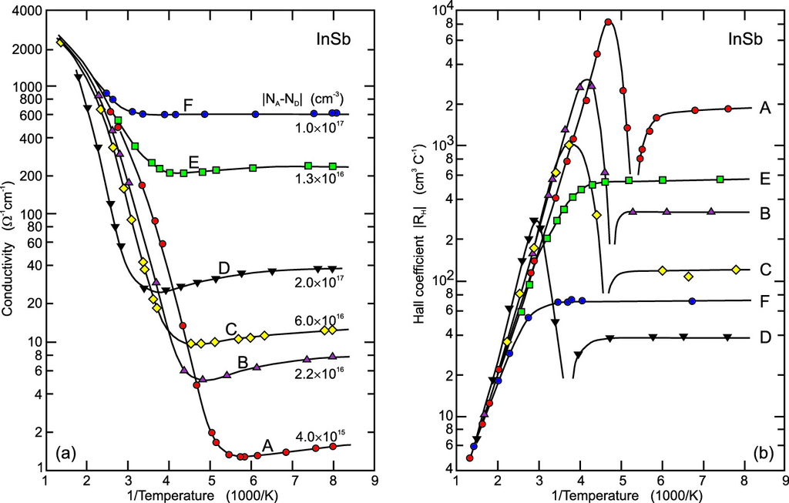

Fig. 15.8

**a** Conductivity and **b** absolute value of the Hall coefficient versus inverse temperature for four p-doped (A–D) and two n-doped (E, F) InSb samples. The doping levels are given in (**a**).

Adapted from [1433]

The simultaneous conduction in a band and an impurity band (cmp. Sect. [8.​6](The_Physics_of_Semiconductors00004.docx#u116076_4_En_8_Chapter)) has been separated with a suitable model assuming two conduction channels for holes [1434] (Fig. [15.9](#u116076_4_En_15_Chapter-Fig9)).

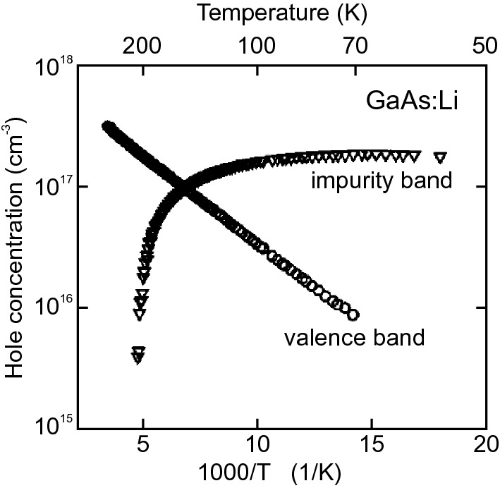

Fig. 15.9

Carrier densities in valence band (*circles*) and impurity band (*triangles*) from evaluating the Hall effect on GaAs doped with lithium (and annealed) taking into account two conduction channels.

Adapted from [1434]

In ([15.8](#u116076_4_En_15_Chapter-Equ8)) an isotropic mass was considered. For semiconductors with multiple valleys and anisotropic extrema, in particular the conduction bands of Si and Ge (cf. Sect. [6.​9.​2](The_Physics_of_Semiconductors00003.docx#u116076_4_En_6_Chapter)), the Hall coefficient has been derived in [1435, 1436]. With

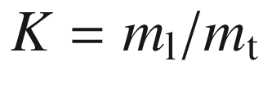

being the mass anisotropy (cmp. Table [6.​5](The_Physics_of_Semiconductors00003.docx#u116076_4_En_6_Chapter-Tab5)), the Hall coefficient ([15.12](#u116076_4_En_15_Chapter-Equ18)) changes to,

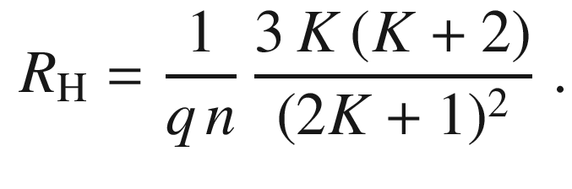

(15.18)

In the derivation of the (unipolar) Hall coefficient we had assumed that all carriers involved in the transport have the same properties, in particular that they are subject to the same scattering time. This assumption is generally not the case (cmp. Chap. J) and we need to operate with the ensemble average of the discussed quantities. The ensemble average of an energy-dependent quantity

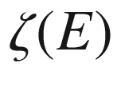

over the (electron) distribution function *f*(*E*) is denoted as

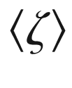

and is given as[3](#u116076_4_En_15_Chapter-Fn3)

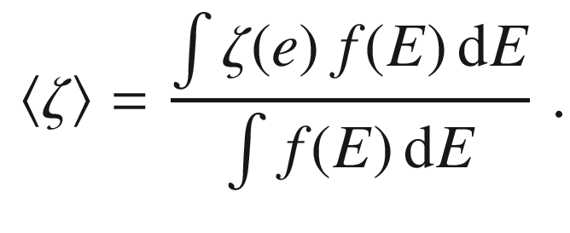

(15.19)

In particular, the average

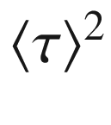

is now different from

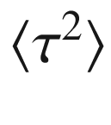

. Considering the equation

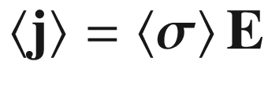

for the ensemble-averaged current density we find (for one type of carrier, cf. ([15.12](#u116076_4_En_15_Chapter-Equ18)))

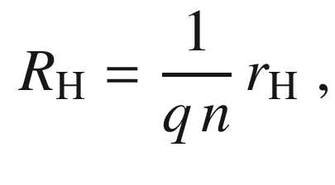

(15.20)

with the so-called *Hall factor*

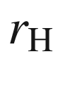

given by

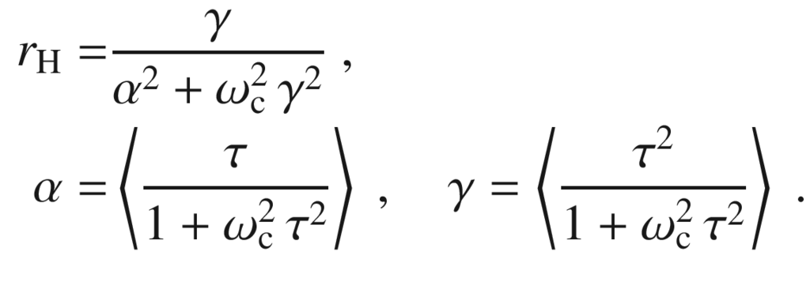

(15.21)

The Hall factor depends on the scattering mechanisms and is of the order of 1. For large magnetic fields the Hall factor approaches 1. For small magnetic fields we have

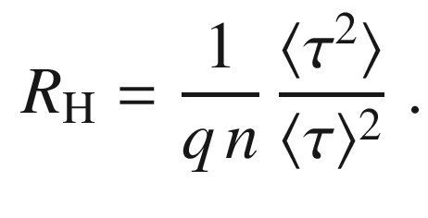

(15.22)

The mobility calculated from (cf. ([15.9d](#u116076_4_En_15_Chapter-Equ12)))

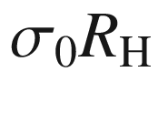

is called the *Hall mobility*

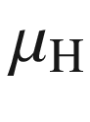

and is related to the mobility via

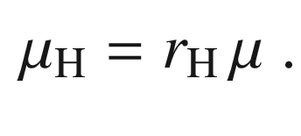

(15.23)

It is assumed so far that the free carrier density and mobility are homogeneous within the volume of current transport. Multi-layer models can be fitted to experimental Hall data in order to account for different conduction channels in different layered parts of the sample [1437]. E.g., in a two-layer model, contributions from bulk and surface/interface conduction can be separated [1438–1440].

The magnetic field dependence of

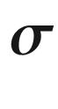

can be used in a general case to separate contributions of carriers with different density and mobility (including its sign) without assumptions and obtain the mobility spectrum

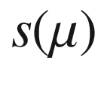

(MSA, mobility spectral analysis),

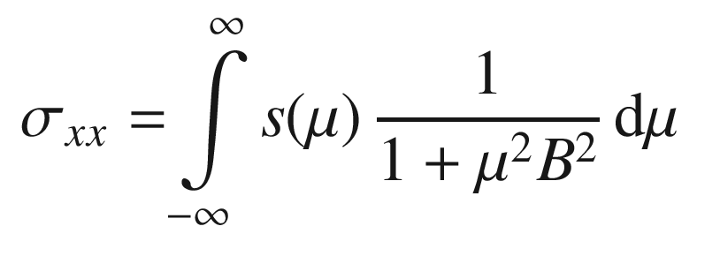

(15.24a)

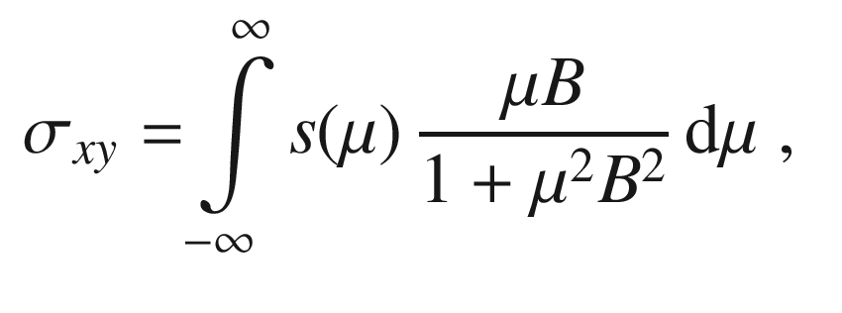

(15.24b)

as a generalization of ([15.13](#u116076_4_En_15_Chapter-Equ19)), ([15.9b](#u116076_4_En_15_Chapter-Equ10)) and ([15.9c](#u116076_4_En_15_Chapter-Equ11)) [1441–1443]. Examples are the separation of electron conductivity in (GaAs-)

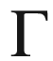

- and (InAs-) X-Minima in a GaAs/(Al,Ga)As/InAs double quantum well structures [1441] (Fig. [15.10](#u116076_4_En_15_Chapter-Fig10)a), substrate and 2DEG electron conductivity in (Al,Ga)N/GaN heterostructures [1444], and electrons and holes in an InAs/GaSb quantum well [1442] (Fig. [15.10](#u116076_4_En_15_Chapter-Fig10)b).

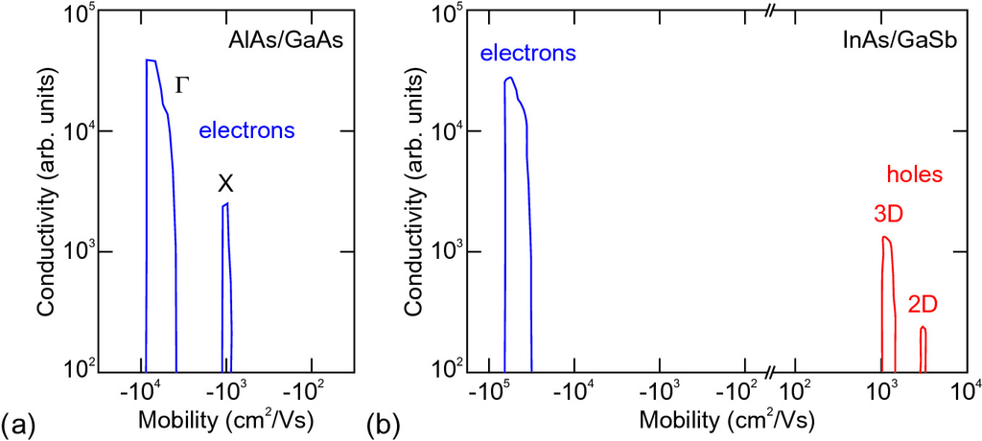

Fig. 15.10

**a** Mobility spectrum of GaAs/(Al,Ga)As/InAs double quantum well structure. Adapted from [1441]. **b** Mobility spectrum of InAs/GaSb quantum well structure.

Adapted from [1442]

In the case of hopping conduction (Chap. [8.​8](The_Physics_of_Semiconductors00004.docx#u116076_4_En_8_Chapter)), the theory of Hall effect is more involved [1445, 1446]. If carriers are transported by hopping, generally, they may not be free to move as expected by ([15.8](#u116076_4_En_15_Chapter-Equ8)) in response to the applied magnetic field and the Lorentz force. A Hall effect occurs only at the junction of *three* (or more) hopping sites [1445]. The sign of the experimentally determined Hall coefficient is often opposite to the one expected from the carrier type according to ([15.12](#u116076_4_En_15_Chapter-Equ18)), e.g., as studied in a-Si [1447, 1448]. The *sign anomaly* depends on intricacies such as the local site geometry and interference processes taking place among bonding and antibonding orbitals of various numbers as summarized in [1449].

#### 15.2.2 Free-Carrier Absorption

The absorption of free carriers was treated in Sect. [9.​9.​1](The_Physics_of_Semiconductors00004.docx#u116076_4_En_9_Chapter) without the presence of a static magnetic field. Solving ([15.8](#u116076_4_En_15_Chapter-Equ8)) for a static magnetic field

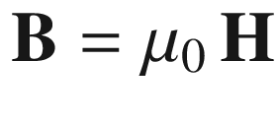

with

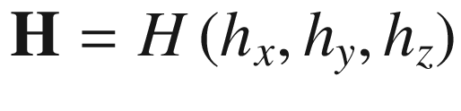

and a harmonic electric field

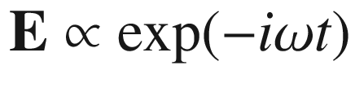

yields for the dielectric tensor (cf. ([9.​72](The_Physics_of_Semiconductors00004.docx#u116076_4_En_9_Chapter)))

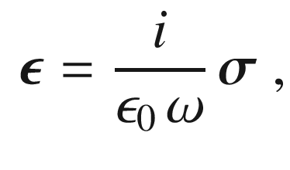

(15.25)

and by comparing to

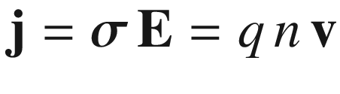

,

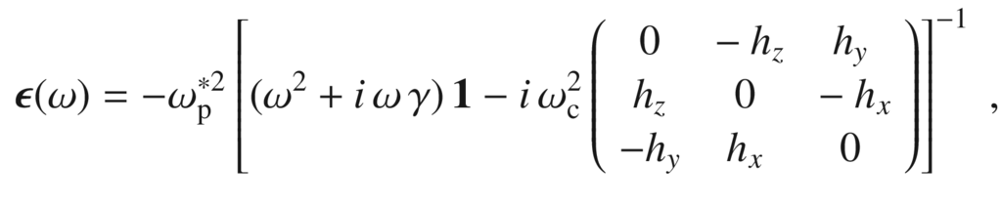

(15.26)

where



denotes the (3 by 3) unity matrix and

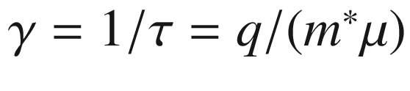

is the damping parameter with

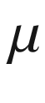

representing the optical carrier mobility (in the non-isotropic case a tensor

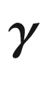

needs to be used). The (unscreened) plasma frequency is given by (cmp. ([9.​77](The_Physics_of_Semiconductors00004.docx#u116076_4_En_9_Chapter)))

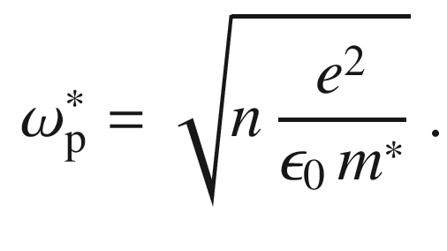

(15.27)

The free-carrier cyclotron frequency is

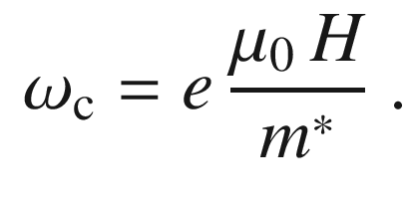

(15.28)

If the effective mass is treated as a tensor,

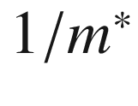

is replaced by

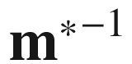

in ([15.27](#u116076_4_En_15_Chapter-Equ34)) and ([15.28](#u116076_4_En_15_Chapter-Equ35)). For zero magnetic field the classical Drude theory for one carrier species is recovered (cf. ([9.​74a](The_Physics_of_Semiconductors00004.docx#u116076_4_En_9_Chapter)))

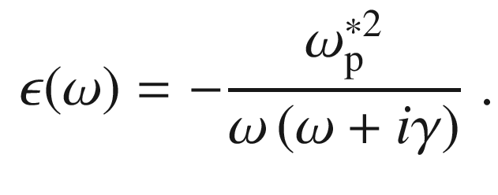

(15.29)

With the magnetic field perpendicular to the sample surface, i.e.

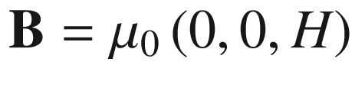

the magneto-optic dielectric tensor simplifies to (cf. ([15.9d](#u116076_4_En_15_Chapter-Equ12)))

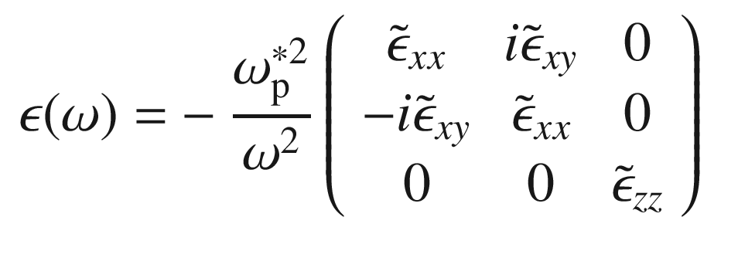

(15.30a)

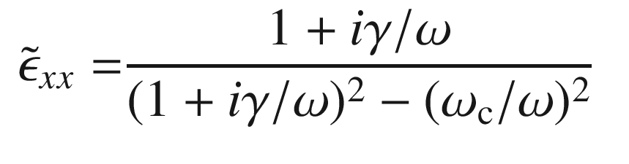

(15.30b)

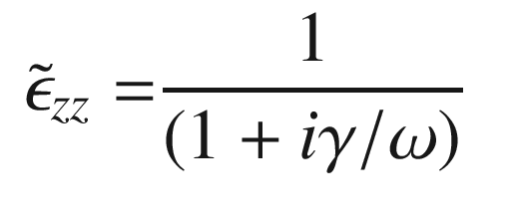

(15.30c)

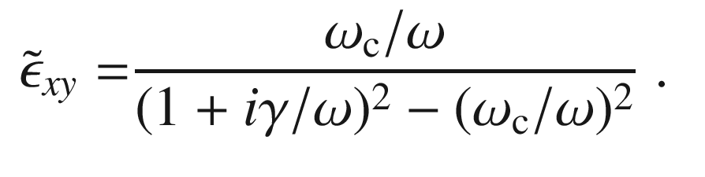

(15.30d)

The in-plane component

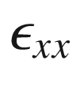

provides information about

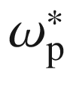

and

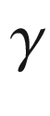

, i.e. two of the three parameters *n*,

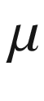

and

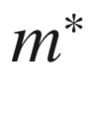

are known. Additionally, the antisymmetric tensor component

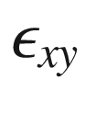

is linear in the cyclotron frequency and provides

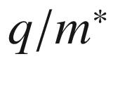

. This subtle but finite birefringence depends on the strength (and orientation) of the magnetic field and can be experimentally determined in the infrared using magneto-ellipsometry [1450, 1451]. Such ‘optical Hall effect’ experiment allows the determination of the carrier density *n*, the mobility

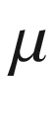

, the carrier mass[4](#u116076_4_En_15_Chapter-Fn4)

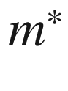

and the sign of the carrier charge

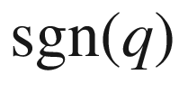

with optical means. The electrical Hall effect (Sect. [15.2.1](#u116076_4_En_15_Chapter-Sec5)) can reveal *n*,



and



but cannot reveal the carrier mass.

#### 15.2.3 Energy Levels in Bulk Crystals

In a 3D electron gas (the magnetic field is along *z*, i.e.

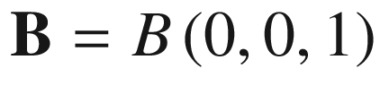

) the motion in the (*x*, *y*) plane is described by Landau levels. Quantum mechanically they correspond to levels of a harmonic oscillator. The magnetic field has no impact on the motion of electrons along *z*, such that in this direction a free dispersion relation

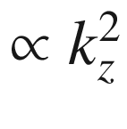

is present. The energy levels are given as

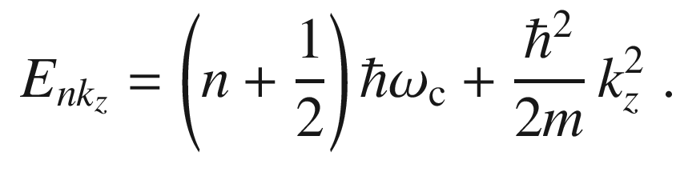

(15.31)

Thus, the states are on concentric cylinders in



-space (Fig. [15.11](#u116076_4_En_15_Chapter-Fig11)a). The populated states of the 3D electron gas (at 0 K) lie within the Fermi vector of length

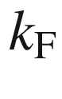

. For the 3D system the density of states at the Fermi energy is a square root function of the Fermi energy ([6.​71](The_Physics_of_Semiconductors00003.docx#u116076_4_En_6_Chapter)). In the presence of a magnetic field the density of states diverges every time that a new cylinder (with a one-dimensional density of states, ([6.​79](The_Physics_of_Semiconductors00003.docx#u116076_4_En_6_Chapter))) touches the Fermi surface at

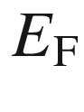

. In real systems, the divergence will be smoothed, however, a pronounced peak or the periodic nature of the density of states is often preserved.

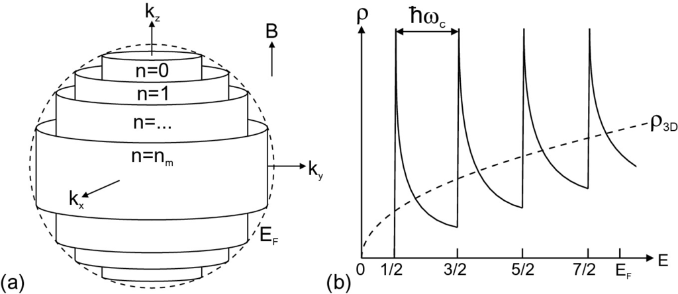

Fig. 15.11

3D electron gas in an external magnetic field. **a** Allowed states in



-space for magnetic field along the *z* direction. **b** Density of states (DOS)

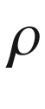

versus energy (in units of

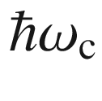

). *Dashed line* is three-dimensional DOS without magnetic field.

Based on [1123]

The period is given by the number

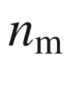

of cyclotron orbits (Landau levels) within the Fermi surface.

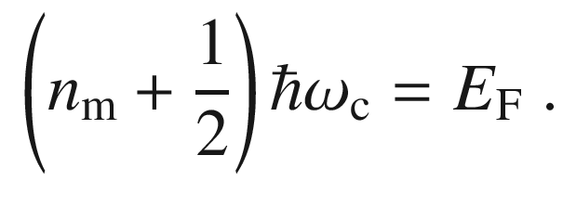

(15.32)

If the number of carriers is constant, the density of states at the Fermi energy at varying magnetic field varies periodically with 1/*B*. From the conditions

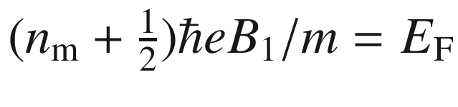

and

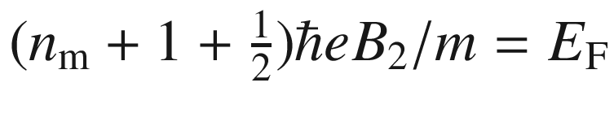

with

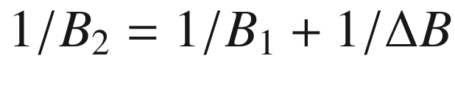

we find,

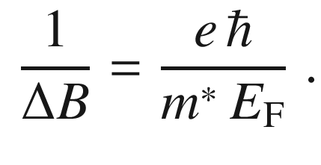

(15.33)

This periodicity is used to determine experimentally, e.g., the properties of the Fermi surface in metals using the Shubnikov-de Haas oscillations (of the magnetoresistance) or the de Haas-van Alphén effect (oscillation of the magnetic susceptibility).

Equation ([15.31](#u116076_4_En_15_Chapter-Equ41)) needs to be extended to account for the splitting ([15.7](#u116076_4_En_15_Chapter-Equ7)) of the Landau level due to the electron spin. According to [1452], the electron Landau level energy can be written as

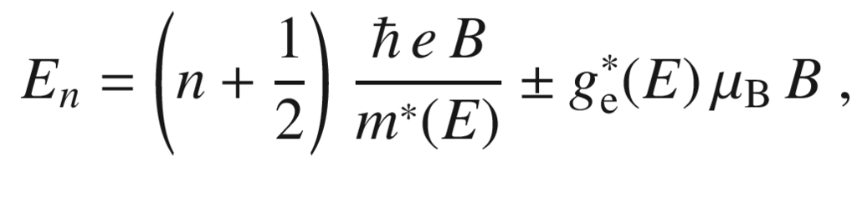

(15.34)

with energy dependent effective mass and *g*-factor

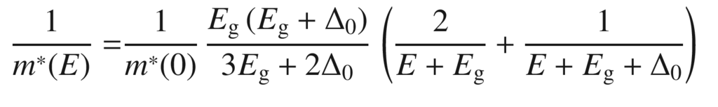

(15.35a)

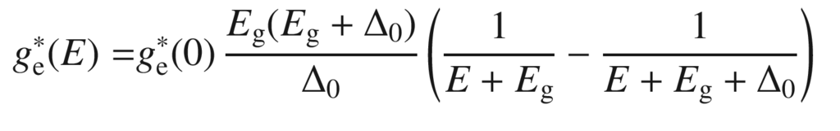

(15.35b)

The band edge value

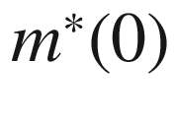

of the effective mass is given by ([6.​43](The_Physics_of_Semiconductors00003.docx#u116076_4_En_6_Chapter)) and that of the *g*-factor by

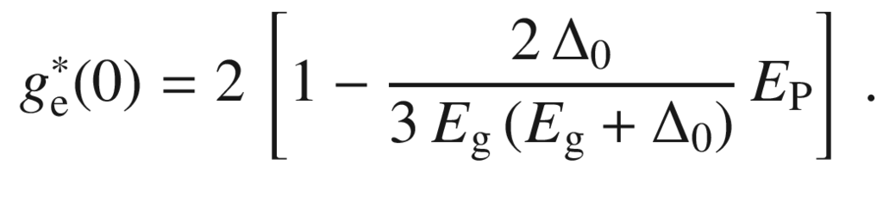

(15.36)

For large spin-orbit splitting, the value of the *g*-factor deviates strongly from 2 and becomes negative.

#### 15.2.4 Magnetic Field Effect on Impurities

The Zeeman effect is the magnetic field dependence (and the lifting of degeneracies) of spectral lines. For semiconductor physics this is a tool to investigate properties of defect related states with sufficiently sharp spectral features. As example we refer to the investigation of the Si:P donor system (cmp. Fig. [9.​33](The_Physics_of_Semiconductors00005.docx#u116076_4_En_9_Chapter-Fig33)) and its linear and quadratic Zeeman effect [1453] as visualized in Fig. [15.12](#u116076_4_En_15_Chapter-Fig12). The difference in transition energies for lines 4 and 1 depends linearly on the magnetic field and is equal to the electron spin splitting. The quadratic Zeeman effect is also termed ‘diamagnetic shift’ and allows a determination of the wavefunction size. In the present case, the electron Bohr radius at the neutral phosphorus donor in Si was found to be

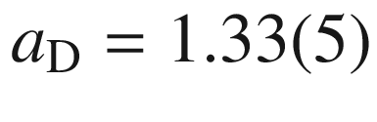

 nm (cmp. ([7.​22](The_Physics_of_Semiconductors00003.docx#u116076_4_En_7_Chapter))) [1453].

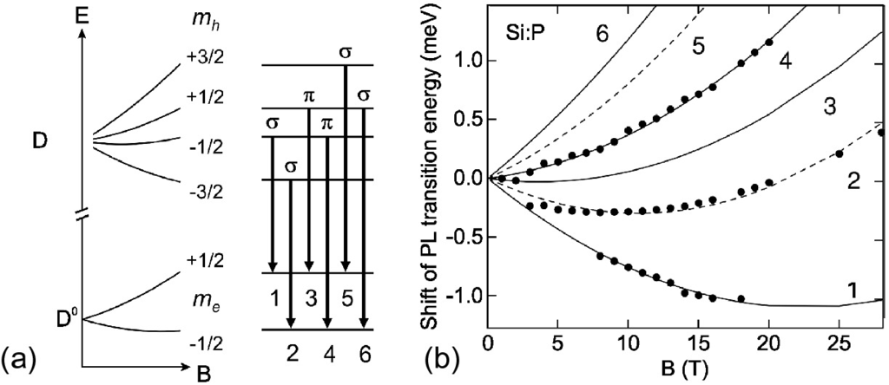

Fig. 15.12

**a** Schematic level scheme and transitions (and their polarization) of donor bound excitons at Si:P. **b** Experimental magnetic field dependent shift of photoluminescence transition energies (from about

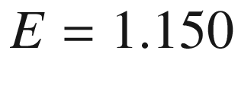

 eV at

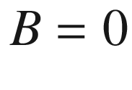

 T) (*symbols*) together with fits for heavy (*dashed lines*) and light (*solid lines*) hole transitions.

Adapted from [1453]

#### 15.2.5 Magnetic Field Effect on Excitons

The effect of an magnetic field on excitons is similar to that on the wave function at an impurity, except that the electron and hole are effected simultaneously. The effect is two-fold: The Zeeman-like effect on the spin states leads to a splitting of the exciton lines which become circularly polarized; for ‘weak’ fields the splitting is linear with the field. Additionally, the magnetic field leads to a reduction of exciton size leading to a quadratic shift of the line center to larger energies, the so-called diamagnetic shift. Calculations for various confinement geometries have been given in [1454]. The change of exciton size leads also to modification of localization effects in disordered quantum wells [1455]. As example the magnetic field dependence of quasi two-dimensional excitons in a WS



monolayer is shown in Fig. [15.13](#u116076_4_En_15_Chapter-Fig13) (cf. Sect. [13.​2.​4](#u116076_4_En_13_Chapter)).

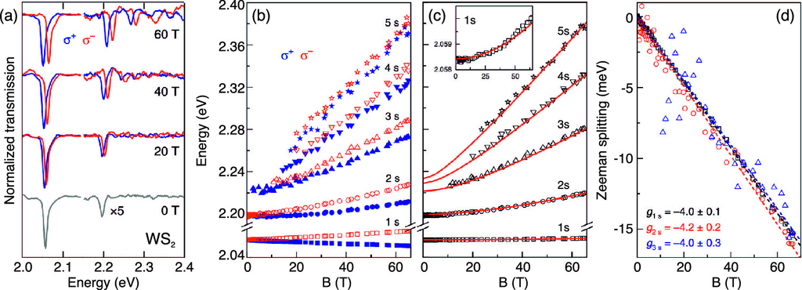

Fig. 15.13

Magnetic field effect on excitons in WS



monolayer. **a** Normalized transmission spectra. **b** Energy position of

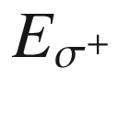

and

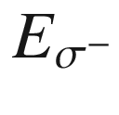

of (circularly polarized) spectral lines of the 1–5 s exciton lines. **c** Calculated energy

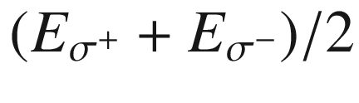

, showing the diamagnetic shift. *Solid lines* are model calculation with reduced exciton mass

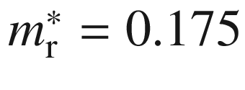

(and further parameters), **d** Zeeman splitting

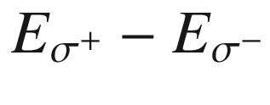

of the 1–3 s states together with linear fits (*dashed line*), *g*-factors are around 4, as labelled.

Adapted from [1313], reprinted under Creative Commons Attribute (CC BY 4.0) license

#### 15.2.6 Energy Levels in a 2DEG

In a 2D electron gas (2DEG), e.g., in a quantum well or a potential well at a modulation-doped heterointerface, a free motion in *z* is not possible and

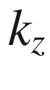

is quantized. The energy levels (for each 2D subband) are only given by the cyclotron energy (Fig. [15.14](#u116076_4_En_15_Chapter-Fig14)a). The density of states is a sequence of

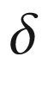

-like peaks (Fig. [15.14](#u116076_4_En_15_Chapter-Fig14)b). Each peak contributes (degeneracy

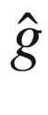

of a Landau level) a total number of

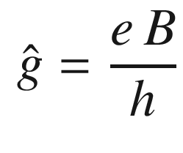

(15.37)

states (per unit area without spin degeneracy and without the degeneracy of the band extremum). In reality, disorder effects lead to an inhomogeneous broadening of these peaks. The states in the tails of the peaks correspond to states that are localized in real space.

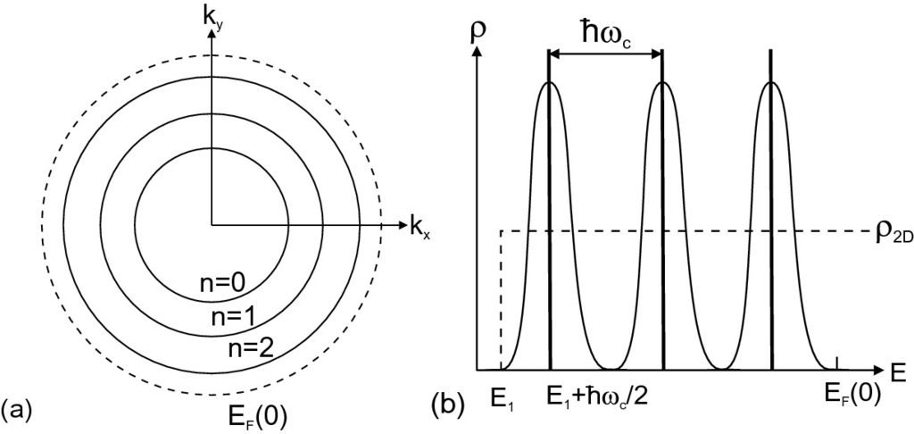

Fig. 15.14

2D electron gas in an external magnetic field. **a** Allowed states in



-space. **b** Density of states (DOS)

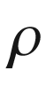

versus energy. *Dashed line* is two-dimensional DOS without magnetic field. *Thick vertical lines*:

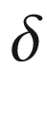

-like DOS without broadening, *curves*: broadened DOS.

Based on [1123]

Also, in a 2D system several physical properties exhibit an oscillatory behavior as a function of Fermi level, i.e. with varying electron number, and as a function of the magnetic field at fixed Fermi energy, i.e. at fixed electron number (Fig. [15.15](#u116076_4_En_15_Chapter-Fig15)).

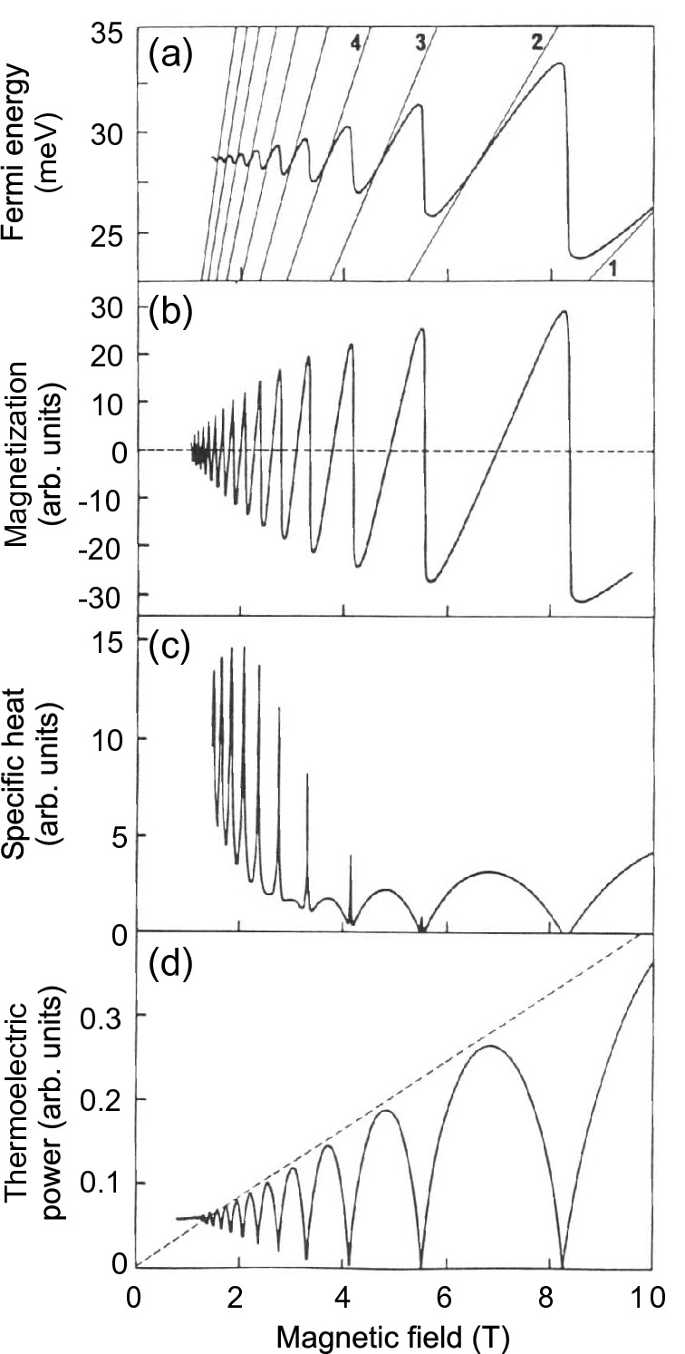

Fig. 15.15

Oscillatory (theory,

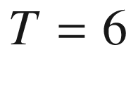

 K) behavior of a 2DEG (GaAs/(Al,Ga)As) in a magnetic field: **a** Fermi level, **b** magnetization, **c** specific heat, **d** thermoelectric power. A Gaussian broadening of 0.5 meV was assumed.

Adapted from [1123, 1456]

#### 15.2.7 Shubnikov-De Haas Oscillations

From the 2D density of states (per unit area including spin degeneracy)

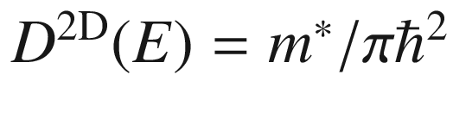

the sheet density of electrons

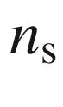

can be expressed as a function of the Fermi level (at

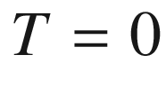

 K without spin degeneracy)

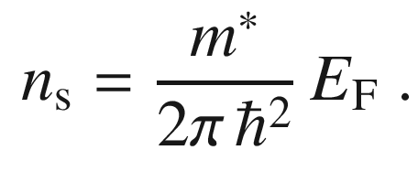

(15.38)

Using ([15.33](#u116076_4_En_15_Chapter-Equ43)) we thus find (without spin degeneracy, without valley degeneracy), that the period of 1/*B* is

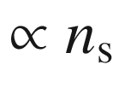

:

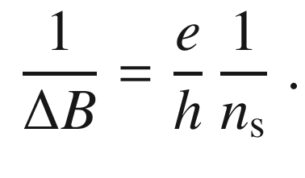

(15.39)

The carrier density of a 2DEG can therefore be determined from the oscillations of magnetoresistance, and is proportional to the density of states at the Fermi level (Shubnikov-de Haas effect). A corresponding measurement with varying field and fixed electron density is shown in Fig. [15.16](#u116076_4_En_15_Chapter-Fig16). The periodicity with 1/*B* is obvious. Since only the component of the magnetic field perpendicular to the layer affects the (*x*, *y*) motion of the carriers, no effect is observed for the magnetic field parallel to the layer.

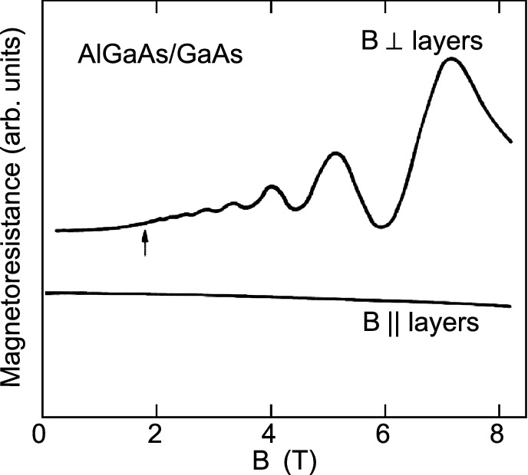

Fig. 15.16

Shubnikov-de Haas oscillations at a modulation-doped (Al,Ga)As/GaAs heterostructure with a 2DEG,

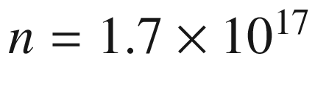

 cm

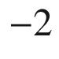

and

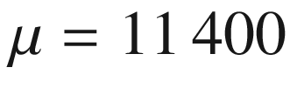

 cm

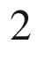

/Vs.

Data from [1457]

In another experiment the carrier density was varied at constant field (Fig. [15.17](#u116076_4_En_15_Chapter-Fig17)). The electron density in an inversion layer in p-type silicon is (linearly) varied with the gate voltage of a MOS (metal-oxide-semiconductor) structure (inset in Fig. [15.17](#u116076_4_En_15_Chapter-Fig17), for MOS diodes cf. Sect. [24.​5](The_Physics_of_Semiconductors00009.docx#u116076_4_En_24_Chapter)). In this experiment, the Fermi level was shifted through the Landau levels. The equidistant peaks show that indeed each Landau level contributes the same number of states.

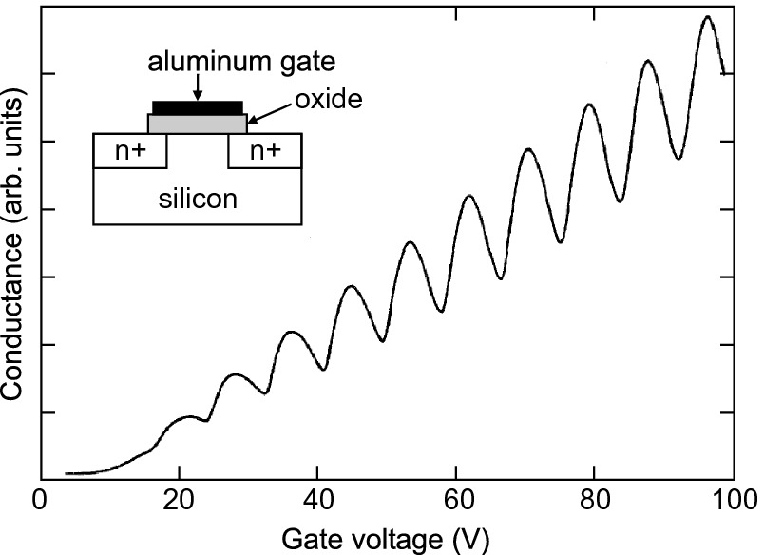

Fig. 15.17

Shubnikov-de Haas oscillations of a 2DEG at the (100) surface of p-type silicon (100

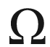

 cm) at a magnetic field of

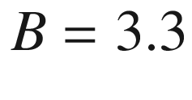

 T and

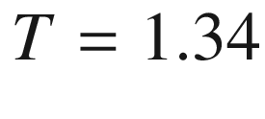

 K. The *inset* shows schematically the contact geometry.

Data from [1458]

#### 15.2.8 Quantum Hall Effect

In high magnetic fields, at low temperatures and for high-mobility, 2D electron gases exhibit a deviation from the classical behavior. We recall that the classical Hall effect (i.e. considering the Lorentz force, classical Drude theory), the generation of a field

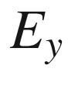

perpendicular to a current flow

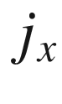

(cf. Sect. [15.2.1](#u116076_4_En_15_Chapter-Sec5)), was described with the conductivity tensor

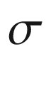

(here, for the (*x*, *y*)-plane only)

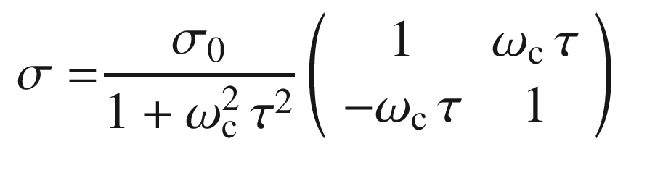

(15.40a)

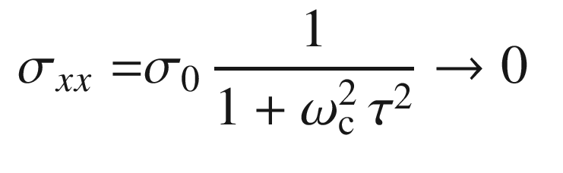

(15.40b)

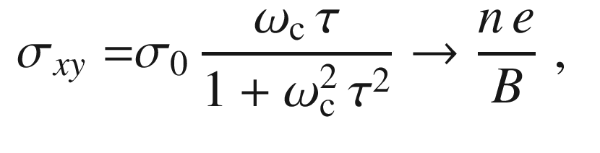

(15.40c)

where

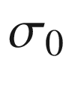

is the zero-field conductivity

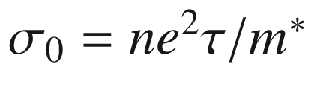

([8.​5](The_Physics_of_Semiconductors00004.docx#u116076_4_En_8_Chapter)). The arrows denote the limit for

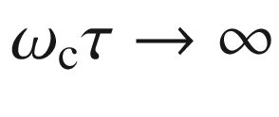

, i.e. large fields. The resistivity tensor

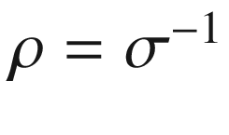

is given by

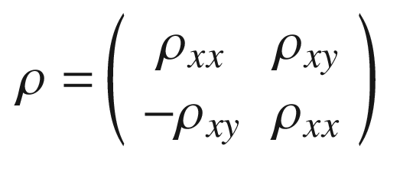

(15.41a)

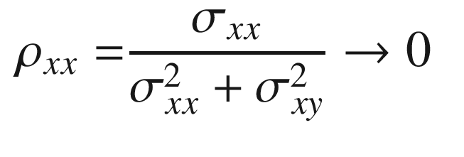

(15.41b)

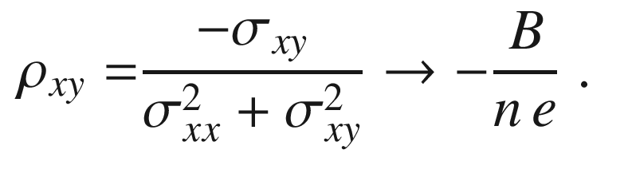

(15.41c)

##### 15.2.8.1 Integer QHE

Experiments yield strong deviations from the linear behavior of the transverse resistivity

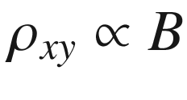

([15.41c](#u116076_4_En_15_Chapter-Equ56)) for large magnetic fields at low temperatures for samples with high carrier mobility, i.e.

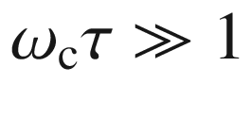

(Fig. [15.18](#u116076_4_En_15_Chapter-Fig18)). In Fig. [15.19](#u116076_4_En_15_Chapter-Fig19)a, b, Hall bars are shown for 2DEGs in silicon metal-oxide-semiconductor field-effect transistor (Si-MOSFET) electron inversion layers and at GaAs/(Al,Ga)As heterostructures, respectively.

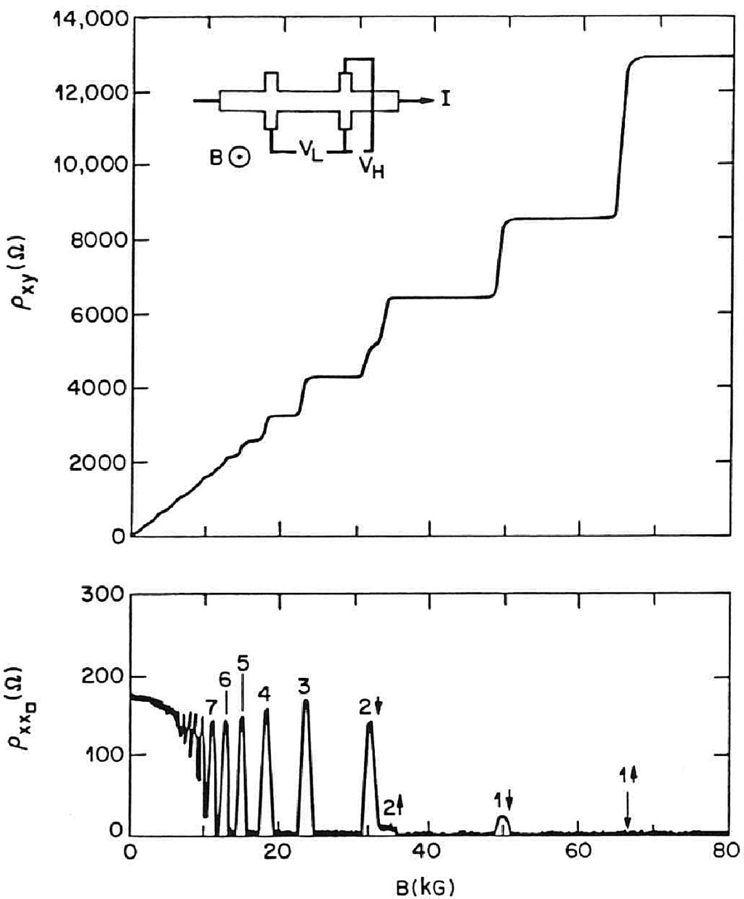

Fig. 15.18

Hall resistivity

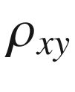

and longitudinal resistivity

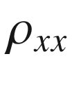

for a modulation-doped GaAs/(Al,Ga)As heterostructure (

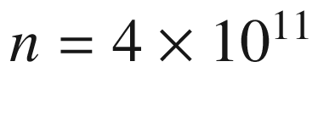

 cm

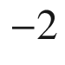

,

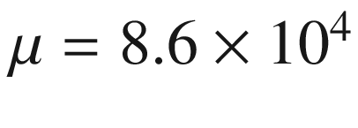

 cm

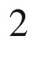

/Vs) at 50 mK as a function of magnetic field (10 kG=1 T). The numbers refer to the quantum number and spin polarization of the Landau level involved. The inset shows schematically the Hall bar geometry,

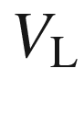

(

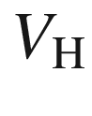

) denotes the longitudinal (Hall) voltage drop.

Reprinted with permission from [1459], ©1982 APS

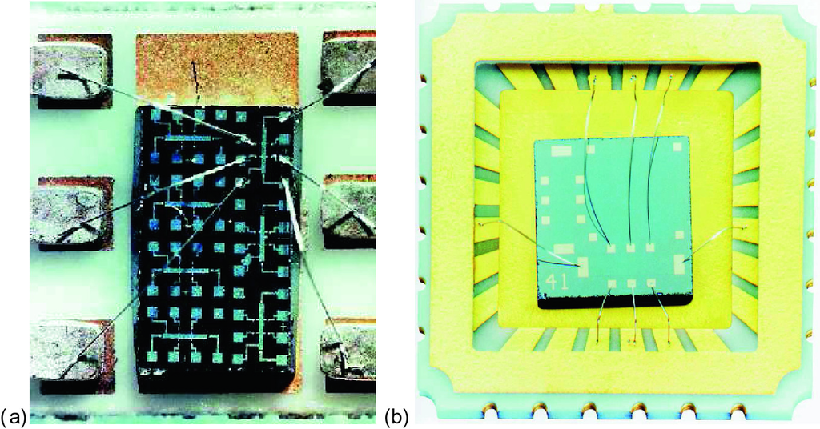

Fig. 15.19

**a** Silicon MOS (metal-oxide-semiconductor) structure of K. v. Klitzing’s et al. original experiments. **b** GaAs/(Al,Ga)As heterostructure sample grown with molecular beam epitaxy for QHE measurements, chip carrier and bond wires.

Reprinted with permission from [1460]

The Hall resistivity exhibits extended Hall plateaus with resistivity values that are given by

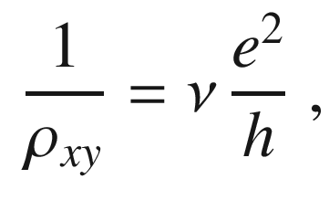

(15.42)

with

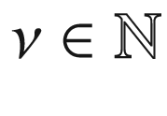

, i.e. integer fractions of the quantized resistance

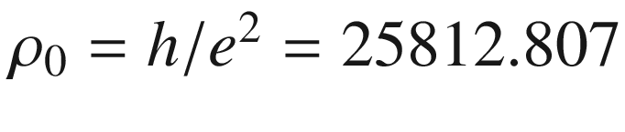

...

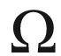

, which is also called the von-Klitzing constant. In Fig. [15.18](#u116076_4_En_15_Chapter-Fig18), a spin splitting is seen for the

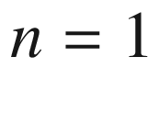

Landau level (and a small one for the

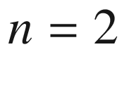

). We note that the topmost Hall plateau is due to the completely filled

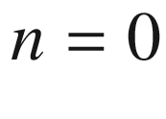

Landau level; the resistance is

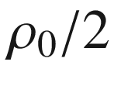

due to the spin degeneracy of 2.

The integer quantum Hall effect, first reported in [1461, 1462], and the value for

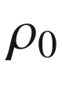

are found for a wide variety of samples and conditions regarding sample temperature, electron density or mobility of the 2DEG and the materials of the heterostructure. Besides the Hall effect in Si-based structures and record mobility (Al,Ga)As/GaAs heterostructures (cf. Fig. [12.​37](The_Physics_of_Semiconductors00005.docx#u116076_4_En_12_Chapter-Fig37)), also (Mg,Zn)O/ZnO heterostructures exhibit the effect [1463, 1464] in the same fashion.

Within the plateau, the resistivity is well defined within 10

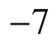

or better up to the

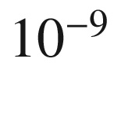

regime. A precise determination allows for a new normal for the unit Ohm [1389, 1465], being two orders of magnitude more precise than the realization in the SI system, and an independent value for the fine-structure constant

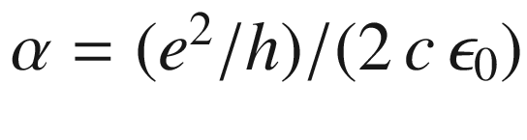

. At the same time, the longitudinal resistivity, starting from the classical value for small magnetic fields, exhibits oscillations and eventually it is close to zero for the plateaus in

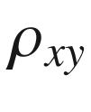

. For

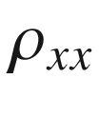

values of 10

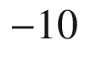

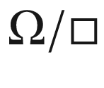

have been measured, which corresponds to 10

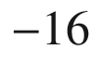

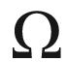

/cm for bulk material, a value three orders of magnitude smaller than for any non-superconductor.

The interpretation of the quantum Hall effect(s) is discussed in [1466] among many other treatises. The simplest explanation is that the conductivity is zero when a Landau level is completely filled and the next is completely empty, i.e. the Fermi level lies between them. The temperature is small, i.e.

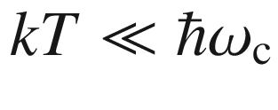

, such that no scattering between Landau levels can occur. Thus no current, similar to a completely filled valence band, can flow. The sheet carrier density



is given by counting the *i* filled Landau levels (degeneracy according to ([15.37](#u116076_4_En_15_Chapter-Equ48))) as

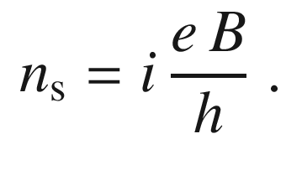

(15.43)

In the transverse direction energy dissipation takes place and the Hall resistivity

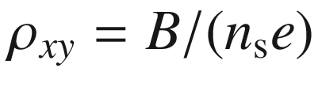

takes the (scattering-free) values given in ([15.42](#u116076_4_En_15_Chapter-Equ57)).

However, this argument is too simple as it will not explain the extension of the plateaus. As soon as the system has one electron more or less, the Fermi energy will (for a system with

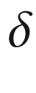

-like density of states) be located in the upper or lower Landau level, respectively. Then, the longitudinal conductivity should no longer be zero and the Hall resistivity deviates from the integer fraction of

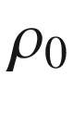

. In general, a single particle picture is insufficient to model the IQHE.

The accepted model for the explanation of the QHE, supported now with plenty of experimental evidence, is the edge state model where quantized one-dimensional conductivity of edge channels, i.e. the presence of conductive channels along the sample boundaries, is evoked [1475].

The most fundamental arguments for the origin of the IQHE come from gauge invariance and the presence of a macroscopic quantum state of electrons and magnetic flux quanta [1468]. This model holds as long as there are any extended states at all in the inhomogeneously broadened density of states (Landau levels) (Fig. [15.14](#u116076_4_En_15_Chapter-Fig14)). These edge states arise from the fact that the quantum Hall state has another topology than the (topologically trivial) surrounding [463, 1469, 1470]. Each plateau corresponds to a distinct topological phase characterized by a Chern number (cmp. ([6.​29](The_Physics_of_Semiconductors00003.docx#u116076_4_En_6_Chapter))) related to the ‘Hofstadter butterfly’ [1471, 1472] (cf. Sect. G.3.1).

It is remarkable that the classical Hall effect is based on homogeneous conduction for a proper evaluation (cf. Fig. [15.7](#u116076_4_En_15_Chapter-Fig7)e), while the quantum Hall effect involves electrical transport only along the edges. A detailed microscopic picture of the edge channels is also of interest. Due to depletion at the boundary of the sample, the density of the 2DEG varies at the edge of the sample and ‘incompressible’ stripes develop for which

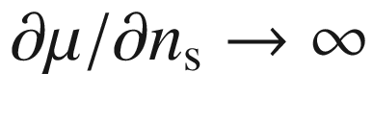

. When the filling factor is far from an integer, the Hall voltage is found to vary linearly across the conductive channel and the current is thus homogeneous over the sample (Fig. [15.20](#u116076_4_En_15_Chapter-Fig20)d). In the Hall plateau, the Hall voltage is flat in the center of the channel and exhibits drops at the edges, indicating that the current flows along the boundary of the sample (edge current) [1473] in agreement with predictions from [1476]. Although the current pattern changes with varying magnetic field, the Hall resistivity remains at its quantized value.

In graphene, the IQHE plateaus take on the resistance values [1249, 1477],

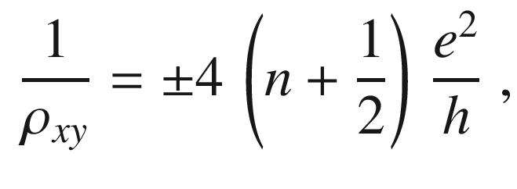

(15.44)

with

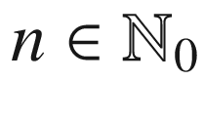

. This new ‘half integer’ quantization condition can be translated into the quantized filling factor

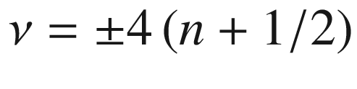

in the usual QHE formalism of ([15.42](#u116076_4_En_15_Chapter-Equ57)). The condition ([15.44](#u116076_4_En_15_Chapter-Equ59)) is due to the different nature of Landau levels for a linear dispersion (Dirac spectrum) [1478]. The

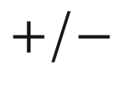

-sign denotes the QHE for electrons and holes, respectively. The factor

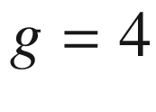

stems from the degeneracy of the Landau levels, accounting for spin degeneracy (when the Landau level separation is much larger than the Zeeman spin splitting) and for the sublattice degeneracy. The two

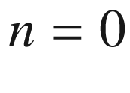

Hall plateaus have even been observed (for

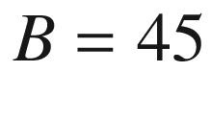

 T) at room temperature [1479].

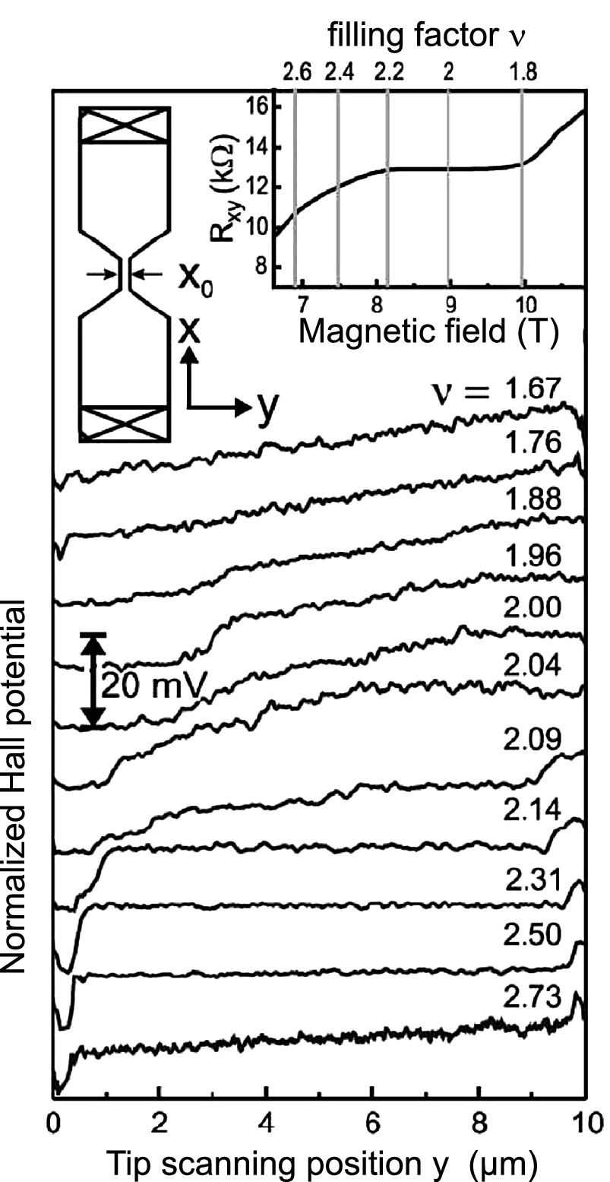

Fig. 15.20

Normalized Hall potential profile for different magnetic fields around filling factor

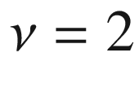

. The overall voltage drop corresponds to 20 mV. The *insets* show the sample geometry and transport data. The 2DEG is from a GaAs/Al

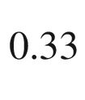

Ga

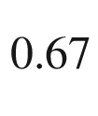

As modulation-doped heterostructure,

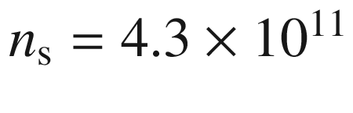

 cm

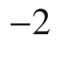

,

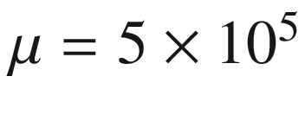

 cm



/Vs,

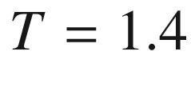

 K.

Adapted from [1473]

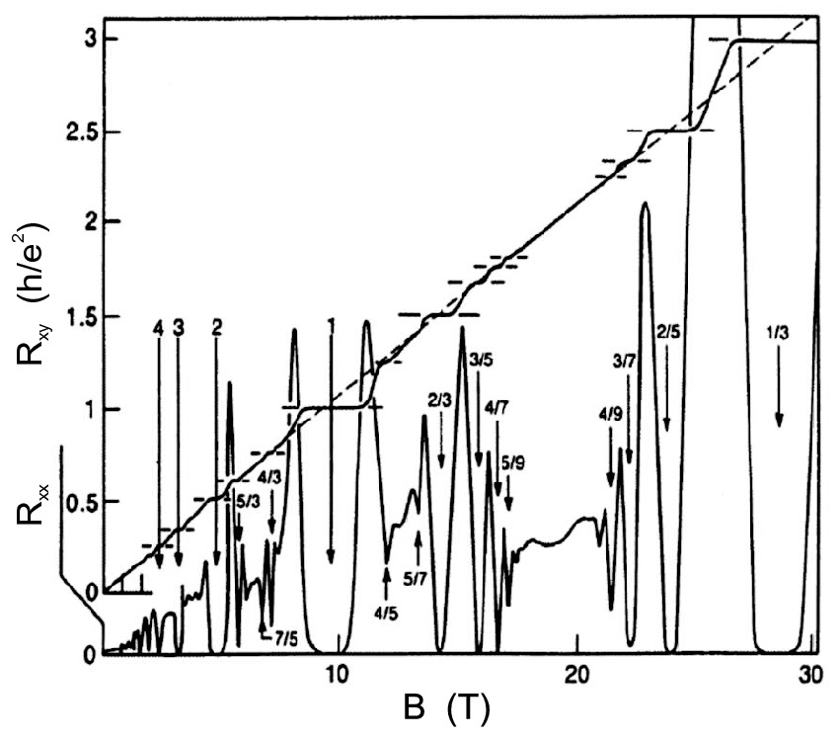

Fig. 15.21

Hall resistance

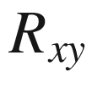

and magnetoresistance

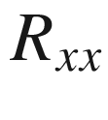

of a two-dimensional electron system (GaAs/(Al,Ga)As heterostructure) of density

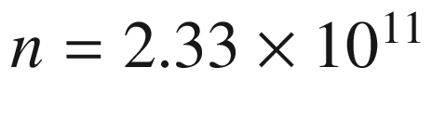

 cm

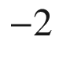

at a temperature of 85 mK, versus magnetic field *B*. Numbers identify the filling factor

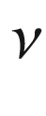

, which indicates the degree to which the sequence of Landau levels is filled with electrons. Plateaus are due to the integral (

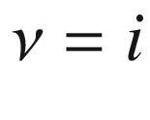

) quantum Hall effect (IQHE) and fractional (

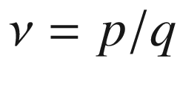

) quantum Hall effect (FQHE).

Adapted from [1480], reprinted with permission, ©1990 AAAS

##### 15.2.8.2 Fractional QHE

For very low temperatures and in the extreme quantum limit, novel effects are observed when the kinetic energy of the electrons is smaller than their Coulomb interaction. New quantum Hall plateaus are observed at various fractional filling factors



. We note that the effects of the fractional quantum Hall effect (FQHE) in Fig. [15.21](#u116076_4_En_15_Chapter-Fig21) mostly arise for magnetic fields beyond the

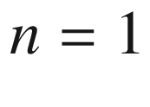

IQHE plateau. The filling factor

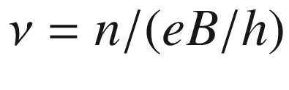

is now interpreted as the number of electrons per magnetic flux quantum

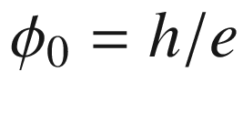

.

The effects of the FQHE cannot be explained by single-electron physics. The plateaus at fractional fillings



occur when the Fermi energy lies within a highly degenerate Landau (or spin) level and imply the presence of energy gaps due to many-particle interaction and the result of correlated 2D electron motion in the magnetic field.

A decisive role is played by the magnetic flux quanta. The presence of the magnetic field requires the many-electron wavefunction to assume as many zeros per unit area as there are flux quanta penetrating it. The decay of the wavefunction has a length scale of the magnetic length

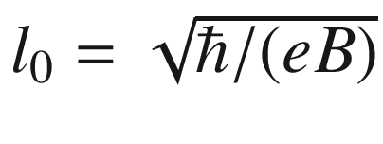

. Since the magnetic field implies a

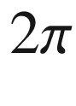

phase shift around the zero, such an object is also termed a *vortex*, being the embodiment of the magnetic flux quanta in the electron system. Such a vortex represents a charge deficit (compared to a homogeneous charge distribution) and thus electrons and vortices attract each other. If a vortex and an electron are placed onto each other, considerable Coulomb energy is gained. At

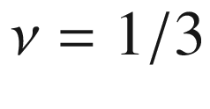

, there are three times more vortices than there are electrons, each vortex representing a charge deficit of

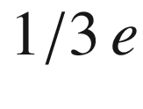

. Such a system is described with many-particle wavefunctions, such as the Laughlin theory for

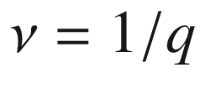

[1468] and novel quasi-particles called *composite fermions* [1481, 1482] for other fractional fillings. For further reading we refer readers to [1483] and references therein.

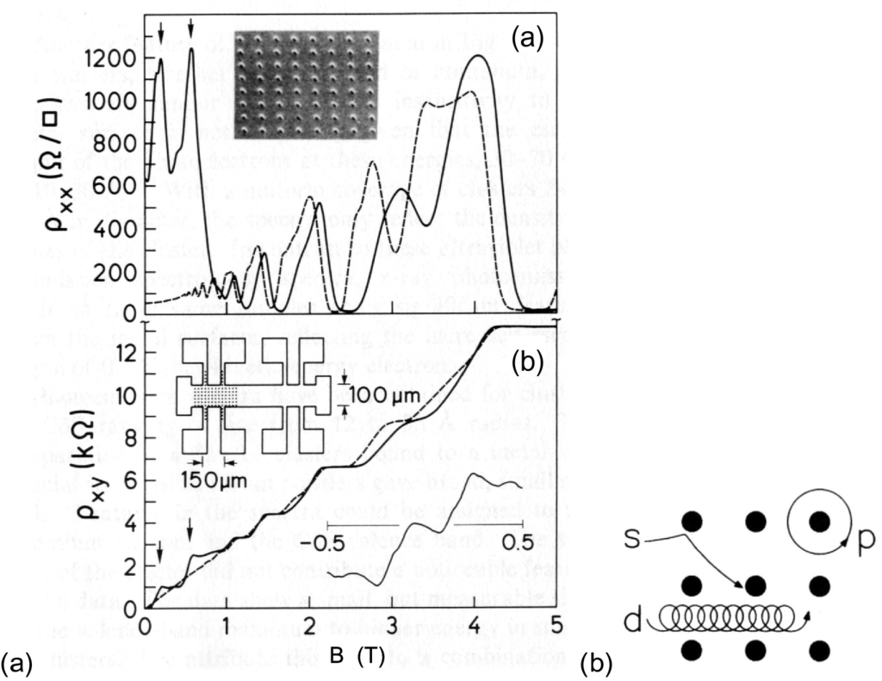

Fig. 15.22

Weiss oscillations: **a** magnetoresistance and **b** Hall resistance of an antidot lattice (*inset* in (**a**)) with pattern (*solid lines*) and without pattern (*dashed lines*) at

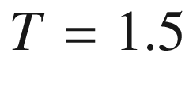

 K. **b** Schematic of the different orbits: (‘p’: pinned, ‘d’: drifting, ‘s’: scattered).

Reprinted with permission from [1484], ©1991 APS

##### 15.2.8.3 Weiss Oscillations

In Fig. [15.22](#u116076_4_En_15_Chapter-Fig22), measurements are shown for a Hall bar in which an array of antidots (in which no conduction is possible) has been introduced by dry etc.hing. The antidot size is 50 nm (plus depletion layer) and the period is 300 nm. These obstructions for the cyclotron motion lead to a modification of the magnetotransport properties.

Before etc.hing of the antidot array the 2DEG has a mean free path length of 5–10

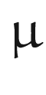

m at 4 K for the mobility of

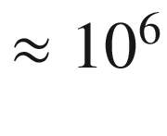

 cm

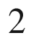

/Vs. At low magnetic fields there is a strong deviation of the Hall resistivity from the straight line to which the QHE levels converge. Similarly,



shows a strong effect as well.

These effects are related to commensurability effects between the antidot lattice and the cyclotron resonance path. When the cyclotron orbit is equal to the lattice period, electrons can fulfill a circular motion around one antidot (pinned orbit, Fig. [15.22](#u116076_4_En_15_Chapter-Fig22)b) that leads to a reduction of conductivity. At high fields, drifting orbits for which the cyclotron orbit is much smaller than the lattice period occur. At small fields, scattering orbits also contribute for which the cyclotron radius is large and the electron has antidots from time to time. Resonances in the Hall resistivity have been found due to pinned orbits enclosing 1, 2, 4, 9 or 21 antidots.

Footnotes

[1](#u116076_4_En_15_Chapter-Fn1_source)

Using the Hall effect, the net *free* charge carrier concentration is determined. We note that the concentration of *fixed* charges in semiconductors can be investigated by depletion layer spectroscopy (Sect. [21.​2.​4](The_Physics_of_Semiconductors00007.docx#u116076_4_En_21_Chapter)).

[2](#u116076_4_En_15_Chapter-Fn2_source)

We note that for a mobility of 10

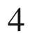

 cm



/Vs,

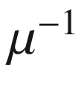

is a field of

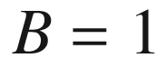

 T.

[3](#u116076_4_En_15_Chapter-Fn3_source)

For this consideration it is assumed that the energy dependence is the decisive one. Generally, averaging may have to be performed over other degrees of freedom as well, such as the spin or, in the case of anisotropic bands, the orbital direction.

[4](#u116076_4_En_15_Chapter-Fn4_source)

We note that mobility and effective mass defined and measured in this way may be referred to as ‘optical’. Other definitions and approaches to the mobility or effective mass may give different results.

© Springer Nature Switzerland AG 2021

M. Grundmann

The Physics of Semiconductors

Graduate Texts in Physics

<https://doi.org/10.1007/978-3-030-51569-0_16>

## 16. Polarized Semiconductors

Marius Grundmann[1](#u116076_4_En_16_Chapter-Aff11)

(1)

Felix Bloch Institute for Solid State Physics, Universität Leipzig, Leipzig, Germany

Marius Grundmann

Email:

[grundmann@physik.uni-leipzig.de](mailto:grundmann@physik.uni-leipzig.de)

## Abstract

In this chapter semiconductors with a spontaneous polarization and ferroelectric semiconductors are discussed. Also the effect of piezoelectricity is treated in some detail for zincblende and wurtzite materials.

### 16.1 Introduction

Semiconductors can have an electric polarization. Such polarization can be induced by an external electric field (Fig. [16.1](#u116076_4_En_16_Chapter-Fig1)a). This phenomenon, i.e. that the semiconductor is dielectric, has been discussed already in Chap. [9](The_Physics_of_Semiconductors00004.docx#u116076_4_En_9_Chapter). In this chapter, we discuss pyroelectricity, i.e. a spontaneous polarization without an external field (Fig. [16.1](#u116076_4_En_16_Chapter-Fig1)b), ferroelectricity,[1](#u116076_4_En_16_Chapter-Fn1) i.e. pyroelectricity with a hysteresis (Fig. [16.1](#u116076_4_En_16_Chapter-Fig1)c) and piezoelectricity, i.e. a polarization due to external stress.

### 16.2 Spontaneous Polarization

The reason for a spontaneous polarization

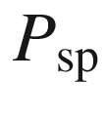

(without external electric field) is the static, relative shift of positive and negative charges in the unit cell. For a slab of semiconductor material (thus ignoring depolarization effects present in other geometries), the polarization causes polarization charges located at the upper and lower surfaces (Fig. [16.2](#u116076_4_En_16_Chapter-Fig2)a). The polarization vector



points from the negative to the positive charge. The electric field due to the polarization charges has the opposite direction. In the absence of free charges, the Maxwell equation

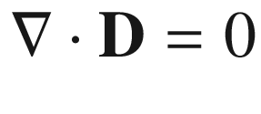

yields for piecewise constant fields at a planar interface (Fig. [16.2](#u116076_4_En_16_Chapter-Fig2)b)

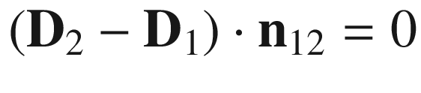

where

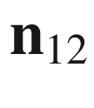

is the surface normal pointing from medium 1 to medium 2. Therefore, the polarization charge

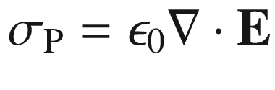

is given by

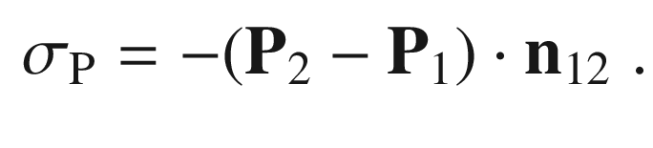

(16.1)

Polarization charges develop at interfaces where the polarization is discontinuous, e.g. an interface between two semiconductors with different spontaneous polarization. Vacuum (at a surface) represents a special case with

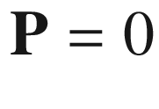

.

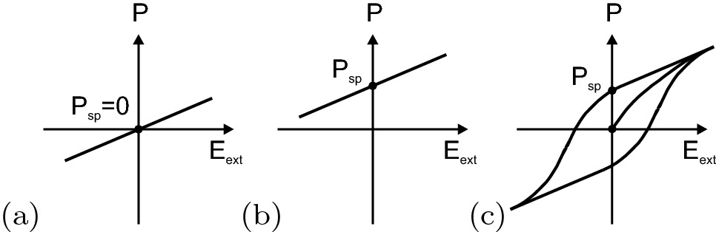

Fig. 16.1

Schematic representation of the polarization versus external electric field dependence for **a** dielectric, **b** pyroelectric and **c** ferroelectric semiconductors

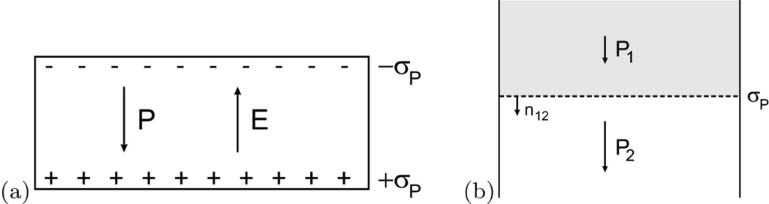

Fig. 16.2

**a** Surface polarization charges

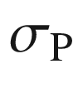

on a slab of semiconductor material with polarization. The electric field is given by

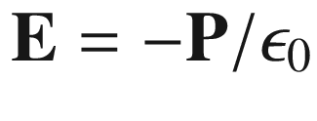

. **b** Polarization charge

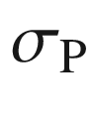

at an interface between two semiconductors with different polarization. In the depicted situation

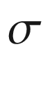

is negative

For cubic zincblende structure semiconductors,



is typically fairly small. The anisotropy of the wurtzite structure allows for sizeable effects (Fig. [16.3](#u116076_4_En_16_Chapter-Fig3)). The main cause is the nonideality of the cell-internal parameter *u* (cf. Sect. [3.​4.​5](The_Physics_of_Semiconductors00001.docx#u116076_4_En_3_Chapter)).

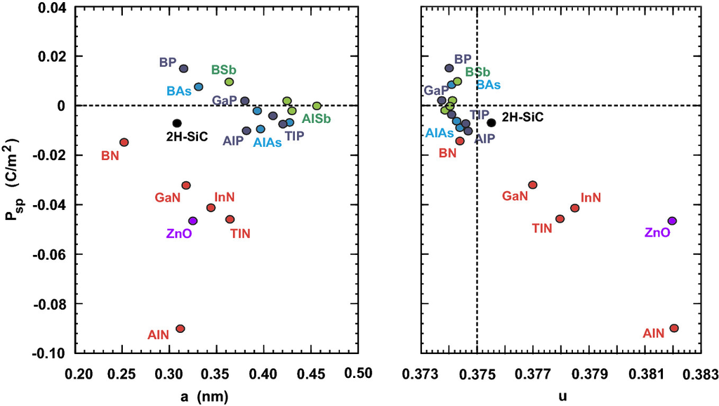

Fig. 16.3

Spontaneous polarization

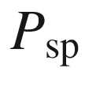

for various semiconductors as a function of the lattice constant *a* (left) and the cell-internal parameter *u* (right). Based on [1487]

### 16.3 Ferroelectricity

Ferroelectric semiconductors exhibit a spontaneous polarization in the ferroelectric phase and zero spontaneous polarization in the paraelectric phase. As a function of temperature, the ferroelectric material undergoes a phase transition from the high-temperature paraelectric phase into the ferroelectric phase. There can be further phase transitions between different ferroelectric phases that differ in the direction of the polarization. The literature until 1980 is summarized in [1488]. A more recent treatment can be found in [1489, 1490].

PbTiO



has perovskite structure (cf. Sect. [3.​4.​10](The_Physics_of_Semiconductors00001.docx#u116076_4_En_3_Chapter)). It exhibits a phase transition at

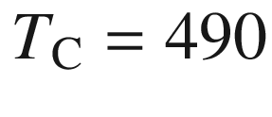

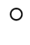

C from the cubic into the (ferroelectric) tetragonal phase as shown in Fig. [16.4](#u116076_4_En_16_Chapter-Fig4)a. Mostly the cell symmetry changes, while the cell volume remains almost constant. A more complicated situation arises for BaTiO



. At 120



C the transition into the ferroelectric phase occurs (Fig. [16.4](#u116076_4_En_16_Chapter-Fig4)b) that is tetragonal with the polarization in the [100] direction. At

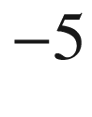

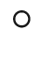

C and

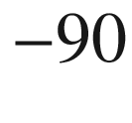

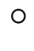

C transitions occur into an orthorhombic and a rhombohedral (trigonal) phase, respectively. The largest polarization is caused by a displacement of the negatively (O) and positively (Ba, Ti) charged ions of the unit cell by

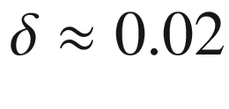

 nm (Fig. [16.5](#u116076_4_En_16_Chapter-Fig5)). Such an origin of the spontaneous polarization is called a *displacement* transition.[2](#u116076_4_En_16_Chapter-Fn2)

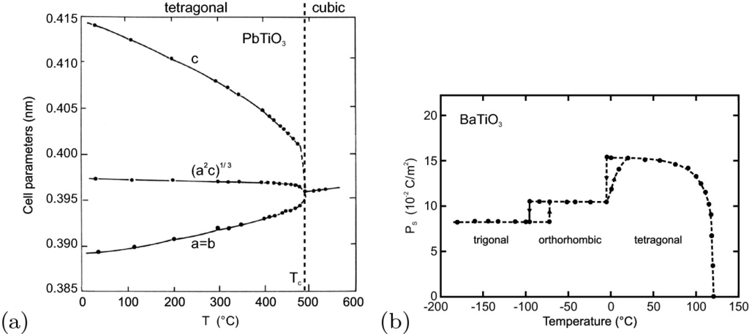

Fig. 16.4

**a** Cell parameters of PbTiO



as a function of temperature. Adapted from [1493]. **b** Phase transitions of BaTiO



as a function of temperature. The spontaneous polarization

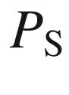

points along

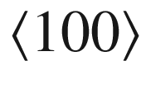

,

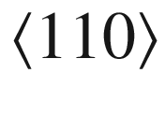

and

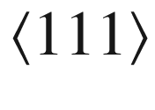

in the tetragonal (

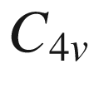

), orthorhombic (

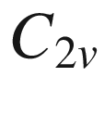

) and trigonal (

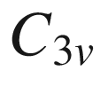

, rhombohedral) phase, respectively. Adapted from [1494]

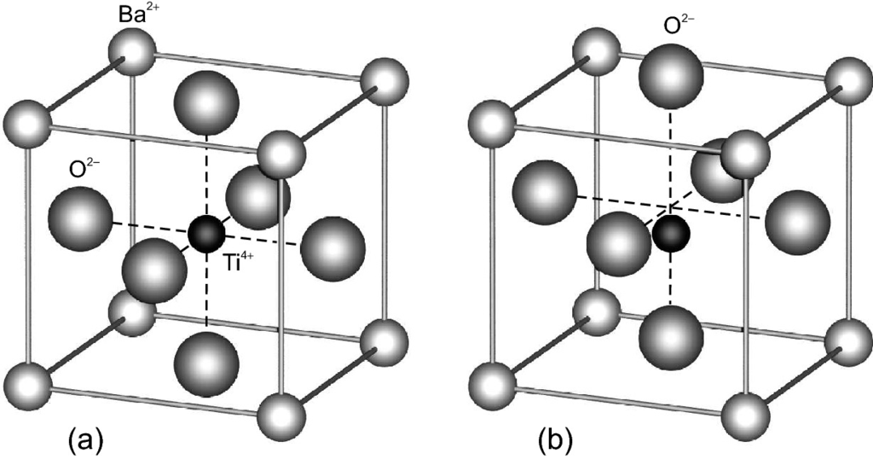

Fig. 16.5

**a** Crystal structure of BaTiO



(see Fig. [3.​27](The_Physics_of_Semiconductors00002.docx#u116076_4_En_3_Chapter-Fig27)). **b** Schematic tetragonal deformation below the Curie temperature, generating a dipole moment

#### 16.3.1 Materials

A large class of ferroelectric semiconductors are of the type ABO



, where A stands for a cation with larger ionic radius and B for an anion with smaller ionic radius. Many ferroelectrics have perovskite (CaTiO



) structure. They are A

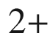

B

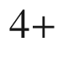

O

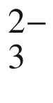

, e.g. (Ba,Ca,Sr) (Zi,Zr)O



or A

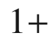

B

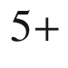

O

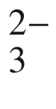

, e.g. (Li,Na,K) (Nb,Ta)O



. Ferroelectrics can also be alloyed. Alloying in the B component yields, e.g. PbTi



Zr

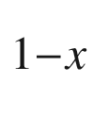

O



also called PZT. PZT is widely used for piezoelectric actuators. Also, alloying in the A component is possible, e.g. Ba



Sr

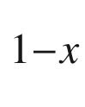

TiO



.

Another class of ferroelectrics are A

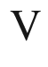

B

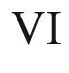

C

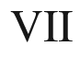

compounds, such as SbSI, SbSBr, SbSeI, BiSBr. These materials have a width of the forbidden band in the

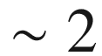

 eV range. A further class of ferroelectric semiconductors are A

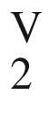

B

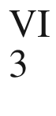

compounds, such as Sb



S



.

#### 16.3.2 Soft Phonon Mode

The finite displacement of the sublattices in the ferroelectric means that the related lattice vibration has no restoring force. The displacement is, however, finite due to higher-order terms (anharmonicity). Thus, for

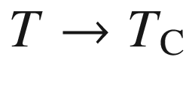

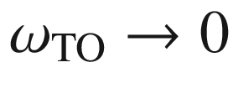

. Such a mode is called a *soft phonon mode*. The decrease of the phonon frequency is shown in Fig. [16.6](#u116076_4_En_16_Chapter-Fig6)a for SbSI.

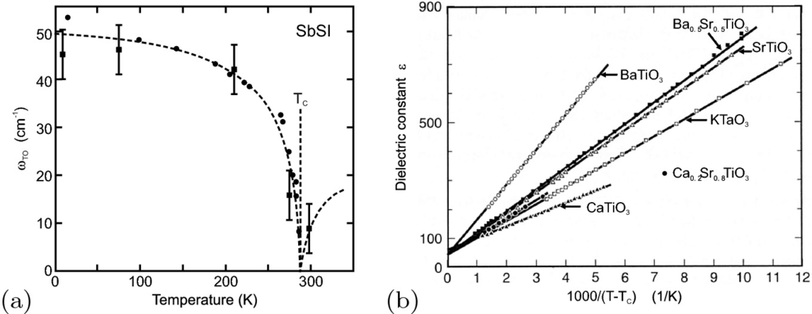

Fig. 16.6

**a** Decrease of the transverse phonon mode of SbSI close to the Curie temperature of

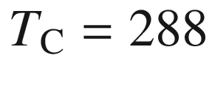

 K. The *dashed curved line* represents a

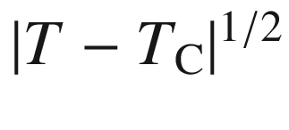

dependence. Adapted from [1495]. **b** Dielectric constant of various perovskites versus

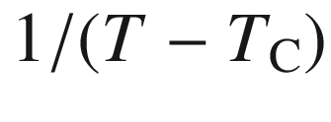

in the paraelectric phase (

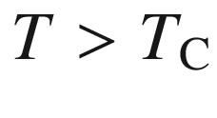

). Adapted from [1496]

From the LST relation ([9.​26](The_Physics_of_Semiconductors00004.docx#u116076_4_En_9_Chapter)), it follows that the static dielectric function must increase strongly. The increase is

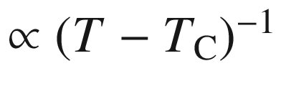

(Fig. [16.6](#u116076_4_En_16_Chapter-Fig6)b).

#### 16.3.3 Phase Transition

In the case of ferroelectrics, the order parameter for the Ginzburg–Landau theory of phase transitions is the spontaneous polarization *P*. The free energy *F* of the ferroelectric crystal is written in terms of the free energy of the paraelectric phase

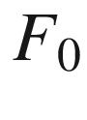

 and is expanded in powers of *P* (here up to

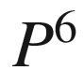

) as

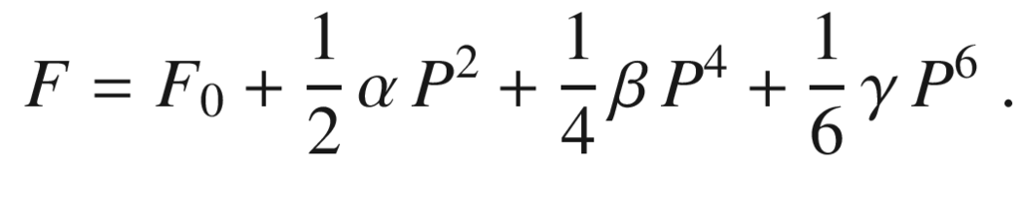

(16.2)

In this equation, we have neglected effects due to charge carriers, an external electric field or external stresses and we assume homogeneous polarization. In order to obtain a phase transition, it has to be assumed that

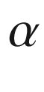

has a zero at a certain temperature

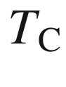

and we assume (expanding only to the linear term)

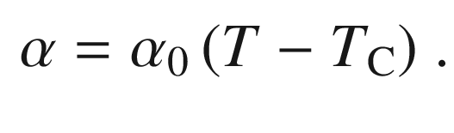

(16.3)

##### 16.3.3.1 Second-Order Phase Transition

For modeling a second-order phase transition, we set

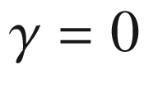

. Thus, the free energy has the form (Fig. [16.7](#u116076_4_En_16_Chapter-Fig7)a)

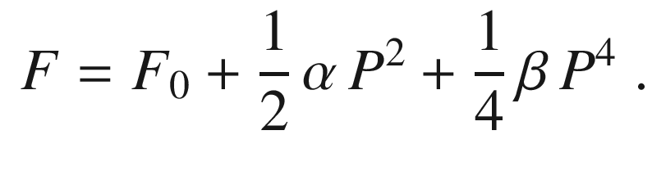

(16.4)

The equilibrium condition with regard to the free energy yields a minimum for

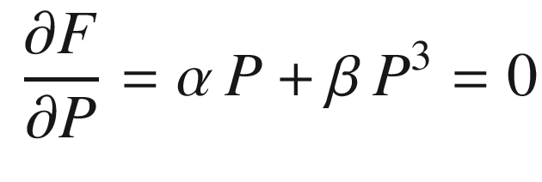

(16.5a)

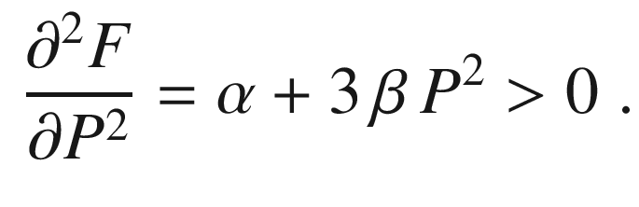

(16.5b)

Equation ([16.5a](#u116076_4_En_16_Chapter-Equ5)) yields two solutions.

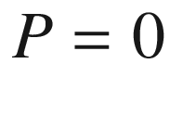

corresponds to the paraelectric phase.

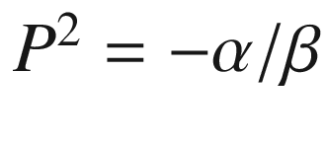

is the spontaneous polarization in the ferroelectric phase. The condition from ([16.5b](#u116076_4_En_16_Chapter-Equ6)) yields that

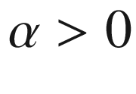

in the paraelectric phase, while

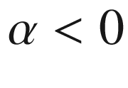

in the ferroelectric phase. Also,

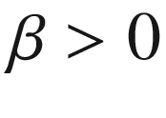

below the Curie temperature (

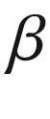

is assumed to be temperature independent in the following). Using ([16.3](#u116076_4_En_16_Chapter-Equ3)), the polarization is given as (Fig. [16.7](#u116076_4_En_16_Chapter-Fig7)b)

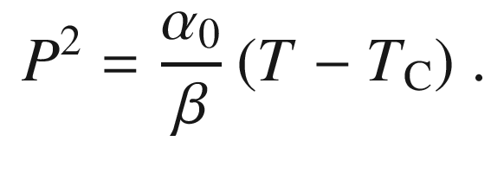

(16.6)

Therefore, the entropy

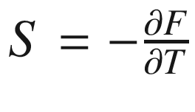

 and the discontinuity

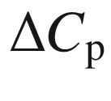

of the heat capacity

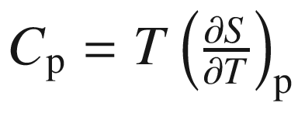

at the Curie point

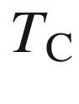

are given by

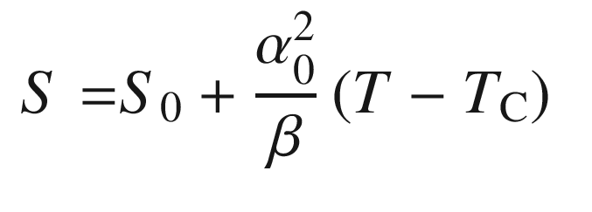

(16.7a)

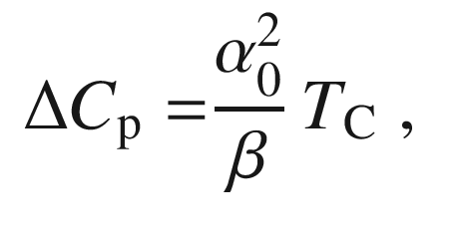

(16.7b)

with

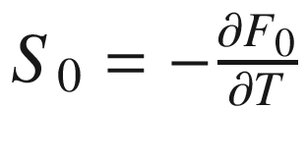

being the entropy of the paraelectric phase. This behavior is in accordance with a second-order phase transition with vanishing latent heat (continuous entropy) and a discontinuity of the heat capacity. The dielectric function in the paraelectric phase is

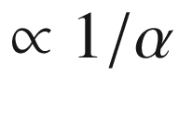

and in the ferroelectric phase

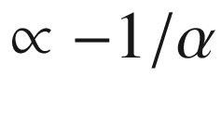

. The latter relation is usually written as the Curie–Weiss law

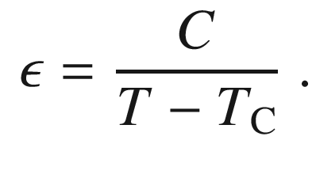

(16.8)

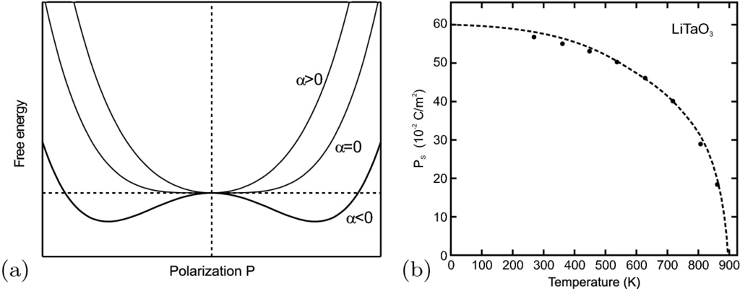

Fig. 16.7

**a** Schematic plot of the free energy versus spontaneous polarization for a second-order phase transition.

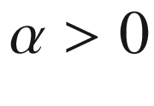

(

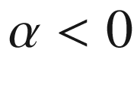

) corresponds to the paraelectric (ferroelectric) phase. **b** Spontaneous polarization of LiTaO



as a function of temperature exhibiting a second-order phase transition. The *dashed line* is theory with suitable parameters.

Adapted from [1497]

##### 16.3.3.2 First-Order Phase Transition

When the

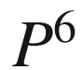

term is included in ([16.2](#u116076_4_En_16_Chapter-Equ2)) (

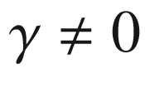

), a first-order phase transition is modeled. However, in order to obtain something new, compared to the previous consideration, now

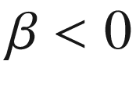

(and

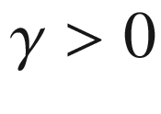

) is necessary. The dependence of the free energy on *P* is schematically shown in Fig. [16.8](#u116076_4_En_16_Chapter-Fig8)a for various values of

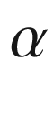

. The condition

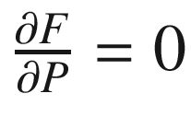

yields

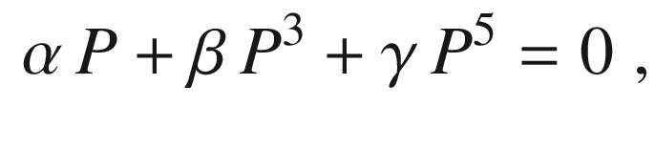

(16.9)

with the solutions



and

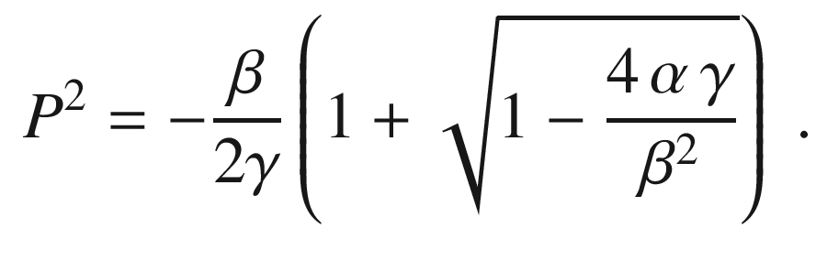

(16.10)

For a certain value of

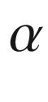

, i.e. at a certain temperature

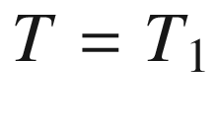

, the free energy is zero for



*and* also for another value

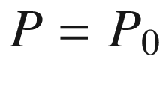

(second curve from the top in Fig. [16.8](#u116076_4_En_16_Chapter-Fig8)a). From the condition

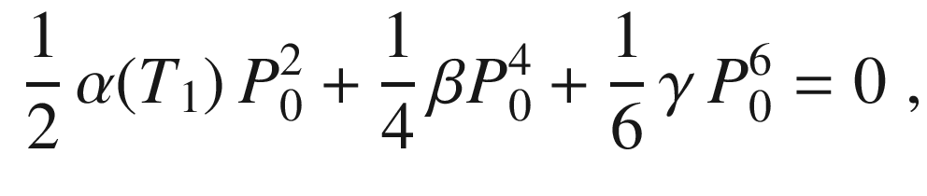

(16.11)

the values for

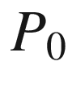

and



at the transition temperature

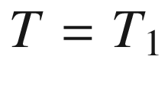

are given by

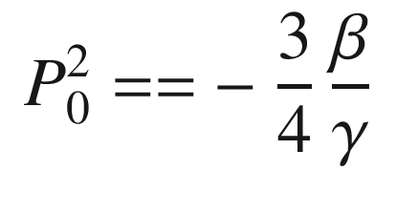

(16.12a)

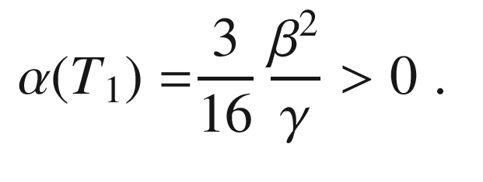

(16.12b)

The schematic dependence of *P* at the phase transition temperature

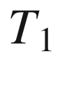

is depicted in Fig. [16.8](#u116076_4_En_16_Chapter-Fig8)b.

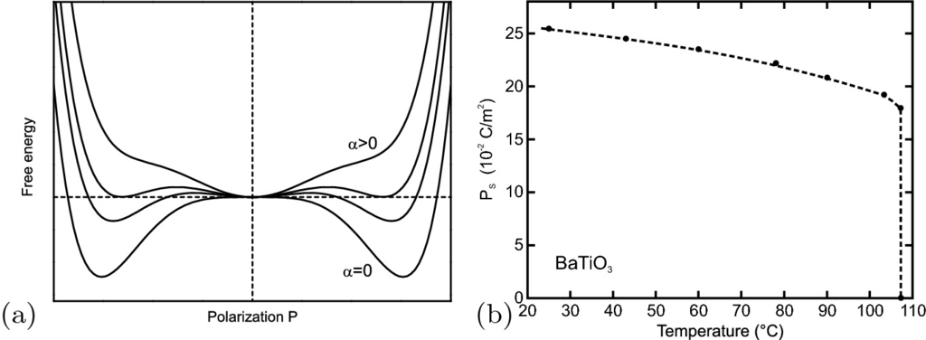

Fig. 16.8

**a** Schematic plot of the free energy versus spontaneous polarization for a first-order phase transition. The lowest curve is for

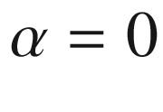

, the others are for



. **b** Spontaneous polarization in BaTiO



as a function of temperature exhibiting a first-order phase transition. The *dashed line* is a guide to the eye.

Adapted from [1498]

For

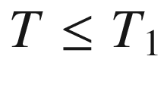

the absolute minimum of the free energy is reached for finite polarization

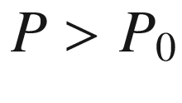

. However, between

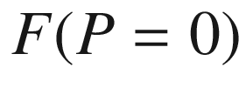

and the minimum of the free energy an energy barrier (second lowest curve in Fig. [16.8](#u116076_4_En_16_Chapter-Fig8)) is present for *T* close to

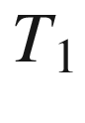

. The energy barrier disappears at the Curie–Weiss temperature

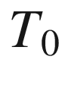

. At the phase transition temperature, the entropy has a discontinuity

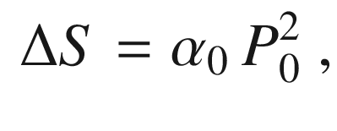

(16.13)

that corresponds to a latent heat

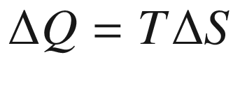

. Another property of the first-order phase transition is the occurrence of hysteresis in the temperature interval between

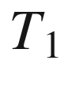

and



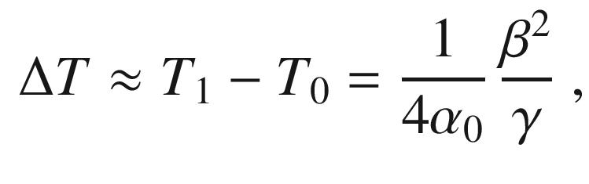

(16.14)

in which an energy barrier is present to hinder the phase transition. For decreasing temperature, the system tends to remain in the paraelectric phase. For increasing temperature, the system tends to remain in the ferroelectric phase. Such behavior is observed for BaTiO



, as shown in Fig. [16.4](#u116076_4_En_16_Chapter-Fig4)b.

#### 16.3.4 Domains

Similar to ferromagnets, ferroelectrics form domains with different polarization directions in order to minimize the total energy by minimizing the field energy outside the crystal. The polarization can have different orientations, 6 directions for *P* along

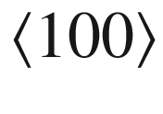

(tetragonal phase), 12 directions for *P* along

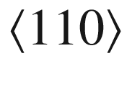

(orthorhombic phase) and 8 directions for *P* along

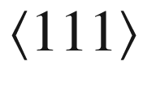

(rhombohedral phase).  In Fig. [16.9](#u116076_4_En_16_Chapter-Fig9), such domains are visualized for BaTiO



. Due to the restricted geometry, domain formation in thin films is different from that in bulk material.

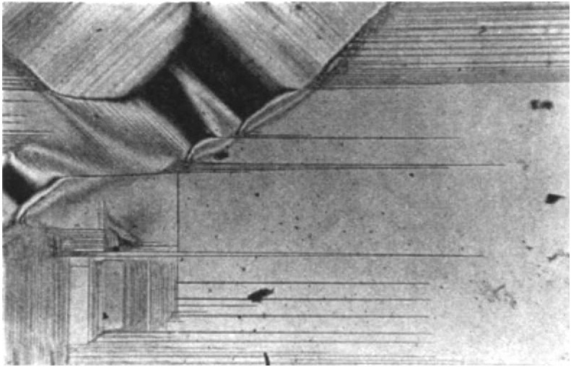

Fig. 16.9

Ferroelectric domains in a BaTiO



single crystal visualized by birefringence contrast.

Reprinted with permission from [1499], ©1949 APS

Domains can also be artificially created by so-called poling. The ferroelectric semiconductor is heated to the paraelectric phase. With electrodes, appropriate electric fields are applied and the material is cooled. The polarization is then frozen in the ferroelectric phase. The domains of a periodically poled structure  in LiNbO



(PPLN) are shown in Fig. [16.10](#u116076_4_En_16_Chapter-Fig10)b. The nonlinear optical properties in such structures can be used for efficient second harmonic generation (SHG).

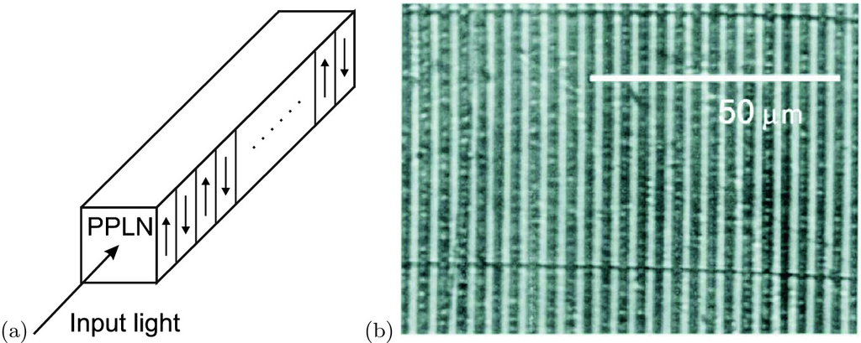

Fig. 16.10

**a** Scheme of PPLN (perodically poled lithium niobate), *arrows* denote the direction of spontaneous polarization. **b** Polarization microscopy image (vertical stripes are domains, horizontal dark lines are scratches)

#### 16.3.5 Optical Properties

The first-order phase transition of BaTiO



manifests itself also in a discontinuity of the band gap (Fig. [16.11](#u116076_4_En_16_Chapter-Fig11)). The coefficient

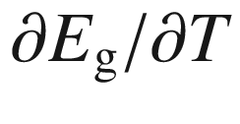

for the temperature dependence of the band gap is also different in the para- and ferroelectric phases.

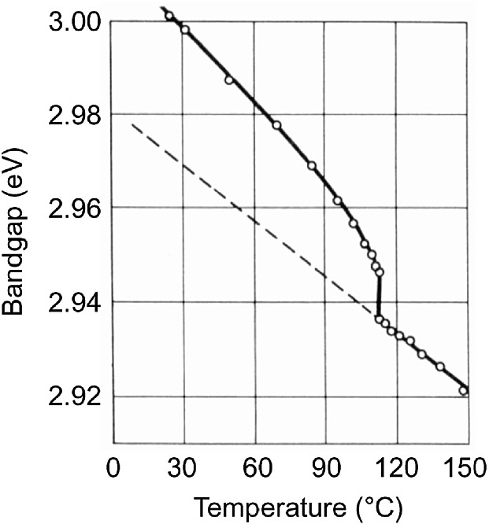

Fig. 16.11

Temperature dependence of the band gap in BaTiO



(for polarized light with

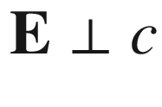

).

Experimental data from [1500]

### 16.4 Piezoelectricity

#### 16.4.1 Piezoelectric Effect

External stress causes atoms in the unit cell to shift with respect to each other. In certain directions, such a shift can lead to a polarization. Generally, all ferroelectric materials are piezoelectric. However, there are piezoelectric materials that are not ferroelectric, e.g. quartz, GaAs and GaN. Piezoelectricity can occur only when no center of inversion is present. Thus, e.g., GaAs is piezoelectric along

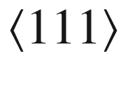

, but Si is not. Also, the cubic perovskite structure (in the paraelectric phase) is not piezoelectric. Generally, the piezoelectric polarization is related to the strains via the tensor

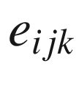

of the piezoelectric modules[3](#u116076_4_En_16_Chapter-Fn3)

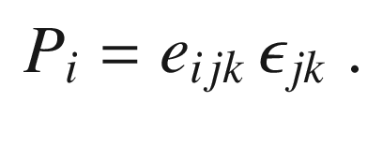

(16.15)

#### 16.4.2 Zincblende Crystals

In zincblende semiconductors, the polarization (with respect to

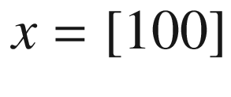

,

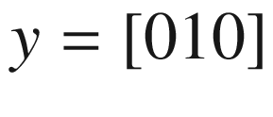

,

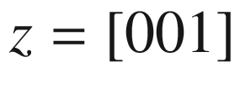

) is due to shear strains only and is given as

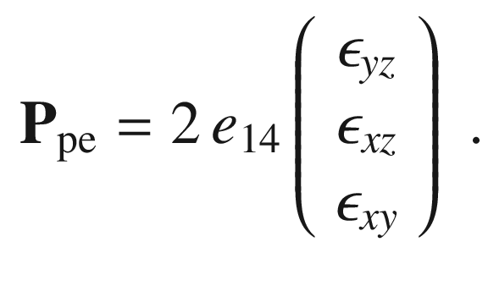

(16.16)

The values of

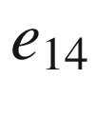

for various zincblende compound semiconductors are listed in Table [16.1](#u116076_4_En_16_Chapter-Tab1). We note that the sign of



reverses from negative in cubic III–V to positive in cubic II–VI semiconductors. This non-trivial behavior involves strain effects on ionic and electronic polarization and ionicity as discussed in [184, 1501]. The coefficient

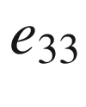

, the equivalent to

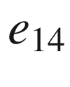

in wurtzite semiconductors (see below), is positive for III–V and II-VI semiconductors.Table 16.1

Piezoelectric coefficients (in C m

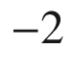

) for various zincblende and wurtzite semiconductors. Data from [165, 1501, 1504], for zb-ZnO from [1505], for zb-GaN from [1506]

| Zincblende | | | | Wurtzite | | | |
| --- | --- | --- | --- | --- | --- | --- | --- |
| III–V | $$e_{14}$$ | II–VI | $$e_{14}$$ |  | $$e_{33}$$ | $$e_{31}$$ | $$e_{15}$$ |
| InSb | $$-0.123$$ | CdTe | 0.054 | CdSe | 0.347 | $$-0.16$$ | $$-0.138$$ |
| InAs | $$-0.078$$ | ZnSe | 0.049 | CdS | 0.385 | $$-0.262$$ | $$-0.183$$ |
| GaSb | $$-0.218$$ | ZnS | 0.254 | ZnS | 0.265 | $$-0.238$$ | $$-0.118$$ |
| GaAs | $$-0.277$$ | ZnO | 0.69 | ZnO | 0.89 | $$-0.51$$ | $$-0.45$$ |
| AlSb | $$-0.118$$ | GaN | 0.375 | GaN | 0.73 | $$-0.49$$ | $$-0.3$$ |
|  | | | | AlN | 1.46 | $$-0.60$$ | $$-0.48$$ |
| BeO | 0.02 | $$-0.02$$ |  |

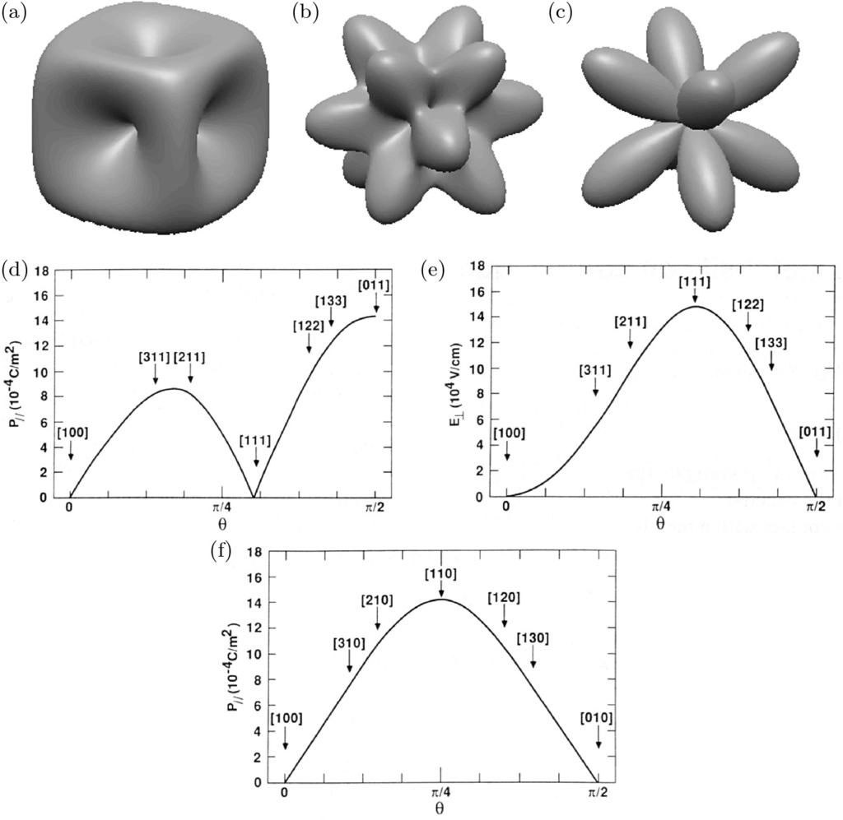

Fig. 16.12

Three-dimensional view of the **a** total, **b** longitudinal and **c** transverse polarization in uniaxially compressed GaAs. Adapted from [1502]. **d** Transverse polarization

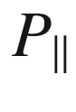

(parallel to the interface) and **e** longitudinal electric field

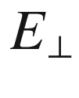

(perpendicular to the interface) in the InGaAs layer of a GaAs/In

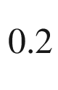

Ga

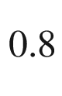

As superlattice with joint in-plane lattice constant (obtained from energy minimization, 1.4% lattice mismatch, the InGaAs is under compressive and the GaAs under tensile strain). The layer thicknesses of the GaAs and InGaAs layers are identical. The quantities are shown for various orientations of the growth direction. The vector of the growth direction varies in the (01–1) plane (

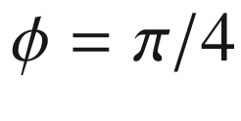

) with polar angle

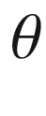

reaching from [100] (

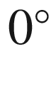

) over [111] to [011] (

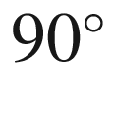

). Image (**f**) depicts the transverse polarization

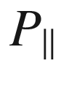

(

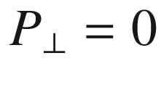

in this geometry) for growth directions in the (001) plane (

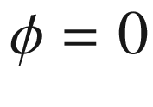

).

Parts **d**–**f** reprinted with permission from [1503], ©1988 AIP

The strain in pseudomorphic heterostructures (cf. Sect. [5.​3.​3](The_Physics_of_Semiconductors00002.docx#u116076_4_En_5_Chapter)) can cause piezoelectric polarization in a piezoelectric semiconductor. In zincblende, the main effect is expected when the growth direction is along [111] and the strain has a purely shear character. In this case, the polarization is in the [111] direction, i.e. perpendicular to the interface (

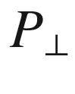

). For the [001] growth direction, no piezoelectric polarization is expected. For the [110] growth direction, the polarization is found to be parallel to the interface (



). The situation is shown for various orientations of the growth direction in Fig. [16.12](#u116076_4_En_16_Chapter-Fig12).

#### 16.4.3 Wurtzite Crystals

In wurtzite crystals, the piezoelectric polarization (with respect to

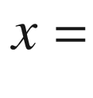

[2–1.0],

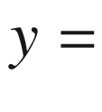

[01.0],

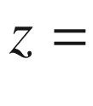

[00.1]) is given by[4](#u116076_4_En_16_Chapter-Fn4)

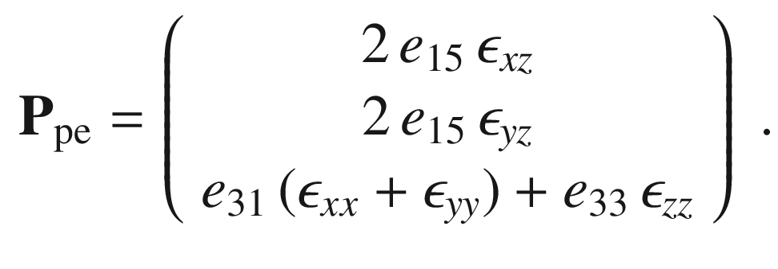

(16.17)

Values for the piezoelectric coefficients of several wurtzite semiconductors[5](#u116076_4_En_16_Chapter-Fn5) are listed in Table [16.1](#u116076_4_En_16_Chapter-Tab1).

The polarization (along *c*) for biaxial strain in heteroepitaxy ([5.​69](The_Physics_of_Semiconductors00002.docx#u116076_4_En_5_Chapter)) on the [00.1] surface is

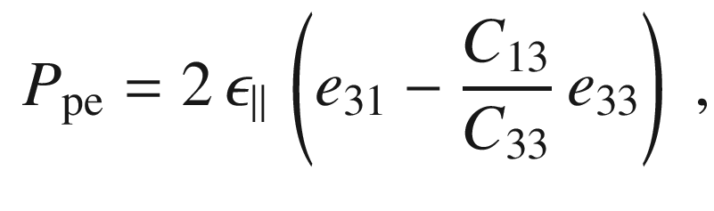

(16.18)

where

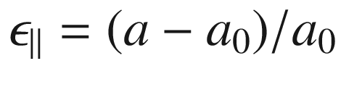

is the in-plane strain. The dependence of the magnitude for GaN on the in-plane strain is shown in Fig. [16.13](#u116076_4_En_16_Chapter-Fig13) together with the polarization for uniaxial stress along [00.1] and hydrostatic strain. In the latter two cases, the polarization is smaller.

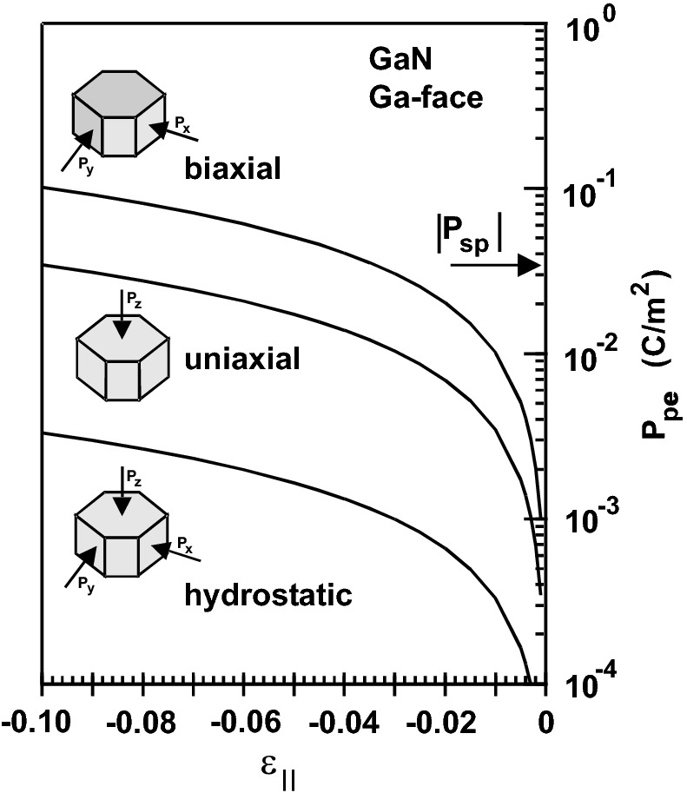

Fig. 16.13

Piezoelectric polarization

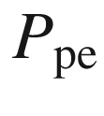

in GaN (Ga-face) versus in-plane strain

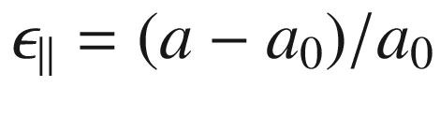

for biaxial, uniaxial and hydrostatic strain. The value of the spontaneous polarization

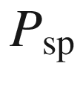

is indicated by an *arrow*.

From [1508]

The difference of spontaneous polarization of the constituent materials in heterostructures and piezoelectric effects in strained quantum wells lead to quantum confined Stark effect (QCSE, Sect. [15.​1.​2](#u116076_4_En_15_Chapter)). The spatial separation of electrons and holes leads to a larger radiative lifetime (Fig. [12.​43](#u116076_4_En_12_Chapter-Fig43)) and thus reduced radiative recombination rate in the presence of nonradiative channels, an effect unwanted in light emitting diodes. In particular nitride based LEDs grown along the *c*-direction are prone to this effect. Therefore growth on nonpolar surfaces such as

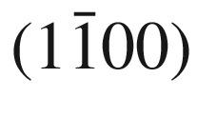

(*m*-plane) and

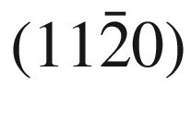

(*a*-plane) has been investigated [1509, 1510]. However, crystal quality for these growth planes seems limited.

An alternative route are ‘semipolar’ planes, e.g.

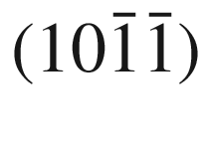

or

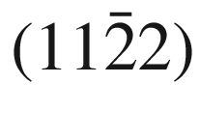

[1511], with at least reduced polarization effects. The



-plane is tilted about 58



(for GaN) from the *c*-axis, close to the theoretically predicted zero of the internal electric field for InGaN/GaN quantum wells [1512] (Fig. [16.14](#u116076_4_En_16_Chapter-Fig14)). Promising experimental results have been published on semipolar growth, especially for InGaN/GaN on

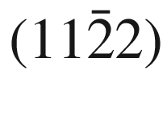

-oriented GaN substrates [1513].

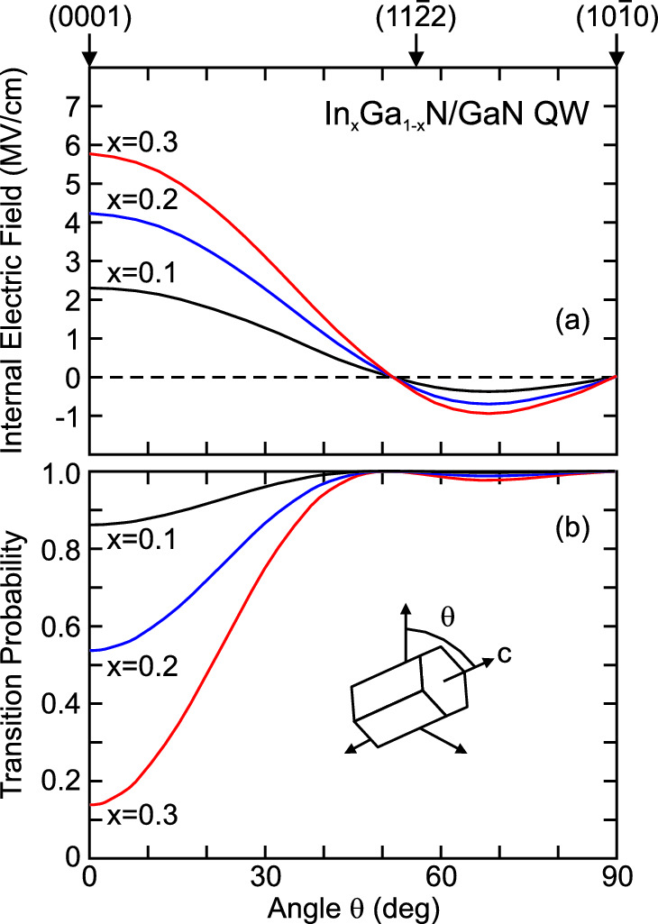

Fig. 16.14

**a** Internal electric field and **b** transition probability for electron-hole pairs in pseudomorphic In



Ga



N/GaN quantum well (

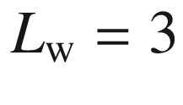

 nm) for three different indium contents *x* as labeled.

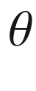

denotes the angle between the *c*-axis and the normal of the interface plane (see *inset*). Based on [1512]

#### 16.4.4 Piezoelectric Effects in Nanostructures

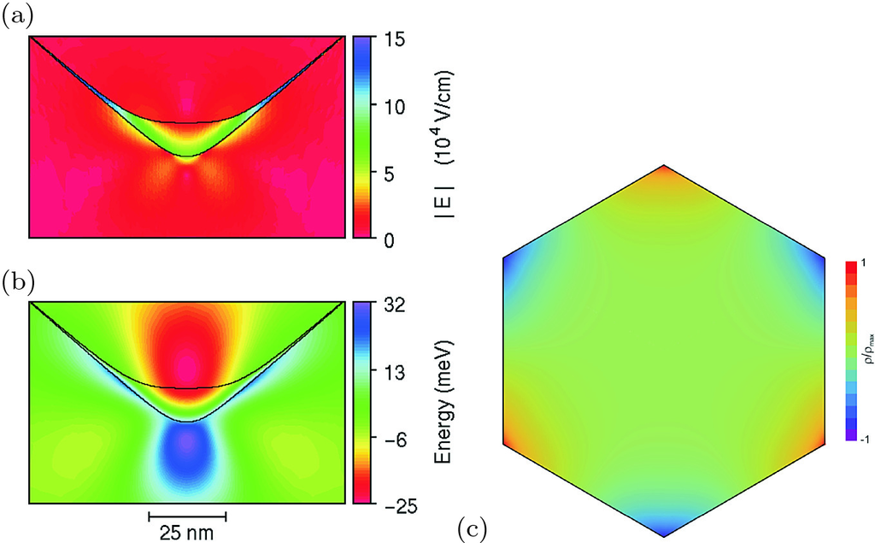

Fig. 16.15

**a** Electric field and **b** additional confinement potential for electrons due to piezoelectric charges for a strained In



Ga



As/GaAs quantum wire. Adapted from [1502]. **c** Piezoelectric charge density in a (111)-oriented GaAs wire with hexagonal cross section. Adapted from [1514]

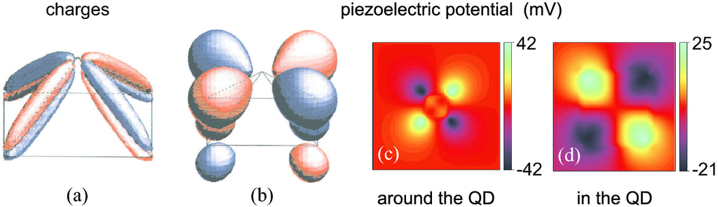

Fig. 16.16

**a** Piezoelectric charges and **b**–**d** resulting Coulomb potential for InAs/GaAs quantum dot with base length

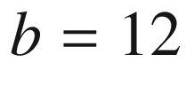

 nm. **a** Isosurfaces corresponding to volume charges

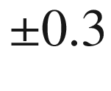

 e nm

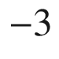

. **b** Isosurfaces for the Coulomb potential at

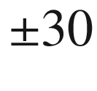

 meV. **c**,**d** Cross section through the Coulomb potential somewhat above the wetting layer in two different magnifications, **d** is a zoom into (**c**). The InAs/GaAs interface is visible in **d** due to the image charge effect.

Parts **a** and **b** reprinted with permission from [417], ©1995 APS

The strain distribution around zincblende strained quantum wires [1502], (111)-oriented wires under torsion [1514] and epitaxial (embedded) quantum dots [417] contains shear components and thus generates piezoelectric fields. In Fig. [16.15](#u116076_4_En_16_Chapter-Fig15)a,b, the electric field and potential due to the piezoelectric charges are shown for a strained In

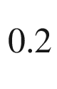

Ga

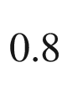

As/GaAs quantum wire. In Fig. [16.15](#u116076_4_En_16_Chapter-Fig15)c the three-fold symmetric piezoelectric charge density within the cross-section of a (111)-oriented GaAs wire under torsion (due to second order piezoelectricity) is depicted.

In Fig. [16.16](#u116076_4_En_16_Chapter-Fig16), the piezoelectric charges and potential are shown for the quantum dot from Fig. [5.​34](The_Physics_of_Semiconductors00003.docx#u116076_4_En_5_Chapter-Fig34). The piezoelectric potential has quadrupole character and thus reduces the symmetry of the QD (to



) [417].[6](#u116076_4_En_16_Chapter-Fn6) Piezoelectric effects are particularly important in wurtzite nanostructures [1515].

Footnotes

[1](#u116076_4_En_16_Chapter-Fn1_source)

Ferromagnetic semiconductors are discussed in Chap. [17](#u116076_4_En_17_Chapter). We note that there exist so called *multiferroic* materials that possess more than one ferroic property [1485, 1486].

[2](#u116076_4_En_16_Chapter-Fn2_source)

The widely accepted model for such ferroelectric is that the basic displacement occurs into the



-direction at low temperature. The three higher symmetry phases at higher temperature are the result of 2 (orthorhombic), 4 (tetragonal) or 8 (cubic) allowed

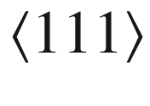

orientations which make the macroscopically averaged polarization appear in

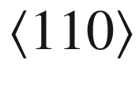

- or



-direction or vanishing altogether, respectively [1491, 1492].

[3](#u116076_4_En_16_Chapter-Fn3_source)

Another formulation is used with parameters

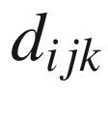

and

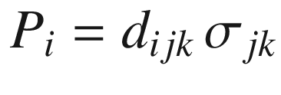

.

[4](#u116076_4_En_16_Chapter-Fn4_source)

In Voigt notation,

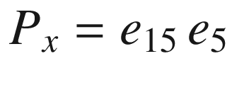

,

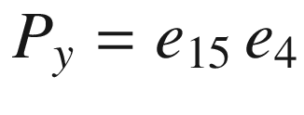

[5](#u116076_4_En_16_Chapter-Fn5_source)

If



for a zincblende material is transformed to a coordinate system along [111], the wurtzite-like piezoelectric constants are

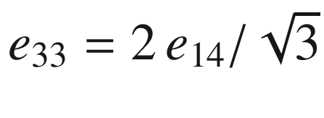

and

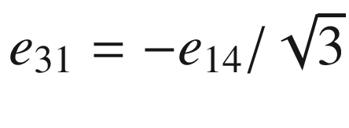

 [1507].

[6](#u116076_4_En_16_Chapter-Fn6_source)

The strain distribution has



symmetry for a square-based pyramid for zincblende materials. The energy levels and wavefunctions are more strongly impacted by the piezoelectric effects than by the strain asymmetry [1382, 1383].

© Springer Nature Switzerland AG 2021

M. Grundmann

The Physics of Semiconductors

Graduate Texts in Physics

<https://doi.org/10.1007/978-3-030-51569-0_17>

## 17. Magnetic Semiconductors

Marius Grundmann[1](#u116076_4_En_17_Chapter-Aff11)

(1)

Felix Bloch Institute for Solid State Physics, Universität Leipzig, Leipzig, Germany

Marius Grundmann

Email:

[grundmann@physik.uni-leipzig.de](mailto:grundmann@physik.uni-leipzig.de)

## Abstract

Materials and properties of two types of semiconductors with spontaneous magnetization or ferromagnetic and paramagnetic properties are explained: Compound materials and diluted magnetic semiconductors. A short introduction to semiconductor spintronics covers the concepts of spin transistor and spin LED.

### 17.1 Introduction

Magnetic semiconductors exhibit spontaneous magnetic order. Even ferromagnetism, important for spin polarization, as needed in spinelectronics (also called *spintronics*), can occur below the Curie temperature that is characteristic of the material. Magnetic semiconductors can be binary compounds such as EuTe (antiferromagnetic) or EuS (ferromagnetic). Another class of magnetic semiconductors contains paramagnetic ions in doping concentration (typically

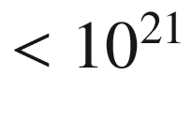

 cm

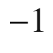

) or alloy concentration *x* (typically

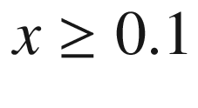

%). Such materials are termed *diluted magnetic semiconductors* (DMS). The incorporation of the magnetic atoms leads first to conventional alloy effects, such as the modification of the lattice constant, the carrier concentration or the band gap. The status of the field up to the mid-1980s can be found in [1516, 1517], mostly focused on II–VI DMS. A review of work on III–V based materials for spintronics, mostly GaAs:Mn, can be found in [1518]. A 2003 review of wide band gap ferromagnetic semiconductors is given in [1519], a 2014 review of Mn-containing DMS in [1520].

### 17.2 Magnetic Semiconductors

In a magnetic semiconductor, one sublattice is populated with paramagnetic ions. The first two ferromagnetic semiconductors discovered were CrBr



[1521] in 1960 and EuO [1522] one year later. Europium monoxide has an ionic Eu

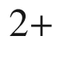

O

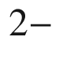

character, such that the electronic configuration of europium is [Xe]4f

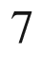

5d

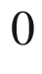

6s



and that of oxygen is 1s

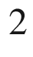

2s



2p

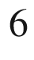

. Some properties of europium chalcogenides [1523] are summarized in Table [17.1](#u116076_4_En_17_Chapter-Tab1).

EuO can be modeled as a Heisenberg ferromagnet with dominant nearest- and next-nearest Eu–Eu interactions [1524]. The Heisenberg exchange parameters

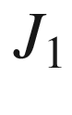

and

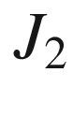

for these four compounds are shown in Fig. [17.1](#u116076_4_En_17_Chapter-Fig1). In the nearest-neighbor interaction



a 4f electron is excited to the 5d band, experiences an exchange interaction with the 4f spin on a nearest neighbor and returns to the initial state. This mechanism generally leads to ferromagnetic exchange. The next-nearest-neighbor interaction

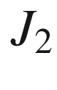

is weakly ferromagnetic (EuO) or antiferromagnetic (EuS, EuSe, EuTe). In the superexchange process, electrons are transferred from the anionic p states to the 5d states of the Eu



cations, resulting in an antiferromagnetic coupling.Table 17.1

Material properties of Eu chalcogenides. ‘FM’ (‘AF’) denotes ferromagnetic (antiferromagnetic) order.

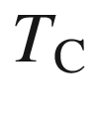

(

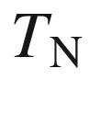

) denotes the Curie (Néel) temperature. Data collected in [1525]

| Material | $$E_{\mathrm {g}}$$  (eV) | Magnetic order | $$T_{\mathrm {C}}$$  ,  $$T_{\mathrm {N}}$$  (K) |
| --- | --- | --- | --- |
| EuO | 1.12 | FM | 69.3 |
| EuS | 1.65 | FM | 16.6 |
| EuSe | 1.8 | AF | 4.6 |
|  |  | FM | 2.8 |
| EuTe | 2.00 | AF | 9.6 |

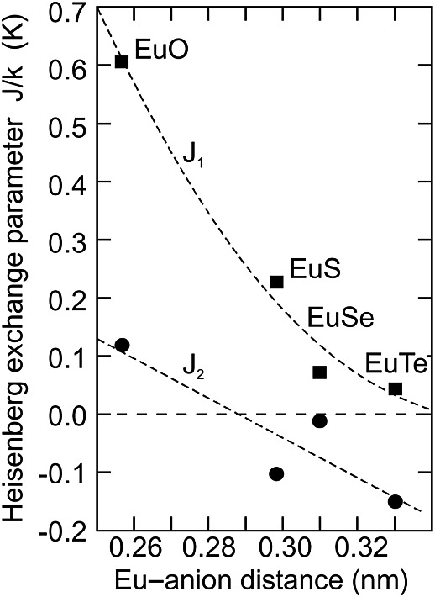

Fig. 17.1

Heisenberg nearest (

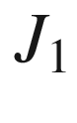

, *squares*) and next-nearest (



, *circles*) exchange parameters (in units of

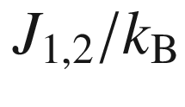

) for the Eu chalcogenides versus the Eu–anion distance. *Dashed lines* are guides to the eye.

Experimental data from [1525]

### 17.3 Diluted Magnetic Semiconductors

Table 17.2

3d, 4d and 5d transition metals and their electron configurations. Note that Hf

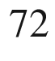

has an incompletely filled 4f-shell with 4f

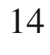

|  |  |  |  |  |  |  |  |  |  |
| --- | --- | --- | --- | --- | --- | --- | --- | --- | --- |
| $$\mathrm{Sc}^{21}$$ | $$\mathrm{Ti}^{22}$$ | $$\mathrm{V}^{23}$$ | $$\mathrm{Cr}^{24}$$ | $$\mathrm{Mn}^{25}$$ | $$\mathrm{Fe}^{26}$$ | $$\mathrm{Co}^{27}$$ | $$\mathrm{Ni}^{28}$$ | $$\mathrm{Cu}^{29}$$ | $$\mathrm{Zn}^{30}$$ |
| 3d | $$3\mathrm{d}^{2}$$ | $$3\mathrm{d}^{3}$$ | $$3\mathrm{d}^{4}$$ | $$3\mathrm{d}^{5}$$ | $$3\mathrm{d}^{6}$$ | $$3\mathrm{d}^{7}$$ | $$3\mathrm{d}^{8}$$ | $$3\mathrm{d}^{9}$$ | $$3\mathrm{d}^{10}$$ |
| $$4\mathrm{s}^{2}$$ | $$4\mathrm{s}^{2}$$ | $$4\mathrm{s}^{2}$$ | 4s | $$4\mathrm{s}^{2}$$ | $$4\mathrm{s}^{2}$$ | $$4\mathrm{s}^{2}$$ | $$4\mathrm{s}^{2}$$ | 4s | $$4\mathrm{s}^{2}$$ |
| $$\mathrm{Y}^{39}$$ | $$\mathrm{Zr}^{40}$$ | $$\mathrm{Nb}^{41}$$ | $$\mathrm{Mo}^{42}$$ | $$\mathrm{Tc}^{43}$$ | $$\mathrm{Ru}^{44}$$ | $$\mathrm{Rh}^{45}$$ | $$\mathrm{Pd}^{46}$$ | $$\mathrm{Ag}^{47}$$ | $$\mathrm{Cd}^{48}$$ |
| 4d | $$4\mathrm{d}^{2}$$ | $$4\mathrm{d}^{3}$$ | $$4\mathrm{d}^{4}$$ | $$4\mathrm{d}^{5}$$ | $$4\mathrm{d}^{6}$$ | $$4\mathrm{d}^{7}$$ | $$4\mathrm{d}^{8}$$ | $$4\mathrm{d}^{9}$$ | $$4\mathrm{d}^{10}$$ |
| $$5\mathrm{s}^{2}$$ | $$5\mathrm{s}^{2}$$ | 5s | 5s | 5s | 5s | 5s | – | 5s | $$5\mathrm{s}^{2}$$ |
| $$\mathrm{La}^{57}$$ | $$\mathrm{Hf}^{72}$$ | $$\mathrm{Ta}^{73}$$ | $$\mathrm{W}^{74}$$ | $$\mathrm{Re}^{75}$$ | $$\mathrm{Os}^{76}$$ | $$\mathrm{Ir}^{77}$$ | $$\mathrm{Pt}^{78}$$ | $$\mathrm{Au}^{79}$$ | $$\mathrm{Hg}^{80}$$ |
| 5d | $$5\mathrm{d}^{2}$$ | $$5\mathrm{d}^{3}$$ | $$5\mathrm{d}^{4}$$ | $$5\mathrm{d}^{5}$$ | $$5\mathrm{d}^{6}$$ | $$5\mathrm{d}^{7}$$ | $$5\mathrm{d}^{8}$$ | $$5\mathrm{d}^{9}$$ | $$5\mathrm{d}^{10}$$ |
| $$6\mathrm{s}^{2}$$ | $$6\mathrm{s}^{2}$$ | $$6\mathrm{s}^{2}$$ | $$6\mathrm{s}^{2}$$ | $$6\mathrm{s}^{2}$$ | $$6\mathrm{s}^{2}$$ | $$6\mathrm{s}^{2}$$ | 6s | 6s | $$6\mathrm{s}^{2}$$ |

In Table [17.2](#u116076_4_En_17_Chapter-Tab2), the transition metals and their electron configurations are summarized. The 3d transition metals are typically used for magnetic impurities in DMS due to their partially filled 3d shell. Due to Hund’s rule, the spins on the 3d shell are filled in parallel for the first five electrons up to half filling (in order to allow the electrons to get out of their way in real space). Thus, the atoms have a sizeable spin and a magnetic moment. The spin of Mn is

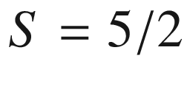

. Most transition metals have a 4s

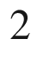

configuration that makes them isovalent in II–VI compounds. We note that Zn has a complete 3d shell and thus no net spin. In Fig. [17.2](#u116076_4_En_17_Chapter-Fig2), an overview of the crystallographic properties is given for Mn-alloyed II–(Se, S, Te, O) based DMS [1526] (DMS with Se, S, and Te have been discussed in [1527]).

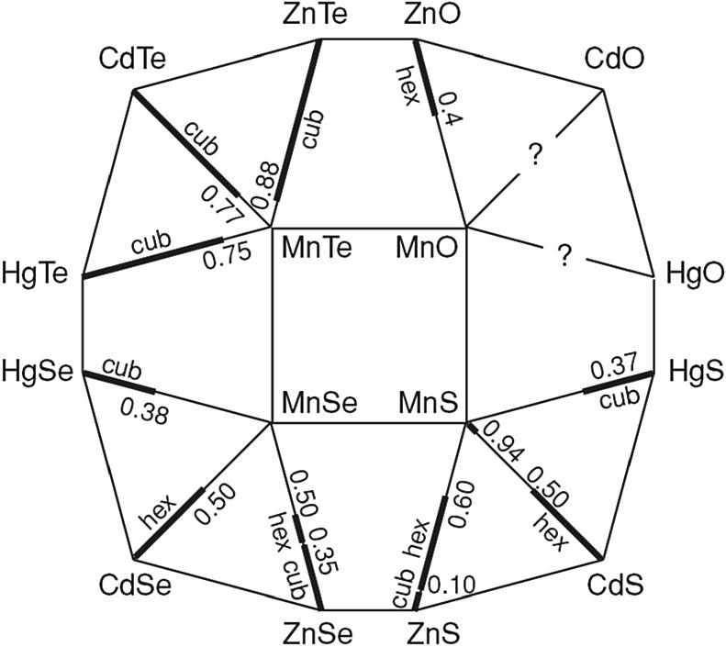

Fig. 17.2

Diagrammatic overview of A

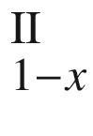

Mn



B

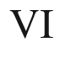

alloys and their crystal structures. The *bold lines* indicate ranges of the molar fraction *x* for which homogeneous crystal phases form. ‘Hex’ and ‘Cub’ indicate wurtzite and zincblende, respectively.

From [1526]

As an example, the properties of Hg

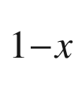

Mn



Te are discussed. This alloy is semiconducting (positive band gap

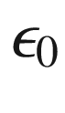

) for

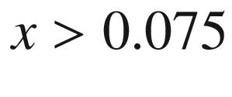

and a zero-gap material (negative interaction gap

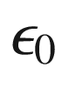

) for smaller Mn concentration (cf. Fig. [6.​46](The_Physics_of_Semiconductors00003.docx#u116076_4_En_6_Chapter-Fig46)). The transitions between the

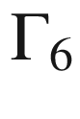

and

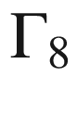

bands can be determined with magnetoabsorption spectra in the infrared [1528]. In Fig. [17.3](#u116076_4_En_17_Chapter-Fig3)a, the magnetic field dependence of transition energies between different Landau levels is shown that can be extrapolated to yield the interaction gap. The interaction gap is shown in Fig. [17.3](#u116076_4_En_17_Chapter-Fig3)b as a function of the Mn concentration.

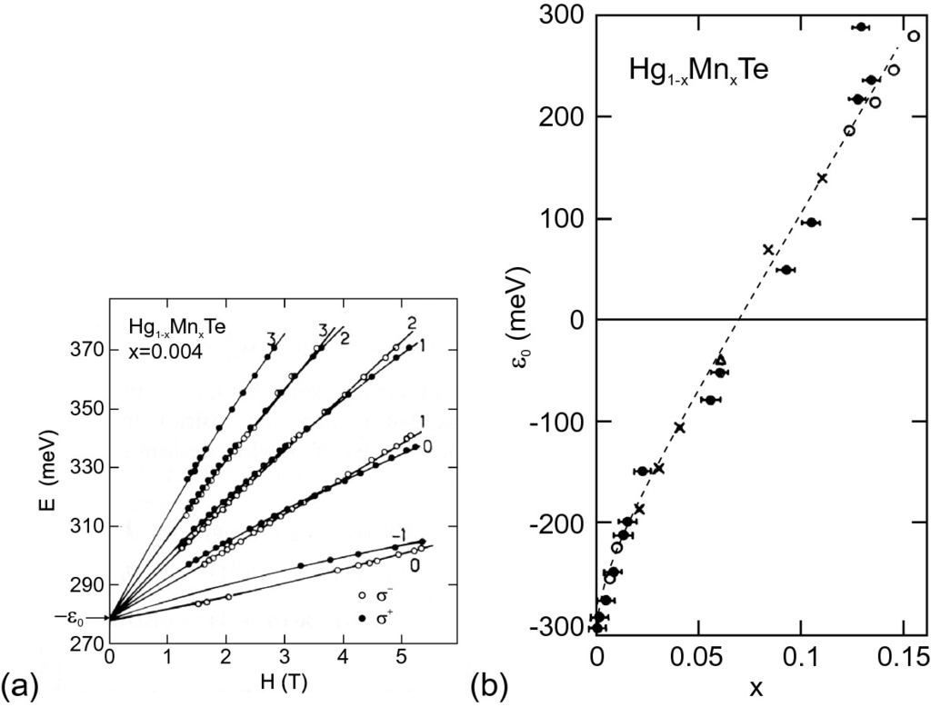

Fig. 17.3

**a** Energies of

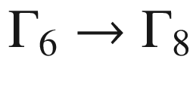

transitions versus magnetic field for Hg

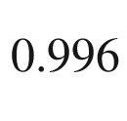

Mn

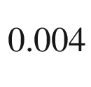

Te at

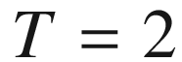

 K. *Symbols* are experimental values for two polarization directions as indicated. Numbers denote quantum numbers of transitions. *Solid lines* are theoretical fits. **b** Interaction gap versus Mn concentration for Hg

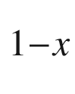

Mn



Te at

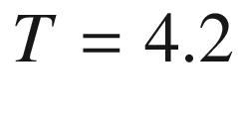

 K. Various *symbols* represent data from different authors and methods. *Dashed line* is a guide to the eye.

Adapted from [1528]

For small Mn concentrations, the DMS behaves like a paramagnetic material. For larger concentrations, the Mn atoms have increasing probability to be directly neighbored by another Mn atom and suffer superexchange interaction (cf. ([3.​24b](The_Physics_of_Semiconductors00001.docx#u116076_4_En_3_Chapter))). At a certain critical concentration

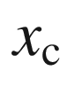

, the cluster size becomes comparable with the size of the sample. If interaction up to the first, second or third neighbor are taken into account for a fcc lattice, the critical concentrations are given by

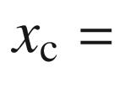

0.195, 0.136, and 0.061, respectively [1529]. The nearest-neighbor interaction between Mn atoms in such DMS as (Zn, Cd, Hg) Mn(S, Se, Te) was found to be antiferromagnetic,[1](#u116076_4_En_17_Chapter-Fn1)  i.e. neighboring spins are aligned antiparallel. Due to frustration of antiferromagnetic long-range order on a fcc lattice, an antiferromagnetic spin glass forms. The transition temperature

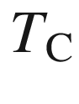

between the paramagnetic and spin-glass phases  of Hg



Mn



Te is shown in Fig. [17.4](#u116076_4_En_17_Chapter-Fig4).

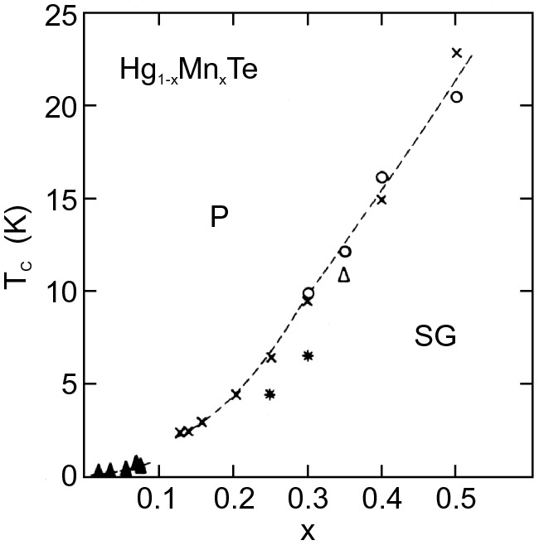

Fig. 17.4

Magnetic phase diagram of Hg



Mn



Te, ‘P’ (‘SG’) denotes the paramagnetic (spin glass) phase. Various *symbols* represent data from different authors and methods. *Dashed line* is a guide to the eye.

Adapted from [1528]

In III–V compounds, the 3d transition metals represent an acceptor if incorporated on the site of the group-III element as, e.g., in the much investigated compound Ga



Mn



As. This material will be used in the following to discuss some properties of magnetic semiconductors. It seems currently well understood and has a fairly high Curie temperature of

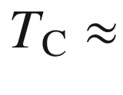

160 K. Ferromagnetism in a diluted magnetic semiconductor is believed to be caused by indirect exchange through itinerant charge carriers. The ferromagnetic coupling can be invoked by the Ruderman–Kittel–Kasuya–Yoshida (RKKY) interaction, i.e. the spins of the paramagnetic ions are aligned via interaction with the free carriers in the semiconductor. A related concept is the double exchange[2](#u116076_4_En_17_Chapter-Fn2) [1530–1532] in which carriers move in a narrow Mn-derived d-band (for d-wave character see Fig. [7.​16](The_Physics_of_Semiconductors00003.docx#u116076_4_En_7_Chapter-Fig16)c). Such a mechanism was first invoked for PbSnMnTe [1533]. Later, ferromagnetism was discovered in InMnAs [1534] and GaMnAs [1535]. In (In,Ga)MnAs a Mn ion (spin up) spin polarizes the surrounding hole gas (spin down), which has been supplied from the Mn acceptors. This mechanism lowers the energy of the coupled system. The interaction

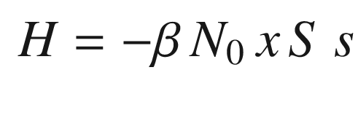

(17.1)

between the Mn d-shell electrons (

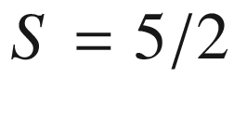

) and the p-like free holes (

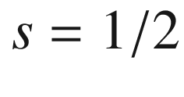

) is facilitated by p–d hybridization of the Mn states.

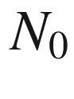

denotes the concentration of cation sites in the A



Mn



B alloys. The coupling via electrons is much weaker (coupling coefficient

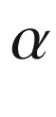

). The holes interact with the next Mn ion and polarize it (spin up), thus leading to ferromagnetic order. The ferromagnetic properties are evident from the hysteresis shown in Fig. [17.6](#u116076_4_En_17_Chapter-Fig6)a. Without the carrier gas such interaction is not present and the material is only paramagnetic. Theoretical results for the Curie temperature of various p-type semiconductors are shown in Fig. [17.5](#u116076_4_En_17_Chapter-Fig5). Generally, the quest for higher Curie temperatures (well above room temperature) is underway and wide band gap materials such as GaN or ZnO doped with transition metals have shown some encouraging results. Mn-substituted chalcopyrite semiconductors are analyzed theoretically in [1536] and are predicted to exhibit less-stable ferromagnetism than III–V semiconductors of comparable band gap.

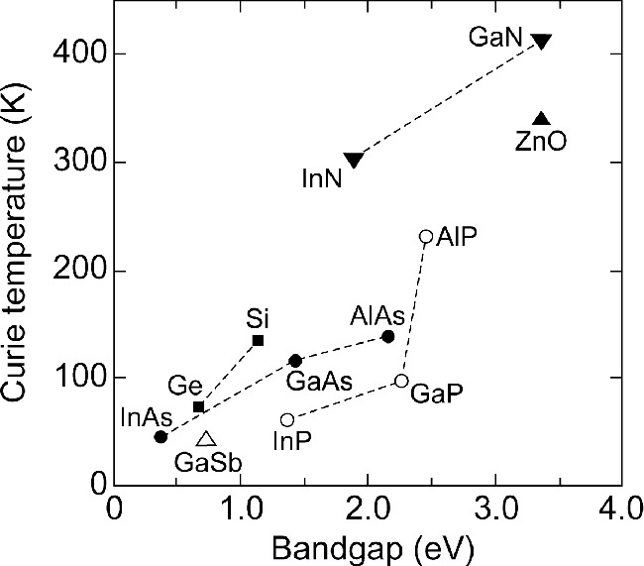

Fig. 17.5

Computed values of the Curie temperature



for various p-type semiconductors plotted versus the band gap (*dashed lines* are guides to the eye). All materials contain 5% Mn on the cation sublattice and a hole concentration of

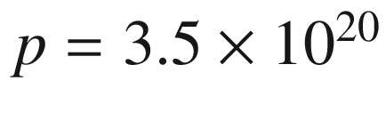

 cm

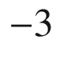

. Values for



taken from [1532]

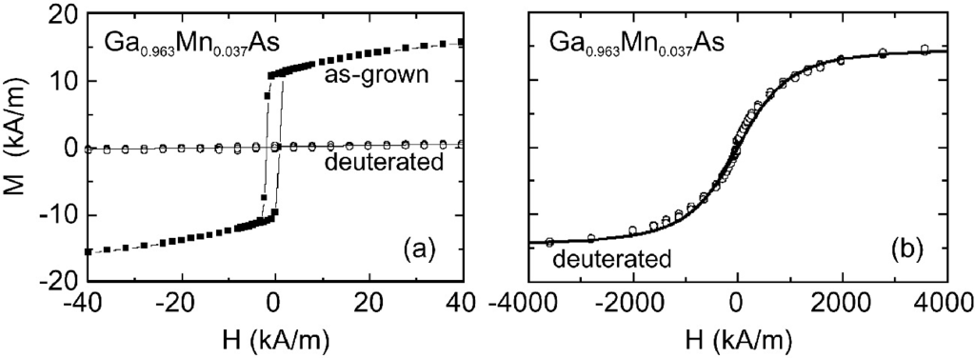

Fig. 17.6

Magnetization *M* versus magnetic field *H* for Ga

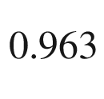

Mn

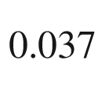

As at low temperature. **a** Comparison of as-grown (*full squares*) and deuterated (*open circles*) thin film with magnetic field in the layer plane at

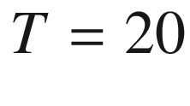

 K. **b** Magnetization of the deuterated sample at



 K for larger magnetic fields. *Solid line* is Brillouin function for

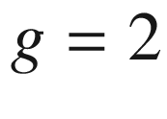

and



.

Adapted from [1538]

The carrier density and thus magnetic properties in a DMS can be controlled in a space-charge region (cf. Sect. [21.​2.​2](The_Physics_of_Semiconductors00007.docx#u116076_4_En_21_Chapter)) as demonstrated in [1537]. In Fig. [17.6](#u116076_4_En_17_Chapter-Fig6), results are shown for hydrogen- (deuterium-) passivated GaMnAs that exhibits ferromagnetism as ‘as-grown’ thin film. The deuterium is incorporated in similar concentration as the Mn, assumes a back-bond position (forming a H–As–Mn complex) and compensates the hole gas from the Mn (cf. Sect. [7.​9](The_Physics_of_Semiconductors00003.docx#u116076_4_En_7_Chapter)). The low-temperature conductivity drops nine orders of magnitude [1538]. Such material displays only paramagnetic behavior. An optimal Mn concentration for ferromagnetic Ga



Mn



As is around

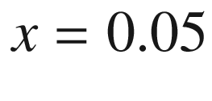

. For smaller Mn concentrations, the hole density is too small and the Curie temperature drops; for larger Mn concentrations, the structural properties of the alloy degrade (phase separation into GaAs and MnAs.[3](#u116076_4_En_17_Chapter-Fn3)).

Magnetic hysteresis has been found in nearly compensated Mn-doped ZnO [1539, 1540] (Fig. [17.7](#u116076_4_En_17_Chapter-Fig7)). Such material is interesting due to its small spin-orbit coupling. The exchange mechanism is under debate.

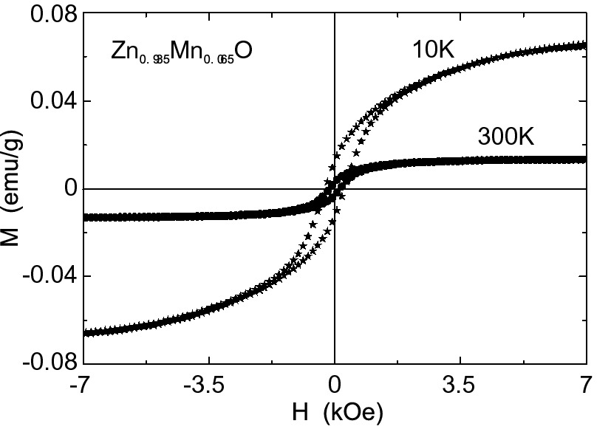

Fig. 17.7

Magnetization *M* versus magnetic field *H* for Zn

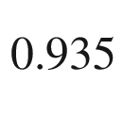

Mn

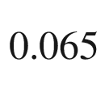

O thin film at

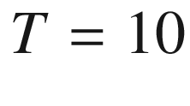

and 300 K. A hysteresis is obvious for both temperatures

### 17.4 Spintronics

Spintronics (as opposed to electronics) is an emerging field that uses the electron *spin* rather than its *charge* for transport, processing and storage of information. Prototype devices are the spin transistor and the spin LED. A crucial point is spin injection, i.e. the creation of (highly) spin-polarized currents. It remains to be seen whether spintronics can be developed to its theoretically envisioned potential and will play a commercially important role in the course of microelectronics. The spin degree of freedom also promises potential for quantum information processing due to its weak coupling to charge and phonons and the resulting long dephasing time.

It shall be mentioned here that the magnetization alters also the ‘classical’ transport properties of the semiconductor. The Hall effect is modified strongly and reflects the magnetic hysteresis, also termed *anomalous* Hall effect (AHE).[4](#u116076_4_En_17_Chapter-Fn4) This effect was already discovered by Hall in 1881 for Ni and Co [1541]; a review of the AHE can be found in [1542]. Also the optical excitation of spin-polarized carriers in non-magnetic materials causes AHE [1543]. For a magnetic material with topological band structure, the internal field can be sufficient to evoke the QHE [1544]; this quantum anomalous Hall effect (QAHE) has been reported for (Bi,Sb)



Te



:Cr [1545] and MnBi



Te

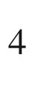

 [1546].

#### 17.4.1 Spin Transistor

In this device (for regular transistors cf. Chap. [24](The_Physics_of_Semiconductors00009.docx#u116076_4_En_24_Chapter)), spin-polarized electrons are injected from contact 1, transported through a channel and detected in contact 2. During the transport, the spin rotates (optimally by

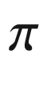

) such that the electrons cannot enter contact 2 that has the same magnetization as contact 1 (Fig. [17.8](#u116076_4_En_17_Chapter-Fig8)). The spin rotation is caused by spin-orbit interaction due to the electric field under the gate contact. This effect is called the Rashba effect and is purely relativistic [1547]. As channel material, a semiconductor with strong spin-orbit coupling such as InAs or (In,Ga)Sb is preferable. However, the use of narrow-gap semiconductors and the increase of spin scattering at elevated temperatures [1548] make the realization of such a transistor at room temperature difficult.

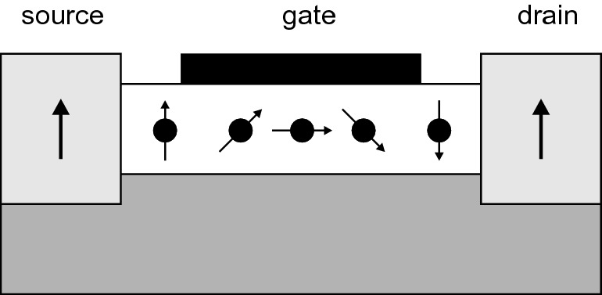

Fig. 17.8

Scheme of spin transistor after the proposal of [1549]. Source and drain are ferromagnets with their magnetization shown schematically as arrows. The channel under the gate transports electrons whose spin rotates in the electric field under the gate

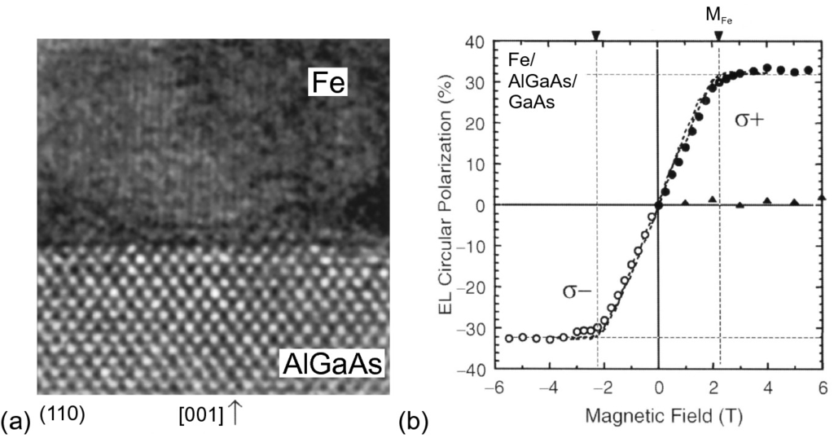

Fig. 17.9

**a** Transmission electron microscopy image of the (110) cross section of the Fe/AlGaAs interface of a spin LED. The *vertical lines* in Fe are the (110) planes with 0.203 nm distance. **b** Magnetic-field dependence of the circular polarization ratio

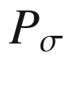

at

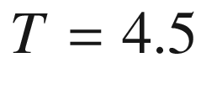

 K ([17.2](#u116076_4_En_17_Chapter-Equ2)) (*filled* and *empty* circles) and the out-of-plane component of the Fe-film magnetization (*dashed line*, scaled to the maximum of

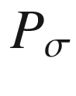

).

Reproduced from [1551] by permission of the MRS Bulletin

#### 17.4.2 Spin LED

In a spin LED (for LEDs see Sect. [23.​3](The_Physics_of_Semiconductors00008.docx#u116076_4_En_23_Chapter)), the injection of spin-polarized carriers into the active layer leads to circularly polarized luminescence. The spin alignment can be achieved with semimagnetic semiconductors grown on top of the active layer or via spin injection from a ferromagnetic metal into the semiconductor (for metal–semiconductor junctions cf. Sect. [21.​2](The_Physics_of_Semiconductors00007.docx#u116076_4_En_21_Chapter)). In Fig. [17.9](#u116076_4_En_17_Chapter-Fig9)a, a Fe/AlGaAs interface is shown.

Ideally, the spin-polarized electrons from the ferromagnetic metal tunnel into the semiconductor and transfer to the recombination region. Subsequently, the emission is circularly polarized (Fig. [12.​30](The_Physics_of_Semiconductors00005.docx#u116076_4_En_12_Chapter-Fig30)b). The degree of circular polarization is

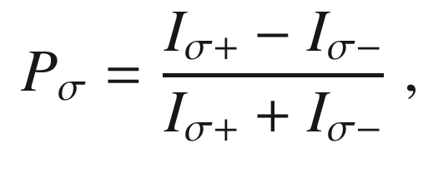

(17.2)

with

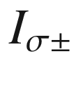

being the intensity of the respective polarization. The degree of polarization depends on the magnetization of the metal. For the saturation magnetization of Fe, the maximum polarization is about 30% at



 K (Fig. [17.9](#u116076_4_En_17_Chapter-Fig9)b) [1550]. The interface and its structural nonideality of the interface presumably prevent the spin injection from being 100% efficient [1551]. Recently, close to pure (95%) circular polarization has been obtained from a (Al,Ga)As/GaAs-based stripe-laser-like (edge emitting) structure with Fe/crystalline AlO



spin-tunnel barrier [1552].

Footnotes

[1](#u116076_4_En_17_Chapter-Fn1_source)

Such superexchange leads to antiferromagnetic interaction if the bond angle is ‘close’ to 180

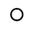

.

[2](#u116076_4_En_17_Chapter-Fn2_source)

This model is also called the Zener model.

[3](#u116076_4_En_17_Chapter-Fn3_source)

MnAs is a ferromagnetic metal. MnAs clusters can be a problem since they create ferromagnetic properties but not in the way the DMS is supposed to work.

[4](#u116076_4_En_17_Chapter-Fn4_source)

This use of the term ‘anomalous’ should be distinguished from the historical use of ‘anomalous’ Hall effect for the sign reversal of the Hall voltage for hole conductors.

© Springer Nature Switzerland AG 2021

M. Grundmann

The Physics of Semiconductors

Graduate Texts in Physics

<https://doi.org/10.1007/978-3-030-51569-0_18>

## 18. Organic Semiconductors

Marius Grundmann[1](#u116076_4_En_18_Chapter-Aff11)

(1)

Felix Bloch Institute for Solid State Physics, Universität Leipzig, Leipzig, Germany

Marius Grundmann

Email:

[grundmann@physik.uni-leipzig.de](mailto:grundmann@physik.uni-leipzig.de)

## Abstract

An introduction to organic semiconductors, based on the sp

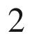

bonding scheme is given, covering small organic molecules and polymers. Their electronic structure, doping schemes, as well as their particular transport and optical properties are covered.

### 18.1 Introduction

Organic semiconductors are based on carbon compounds. The main structural difference from inorganic semiconductors is the bond based on sp



hybridization  (cf. Sect. [2.​2.​3](The_Physics_of_Semiconductors00001.docx#u116076_4_En_2_Chapter)) as present in benzene (and graphite). Diamond, although consisting of 100% carbon, is not considered an organic semiconductor. We note that carbon can form further interesting structures based on sp

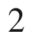

bonds, such as carbon nanotubes (Sect. [14.​3](#u116076_4_En_14_Chapter)), (single or few layer) graphene sheets (Sect. [13.​1](#u116076_4_En_13_Chapter)) rolled up to form cylinders, or fullerenes, e.g. soccer-ball-like molecules such as C

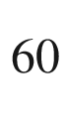

.

In the 1980 Handbook on Semiconductors only a good ten pages were devoted to organic semiconductors [1553]. Now several textbooks are available [1554, 1555] for a much more detailed treatment than given here.

### 18.2 Materials

#### 18.2.1 Small Organic Molecules, Polymers

The prototype organic molecule is the benzene molecule with its ring-like structure (Fig. [2.​8](The_Physics_of_Semiconductors00001.docx#u116076_4_En_2_Chapter-Fig8)).

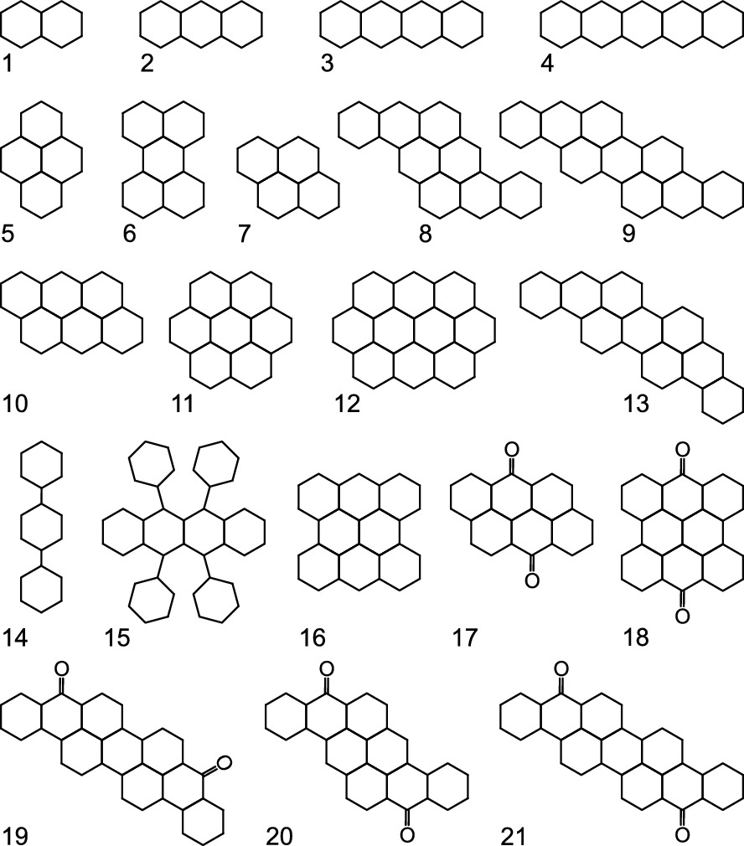

Fig. 18.1

Various organic compounds: 1: naphtalene, 2: anthracene, 3: tetracene, 4: pentacene, 5: pyrene, 6: perylene, 7: chrysene, 8: pyranthrene, 9: isoviolanthrene, 10: anthanthrene, 11: coronene, 12: ovalene, 13: violanthrene, 14: p-terphenyl, 15: rubrene, 16: m-dinaphthanthrene, 17: anthanthrone, 18: m-dinaphthanthrone, 19: violanthrone, 20: pyranthrone, 21: isoviolanthrone

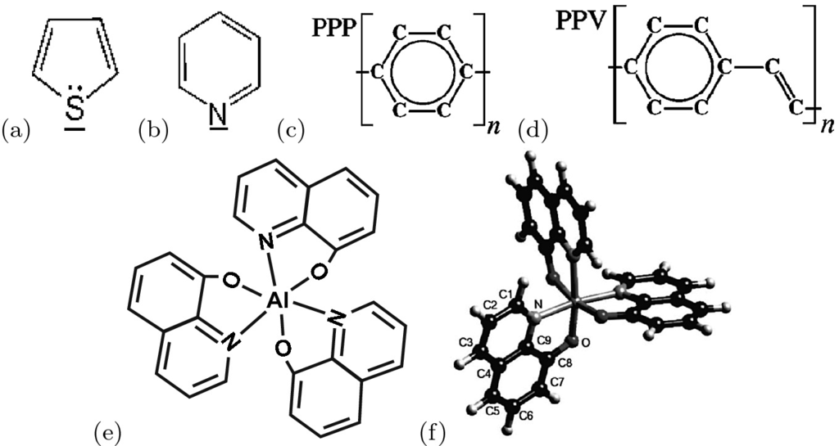

Fig. 18.2

Organic compounds: **a** thiophene, **b** pyridine, **c** poly-(p-phenyl), **d** poly-(p-phenylvinyl), **e** Alq



(tris-(8-hydroxyquinolate)-aluminum) and **f** a three-dimensional view of the Alq



molecule.

Part (**f**) reprinted with permission from [1556], ©1998 AIP

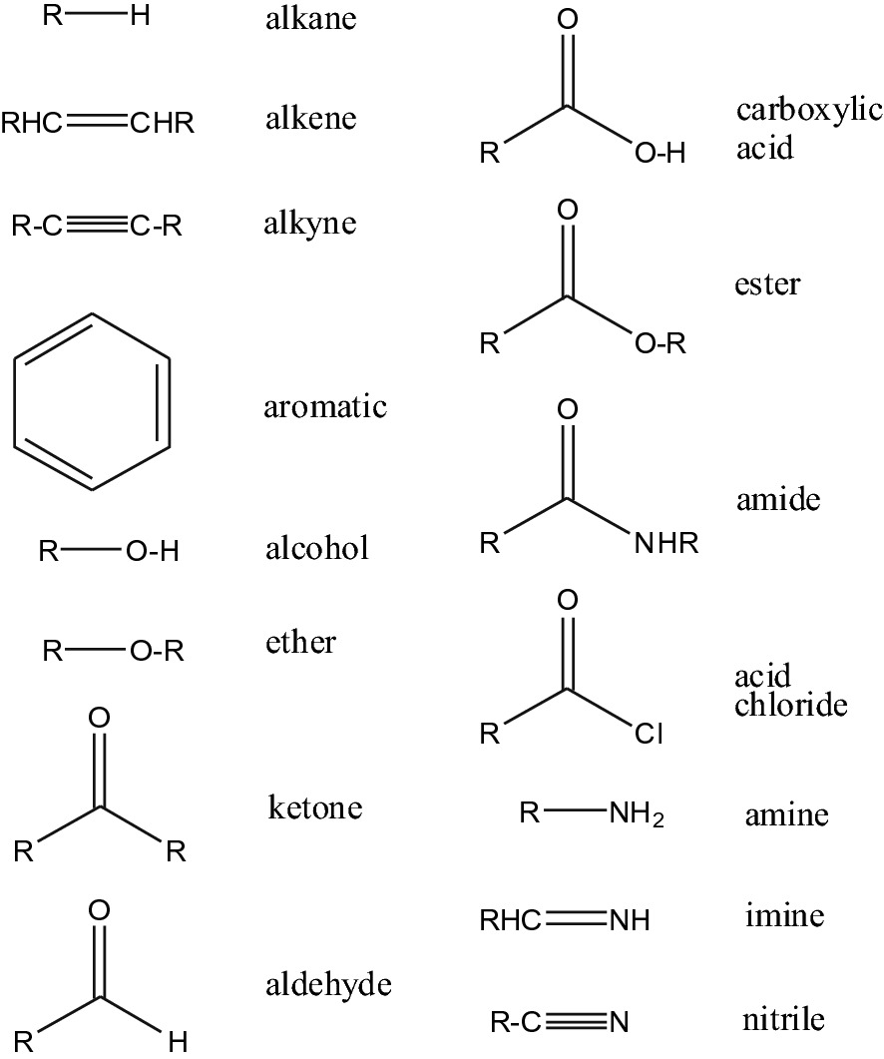

Fig. 18.3

Building blocks of organic molecules, ‘R’=alkyl group, i.e. CH



(methyl-), CH



CH



(buthyl-),

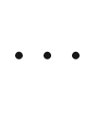

There is a large number of organic, semiconducting molecules that differs by the number of benzene rings (Fig. [18.1](#u116076_4_En_18_Chapter-Fig1)), the substitution of carbon atoms by nitrogen or sulfur (Fig. [18.2](#u116076_4_En_18_Chapter-Fig2)a, b), the polymerization (Fig. [18.2](#u116076_4_En_18_Chapter-Fig2)c) or the substitution of hydrogen atoms by side groups (Fig. [18.2](#u116076_4_En_18_Chapter-Fig2)d). Since PPV is insoluble, typically derivatives such as MEH-PPV[1](The_Physics_of_Semiconductors00007.docx#u116076_4_En_18_Chapter-Fn1) [1557] that are soluble in organic solvents are used. Compared to benzene, the substitution of one carbon atom by nitrogen (pyridine) represents doping with one electron. In Fig. [18.3](#u116076_4_En_18_Chapter-Fig3), the most important building blocks of organic molecules are shown.

#### 18.2.2 Organic Semiconductor Crystals

Small organic molecules can crystallize into solids, so-called *organic molecular crystals* (OMC), due to van-der-Waals interaction. In Fig. [18.4](#u116076_4_En_18_Chapter-Fig4)a, the monoclinic unit cell of an anthracene crystal [1558] is shown as an example. Also tetracene and pentacene (Fig. [18.4](#u116076_4_En_18_Chapter-Fig4)b) have this layered ’herringbone‘ structure. A comparison of the unit cells of oligoacene crystals is given in Table [18.1](The_Physics_of_Semiconductors00007.docx#u116076_4_En_18_Chapter-Tab1).

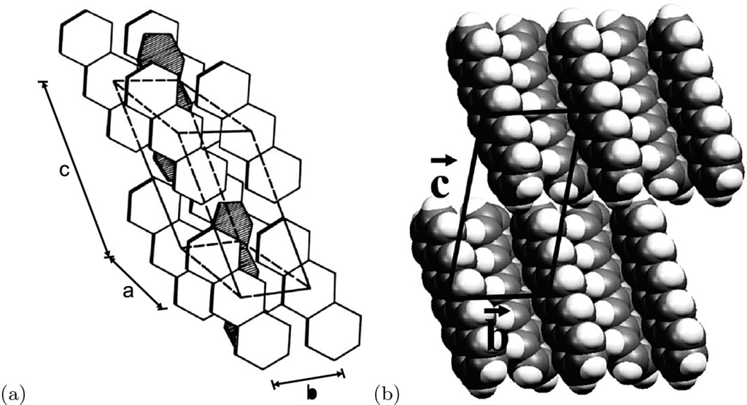

Fig. 18.4

**a** Monoclinic unit cell (for size see Table [18.1](The_Physics_of_Semiconductors00007.docx#u116076_4_En_18_Chapter-Tab1)) of anthracene crystal. **b** Two herringbone layers of pentacene in a projection onto the bc plane of the triclinic unit cell.

Adapted from [1566]

Crystal growth of single crystal OMC is achieved with a variety of methods, among them sublimation, Bridgman- and Czochralski-type methods [1560, 1561], vapor phase growth [1562, 1563] or from solution [1564, 1565]. Single organic molecular crystals exhibit intrinsic material properties. The practical use of organic semiconductors involves thin films, e.g. in LEDs (OLED, Sect. [23.​3.​7](The_Physics_of_Semiconductors00008.docx#u116076_4_En_23_Chapter)) and transistors (OFET, Sect. [24.​6.​4](The_Physics_of_Semiconductors00009.docx#u116076_4_En_24_Chapter)). Thin films of organic molecules are typically disordered and their performance parameters are inferior to that of OMCs.